A REPORT ON
Enercore Website Development and Deployment
By
Name of the student Enrollment No.
Akshit Wadhwa 230784
Mentored by:
Dr.Pooja Chaudhary
Assistant Professor SOET
Prepared in the partial fulfillment of the
Practice School II Course
AT
Enercore Pvt limited, A-01, Sector – 59, Noida, Uttar Pradesh

A Practice School II Station of

BML MUNJAL UNIVERSITY
(August ,2025)

Certificate of authenticity CERTIFICATE
This is to certify that Practice School Project of Akshit Wadhwa titled Enercore Webiste development and deployment to the best of my knowledge is a record of Bonafide work carried out by him under my guidance and/or supervision. The contents embodied in this report, to the best of my knowledge have not been submitted anywhere else in any form for the award of any other degree or diploma. Indebtedness to other works/publications has been duly acknowledged at relevant places. The project work was carried during 2nd June to 27th July in Enercore Pvt Limited

 | 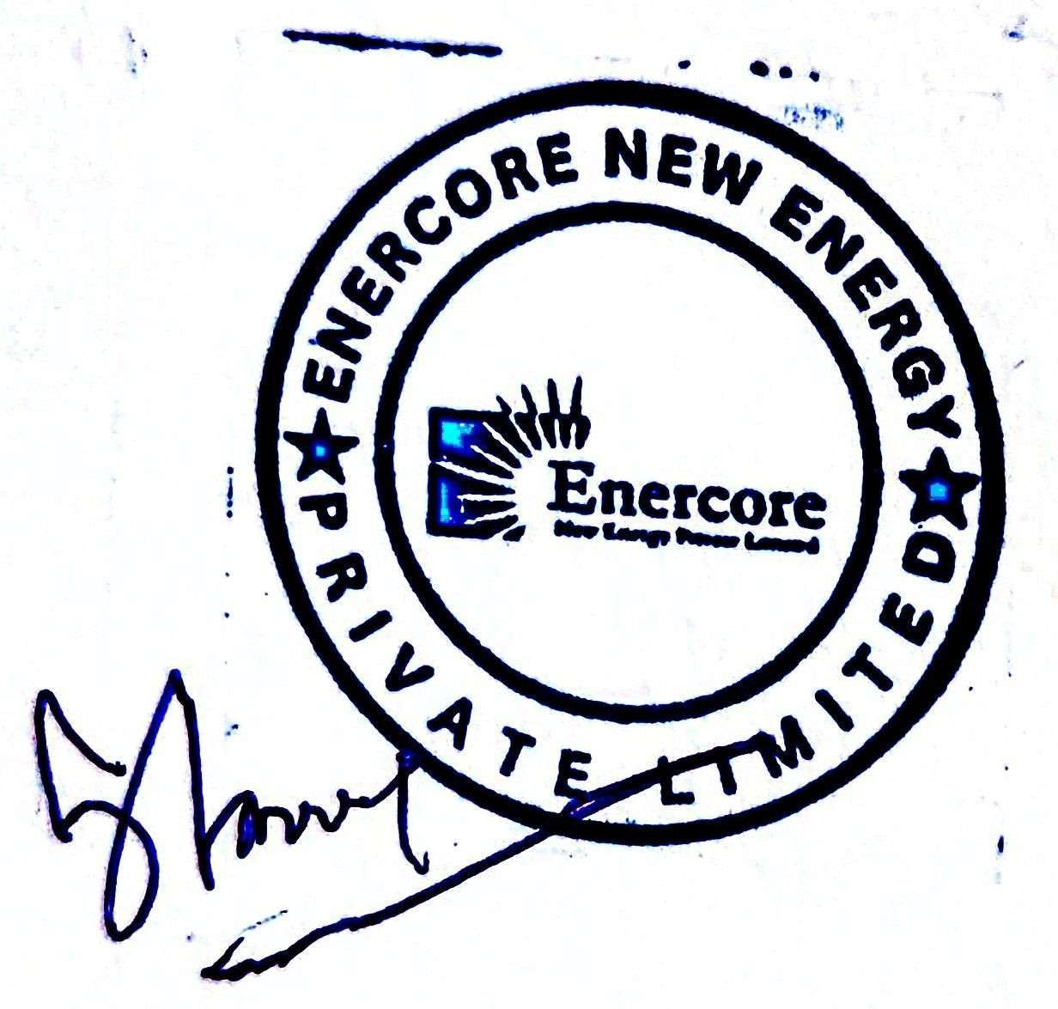
Signature of PS-II Faculty Mentor | Signature of industry Mentor/Supervisor
Name: Ms. Pooja Chaudhary | Name: Mr. Sidhyant Manu
Designation: | Designation: Director, Enercore  Pvt Ltd
Date |   (Seal of the organization with Date)

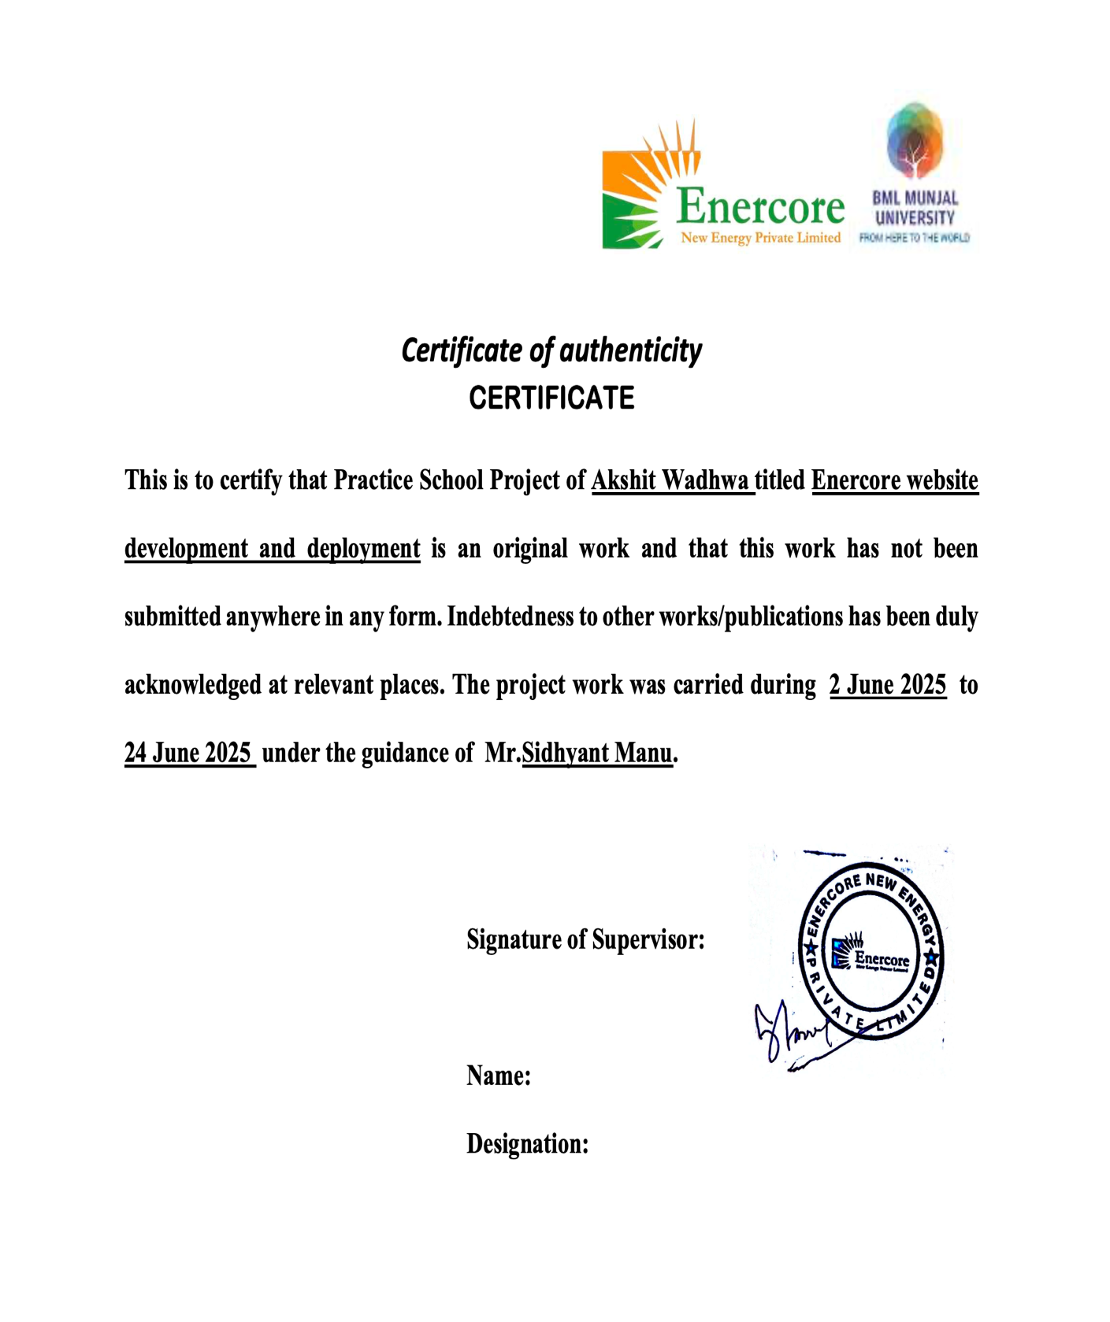

Joining Report

BML MUNJAL UNIVERSITY PRACTICE SCHOOL – II JOINING

Date: 6th Augest, 2025

Name of the Student | Akshit Wadhwa
Name and Address of the Practice School – II Station | Enercore Pvt limited, A-01, Sector – 59, Noida,  Uttar Pradesh
Date of Joining PS-II station as per offer letter | 2nd June 2025
Actual date of reporting to PS-II stations | 2nd June 2025
Department Allocated | Web development and Research
Name and Designation of the Industry Guide/ Industry Mentor for the Project | Mr.Sidhyant Manu
Industry Mentor Contact No. | 9560457193
Industry Mentor E-mail Address (Compulsory) | Sidhyant.manu@enercore.org

Acknowledgements

I would like to express my heartfelt gratitude and appreciation to all the individuals who have been instrumental in making my internship journey a truly enriching and rewarding experience. I extend my heartfelt thanks to the esteemed Head of the organization, Vice Chancellor Prof. Shyam Menon, and Dean of the School of Engineering and Technology (SoET) Prof. Maneek Kumar, for providing me with this invaluable opportunity and their unwavering support throughout my internship.

I also want to express my sincere gratitude to the PS (Practical Skills) programme coordinators Dr Anubhav Agarwal, Dr Ranbir Singh, Dr Atul Mishra and Dr Kiran Khatter for their assistance in obtaining the internship.

I would like to express my profound gratitude to my faculty mentor Ms. Pooja Chaudhary, whose continuous encouragement and feedback have been crucial in refining my skills and knowledge. I also want to acknowledge and expresses thanks to our faculty mentor Mr.Sidhyant Manu for his assistance and support during the internship. I would also express my sincere gratitude to Mr. Shekhar our professional expert for his support.

LIST OF ABBREVIATIONS

Abbreviations Full Form

HTML Hyper Text Markup Language

CSS Cascade Style Sheet

JS JavaScript

UI User Interface
UX User Experience
API Application Program Interface
DOM Document Object Model

Abstract

This project presents the development of a comprehensive corporate website for Enercore New Energy Private Limited, a clean teach company specializing in solar energy solution and sustainable development. The website serves as a digital platform showcasing the company’s commitment to Environmental, Social and Governance principles while offering an in-depth information about its renewable energy services and corporate profile.
The project demonstrates proficiency in full stack web development, responsive design implementation, and corporate website architecture. This report demonstrates the successful
Creation of Enercore’s digital presence that effectively shows its sustainable energy solutions and while maintain high standards of user experience and accessibility. The website functions both as a marketing asset and an information hub for stakeholders, investors, and prospective clients interested in renewable energy.
Some notable features of this website include interactive ESG section that presents the company’s six strategic sustainability pillars, a detailed project portfolio featuring completed solar installations, a team section introducing key leadership members, and comprehensive information on the company’s Remote Monitoring System (RMS) for solar asset management. We have deployed the website as a multi-page, fully responsive website utilizing modern technologies such as HTML5 , CSS3 and JavaScript. The design emphasizes a modern, user-centric interface incorporating sustainability themes, including a green color palette and professional visuals that reflect Enercore’s dedication to the environment.

Table of Content

Contents Page No.

- Introduction of the Organization’s Business Sector 7
- Overview of the organization 8
  - Brief history 8
  - Business size 8
  - Competitors 9
  - Product line 9
- Plan of your internship program
  - Brief introduction of branch/department 10
  - Start and end dates
  - The names of the department visited during the stay of the internship 10
  - Duties/Responsibilities Performed 11
- Background and description of problem 13
- Main Text
  - Beginning with the project 14
  - Experimental work/data collection
  - Methodology 15
  - A description of activities or programs. 17
  - The results obtained/illustrations 18
- Conclusion 21
  - Future Scope 22
- References 23
- LIST OF ABBREVIATIONS 24

Introduction of the Organization’s Business Sector

Enercore private limited operates in the renewable energy sector, specifically

focusing on solar power projects and carrying sustainable development initiatives. It

is rapidly expanding in the renewable energy sector with focusing on solar

photovoltaics (PV) technology and clean energy solutions. This sector represents one of the fastest-growing industries globally which can increase climate change mitigation, increase energy security and lead to sustainable development.

Enercore also handles Open Access Capex projects which involve the engineering, procurement and construction of solar power projects.

In the renewable energy sector, Enercore is making its mark by 16+ completed projects across various sector demonstrating and ensuring quality service delivery.

Enercore is built around strong commitment to sustainable practices and corporate responsibility. This includes deploying renewable energy for Climate Action to reduce its carbon footprint, as well as optimizing energy consumption and generation to enhance Energy Efficiency.

This comprehensive approach to renewable energy, combined with strong ESG principles and technological innovation, positions. Henec Enercore is a key player in India’s transition toward a sustainable energy future.

Overview of the organization

2.1 Brief History Of The Company

Enercore is a cleantech company providing green energy solutions to clients to reduce

there are carbons footprint as well as optimizing energy consumption and enhance

Energy Efficiency. It was established on 12th July 2024 and its current office is as C16- Siddharth Vihar, Ghaziabad, UP-201009.The organization invests in its workforce through Employee Learning and development to promote inclusive workplace practices. It is staffed by experienced professionals and technical experts, who provide turnkey solar solutions and exceptional customer service. The company is also committed to Corporate Social Responsibility (CSR) initiatives, with the goal of empowering local communities and fostering sustainable development in the vicinity of its project sites.

Business size

Enercore is making its mark by 16+ completed projects across various sector demonstrating and ensuring quality service delivery. The company is led by a distinguished leadership team including Mrs. Uma Singh (Managing Director), Mr. Sidhyant Manu (Director/COO), Mr. Shekhar Keshav (Honorary Director), and Mrs. Priti Agarwal (Honorary Director), who bring extensive expertise in renewable energy and sustainable business practices. Enercore is built around strong commitment to sustainable practices and corporate responsibility. It has catered to 10 plus clients in the India domain by providing End to End engineering solutions and constructions of solar power projects under Capex mode.Working with companies such as Mahagenco Design and Engineering, Caparo Maruti India Pvt Ltd Reduce electricity bills by up to 50% with Advanced engineering solutions to maximize energy output and system efficiency. Capital & Share Structure: E-Kors Renewables is registered with an authorized and paid-up share capital of ₹100,000

Competitors

Enercore operates within the rapidly expanding renewable energy sector, specifically focusing on solar photovoltaic (PV) technology and clean energy solutions. Companies such as Solarworld Energy Solution, Fourth Partner Energy and solar energy corporation of India are some on the competitors of Enercore Private limited as they deal in the same renewable energy sector. Tata Power Solar, Adani Green Energy, Renew Power , Mid-sized EPC firms specializing in solar/wind installations, Biomass and energy storage solution providers.
Companies such as solar energy corporation of India deal in deploying accessible, reliable and scalable renewable energy solution. Although it deals in solar, wind as well as Hybrid Projects while Enercore is only limited to solar for now
With over 12 years of expertise and a project portfolio exceeding 1 GW, SOLARWORLD provides comprehensive renewable energy solutions. The company is a recognized leader in quality and reliability, offering services that include end-to-end Solar EPC, Solar Park Development, and the deployment of both Rooftop and Ground-Mounted Solar Projects. Serving a diverse clientele that includes government organizations, industries, and commercial enterprises, SOLARWORLD has established itself as a trusted partner to major industry players.

  - Product line

Enercore offers several services that can be considered its products in the renewable energy sector. These include Opex Projects, which can reduce electricity bills by up to 50% without initial investment. The company also provides Open Access Capex Projects, which involve the engineering, procurement, and construction of solar power projects. Additionally, Enercore offers state-of-the-art Design & Engineering services, end-to-end consulting for technical and legal compliances, and Asset Management services for the operation and maintenance of solar power plants to maximize efficiency and return on investment.

Plan of your internship program
3.1 Introduction of branch/department

The project was assigned to the Software Development Department. We had to break down the components and work on the UI/UX design for the frontend of the website carefully displaying what are the architecture and structure.
We made the design using Figma for the frontend and took the input from our Mentor.
The codebase was made using the web development languages such as HTML , CSS and JavaScript with proper structure and technical implementation.
Production level commits as well as pull requests were followed so that the codebase didn’t get cluttered with faulty code.
To sort the assets which we will need in the website , we used the photos , drone shots as well as customer interviews mapped that to be put in the website. It was ensured that there be a responsible and it be accessible across devices

  - Start and end dates
The two-month internship under the Development Department started on 2 June 2024 and ended on 27 July 2024.

  - Departments visited and the duration of stay
This project was primarily undertaken by the Web Development Department within the organization. The Web Development Department is responsible for designing, developing, and maintaining the company’s digital presence including its corporate website and related web applications. To know about the company, we had to first reach the research department to know the ins and outs of the company for which we are designing the website. To name a few, the design, development, testing and the deployment department were visited by us and gave us an idea to learn more about managing the project timeline. The duration of each page/ department depended on the amount of work there was to complete in it. Typically, the work was spread week wise with designing in the first week along with making some tweaks to the old website which was made by the pervious team who worked at Enercore.Overall, the work lasted for a total of 8 weeks as the part of the Internship assigned by the University

  - Duties/Responsibilities performed

The Enercore website is implemented as a set of modular , well – structured HTML pages , each styled with CSS and enhanced with JavaScript for interactivity.

- A consistent, responsive navigation bar appears on every page, providing users with easy access to different sections of the website. For organized access to subpages and features, the navigation system incorporates dropdowns and mega-menus.
- Making the code clean as well as understandable . Documenting the code at every step was important as after our internship , the others can access it and manage the code for more updating and understanding.
- The project assigned was to make a working and functioning website for Enercore Private Limited. The main points were to have design intuitive navigation and clear layouts, Ensure the website is easy to use for all visitors, regardless of technical skill , Make content easy to find and understand.
- To make the design more structured and readability , each page is divided into <section> , <div> and other semantic HTML elements to enhance visual appeal and communicate the brand visual appeal and communicate the brand and services .
- Text content is structed with headings , paragraphs , and lists for clarity , readability.

Performance
- Optimize images and assets for fast loading times , minimize the use of heavy scripts and unnecessary plugins. To produce high-quality content, it is essential to ensure that all information is accurate, current, and relevant. The content should be organized in a logical manner, using clear and professional language, and it must be free of any spelling and grammar errors.
- Maintainability is also very important for keeping the website active and working. For this , the code needs to be well documented , organized and clean so that other developers can also understand it

- Background and description of problem

Enercore New Energy Private Limited is a rapidly expanding company in the renewable energy sector, with a core on solar energy and sustainable development. As its projects and commitments grow, the company's website acts as a centralized platform, offering easy access to essential information such as project portfolios, team profiles, ESG policies, and CSR initiatives for various stakeholders.
Before it didn’t had a client end website which had shown the projects of Enercore and lacked the gap between them.
The website is a crucial tool for lead generation and client engagement, featuring contact forms, detailed service information, and case studies. It also supports marketing efforts to help the company reach a broader audience, emphasizing that a successful and sustainable web project is built on creating a secure, accessible, user-friendly, and professional platform that effectively represents the organization.
In the tech industry, to build credibility and trust, it is essential to have a direct channel for communication with clients, partners, and the public. This channel should be used to provide updates on new projects, share company news, and offer industry insights.
We had firstly created a design to accommodate all the features which were needed by Enercore and then listed them out for our mentor to verify. The platform is a vital tool for enhancing the company’s professional image, centralizing key information, and facilitating communication with all stakeholders. It serves as a crucial instrument for business development, brand building, and demonstrating the company's values and capabilities within the competitive renewable energy sector.

- Main Text
5.1 Beginning with the problem

Before making this website we had to keep in mind as well as make several assumptions so that we have a base line to start from and how the final output will look.
- Firstly we had to understand who will be the primary users using the past clients and the projects Enercore had done. We took inspiration from the companies which worked on the same topics and saw how their website was deployed . We saw the structure they had made so that our website will have a above hand in that.
- We made the planning of proper content deployment of all the images , company information, project details, team profiles, etc. The website is a crucial tool for lead generation and client engagement, featuring contact forms, detailed service information.
- Maintenance and updating the software was also on our mind for smoothing who will maintain and update the website after launch.
- Keeping the timeline is mind as we only had two months to design , build , debug and deploy the website. Proper assumption with resources allocated for design, development, and testing.
- To make the design more appealing he organization has established branding (logo, colors, fonts, tone) to ensure visual and messaging consistency. Transparent project execution with high-quality components and timely delivery.
- Making these assumptions ensures that the website development process is smooth, efficient, and aligned with the organization’s goals and user needs

  - Experimental work/data collection

Enercore works in the vast field of solar panel installation and maintenance to advanced asset management and ESG (Environmental, Social, and Governance) initiatives. A dedicated website was essential to clearly present these offerings to potential clients, partners, and stakeholders. To ensure user trust, it is essential to protect user data and privacy by avoiding the exposure of sensitive information in the codebase or through forms. The website must also be fully responsive and function effectively on all devices.
- Enercore had already made a website previously made by our seniors, but it was in the need for some static as well as backend updating. We were given the task of designing this new website from scratch by taking inspiration from the previous on and improve upon that one. We had to use the along with proper section tags for content organization. updated assets as well as the new CSS designs.
- Identifying need for professional solar energy company website, Planned navigation structure with dropdown navbar menu. The content section integration along with responsive design for mobile as well as laptop usage.
- To produce high-quality content, it is essential to ensure that all information is accurate, current, and relevant. The content should be organized in a logical manner, using clear and professional language, and it must be free of any spelling and grammar errors.
- Learning JavaScript to use Dynamically loading the footer on every page, handling menu toggles for mobile navigation, and adding interactive effects.

Methodology

Establishing credibility, reaching a wider audience, and effectively communicating services and values are crucial for any organization, making a professional and informative website essential. For Enercore New Energy Private Limited, the decision to develop a dedicated website was driven by the need to showcase its renewable energy solutions and sustainability initiatives, while also providing stakeholders with easy access to company information. To ensure the project's success, a survey was conducted among potential users, clients, and internal stakeholders. The feedback revealed a strong demand for a user-friendly interface, detailed project portfolios, and clear communication of the company’s ESG and CSR activities. This valuable input guided the website's structure and content, ensuring the final product not only met business objectives but also provided an engaging and valuable experience for all visitors. The survey also included to optimize performance, images and assets should be optimized for fast loading times. The use of heavy scripts and unnecessary plugins should be minimized. Additionally, responsive design techniques should be employed to ensure layouts adapt to different screen sizes.

The Algorithm and Tools Used Are --
- A dropdown , toggle menu to using JavaScript how or hide dropdown and mega menus when users hover over or click navigation items. This involves simple event handling and toggling CSS classes.
- JavaScript Fetches the footer HTML from a separate file and injects it into each page. This uses asynchronous logic (promises/callbacks) to update the DOM after the content is loaded.
- Mobile responsiveness improved significantly, with consistent performance across major devices and browsers primarily related to user interface interactivity, such as menu toggling, dynamic content loading, responsive design adjustments, and basic form validation.
- Correct Design Using HTML , CSS which gives a catchy vibe upon the landing page for better understanding. including image sliders or carousels, algorithms are used to cycle through images automatically or in response to user input.
- Since more than one person was working on the project, the CSS was merged using GitHub with debugging any mistake using pair programming. These are essential for creating a modern, user-friendly, and interactive website.
- Separate content sections for Showcasing the about us menu of enercore website. We have used dynamical styling on the navbar which is an addition to the previous version. Some java script functionalities include hovering effect as well a as a custom dropdown menu for style as well as smoothness .
- Version control was being used to track the current version and the previous version so that all the members can know what al changes can be made.

- Chart.js: Selected for creating interactive data visualizations due to its Comprehensive chart types suitable for energy data

  - A description of activities or programs.
In this we developed the codebase using VsCode environment as it offers live sharing of code as well as its connection with git and GitHub. GitHub and its branching system were used in this project to manage code versions, enable collaborative development, and ensure a stable, well-organized workflow for building and maintaining the Enercore website.
We had made branches for each of the members of the team so that work can be done in partner and pairs. Modernizing the web appearance of Enercore through responsible design, interactive data visualization and implementation of performance adaptation techniques. The modular, component-based architecture ensures stability and scalability for future promotion.
The Activates Performed Were-
- Requirement Gathering and Analysis
- Compiled and organized content for various sections
- Dynamic Features and Reusability
- Version Control and Collaboration using git
- Deployment and Maintenance Planning
- Mobile-specific adaptation
These activities ensured the successful delivery of a modern, functional, and visually appealing website that effectively communicates Enercore’s mission, services, and achievements to its stakeholders.

  - The results obtained/illustrations
The completed Full stack website for Enercore made using HTML, CSS and JavaScript were a great success as we were able to learn production level development and deployment.
We enhanced the user experience from the previous version and added interactive features such as dropdown menus, mobile navigation toggles, and simple animations. These activities ensured the successful delivery of a modern, functional, and visually appealing website that effectively communicates Enercore’s mission, services, and achievements to its stakeholders.
Seeing from the documentation of the tasks which was given to us to improve the codebase given to us done by the seniors of BML university. We took inspiration from there design also and made changes upon that to achieve the result.

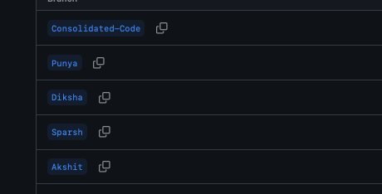
As you can see above , branch system was followed to maintain version system as well as code documentation.
This was done on GitHub which is a powerful platform build around Git, a version control system .It isn’t just a place to store our code but also a massive social network for developers.
To store the assets we have also have used firebase in some places so that the deployment is smooth.
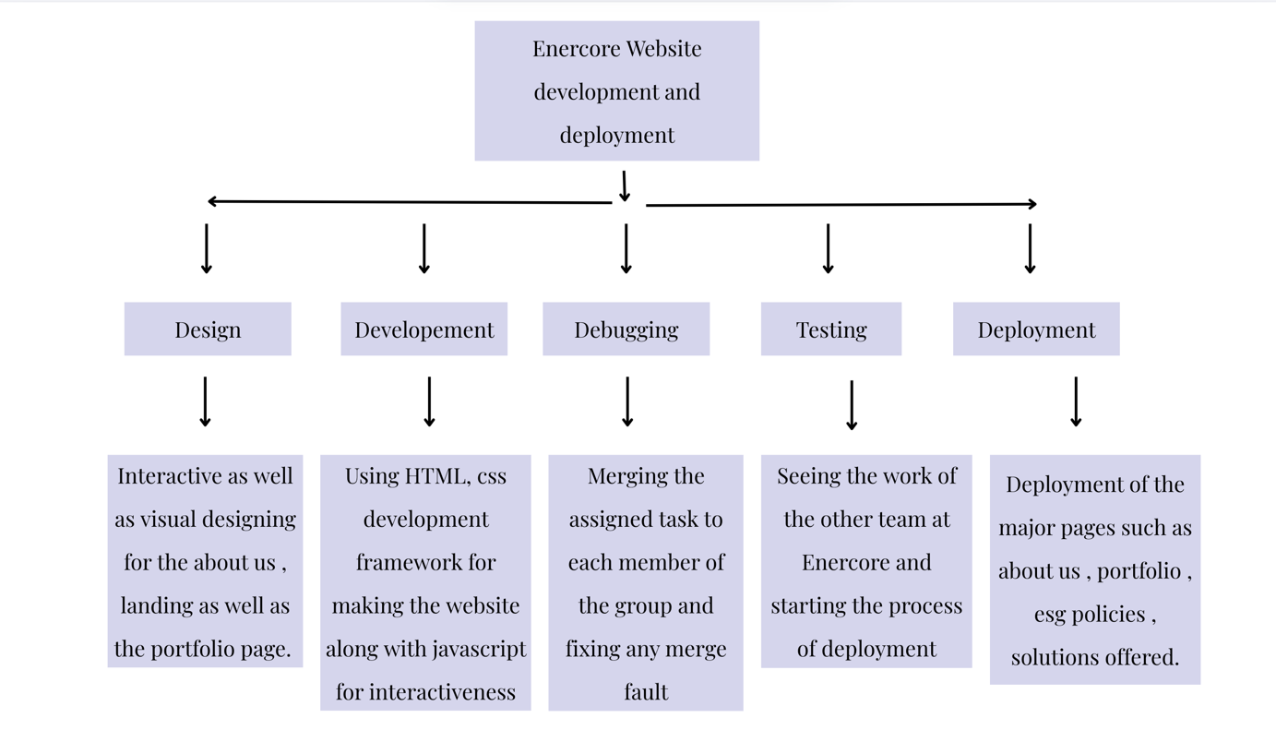

The photos as well as the preview of the site is shown below . A process chart table is also attached which’s shows the steps we followed to complete the takes given to us.
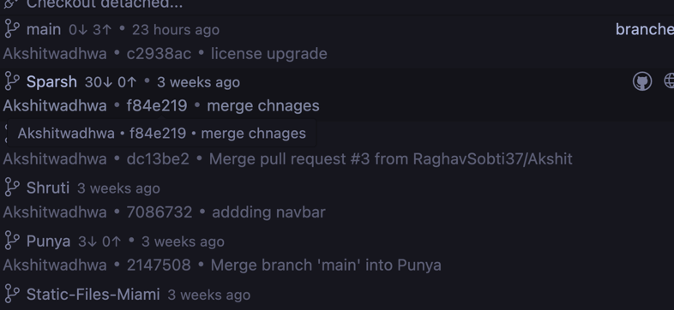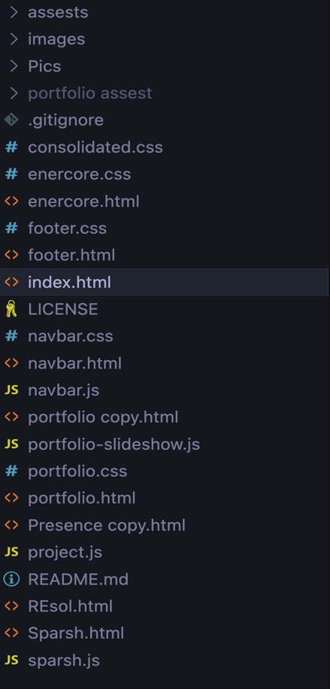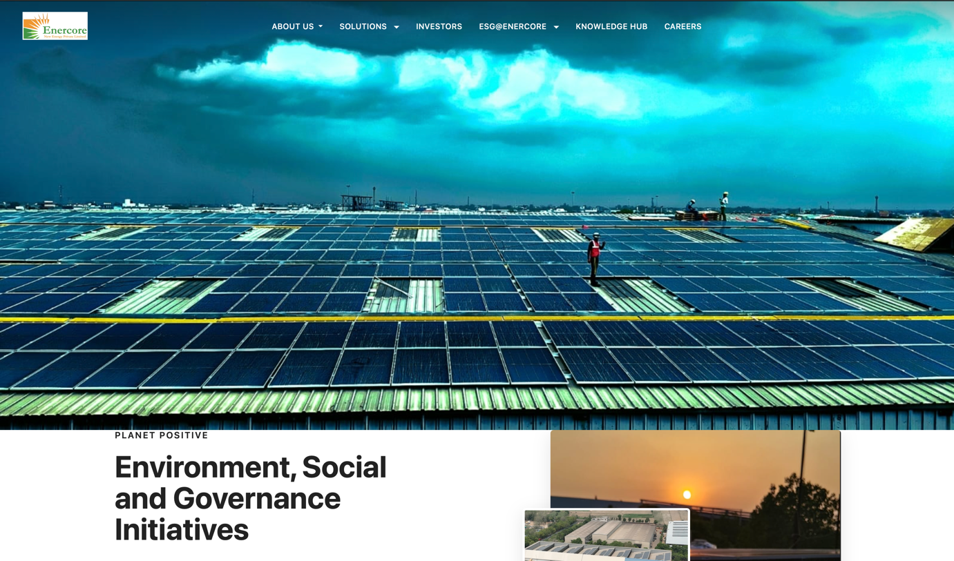
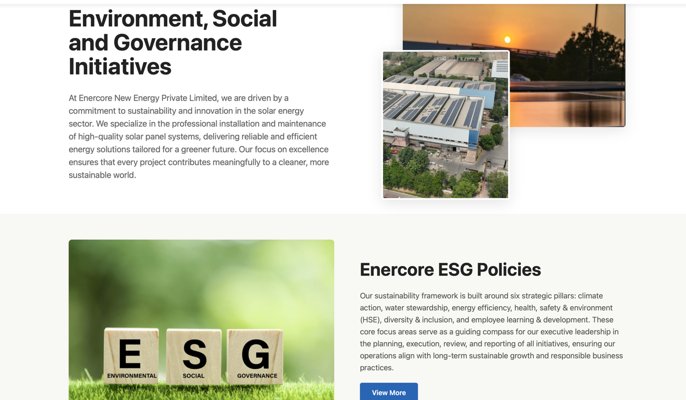

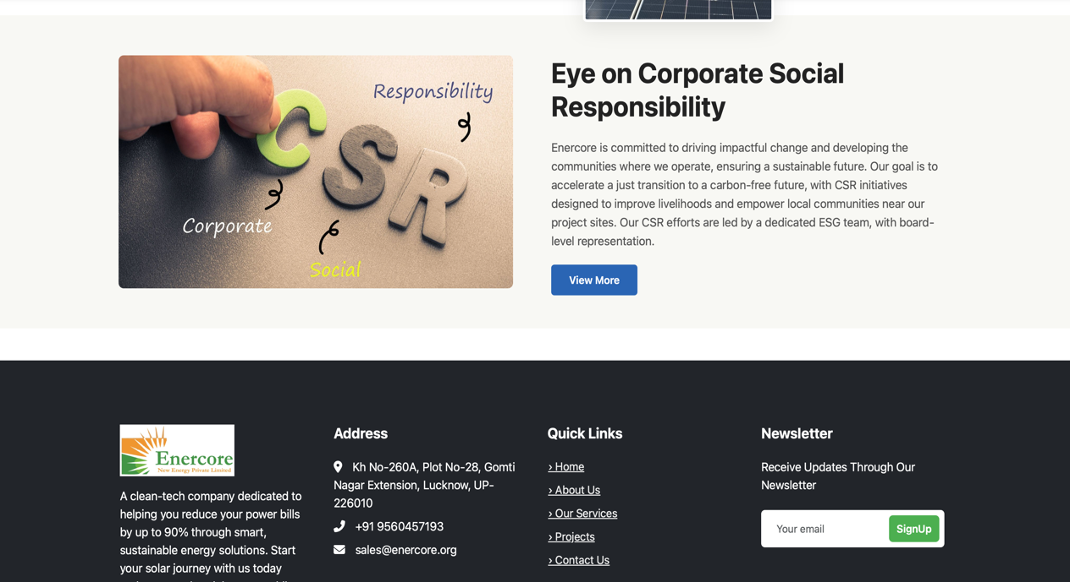

- Conclusion
The project successfully developed a modern, responsive, and visually appealing corporate website for Enercore New Energy Private Limited. The new digital presence effectively showcases the company's services, project portfolio, team, and ESG/CSR initiatives, thereby improving brand visibility and credibility. The site was designed to enable easy navigation and access to information for clients, partners, and stakeholders, with a focus on user-friendliness and accessibility across all devices. Key technical implementations included reusable components for easier maintenance, interactive features like dropdown menus and dynamic content loading to enhance user engagement, and Git/GitHub version control to maintain code quality. Ultimately, the project established a scalable foundation that supports business development, lead generation, and better communication with stakeholders.
The below mentioned picture shows the navbar built for the website.
The selection of technologies for this project was based on industry best practices, performance
requirements, scalability needs, and the existing technical infrastructure at Enercore. The chosen stack balances modern development capabilities with reliability and maintainability.
The below mentioned picture shows the navbar built for the website.

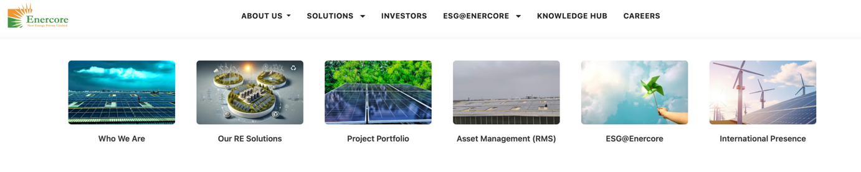

  - Future Scope:
The foundation established during this internship creates several opportunities for future enhancement and expansion that can improve the user experience and business results.
Advanced data analytics and AI integration:
Future development may include machine learning algorithms to provide energy production, consumption adaptation recommendations and future stating analysis for maintenance scheduling. This can include:
- Future maintenance alert based on system performance pattern
- Weather -based energy production forecast
- Personal energy consumption recommendations
- Detection of automatic discrepancy for system issues
- Integration with smart home equipment for comprehensive energy management Progressive web application (pwa) development:
Converting existing web applications into a progressive web app will provide user experience:
- Offline functionality to access important system information
- Information for system alert and maintenance reminder
- Experience like native app without the need for app store download
- Better performance through advanced cashing strategies
- Cross-platform compatibility with a single codebase Increased data visualization and reporting:
Future recurring may include more sophisticated visual abilities:
- Interactive 3D models of solar installations
- System maintenance guidance enhanced reality features
- Advanced comparison tool for benchmarking against uniform systems
- Customable dashboard widgets for various user types

7 REFERENCES

1] Chen, L., Wang, K., and Zhang, Y. (2023). "User experience design in renewable energy applications: a comprehensive study." Journal of Clean Energy Technologies, 11 (2), 45-62.
- Smith, R. A., and Johnson, M. B. (2022). "Mobile-first design strategies for enterprise applications in the energy sector." International Conference on Web Technologies and Applications, 234–249.
- Patel, S., Kumar, A., and Singh, R. (2023). "Performance adaptation techniques for data-intensive web applications." IEEE transactions on web engineering, 15 (3), 112–128.
- Williams, E. T., Brown, J. D., and Davis, c. l. (2022). "Reach Standards at Energy Monitoring Systems: Implementation and Best Practices." ACM transactions on accessible computing, 8 (4), 78-95.
- Thompson, K. M., and Anderson, P. J. (2023). "The best practices for data visualization solar power applications." Renewable energy and sustainable development, 9 (1), 156–171.
[4] Global web performance report. (2023). "Loding speed effect on user engagement: energy field analysis." Web performance analytics quarterly, 7 (2), 23–35.
[[] Martinez, c. R., and Lee, H.S. (2022). "Web design implementation responsible in enterprise solar management system." Solar Energy Technology and Application, 18 (4), 289-304.
[[] International Renewable Energy Agency (Irena). (2023). "Digital changes in the renewable energy sector: trends and opportunities." Irena Technology Roadmap Series.
[4] Kumar, V., Shah, N., and Gupta, M. (2022). "Security idea for web-based energy management platforms." Cyber security in energy systems, 5 (3), 145–162.
[10] World Wide Web Consortium (W3C). (2023). "Web Material Access Guidelines (WCAG) 2.1 - Implementation Guide for Energy Applications." W3C Technical Report.

