Project Report
Generative AI and LLMs
CSE3720

Autonomous Research Assistant: A Multi-Agent Generative AI System for Research Paper Exploration, Literature Review Generation, and Research Gap Analysis

By
Akshit Wadhwa
230784
Anish Choudhary
230820
Deepnder
230821

Department of Computer Science and Engineering
School of Engineering and Technology
BML Munjal University
May 2026

Declaration by the Candidates
We hereby declare that the project entitled "Autonomous Research Assistant: A Multi-Agent Generative AI System for Research Paper Exploration, Literature Review Generation, and Research Gap Analysis" has been carried out to fulfil the partial requirements for completion of the core-elective course Generative AI and LLMs offered in the 6th Semester of the Bachelor of Technology program in the Department of Computer Science and Engineering during AY 2025-26. This work has been carried out by us and submitted to the course instructor Dr. Soharab Hossain Shaikh. Due acknowledgments have been made to all external tools, libraries, papers, APIs, and materials used in this project.

Akshit Wadhwa & Signature: __________________________
Anish Choudhary & Signature: __________________________
Deepnder & Signature: __________________________

Place: BML Munjal University
Date: ______ May, 2026

Contents
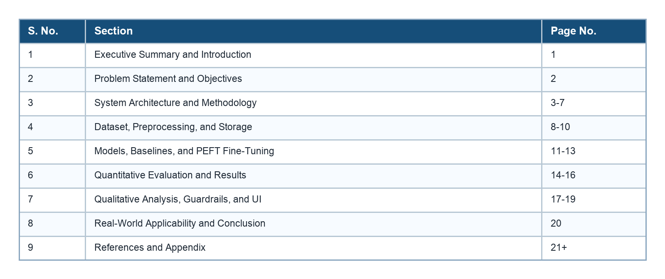

1. Executive Summary and Introduction
Project in one line: ScholarSynth AI is a multi-agent GenAI research assistant that retrieves academic papers, indexes them semantically, generates grounded literature reviews and research-gap analysis, and demonstrates measurable improvement using LoRA fine-tuning.
The volume of scientific literature is growing faster than most students and early-stage researchers can manually review. A user who wants to explore a topic such as retrieval-augmented generation, AI chatbots, guardrails, or transformer models must search multiple sources, inspect abstracts, compare methods, and then synthesize the material into a coherent review.
This project addresses that challenge through an end-to-end system for topic-based paper retrieval, semantic search, RAG-based generation, fine-tuned academic summarization, guardrails, and a Streamlit demonstration interface.
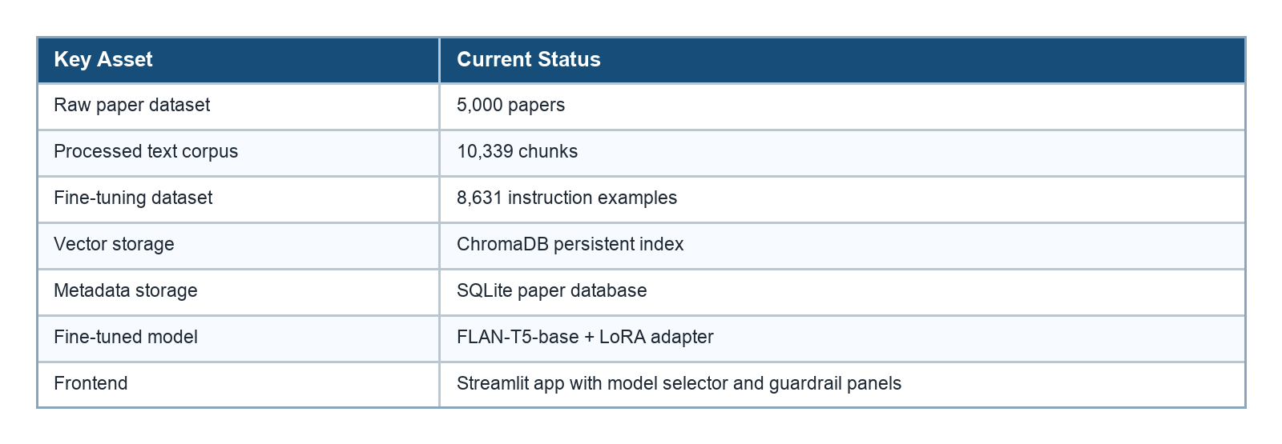

2. Problem Statement and Objectives
Traditional paper search is mostly keyword-driven and does not automatically explain, compare, or synthesize papers. Generic LLMs can help write text, but they may hallucinate claims, citations, or paper details when not grounded in retrieved evidence.

2.1 Objectives
- Collect an application-specific research paper dataset from arXiv and Semantic Scholar.
- Preprocess academic text through cleaning, normalization, deduplication, chunking, and train-validation-test splitting.
- Store paper metadata in SQLite and semantic embeddings in ChromaDB.
- Build baseline systems using pretrained FLAN-T5, prompt-engineered FLAN-T5, and RAG.
- Fine-tune FLAN-T5 with LoRA for academic summarization and explanation tasks.
- Compare pretrained, prompt-engineered, RAG, fine-tuned LoRA, and RAG + LoRA systems quantitatively and qualitatively.
- Implement input and output guardrails for safer research assistance.
- Provide a Streamlit UI suitable for project demonstration and viva explanation.

2.2 Evaluation Criteria Mapping
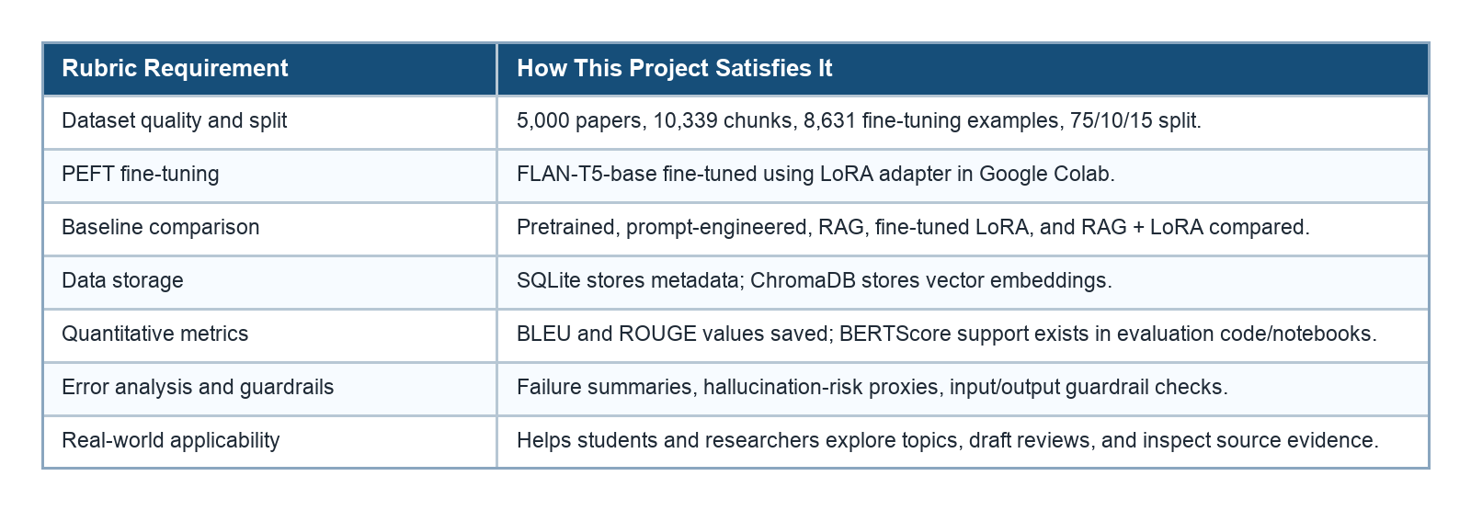

3. System Architecture and Methodology
The system is divided into independent but connected stages. This makes the project easier to explain, test, and extend: data collection creates the corpus, preprocessing prepares usable chunks, storage enables retrieval, generation produces outputs, and evaluation demonstrates whether fine-tuning improves over baselines.
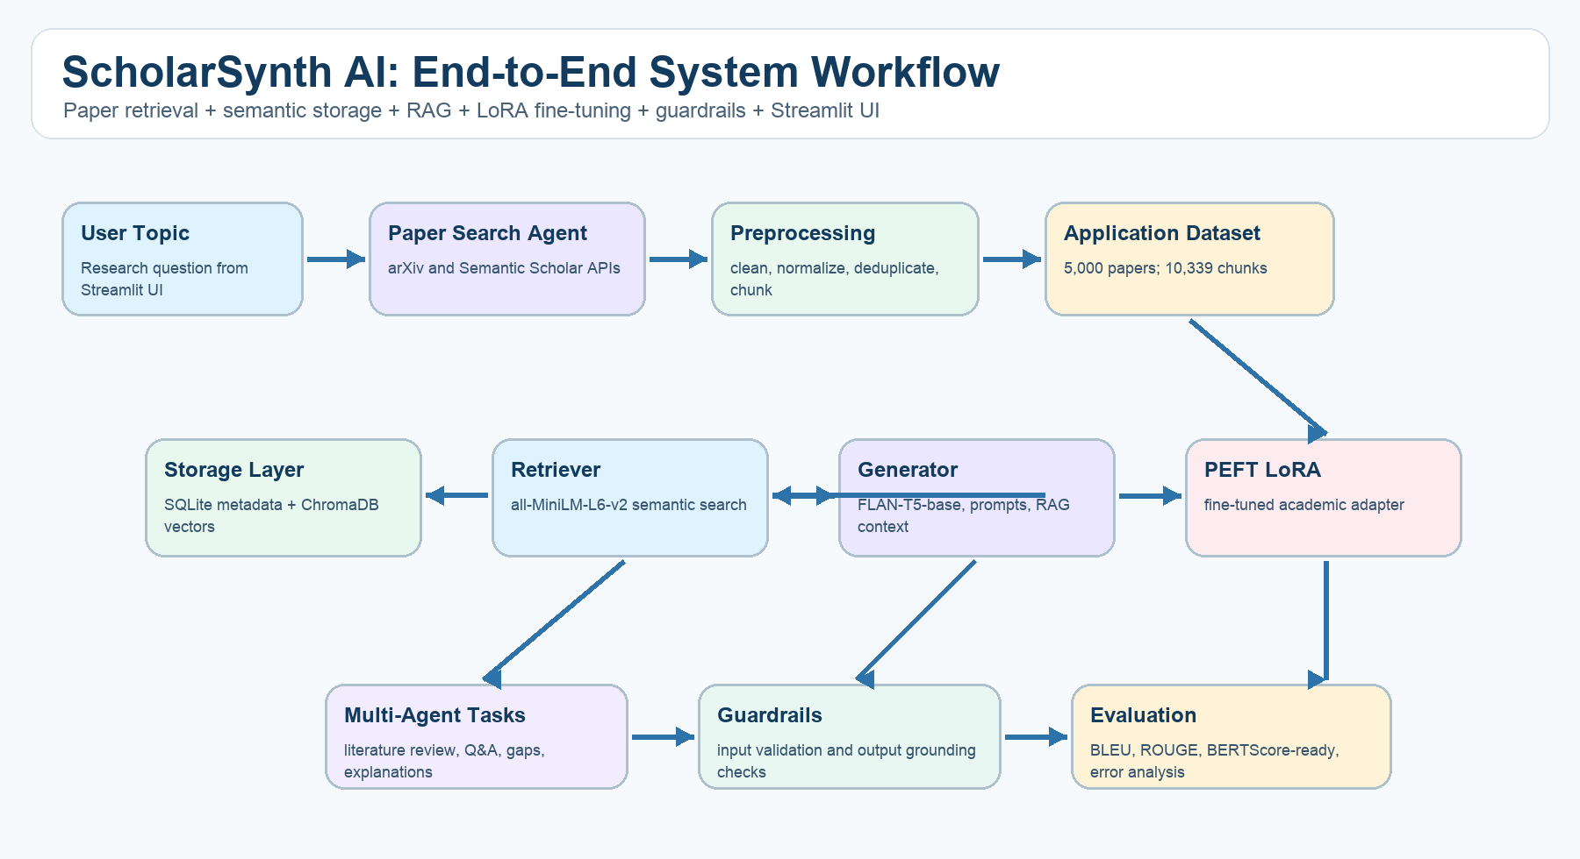
Figure 1: End-to-end ScholarSynth AI workflow.
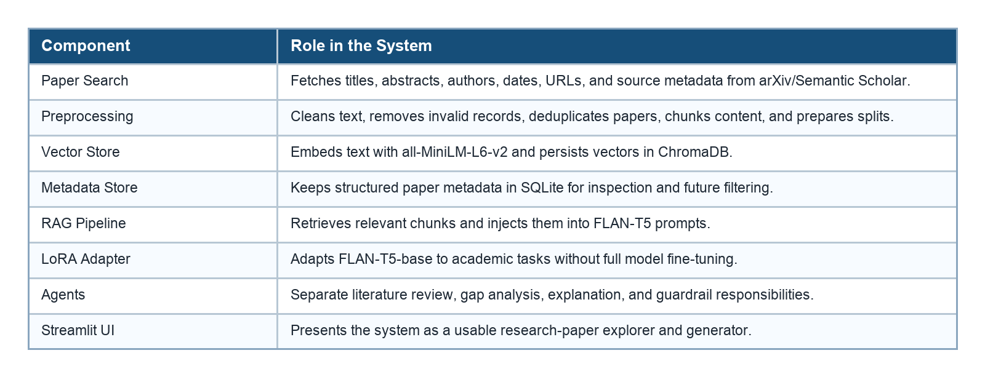

4. Dataset, Preprocessing, and Storage
The dataset focuses on Generative AI and LLM-related research areas such as Hugging Face models, AI chatbots, RAG, transformers, neural networks, hallucination, guardrails, multi-agent systems, scholarly search, and literature review generation.

4.1 Dataset Size and Split
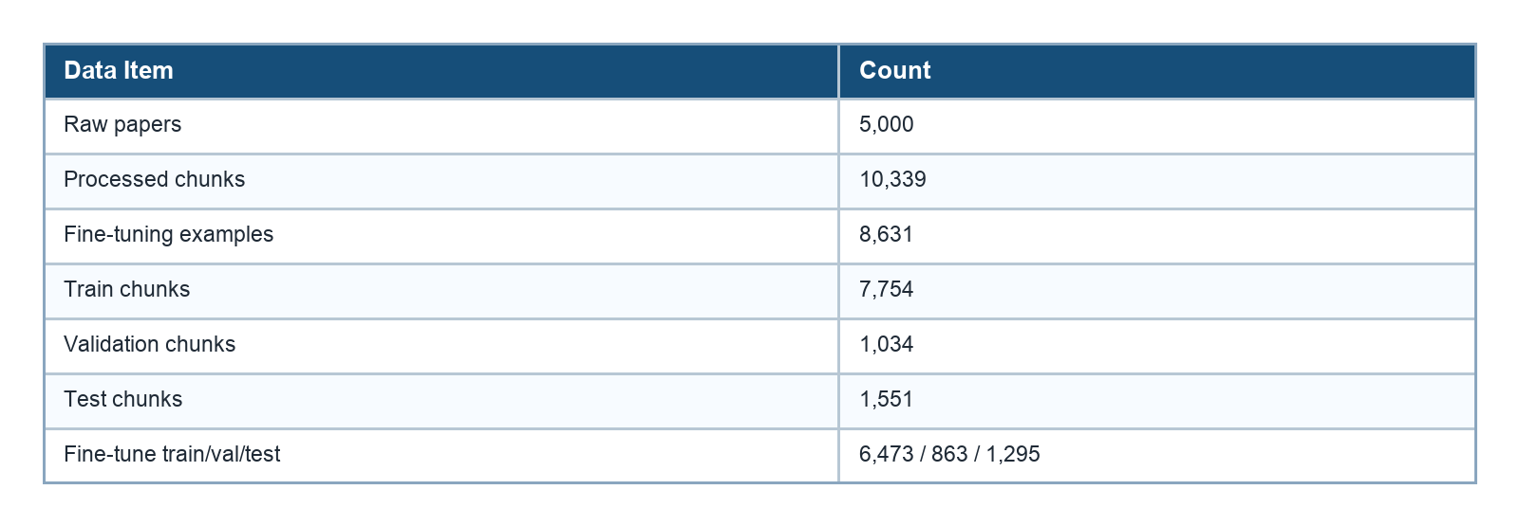
The split ratio is 75% training, 10% validation, and 15% testing. The split is important because fine-tuning and evaluation must not use the same examples; otherwise, reported improvements would not be reliable.

4.2 Preprocessing Steps
1. Remove missing or invalid title/abstract records.
2. Normalize whitespace and clean academic text.
3. Deduplicate repeated papers from API overlap.
4. Combine title and abstract into retrievable text.
5. Chunk long content for vector retrieval.
6. Create instruction-style examples for summarization, explanation, Q&A, comparison, literature review, and gap analysis.

4.3 Storage Design
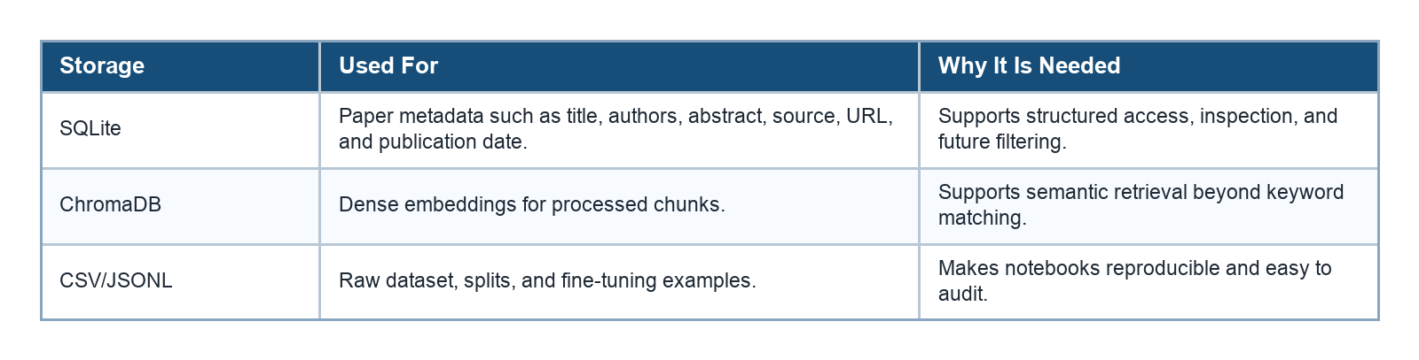

5. Models, Baselines, and PEFT Fine-Tuning
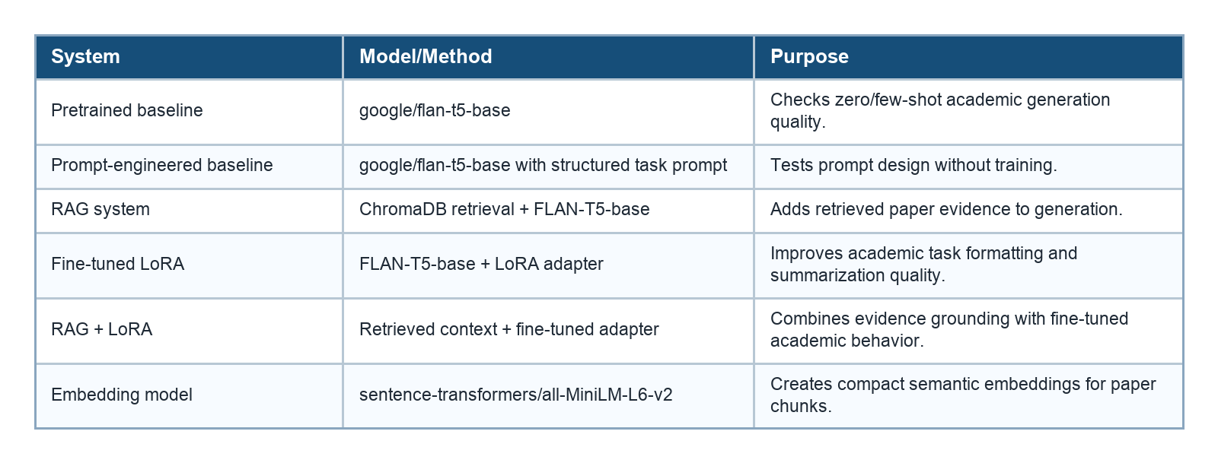

5.1 Why LoRA/PEFT Was Used
Full fine-tuning of a language model is expensive and impractical on a student MacBook. LoRA is parameter-efficient: it keeps the base FLAN-T5 model mostly frozen and trains a small adapter. This is suitable for Google Colab, easier to store, and still demonstrates actual fine-tuning rather than only API prompting.

5.2 Multi-Agent Responsibilities
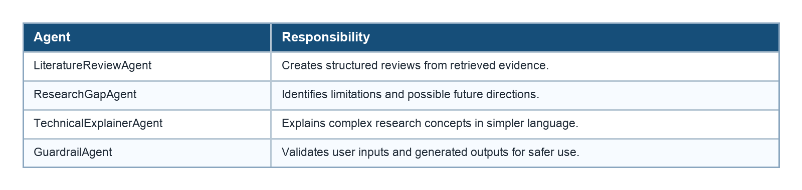

6. Quantitative Evaluation and Results
The latest saved comparison evaluates five systems on 200 examples. The larger LoRA-only test evaluates the trained adapter on 1,200 examples. BLEU and ROUGE measure overlap with reference outputs; BERTScore support is implemented in the project for semantic scoring.
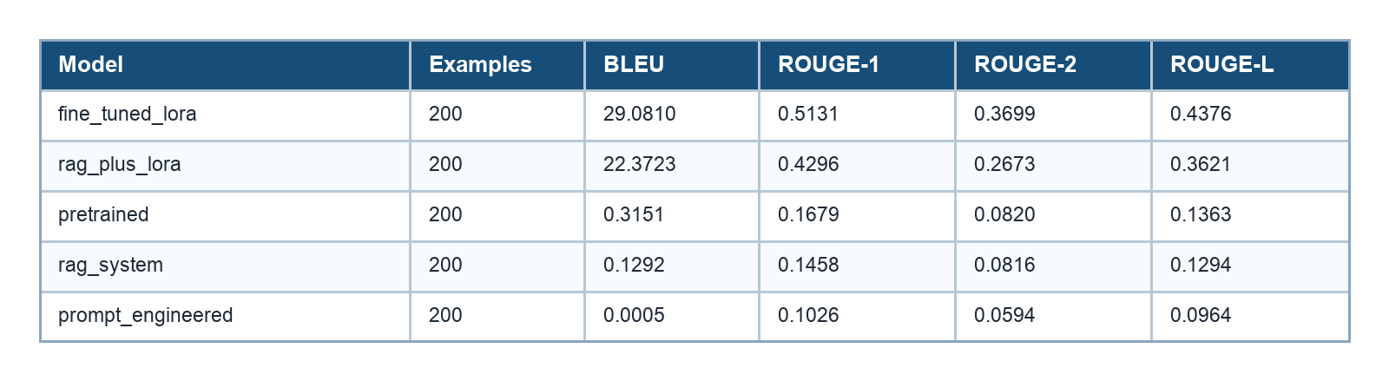
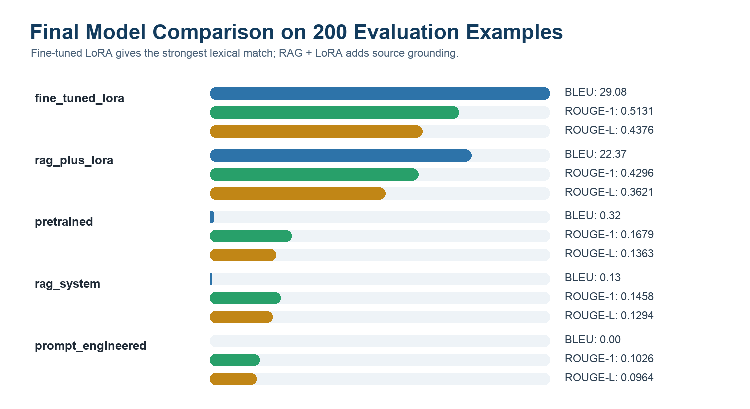
Figure 2: BLEU, ROUGE-1, and ROUGE-L comparison across evaluated systems.
Best fine-tuned model result: The LoRA-only test on 1200 examples achieved BLEU 47.2745, ROUGE-1 0.6561, ROUGE-2 0.5404, and ROUGE-L 0.6031.

6.1 Interpretation of Results
- Fine-tuned LoRA is the strongest lexical scorer, showing clear improvement over all baseline systems.
- RAG + LoRA is second overall and is preferable for demo answers where source grounding matters.
- Pretrained and prompt-engineered FLAN-T5 produce weaker academic task outputs because they are not adapted to the project dataset.
- RAG alone is useful for evidence retrieval, but generation quality improves substantially when paired with the LoRA adapter.

6.2 RAG + LoRA Task-Level Results
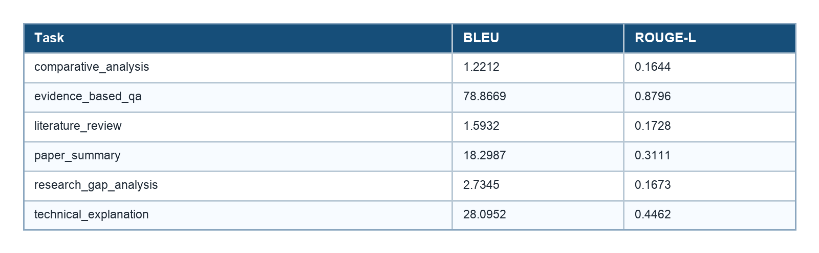

7. Qualitative Analysis, Guardrails, and UI
Quantitative metrics alone cannot determine whether a research assistant is safe or useful. The project therefore includes qualitative review through best/worst cases, retrieved-evidence inspection, hallucination-risk proxies, and guardrail checks.
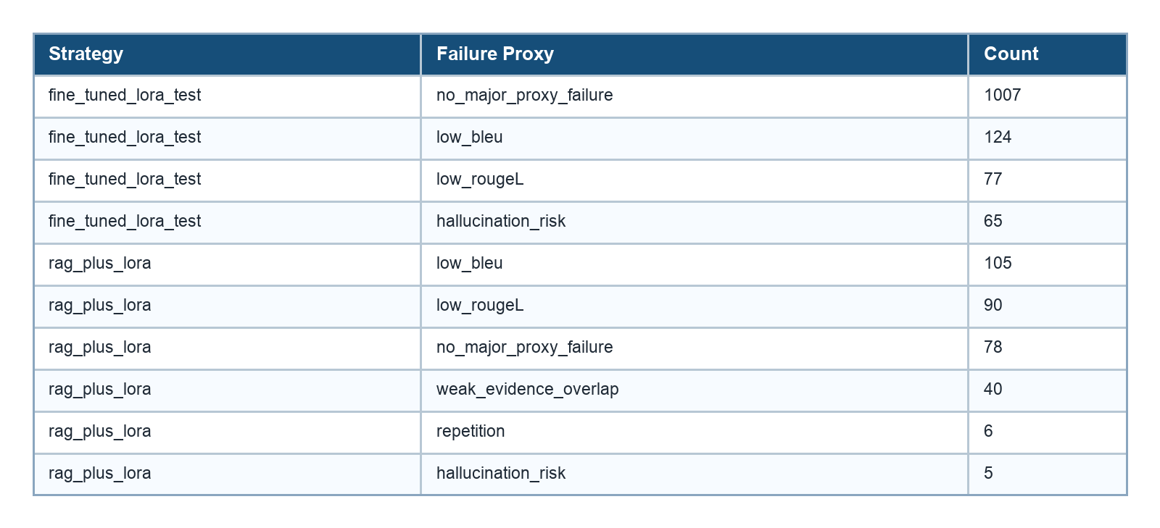

7.1 Guardrail Findings
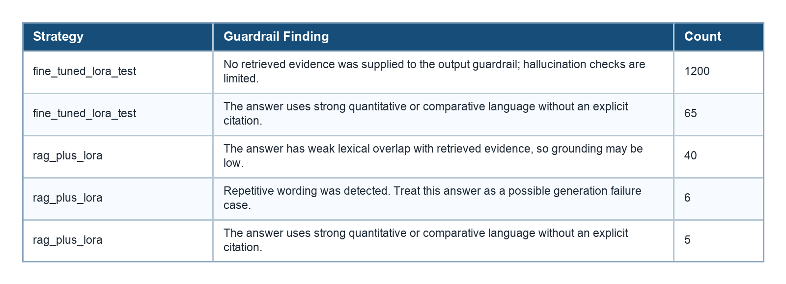

7.2 Input and Output Guardrails
- Input guardrails block empty queries, overly long queries, prompt-injection attempts, and credential-like text.
- Warnings are shown for very short, off-scope, or personal-data-like queries.
- Output guardrails flag empty answers, repetitive wording, weak evidence overlap, generic disclaimers, citation-like text, and unsupported quantitative claims.
- The Streamlit UI displays guardrail findings in expandable panels so the demo user can inspect risks rather than blindly trust the answer.

7.3 Streamlit Demonstration Interface
The frontend in app.py provides the demonstration layer. It includes dataset status cards, light/dark theme support, paper fetching, local index building, task selection, model selection, retrieved evidence tabs, and guardrail feedback. The available generation modes are Base FLAN-T5, Fine-tuned LoRA, and RAG + Fine-tuned LoRA.

8. Real-World Applicability and Conclusion
ScholarSynth AI is useful for students, research interns, and academic teams who need to quickly understand a new research area. It can reduce time spent on paper discovery, abstract reading, method comparison, and first-draft literature review preparation. The system remains explainable because retrieved paper titles and chunks are available for inspection.

8.1 Viva Explanation Flow
1. Start with the problem: too many papers, keyword search is limited, and LLMs hallucinate without evidence.
2. Explain the data pipeline: collect 5,000 papers, clean them, chunk them, and split them properly.
3. Explain storage: SQLite for metadata and ChromaDB for embeddings.
4. Explain models: FLAN-T5 baselines, RAG, LoRA fine-tuning, and RAG + LoRA.
5. Show the result table: LoRA improves strongly over pretrained, prompt-engineered, and RAG-only baselines.
6. Show guardrails and error analysis: the system detects weak grounding, repetition, and unsupported claims.
7. End with real-world use: faster literature exploration with visible evidence and a Streamlit demo.

8.2 Conclusion
The project satisfies the main evaluation requirements: application-specific dataset construction, preprocessing and split, PEFT fine-tuning, baseline comparison, vector and SQL storage, quantitative evaluation, qualitative error analysis, guardrails, and frontend integration. The clearest improvement is achieved by the fine-tuned LoRA model, while the RAG + LoRA system is the strongest demonstration choice for grounded academic assistance.

9. References
1. Raffel et al., Exploring the Limits of Transfer Learning with a Unified Text-to-Text Transformer, 2020.
2. Chung et al., Scaling Instruction-Finetuned Language Models, 2022.
3. Hu et al., LoRA: Low-Rank Adaptation of Large Language Models, 2021.
4. Lewis et al., Retrieval-Augmented Generation for Knowledge-Intensive NLP Tasks, 2020.
5. Reimers and Gurevych, Sentence-BERT: Sentence Embeddings using Siamese BERT-Networks, 2019.
6. Zhang et al., BERTScore: Evaluating Text Generation with BERT, 2020.
7. Papineni et al., BLEU: a Method for Automatic Evaluation of Machine Translation, 2002.
8. Lin, ROUGE: A Package for Automatic Evaluation of Summaries, 2004.
9. arXiv API Documentation and Semantic Scholar Graph API Documentation.
10. Hugging Face Transformers, PEFT, Sentence Transformers, ChromaDB, and Streamlit documentation.

Appendix A: Project Files
