GIT Commands

GIT Installation :
Command : yum install git
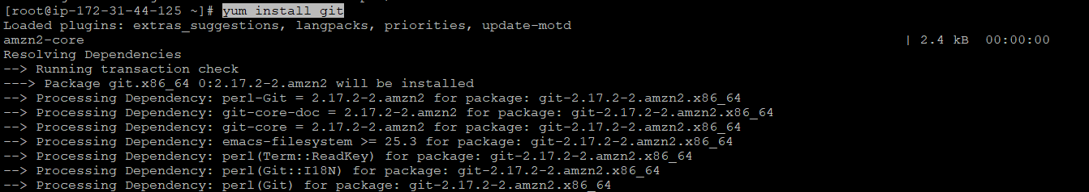
To check the version installed : git --version

Initial Configuration :
git config --global user.name "MuthuSusithra"
git config --global user.email "dmsusithra@gmail.com"
git config --global core.editor vim
git config --global core.compression 2
git config --global diff.tool vim.diff
To list : git config -l
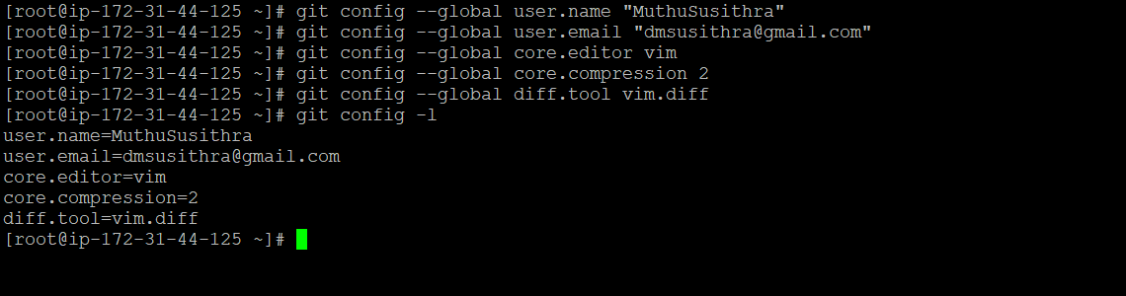

Creating a new local repository :
- Create a directory to contain the project.
- Go into the new directory.
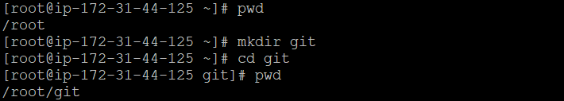
- Type git init - to create a local repo
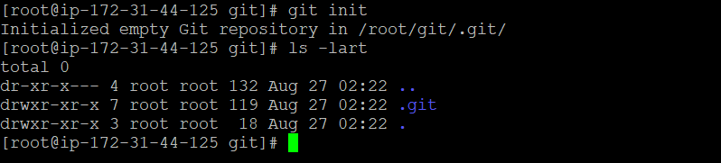
- Write some code.
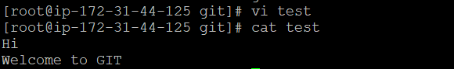
- Type git add <file_name> - to add from working to staging area
- Type git commit -m "Commit message" – to add from staging to local repo
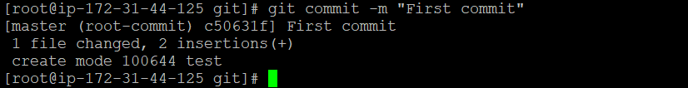
git commit –a -m "Commit message" – to add directly from working to local repo
To check status :
git status
git status -s
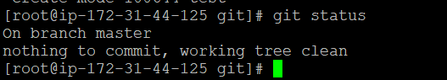
DIFF :
Command : git diff – to view the difference before moving to staging area
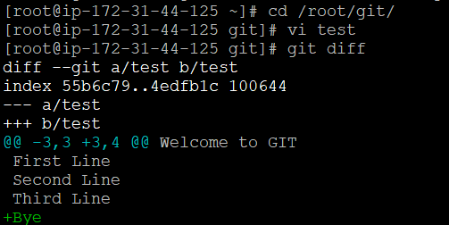
git diff --staged – to view the difference once moved to staging area
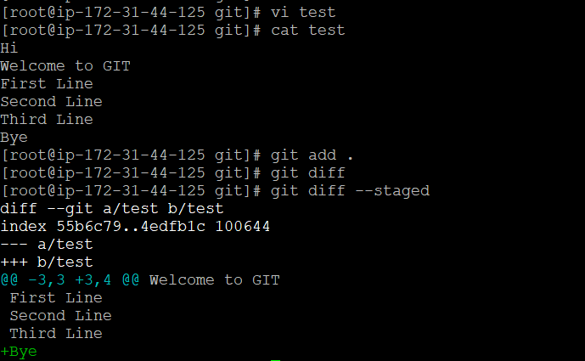
View Commit Log :
git log
git log --oneline
git show <commit_id>
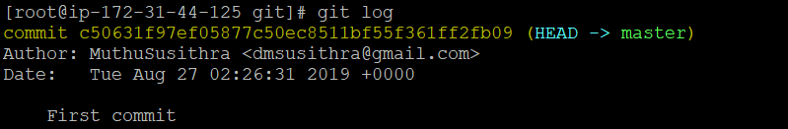
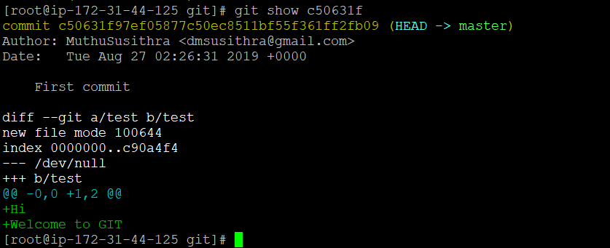

Connect to GITHUB :
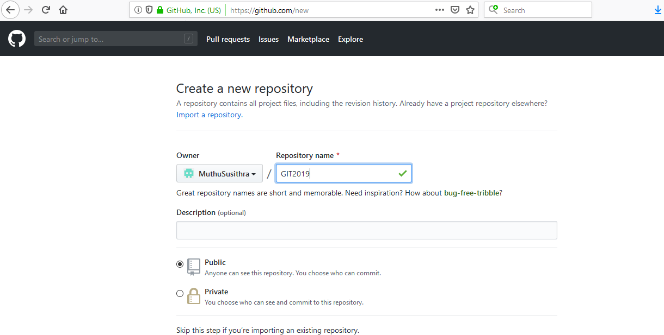
git remote add origin https://github.com/MuthuSusithra/GIT2019.git
git push origin master

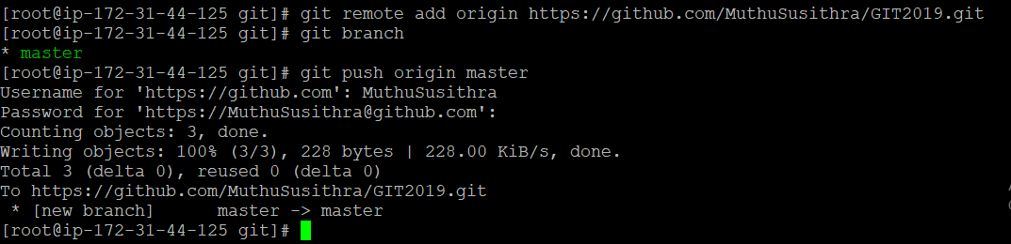
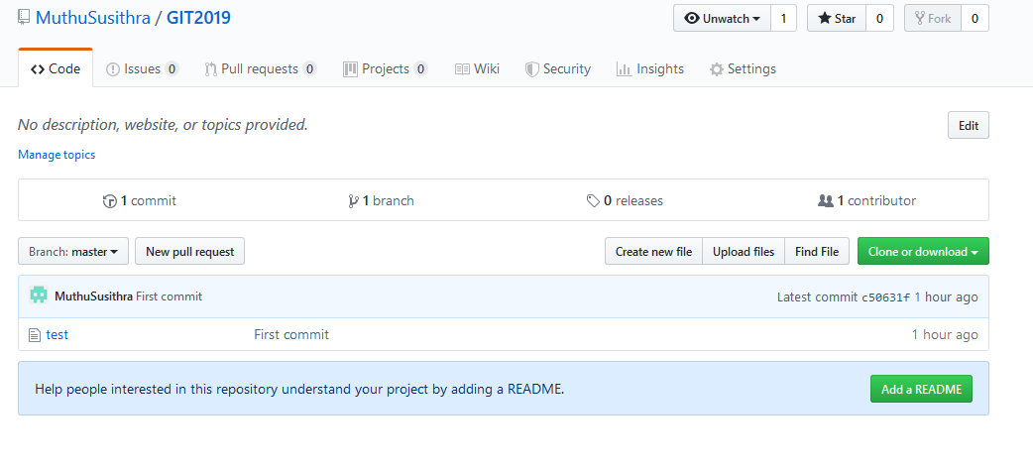
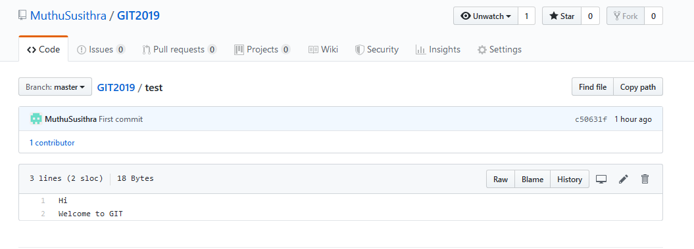

BRANCH :
git branch – to view what is the current branch
git branch <branch_name> – to create a new branch
git checkout <branch_name> – to navigate to another branch
git branch -d <branch_name> – to delete the local branch, only if you have already pushed and merged it with your remote branches.
git branch -D <branch_name> – to force delete the branch regardless of its push and merge status, so be careful using this one!

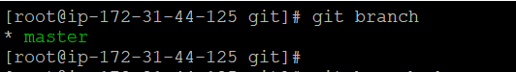
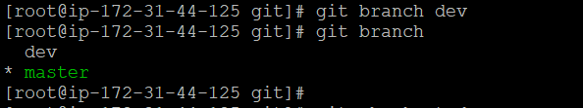
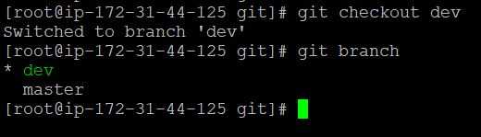
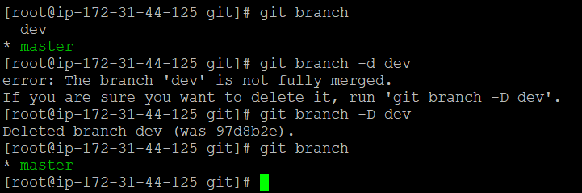
Remove/Rename Operations :
To remove file from staging area : git reset <file_name>
To remove all untracked files : git clean –f
To rename the recent commit : git commit --amend
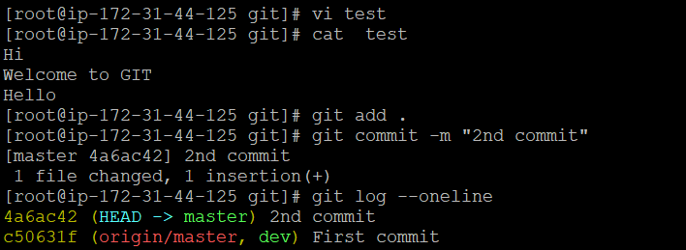
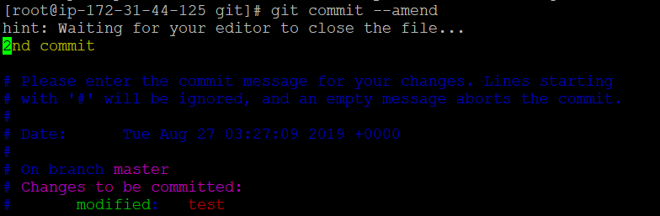
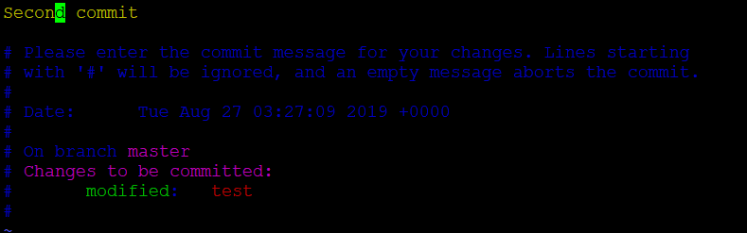
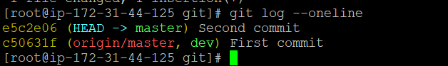
To delete the commits :
git reset –-hard HEAD^
git reset –-hard HEAD~n – to delete the last “n” number of commits [Eg : git reset –hard HEAD~2 will delete the last 2 commits]
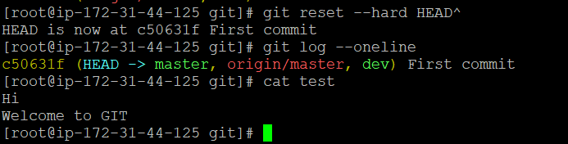
To view line by line history : git blame <file_name>
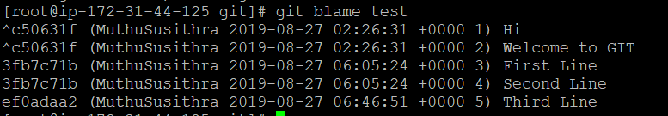

CLONE and FORK:
git clone https://github.com/MuthuSusithra/GIT2019.git - to copy an existing repository from github
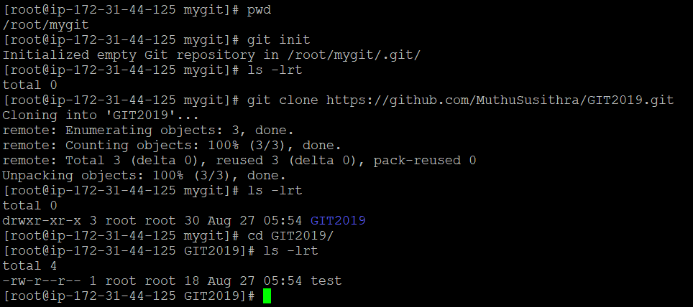
A fork is a copy of a repository. Forking a repository allows you to freely experiment with changes without affecting the original project.
Most commonly, forks are used to either propose changes to someone else's project or to use someone else's project as a starting point for your own idea.
A great example of using forks to propose changes is for bug fixes. Rather than logging an issue for a bug you've found, you can:
- Fork the repository.
- Make the fix.
- Submit a pull request to the project owner.
If the project owner likes your work, they might pull your fix into the original repository!
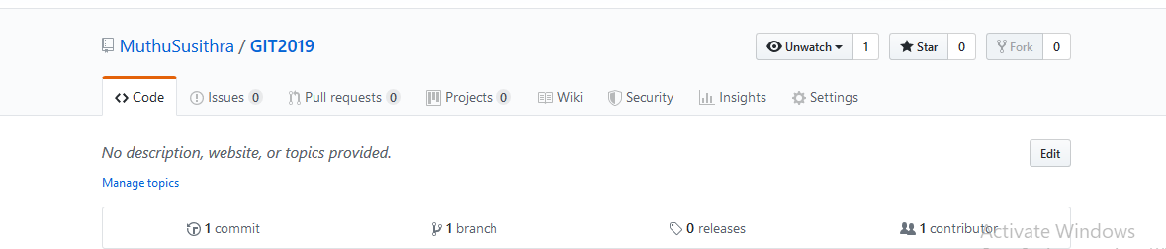
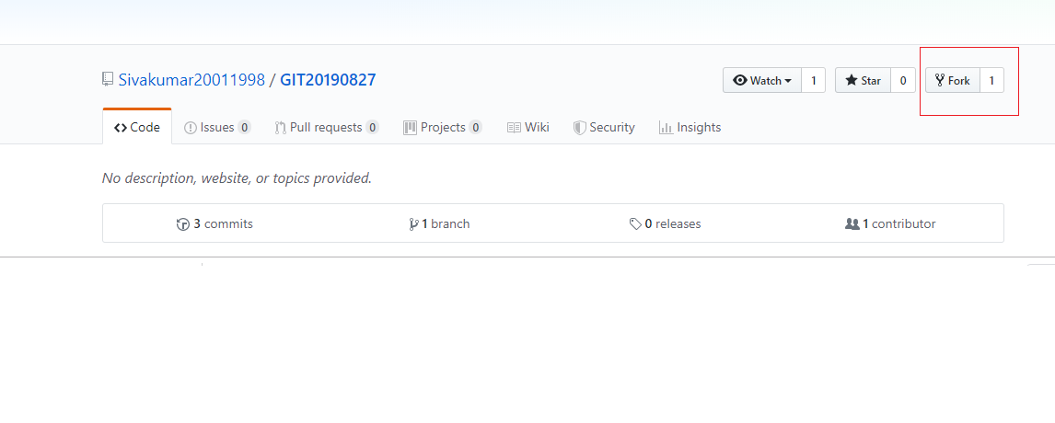
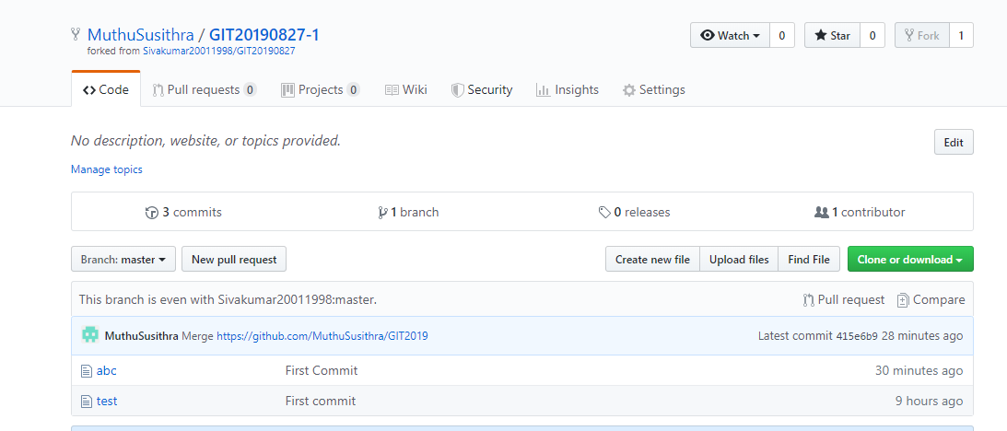
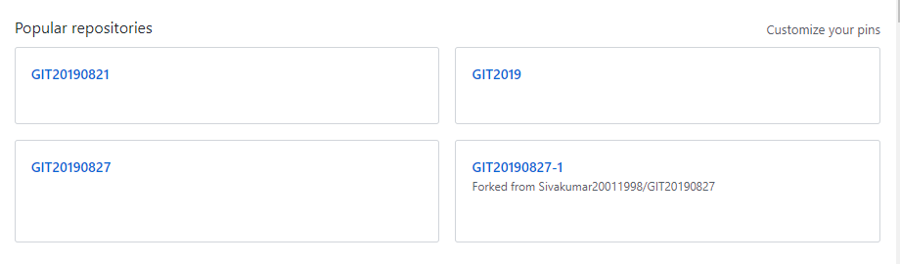
MERGE :
git merge <branch_name> - To merge the branch with master branch
Note : merge should be executed only from master branch .
Example : Consider two branches “master” and “dev” with files as below .
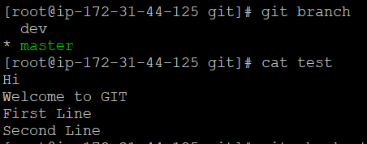
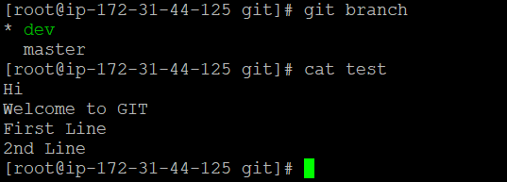
To merge dev with master : git merge dev (from master branch)
In this case, it creates conflict as the last line in both the files are different .
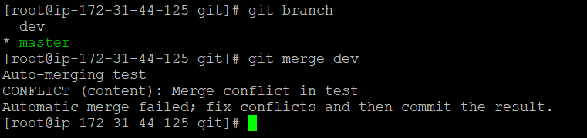
To resolve this conflict , we need to use mergetool .
Add the below configuration for using mergetool :
git config --global merge.tool vimdiff
git config --global merge.conflictstyle diff3
git config --global mergetool.prompt false
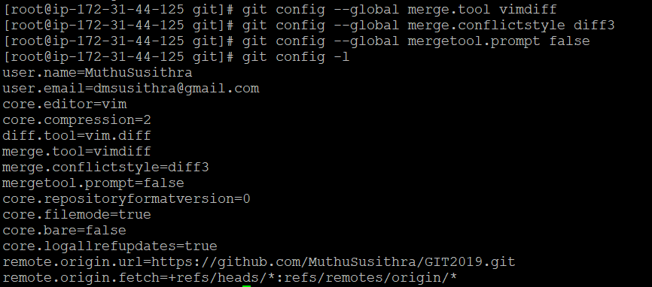
git mergetool – to merge when conflicts are present
Operations in mergetool :
Ctrl+WW – to navigate to each box
:diffg LO – to select LOCAL box
:diffg RE – to select REMOTE box
:diffg BA – to select BASE box
:wqa – To save and quit all
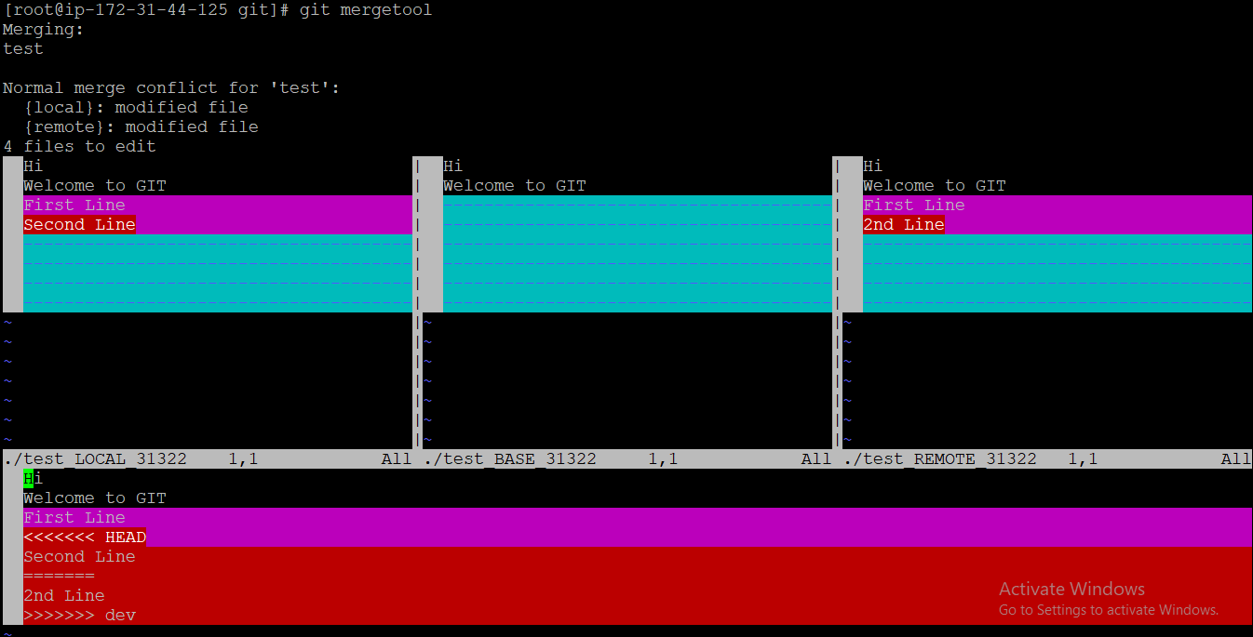
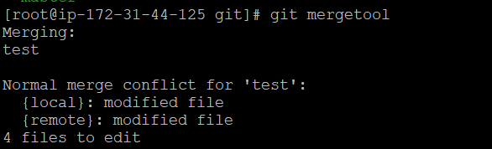
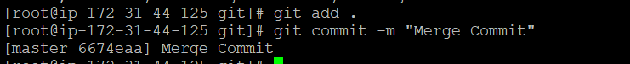
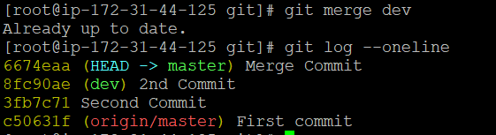
REBASE :
git rebase master – to be executed from feature branch
git checkout master
git merge <feature_branch>
Execute “git rebase master” from feature branch to change the head of feature branch to that in master branch .
Once the head is changed , you can merge the changes from master branch .
CHERRY-PICK :
To select the particular commit using its commit id
Command : git cherry-pick <commit_id>
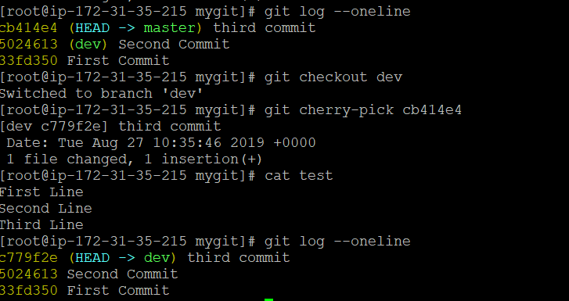

FETCH & PULL :
The git pull command first runs git fetch which downloads content from the specified remote repository. Then a git merge is executed to merge the remote content refs and heads into a new local merge commit.
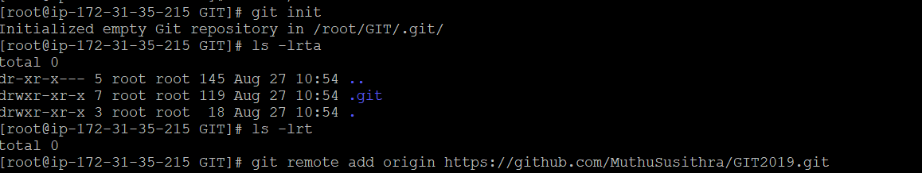
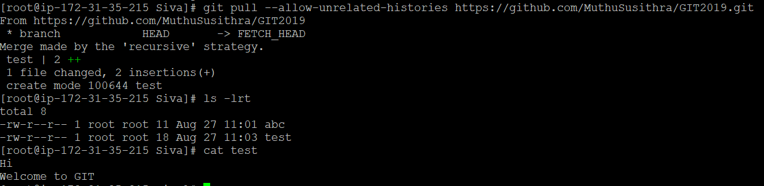
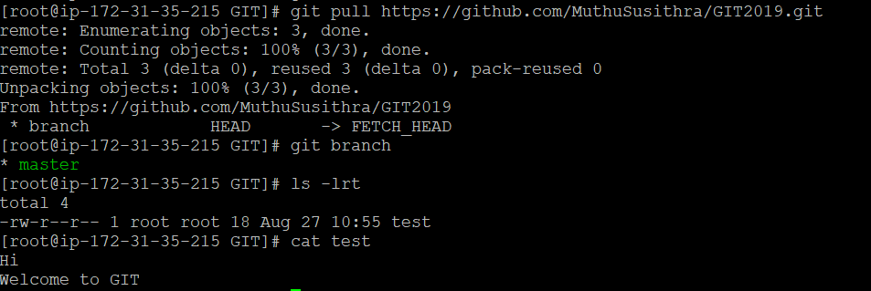
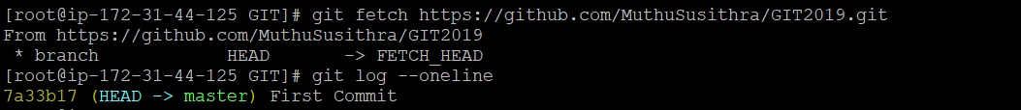
STASHING :
Used when you want to record the current state of the working directory and the index, but want to go back to a clean working directory .
Commands :
git stash – to move your changes from current working directory to stash
git stash pop - removes the changes from your stash and reapplies them to your working copy.
git stash apply - Reapplies the changes to your working copy and keep them in your stash . [This is useful if you want to apply the same stashed changes to multiple branches.]
git stash list – to list the stashes
git stash save “description” – to give description for the stash
git stash clear – to clear all of your stashes
git stash drop stash@{1} – to delete the particular stash

WEBHOOKS :
Webhooks provide a way for notifications to be delivered to an external web server whenever certain actions occur on a repository or organization.
You can configure a webhook to execute whenever:
- A repository is pushed to
- A pull request is opened
- A GitHub Pages site is built
- A new member is added to a team

