# Report on

**COLLEGE ERP SYSTEM**

**Submitted by Group No. GA05**

ABHISHEK GAUTAM - 2100290140005 ISHIKA - 2100290140072

AKASH SINGH - 2100290140013

# Session:2022-2023 (4th Semester)

Under the supervision of

# Prof. Dr. Vipin Kumar

**KIET Group of Institutions, Delhi-NCR, Ghaziabad**



**DEPARTMENT OF COMPUTER APPLICATIONS KIET GROUP OF INSTITUTIONS, DELHI-NCR,**

**GHAZIABAD-201206**

(MARCH- 2023)

**ABSTRACT**

The main conceptual idea of the ERP System is based on web application that provides a simple

interface for maintenance of different student, faculty, attendance, exam, lectures, fees and other

information. It automates the existing manual system by the help of computerized equipment and full-

fledged computer software, so that the valuable data can be stored for a longer period with easy

accessing and manipulation of the same.

ERP System can lead to error free, secure, reliable and fast management system. The system allows

the admin to manage students, faculties, exam, fees and other information. Our system allows a

faculty to input student's attendance into the database which can later be viewed by students and

faculties. The students can view his attendance through a separate student login panel. Study

materials can also be provided to students by their respected faculty. This System can maintain

computerized records without redundant entries. That means that without any distraction one is able to reach the information.

In a college there are various sections and each section handles all student information and college database. These sections are linked with each other. Current System of college is having problems of interlinking and data repetition. To overcome these problems, we present College ERP System which is automated and centralized. This system has easy user interface and have powerful data management system which makes this system very useful

Keywords— ERP System, Case Study, ERP Survey, Enterprise Resource Planning, modules, Management System

**TABLE OF CONTENT**

1. Introduction 4
2. Literature Review 5
3. Project / Research Objective 7
4. Technology Used 8
5. Research Methodology 9
6. Project / Research Outcome 10
7. Modules 11
8. Proposed Time Duration 13

References 14

**Introduction**

Enterprise Resource Planning (ERP) college web application is the one kind of web application which integrates all the modules of college on a single system that can be handled by the admin and access by the students and faculties with their valid user id and password

.

The ERP System for College has been developed to override the problems prevailing in the practicing manual system. This software is supported to eliminate the hardships faced by this existing system. Moreover, this system is designed for the particular need of the department to take away operations is a smooth and effective manner.

The application is reduced to avoid errors while entering the data. The system can be used by users without any formal knowledge. It also gives message while entering valid and invalid data. Thus, by this all it shows it is user-friendly. It can lead to reliable, secure, error free and fast management system.

Every organization, has challenges to manage the information of student, faculty and exams. Every ERP System has different management need; therefore, we design exclusive to integrate distinct sections of the organization into consistent manner so that complex functions can be handled smoothly by any technical or non-technical persons. This is designed to assist in strategic planning, and ensure that organization is going through right level of information and details of future goals.

Also, for those busy executive who are always on the go are able of access our system with remote access features

The main objective of the existing system is to provide a user-friendly interface. The College ERP system now computerizes all the details that are maintained manually. Once the details are fed into the system or computer there is no need for various persons to deal with separate sections. Only a person is enough to maintain all the reports and records. The security can also be given as per the user requirement.

¬ High volumes of data can be stored with case.

¬ Maintenance of file is efficient and flexible.

¬ Records are always updated.

¬ Edition of Stored data and procedures can be easy.

¬ Reports can be generated with cases.

¬ Accurate and perfect calculations are made.

**Literature Review**

ERP is stands for Enterprise Resource Planning. Enterprise resource planning (ERP) is business management software or a system which is typically used to manage core departmental data of respective business. ERP provides an integrated view of business processes, often in real-time, using common databases maintained by database management systems. ERP system track business resources— raw materials, cash, production capacity and the status of business commitments like: payroll, purchase orders, and orders. The application that makes up the system share data across the various departments (purchasing, accounting, sales, manufacturing etc.) That provides the core data. ERP facilitates information flow between business function, and manages connections to outside stakeholders.

Every college has to maintain a management system for various sections which may include performance analysis, attendance system, test wise result, student information, fee structure, academic information, transport facility, staff information and many more. Managing all these sections manually on paper becomes very time consuming and complex tasks. In such system there is high possibility of misplacement of collected data and data redundancy in the form of paper records in order to overcome these drawbacks there is a need to design and implement College ERP system where a college staff can track a student profile in all counselors to be trained in evidence-based practices and to provide personalized and empathetic care.

College ERP system is an online web-based system which implements a user friendly and attractive interface for college. The aim for deployment and implementation of this system is to replace manual system of colleges with an automated web-based system. This College ERP system also manages data accurately and efficiently which is stored over a long period of time. College ERP system provides single access point to all administrative system of colleges. In previous systems all the departments are worked independently and separately. If anyone want to access that data collectively then it is not possible with such systems.

System study of such system shows that all the booking was done manually on registers, which was very complicated job. Report generation of all records was also not possible in the existing system. Also, the work of college was manually maintained and stored. All this data is maintained through register or file system in the college

Current mode of working is based on manual system in which the all the data is first received from respective personnel and then entered in the registers or files. It is very complex job and time consuming also. The existing system is also dependent on students, if the students are absent. Then performance of student will be affected. Due to huge volume of data, a lot of problems are involved in maintaining, updating and retrieving selected information. Since previous system is totally maintained manually, some of the difficulties involved in existing system are as follows: -

1. Redundancy of data.

2. Difficulty in updating the data.

3. Non-centralized data.

4. Delay in retrieving information.

5. Problem for keeping the data.

6. Not proper retrieval of information.

**PROJECT OBJECTIVE**

ERP may be defined as an integrated system too, what makes possible a single information flow,

continuous and consistent for the entire institute under a unique database.

Admin can add, update and can delete any information, service or user.

To enable faculty to add marks and attendance.

To enable students to view their attendance,marks and profile.

To share study material with students.

Allows user to interact with each other through messages.

User can change the password after logging.

College management systems are cloud-based educational ERP system that allows colleges and universities to control the admission process online. It manages students' enrollment and students attendance and online fees, grades assignments, library books and more. It also allows for online marks, results and reports on student performance and more. It also helps to ease the work of teachers.

The educational enterprise resource planning (ERP) software, E-SCOP(ERP Software) is a well recognized Web-based College / Institute ERP. E-SCOP College ERP has 25+ pro modules and 30+ inbuilt modules. While the name suggests – College ERP Software comprises nearly all activities of a College – under one Application. Under College ERP, we discuss Registration cum Admission, Fees, Time Table, Transport Module, Examination, Inventory & Accounts, Library, HR & Payroll Module, Reception, Hostel, Class Teacher etc. modules with improved reporting system. The major concern of A

software companies in India is to fill the gap in the complete market for education institute management software. You can export your reports into different formats- .html, .pdf, .xls, .csv etc.

* Multiple College Branches Managed under single solution.
* Responsive Web application- (Mobile, Tab, Computer)
* Preconfigured all College policy to minimize user intervention and reduce dependency.
* Complete college ERP from enquiry to alumni.
* Managing all stake holders like Student, Parents, Teacher, Staff, Principal, Admin, Management.
* Online Fee with instant Easy Loan Facility (Within 2 Minutes/No Guarantor required) for Students
* Role Based System as per user rights.
* Multilevel Automated Work Flow.
* GPS tracking through mobile APP
* Online Payment with Instant Loan facility for students
* Third Party Integration like Biometric , IP Camera, Bus/ Van GPS

:

* Advance Java
* Tomcat Server
* MySql Server
* Servlets
* Jsp
* HTML / CSS
* Bootstrap
* Javascript

We select the java language for our project, because Java is an object oriented programming language.

It has two lives, one as a stand-alone computer language for general-purpose programming and the other as a supporting language for Internet programming.

Advance Java is used for web development purpose by using it as a backend system programming language.

## Hardware Requirements:

1. i3 Processor or higher Based system.
2. Memory: 1 GB RAM.
3. Hard Drive: 50 GB.
4. Internet Connection

## Software Requirements:

1. Windows 7 or higher.
2. Eclipse
3. SQL Server

The development of a College ERP (Enterprise Resource Planning) system requires a systematic approach to ensure that the project is completed successfully. Here is a proposed methodology for developing a College ERP system

1. Requirement gathering: The first step in developing a College ERP system is to gather all the requirements from the stakeholders. This includes identifying the key functionalities that the system should have, such as student registration, course management, fee management, attendance tracking, and academic progress tracking.
2. Feasibility analysis: Once the requirements have been gathered, a feasibility analysis should be conducted to assess the technical feasibility of the project. This includes analyzing the existing IT infrastructure of the college, identifying any potential roadblocks, and evaluating the cost-benefit of developing the system.
3. System design: The next step is to design the system architecture, database schema, and user interfaces. This requires close collaboration between the development team and the stakeholders to ensure that the system meets all the requirements and is user-friendly.
4. Development and testing: With the system design in place, the development team can begin building the system. Regular testing should be carried out to ensure that the system functions as expected and meets all the requirements.
5. Deployment: Once the system is ready, it can be deployed to the college's IT infrastructure. This involves installing the necessary hardware and software, configuring the system, and conducting user training.
6. Maintenance and support: After the system is deployed, it requires ongoing maintenance and support to ensure that it continues to function effectively. This includes fixing bugs, updating the system, and providing technical support to users.

In summary, developing a College ERP system requires a well-defined methodology that includes requirement gathering, feasibility analysis, system design, development and testing, deployment, and maintenance and support. By following this methodology, colleges can ensure that their ERP system is effective, efficient, and meets the needs of all stakeholders.

Top of Form

Bottom of Form

Implementing an ERP (Enterprise Resource Planning) system in a college or university can provide numerous benefits. Here are some potential research outcomes related to a college ERP project:

1. Improved Efficiency: ERP systems can streamline and automate various administrative processes, such as admissions, student registration, course scheduling, billing, and financial aid. This can lead to increased efficiency and productivity, as staff can spend less time on manual tasks and more time on higher-value activities.
2. Better Data Management: An ERP system can provide a central repository for all types of data, including student records, financial information, and institutional performance metrics. This can help ensure data accuracy, consistency, and security, as well as enable real-time access and reporting.
3. Enhanced Communication: With an ERP system, staff, faculty, and students can communicate more effectively and efficiently, as the system can facilitate email, messaging, and collaboration tools. This can improve overall campus communication, as well as support student engagement and retention.
4. Improved Decision Making: An ERP system can provide data analytics and reporting capabilities that enable administrators to make data-driven decisions about resource allocation, program effectiveness, and overall institutional performance. This can lead to better outcomes for students and the institution as a whole.
5. Increased Cost Savings: By streamlining processes and improving data management, an ERP system can help reduce operational costs and improve financial performance. This can enable colleges and universities to invest more resources in core academic and research programs.

Overall, implementing an ERP system in a college or university can help improve operational efficiency, data management, communication, decision making, and financial performance. However, successful implementation requires careful planning, stakeholder engagement, and ongoing training and support Top of Fom

**MODULES**

A college ERP (Enterprise Resource Planning) project typically involves the integration of various modules to manage different aspects of the college's operations. Some of the essential modules that a college ERP project may include are:

1. Admission Management Module: This module manages the admission process, including the application process, screening of applicants, admission offers, and enrolment.
2. Academic Management Module: This module manages the academic aspects of the college, including course scheduling, class attendance, grading, and examination management.
3. Student Information Management Module: This module manages the personal and academic information of students, including their profiles, academic records, attendance, and disciplinary records.
4. Finance Management Module: This module manages the financial aspects of the college, including budgeting, accounting, billing, and payment processing.
5. Human Resource Management Module: This module manages the human resource aspects of the college, including staff and faculty profiles, payroll, performance evaluation, and employee benefits.
6. Library Management Module: This module manages the college library, including book and journal acquisitions, cataloging, circulation, and online access.
7. Hostel Management Module: This module manages the college hostel, including room allocation, maintenance, billing, and security.
8. Transportation Management Module: This module manages the transportation services provided by the college, including route planning, vehicle scheduling, and tracking.
9. Alumni Management Module: This module manages the college's alumni network, including the maintenance of alumni records, events, and fundraising.
10. Inventory Management Module: This module manages the inventory of the college, including the procurement, storage, and distribution of goods and supplies.

These are some of the essential modules that a college ERP project may include, but there may be additional modules based on the specific requirements of the college.

Top of Form

Top of Form

**GANTT CHART**

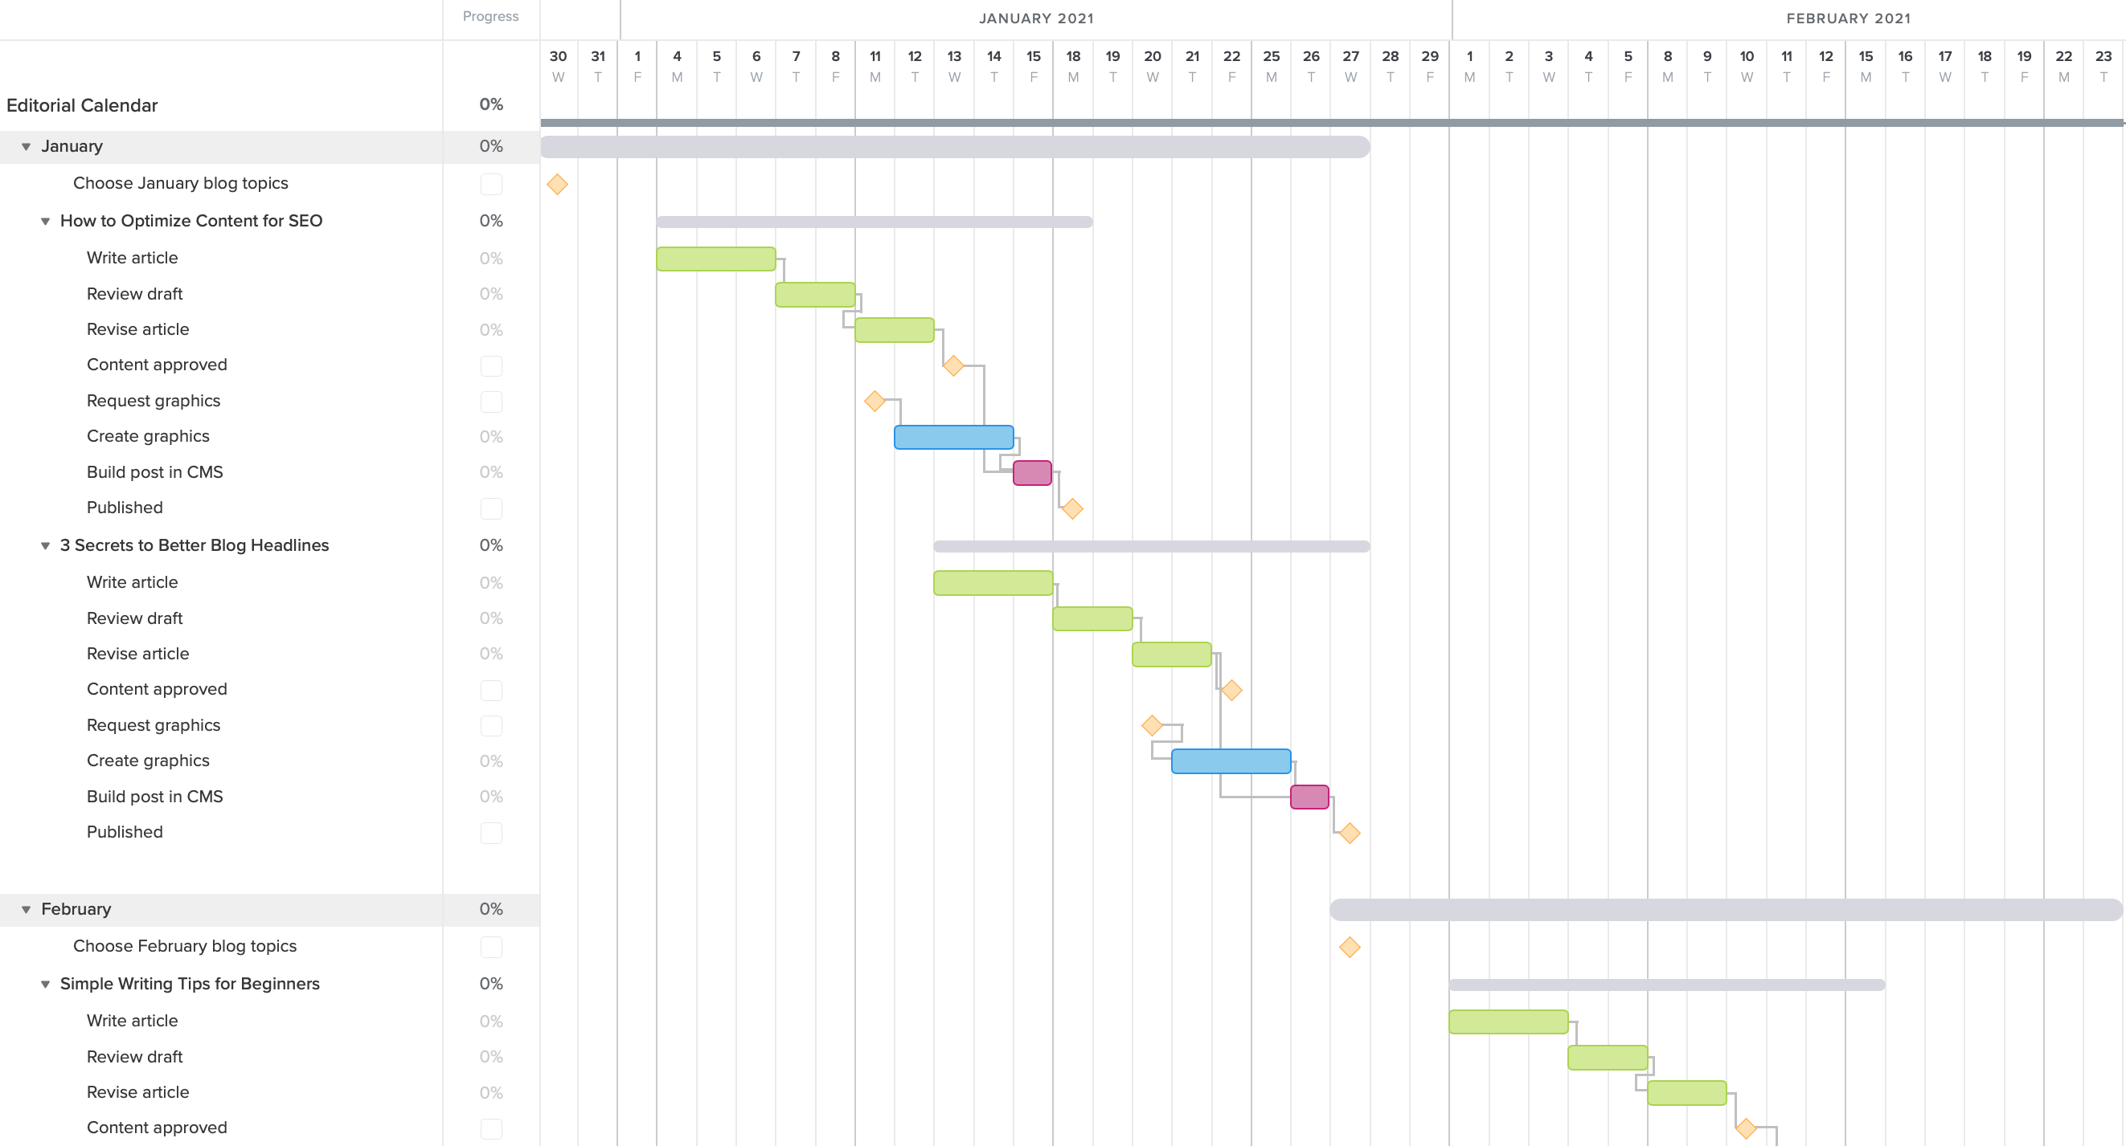

[1] W3School HTML/CSS Tutorials References and Examples@http://www.w3schools.com/. (W3School is not related to W3C).

[2] PHP Language References @http://php.net/manual/en/langref.php.

[3] Wenjie Yang, Haoxue Liu, Jie Shi,” The Design of Printing Enterprise Resources Planning (ERP) Software” IEEE-2010.

[4] PranabGarg, Dr.HimanshuAggarwal “Comparative Analysis OfErp Institute Vs Non Erp Institute; Teacher Perspective, IJMBS-2011.

[5] Sun, A., A. Yazdani and Overend, J (2005). "Achievement assessment for enterprise resource planning (ERP) system implementations based on critical success factors." Int. J. Production Economics 98: 189-203

. [6] Briukhanov V M, Kiselev V I, Timchenko N S, Vdovin V M, Monitoring the Opinions of Parents of College Students as a Component of the Institution'S In-House Education Quality Management System,

[7] Russian Education and Society, 2010, 52(5): 79-88.

[8] Weng Martin M, Chen Yung-Hui, Hang Jason C, Shih Timothy K, Hsu Hui- Huang, An Ims-Qti Compliant Multimedia Assessment Management System with Spc and Student Response Time to Analyze Learning Activities, Journal Of Internet Technology, 2015, 16(2): 223-244.

[9] Currie Kay, McCallum Jacqueline, Murray John, Scott Janine, Strachan Evelyn, Yates Lynda, Wright Marty, Developing a National Computerised Absence Monitoring and Management System to Reduce Nursing Student Attrition: Evaluation of Staff and Student Perspectives, 2014, 34(5): 738-743.