# Synopsis

**Report on**

# “Evaluation of Academic Performance”

by

Yash Verma- 2100290140155

Akhil Trivedi- 2100290140014

Deepshikha Singh- 2100290140057

# Session: 2022-2023 (4th Semester)

Under the supervision of

# Dr. Vipin Kumar (Associate Professor)

KIET Group of Institutions, Delhi-NCR, Ghaziabad



DEPARTMENT OF COMPUTER APPLICATIONS

KIET GROUP OF INSTITUTIONS, DELHI-NCR, GHAZIABAD-201206

(March 2023)

# ABSTRACT

The **"Evaluation of Academic Performance"** project aims to develop an online program or website that will provide faculty with access to a platform where they can easily keep track of the grades that students receive on internal exams, assignments submitted by the students, and their attendance, in order to evaluate students' performance without the hassle of creating time-consuming spreadsheets. All over the world, the educational system has changed its teaching and learning methods. One of its important aspects, evaluating the students’ overall performance has become a complex task with these changing patterns. It makes life easier for the staff by consolidating all student data onto a single platform. This website will be useful for the students as well because they can monitor their activities.

Hence, we have proposed, designed and implemented a solution, It aids a teacher in creating the student's final report card based on how well the student performed on the factors mentioned above. Here, the teacher can identify the subject in which the student is underperforming so that he or she can force the student to study on that poor subject by giving him or her more coursework or classes.

It is built using React, Spring Boot and MySQL.

# TABLE OF CONTENTS

1. Introduction 4
2. Literature Review 5
3. Project Objective 6
4. Module Description 7
5. Project Outcome 9
6. Conclusion 12
7. Proposed Time Duration 13

References 14

**INTRODUCTION**

Academic performance is the measurement of student achievement across various academic subjects. Teachers and education officials typically measure achievement using classroom performance, graduation rates, and results from standardized tests. The concept of Academic performance is believed to possess an amorphous nature, since it broadly incorporates various factors ranging from attaining a professional degree to the development of students in the moral sense. The perspective-oriented nature of “academic performance” further creates hindrance in giving an exhaustive definition of the term. For some entities, completing courses and gaining knowledge and skills may be the meaning of academic performance.

Students can easily look for project specifics, academic attendance data, and mark/percentage details with the use of this student performance analysis system. Students can use the project title, the guide’s name, or the academic year to look for projects. The teachers and HODs input all the information regarding the projects, as well as information regarding student attendance and grades. There are three modules in it: student, teacher, and HOD. Students are required to register, log in, fill out their academic information, view projects, check their attendance, and view their grades in a graphed format, along with events and notices. Teachers have access to a secure login page where they may accept students, submit grades, upload attendance, add project details, view scheduled activities, and post notices. HOD can access their account to handle teachers' reports, events, see Attendance, and academic details and manage notice.

# LITERARY REVIEW

Numerous studies have attempted to define the factors affecting students' universal achievement or performance. These studies are reviewed to support the hypothesis that any students' achievement and performance in the University depend on different types of factors, such as personal, teacher, and institution factors.

## 2.1 Web Based Student Information Management

The design and implementation of a comprehensive student information system and user interface is to replace the current paper records College Staff are able to directly access all aspects of a student’s academic progress through a secure, online interface embedded in the college’s website. The system utilizes user authentication, displaying only information necessary for an individual’s duties. Additionally, each subsystem has authentication allowing authorized users to create or update information in that sub-system. All data is thoroughly reviewed and validated on the server before actual record alteration occurs.

In addition, toa staff user interface, the system plans for student user interface, allowing users to access information and submit requests online thus reducing processing time. All data is stored securely on SQL servers managed by the college administrator and ensures highest possible level of security. The system features a complex logging system to track all users access and ensure conformity to data access guidelines and is expected to increase the efficiency of the college’s record management thereby decreasing the work hours needed to access and deliver student records to users.

# PROJECT OBJECTIVE

The purpose of this study is to examine the factors affecting students’ academic performance at university. For easy analysis of these factors, the objective is a further breakdown as follows;

(i) To examine the effects of personal factors on student’s academic performance.

(ii) To assess the effect of teacher-related factors influencing student’s academic performance.

(iii) To investigate the institution related factors influencing students’ academic performance.

This research project is undertaken on these three factors because the factors were found to affect the performance of university students. The research is targeting the education industry in India. This is because of the importance of the education sector in advancing and sustaining the social development in Oman. There are many educational institutions, academicians, and the parents interested to know the factors that increase and decrease student performance in school. Hence, the outcomes will benefit all these groups in society.

# MODULE DESCRIPTION

Module framework adopted in this study is outlined in Figure 1.

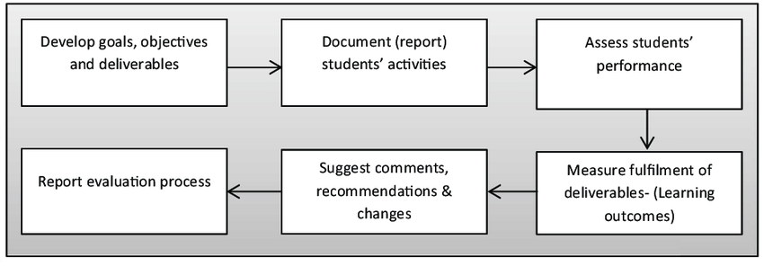

**Fig. 1** Flow chart for the Module framework

This model was based on five selected attributes, which are leadership, communication, teamwork, discipline and CGPA. Figure 1 shows the Rubric Scoring Template that is useful as a clear guideline to the evaluators. It is designed specifically to assist the evaluators in classifying the score input range for each criterion obtained by the respective candidates.

# PROJECT OUTCOME

The suggested system gives the student quick access to precise project and grade point data. Students may quickly and easily read all the material with only one click. The suggested system keeps an information database where all the data is kept. There is zero danger of data loss with this system. It is quite simple to add information and search for it, and it doesn't take much time or physical work. The system is made up of the following three major components and their supporting modules:

* + 1. Dashboard
    2. Academics
    3. Attendance marks
    4. Internal marks
    5. Assignment
    6. Final Report

1. Student

* Sign up: Students can sign up and get credentials.
* Login: Students can use their credentials to log in.
* Profiling and Academic Information: Students may enter their personal and academic information.
* See Projects: Students may look at the completed work.
* See Attendance & Academic Marks: Students have the option to view their attendance and grades as a graph.
* See Events: Students may view events currently taking place or upcoming events.
* See Notice: The notification is also available to students.

1. Teacher

* Login: Teachers can access the website by entering their login information.
* Approve Students: They are able to do this.
* Add Student Marks: Students' academic marks may also be added.
* Upload Attendance: Students' attendance can be uploaded. Also, they can add project specifics.
* See Assigned Events: The assigned events are visible.
* View Notice: The notification may also be viewed by them.

1. HOD

* Login: The HOD may log in with their credentials.
* Managing Teachers: HOD has management capabilities.
* Manage Event: The HOD can assign students to events.
* See Attendance & Academic Information: The HOD can view the students' attendance and academic information.
* Control Notice: HOD has control over notice.

A login and password are issued to authorized administration, test section, and other faculty members so they can access the Student Performance Analysis System.

# HARDWARE AND SOFTWARE REQUIREMENTS

**Operating System**: Microsoft Windows Front End: React

UI/UX: Figma

## Software Requirements:

* + Windows 10/11 or equivalent
  + React
  + Spring Boot
  + RDBMS (Back end): MySQL

## Hardware Requirements:

* Processor – Intel i3 5th generation or higher
* RAM – Minimum 4 GB, recommended 8 GB
* Disk space - Minimum 10 GB of free disk space
* Network Connectivity

# CONCLUSION

When there are a variety of factors used in the evaluation, qualitative evaluation involving assessment is typically subjective, which can cause issues with opinion and make it difficult to determine which pupils do better. Also, compared to the current existing traditional method practices, it simplified the work of the assessors because they were not required to do the difficult and time-consuming operation.

In the end, the systematic system that is being offered is created expressly to guarantee fairness and transparency throughout the assessment of student performance. Hence, it is possible to avoid any unfavorable and unethical behavior on the part of the evaluators, such as bias, favoritism, stereotypes, unfairness, and prejudice. By utilizing a system that is not just reliant on human judgement, it is possible to reduce student dissatisfaction since they understand that the method of choosing the best student is fair and transparent.

# PROPOSED TIME DURATION

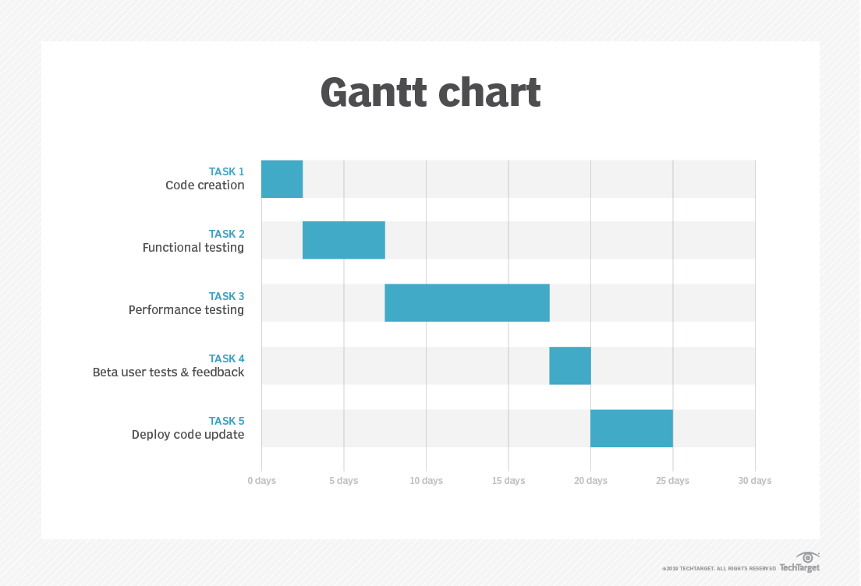

# REFERENCES

1. Ch. Aswani Kumar; K. Sumangali,” Performance evaluation of employees of an organization using formal cept analysis”, International Conference on Pattern Recognition, Informatics and Medical Engineering (PRIME-2012)
2. Shaomei Yang; Qian Zhu, “An Evaluation Model on Employee Performance Based on Improved BP Neural Network”, 2008 4th International Conference on Wireless Communications, Networking and Mobile Computing.
3. TANG Yu-fang, ZHANG Yong-sheng,,―Design and implementation of college student information management system based on the web services‖. Natural Science Foundation of Shandong Province(Y2008G22), 978-1- 4244-3930-0/09 2009 IEEE.
4. TANG Yu-fang, ZHANG Yong-sheng,,―Design and implementation of college student information management system based on the web services‖. Natural Science Foundation of Shandong Province(Y2008G22), 978-1- 4244-3930-0/09 2009 IEEE.