Question 1:

CREATE TABLE department (
dept_id INT PRIMARY KEY,
dept_name VARCHAR(30)
);

CREATE TABLE employee (
emp_id INT PRIMARY KEY,
emp_name VARCHAR(50),
salary NUMERIC(10,2),
dept_id INT REFERENCES department(dept_id)
);

INSERT INTO department VALUES
(1, 'IT'),
(2, 'Sales'),
(3, 'HR');

INSERT INTO employee VALUES
(101, 'Aman', 90000, 1),
(102, 'Neha', 70000, 1),
(103, 'Raj', 50000, 1),
(104, 'Priya', 80000, 2),
(105, 'Karan', 60000, 2),
(106, 'Riya', 40000, 2),
(107, 'Mohit', 75000, 3),
(108, 'Simran', 55000, 3);
select t.dept_name, e1.emp_name, round(e1.salary,0) from
Employee e1 join (
Select d.dept_name, d.dept_id
from Employee e
join department d
on d.dept_id=e.dept_id
group by d.dept_name, d.dept_id
having count(*)>=3) t
on t.dept_id=e1.dept_id
where e1.salary>(select avg(salary) from Employee where dept_id=t.dept_id);

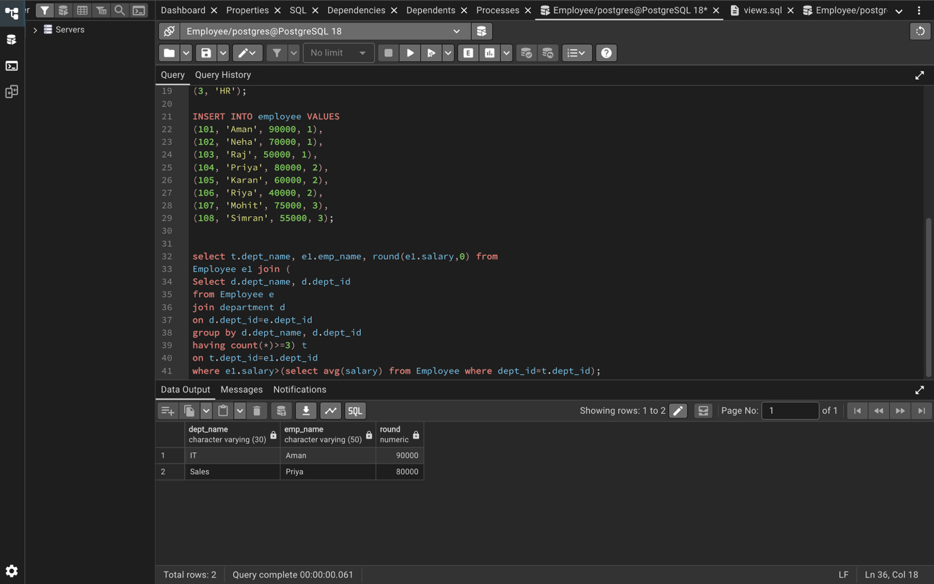

Question 2:

CREATE TABLE bank_customer (
customer_id INT PRIMARY KEY,
customer_name VARCHAR(50),
balance NUMERIC(10,2)
);

CREATE TABLE customer_audit (
audit_id SERIAL PRIMARY KEY,
customer_id INT,
customer_name VARCHAR(50),
action VARCHAR(20),
action_time TIMESTAMP
);

INSERT INTO bank_customer VALUES
(1, 'Rahul', 50000),
(2, 'Neha', 75000);

create or replace function customer_aud_fn()
returns trigger
language plpgsql
as $$
begin
if TG_OP = 'INSERT' then
insert into customer_audit
(customer_id, customer_name, action, action_time)
values
(NEW.customer_id, NEW.customer_name, 'Added', now());

elsif TG_OP = 'DELETE' then
insert into customer_audit
(customer_id, customer_name, action, action_time)
values
(OLD.customer_id, OLD.customer_name, 'Removed', now());
end if;

return null;
end;
$$ ;

create trigger customer_aud
after insert or delete
on bank_customer
for each row
execute function customer_aud_fn();

insert into bank_customer values (8,'Akshra');

select * from customer_audit;

