Game Design Document

Fill up the following document

1. Write the title of your project.

GARDENAGE

1. What is the goal of the game?

The goal of the game is to acquire the success by repairing and making a beautiful garden.

1. Write a brief story of your game.

You were having a beautiful garden in your backyard, because of a

destructive cyclone you had to leave the house & few years later you

came back to restore your dreamplace:your beautiful garden.

1. Which are the playing characters of this game?

* Playing characters are the ones who respond to the user based on the input from the user.
* Cars, monkeys, dinos, wizards, etc., are the playing characters in the game.

|  |  |  |
| --- | --- | --- |
| Number | Character Name | What can this character do? |
| 1 | You(enter name in game) | Play games/do tasks,rebuild the garden |
| 2 | Juno(past neighbour) | Talk/give suggestions |
| 3 | Rose(past neighbour) | Will be used to show the twists |
| 4 | Emma(friend) | Will be used to show the twists in game |
| 5 | Carson(Uncle) | Will be used to show the twists |
| 6 | Pet(dog/cat)(name in game) | Will interect with your  actions |
| 7 | - | - |
| 8 | - | - |

1. Which are the Non-Playing Characters of this game?

* Non-Playing characters are the ones that don't have an action or behavior when the user interacts with the game.
* Hurdles, stones, bananas, coins, etc., are non-playing characters in the game.

|  |  |  |
| --- | --- | --- |
| Number | Character Name | What can this character do? |
| 1 | Garden Benches | nothing |
| 2 | Fountain | nothing |
| 3 | Pond | nothing |
| 4 | Bridge | nothing |
| 5 | Garden swing | nothing |
| 6 | Trees | nothing |
| 7 | Statues | nothing |
| 8 | Bushes | nothing |

Draw your imagination of this game. What does this game look like?

* Draw the game either on your computer or on paper.
* Add images of the game scenes to show each of the playing and non-playing characters at least once.

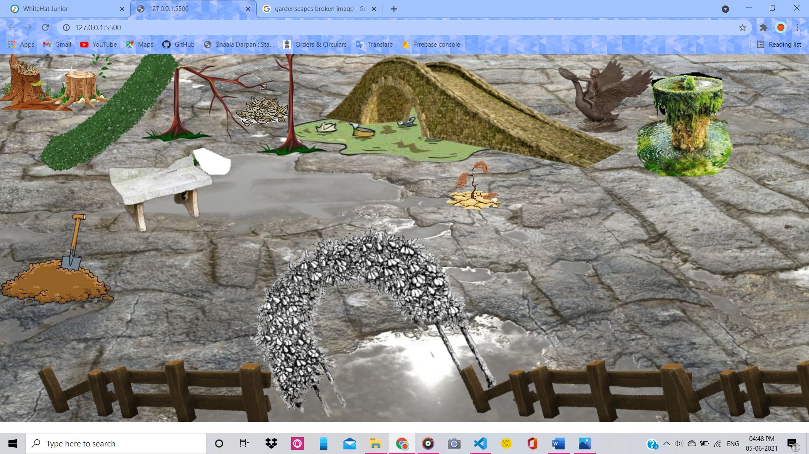

Before restoring👆🏻

After restoring 👇🏻(something like this)(‘for reference only’)

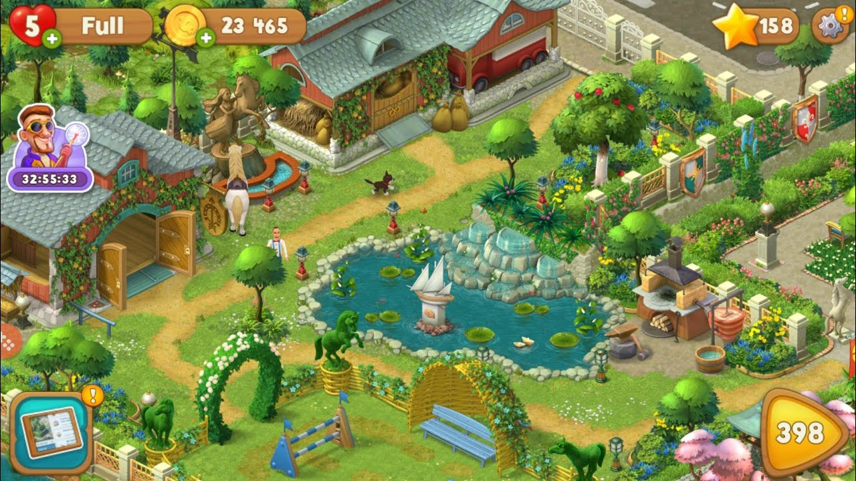

How do you plan to make your game engaging?

Firstly their would be a ruined garden then the player will earn coins.

I will make it engaging by making a hidden objects game inside it or by matching the same objects(garden objects here)like flowers, leaves etc.