Synopsis

on

**School Management System**

Submitted By: Submitted to:

Akshit Agarwal Mr. Prateek

12th A (PCM) Bansal Sir (I.P.)

M12007

**Introduction**

**School Management System** is an Advanced Computerized and Digitalized System of Software and WebApps with the help of which School data and activities are managed.

It is designed using *Python* as its skeleton equipped with frameworks like *Django* for Backend and API, *Pandas* and *Matplotlib* for Data Analysis, and also with other languages such as *HTML*, *SCSS*, *JSX* and *JavaScript* with frameworks like *React* for it’s Frontend Interface. It uses *MySQL/PostgreSQL* as the secure Backend Database but can be equipped with many other Databases like *SQLite* too without any Hassle!

The System maintains almost all the Tasks which can be Digitalized in Schools like Attendance, Time Table, Classes, Assignment Sharing, Communication with Teachers, Admin and Management Portal, Parent Portal and a lot more with all this in one, easy to use app.

Most of the System works on the concept of REST API in which the Client applications interacts with the Server by making HTTP requests, the same way most of the modern websites work today.

**Mission of the Project**

The mission of this Project is to facilitate easy, fast and modern management and administration of a School with capabilities like Uploading Time Tables and Scheduling Classes, advanced Attendance System, Parent Portal, Admin and Management Portal, secured Storage, faster services and a lot more.

This helps in more managed and faster conveying of information at any time of the day, easy and efficient storage of records and data, easy retrieval of information when needed, reduces manpower and increases overall efficiency.

**Existing System**

The Existing System for management is partially Digitalized and is only limited to operations like Handling and Storage of Data Digitally.

Tasks like interaction/communication between Teachers and Students are either done one-by-one in physical classrooms or by calls and apps like Zoom and WhatsApp which is very informal and insecure and also end up being a distraction.

**Drawbacks of the Existing System**

* Manual entry consumes more time
* Difficult to maintain Bulk Record of Data
* Not easy to prepare Daily Reports and Analysis
* Lack of Accuracy and error prone
* Less Secure
* Hard to trace Details
* Human Errors
* Manual System is unreliable and slow
* Overall efficiency is Less

**Proposed System**

The new proposed system is a digitalized version of the normal system equipped with more and better facilities, more formal, totally customizable, faster and reduces manpower, easy to analyze and a lot more! Having a formal system makes it a lot easy, faster and secure to manage our tasks.

**Advantages of Proposed System**

* Secure Data
* Faster Process
* Minimal or no Errors
* Better Management
* Save a lot of Manpower
* Can easily make Daily Reports and Analysis
* Elimination of Paperwork
* High Reliability and Security
* Fast and Economical

**Application Modules/Features**

* Detailed User Records
* Automated Attendance
* Admin and Management Portal
* Teacher Portal
* Parent Portal
* Student Portal
* Assignment Sharing
* Online Time-Table and Class Scheduler
* Attendance and Result Data Visual Analysis
* Advanced and Secure Storage
* Backup and Restore
* Upgradable and Token based Secure Authorization API
* Interactive Software and Web Applications
* Customizable as per needs
* Encrypted Data

**A Small Representation of Structure and Working of the System:**

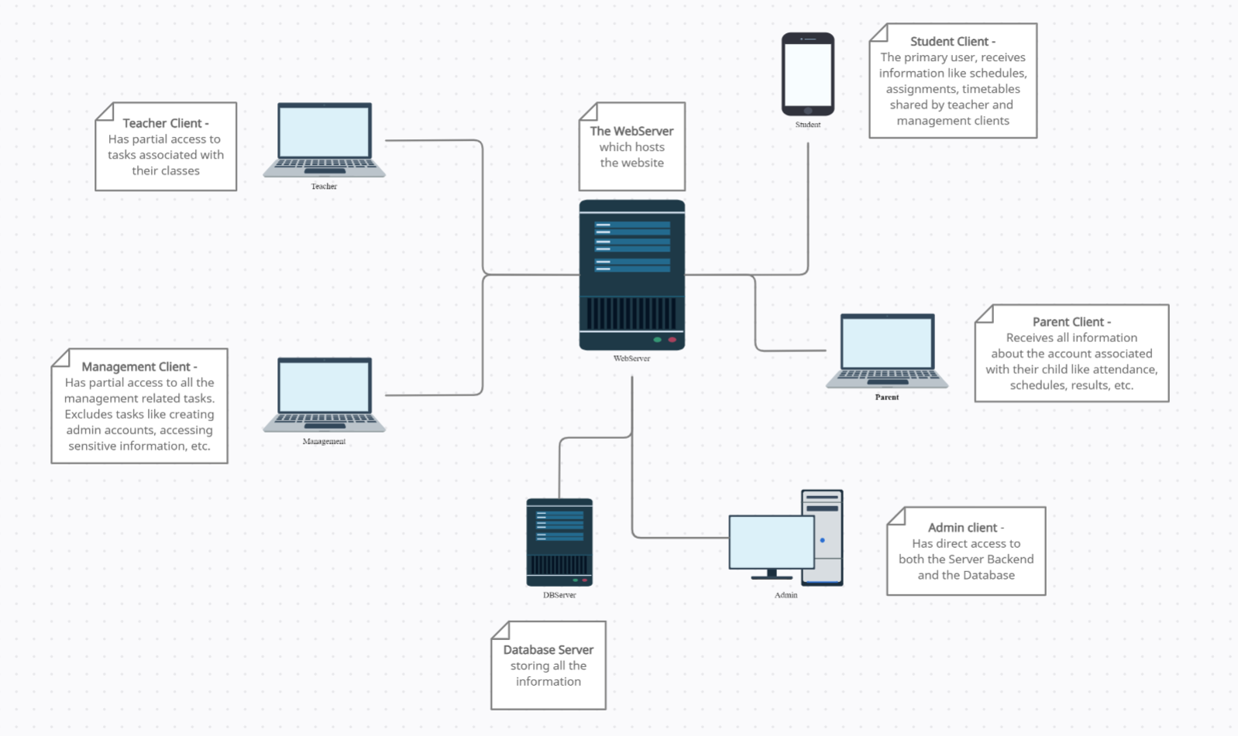

(Refer to <https://app.creately.com/diagram/QeLmmucJNfR/view> for a scalable diagram)

**Block Diagram:**

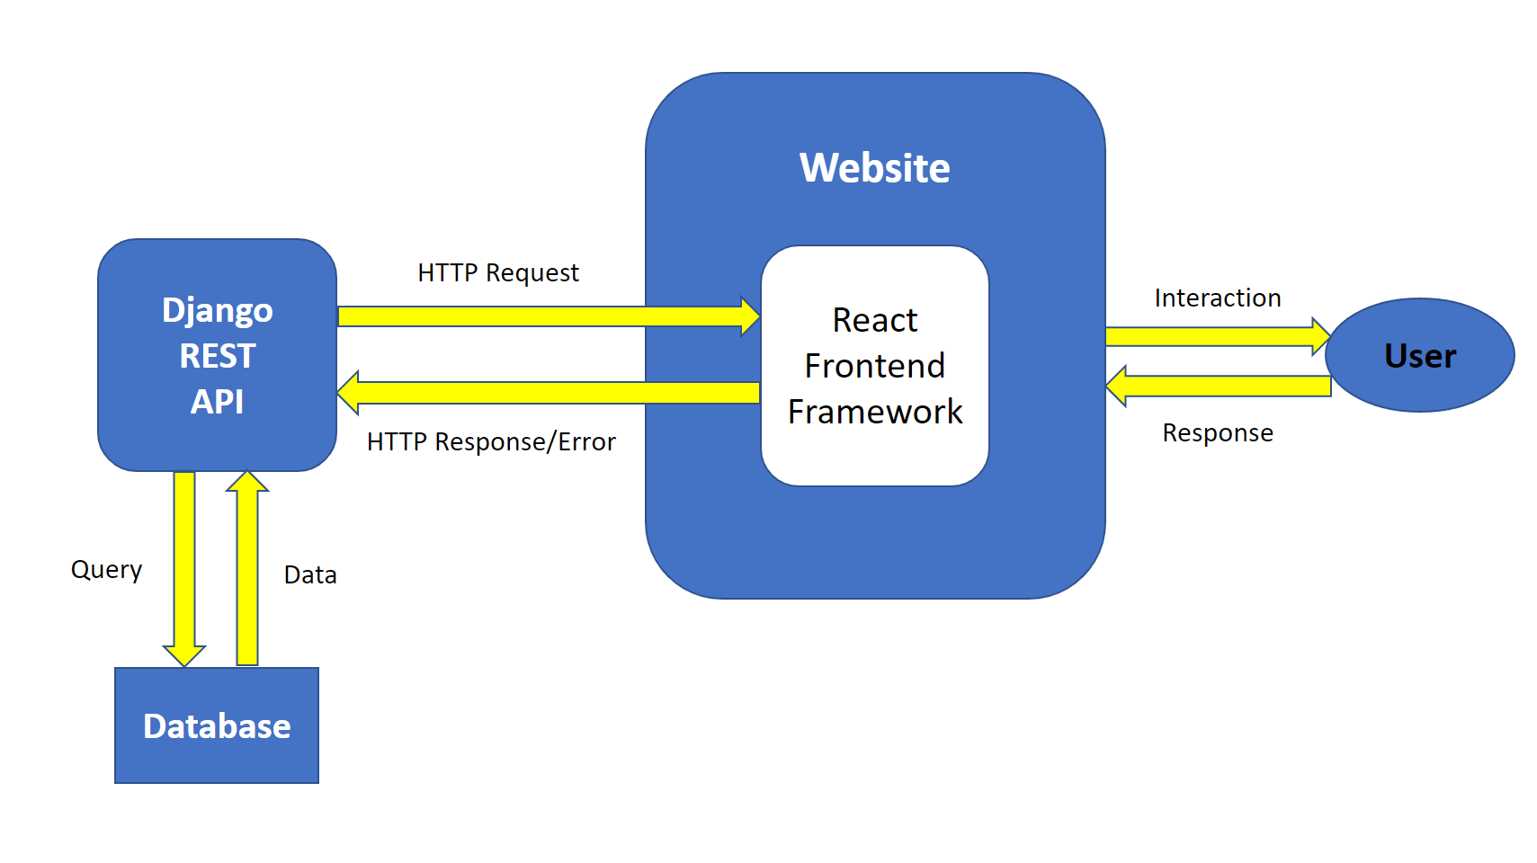

**Software Requirements**

* Python 3.9 or Above
* MySQL 8.0 or Above / PostgreSQL 13 or Above
* Node.js v16.13.0 or Above