Full Stack Development with MERN

Project Documentation
Project Title: Flight Finder
Team Members:
- Hitanshu Yadav [22BCE10527]
- Mohammad Asif Raza [22BSA10190]
- Akshat Singh [22BCE10690]
- Mallika Manish Rajpal [22BCE10455]

2. Project Overview

Purpose
The Flight Booking App aims to provide a modern, responsive, and user-friendly platform for booking flights. It streamlines the booking process by offering real-time search, secure payments, and clear pricing information. This MERN stack application caters to users seeking efficient flight comparisons and personalized booking experiences.

Features
- Advanced flight search and filtering (destination, date, airline, price)
- Real-time comparison of flights
- Secure authentication and user account management
- Transparent and streamlined booking with integrated payment
- User dashboard for managing trips and history

3. Architecture

Frontend
The frontend uses React for a modular, component-driven architecture. It leverages Bootstrap and custom CSS for responsiveness. API calls are made using Axios to fetch and display flight data.

Backend
Node.js with Express.js handles server-side logic including routing, authentication, and booking transactions. It interacts with MongoDB using Mongoose ORM.

Database
MongoDB stores user profiles, flight information, and booking records. Collections include users, flights, and bookings. Each booking references both user and flight documents.
System Architecture Diagram:
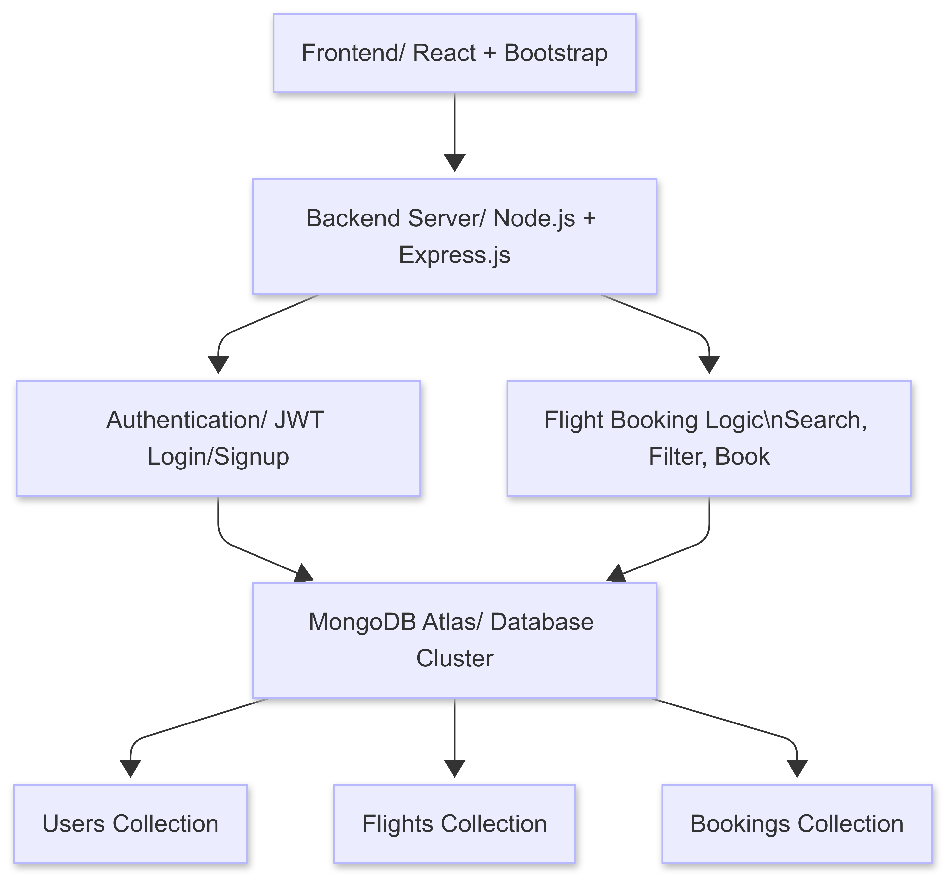
Figure 3.1

4. Setup Instructions

Prerequisites
- Node.js >= 16
- MongoDB >= 4
- npm or yarn
- Postman for testing (optional)

Installation
1. Clone the repository
2. Navigate to `/client` and run `npm install`
3. Navigate to `/server` and run `npm install`
4. Set environment variables in `.env` file (MONGO_URI, JWT_SECRET, etc.)
5. Run `npm start` in both client and server directories

5. Folder Structure

Client
`/components`: React UI components
`/pages`: Page-level views
`/services`: API service layer
`/styles`: CSS files and theme

Server
`/routes`: API endpoints
`/controllers`: Business logic for endpoints
`/models`: Mongoose schemas
`/middleware`: Authentication, error handling

6. Running the Application
- Frontend: `cd client && npm start`
- Backend: `cd server && npm start`

7. API Documentation
**Auth APIs**
- `POST /api/auth/register` - Register a new user
- `POST /api/auth/login` - Login user and return JWT
**Flight APIs**
- `GET /api/flights` - Get list of available flights
- `GET /api/flights/:id` - Get flight details
**Booking APIs**
- `POST /api/bookings` - Book a selected flight
- `GET /api/bookings/user/:id` - Get bookings for a user

8. Authentication
Authentication is handled using JSON Web Tokens (JWT). Upon login, a token is issued and stored on the client. Protected routes use middleware to verify the token and authorize access. Role-based access (user/admin) can be integrated.

9. User Interface
Clean, responsive UI with the following sections:
- Flight search form
- Results table with filters
- Booking confirmation page
- User login/signup and dashboard
Sample UI Screenshots:
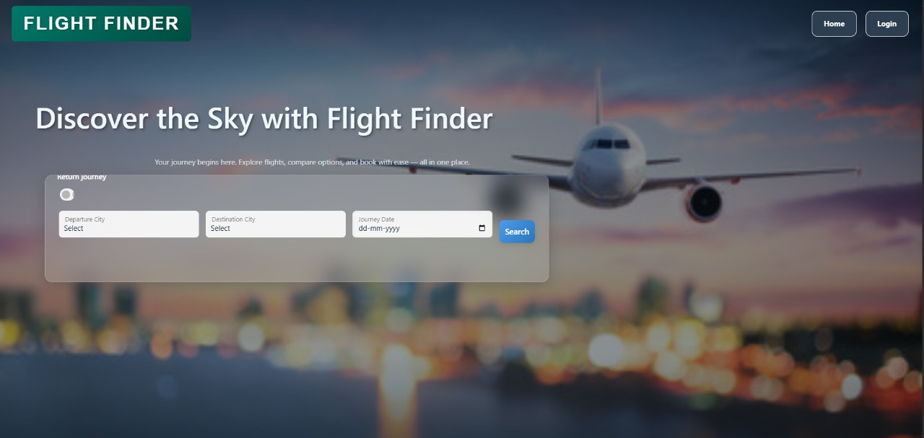
Figure 9.1
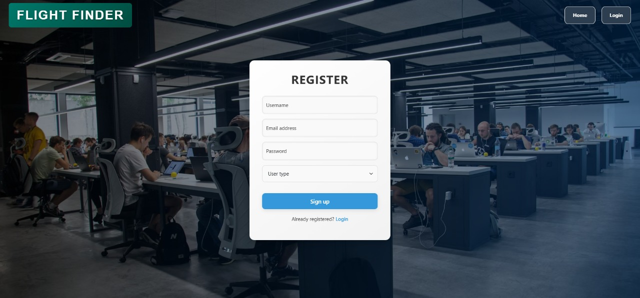
Figure 9.2
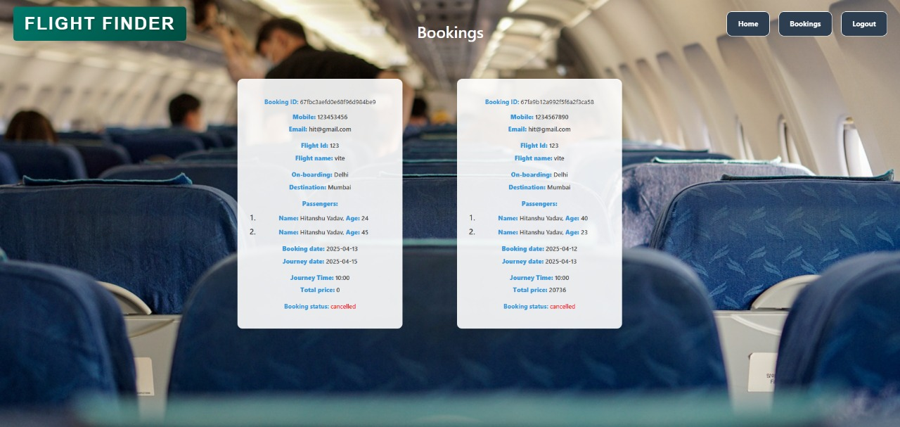
Figure 9.3
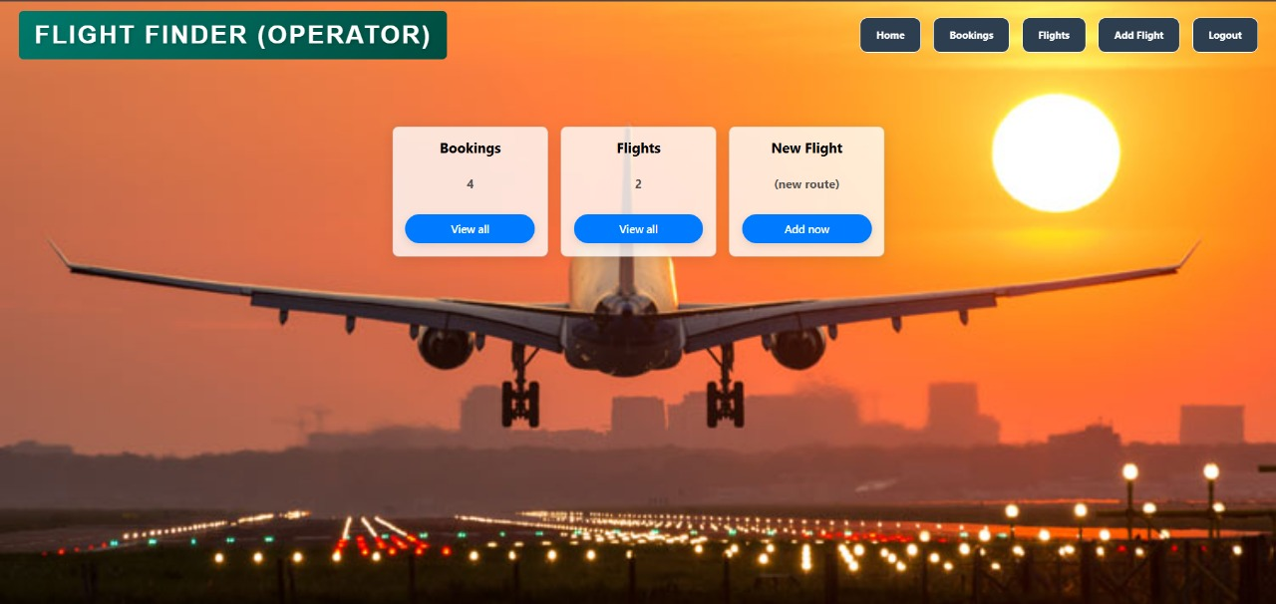
Figure 9.4
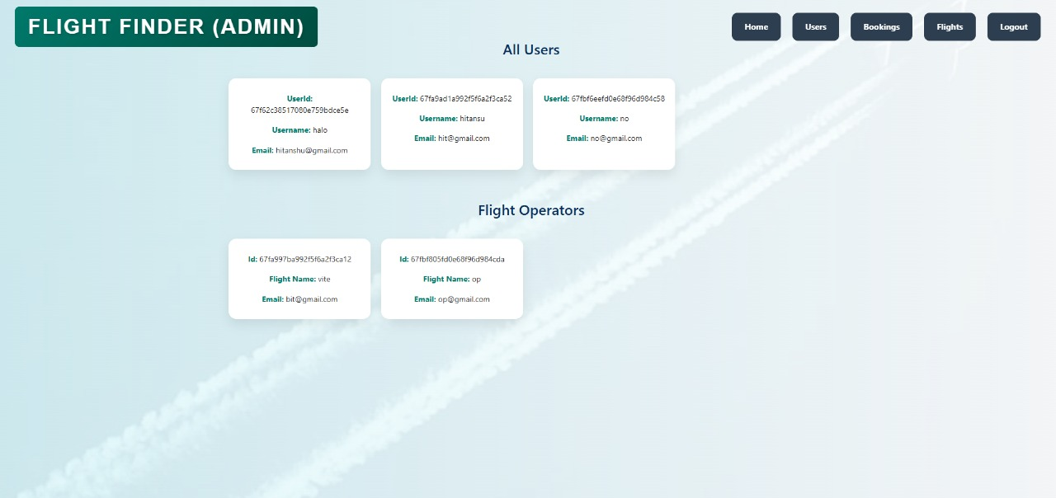
Figure 9.5
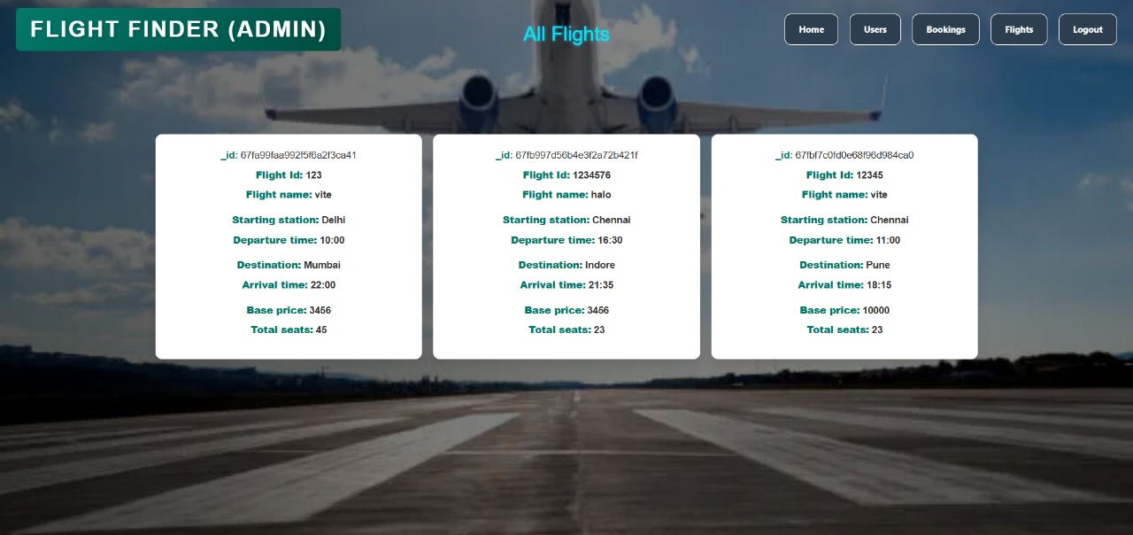
Figure 9.6

10. Testing
API endpoints were tested using Postman. Frontend components were manually tested across devices. Performance was analyzed using Chrome DevTools. Example test scenarios include booking workflows and login edge cases.

11. Demo Video
Live demo available at:
GitHub Link
Google Drive

12. Known Issues
- No native mobile application yet
- Offline access not supported
- Only English supported
- Limited flight provider APIs integrated

13. Future Enhancements
- Integrate hotel and car rental booking services
- Develop native iOS and Android apps
- Support multi-language and currency localization
- AI-based price prediction and booking suggestion
- Real-time flight status updates and loyalty program integration

