Practical File
of

Fundamentals of C Programming
(24CSE0107)

Batch-2025

Bachelor of Engineering (CSE)



Submitted By  Rakesh Kumar  Roll No. 2510991344  Group No.9, Sem: 2nd, BE (CSE)  Chitkara University, Punjab, 140401  India | Submitted To  Dr. Tejpal Sharma  Associate Professor, CSE  Chitkara University, Punjab, 140401  India

Department of
Computer Science and Engineering,
Chitkara University School of Engineering and Technology,
Chitkara University, Punjab, India
Index
Sr. No. | Experiment | Page No.
1 | Install C compiler (GCC/Code::Blocks), set up IDE, compile and run the first "Hello, World!" program. | 1
2 | Write a Program to show the use to input (Scanf)/output (Printf) statements and block structure of C-program by highlighting the features of “stdio.h”. | 2
3 | Write a program to add two numbers and display the sum. | 3
4 | Write a program to calculate the area and the circumference of a circle by using radius as the input provided by the user. | 4
5 | Write a Program to perform addition, subtraction, division and multiplication of two numbers given as input by the user. | 5
6 | Write a program to evaluate each of the following equations.  (i) V = u + at. (ii) S = ut+1/2at² (iii) T=2*a+√b+9c (iv) H=√b²+p² | 6-7
7 | Write a program to swap two variables:  a) By using temporary variable.  b) Without using temporary variable | 8-9
8 | Write a Program to find the greatest among three numbers using:  • Conditional Operator  • If-Else statement | 10-11
9 | Write the following programs using switch case statement:  - To check that an input alphabet is vowel or consonant  - To check whether a number is positive, negative or zero | 12-14
10 | Write a program using while loop to print the sum of first n natural numbers. | 15
11 | Write a program to check a number is Armstrong or not using For loop. | 16-17
12 | Write the program to count the digits in a number and then print the reverse of the number also. | 18-19
13 | Write a program to generate the Fibonacci series. | 20-21
14 | Write a program to print the following patterns:  a)  *  * *  * * *  * * * *  * * * * *  * * * * * *  b)  *  * *  * * *  * * * *  * * * * *  * * * * * * | 22-23
15 | Write the program to print the following pattern:  1 2 3 4 5 6  2 4 6 8 10 12  3 6 9 12 15 18  4 8 12 16 20 24  5 10 15 20 25 30  6 12 18 24 30 36 | 24-25
16 | Write a program to perform the following operations on 1D-Array:  - Insert  - Update  - Delete  - Display  - Search | 26-30
17 | Write a program to calculate the sum of array elements by passing it to a function. | 31-32
18 | Write a program matrix multiplication using the concept of 2D array | 33-35
19 | Write a program to transpose a given matrix. | 36-37
20 | Write a menu driven C program to show the use of in-built string functions like strlen, strcat, strcpy, strcmp, strrev etc. | 38-40
21 | Write a program to check that the given number is prime, Armstrong or perfect using the concept of functions. | 41-43
22 | Write a program to calculate the area and circumference of a circle using functions. | 44-45
23 | Write a program to swap two variables using the concept of call by value and call by reference. | 46-48
24 | Write a program to show the use of passing pointer as arguments to the functions. | 49-50
25 | Write a program to find the factorial of a number by using the concept of recursion. | 51-52
26 | Write a Program in C to display the total number of appearances of a substring provided as input by the user in a given string. | 53-54
27 | Write a program to display the sum of the digits of a number by using the concept of recursion. | 55-56
28 | Write a C program to add two distances in inch & feet using the concept of structures. | 57-58
29 | Write a C program to add two complex numbers using the concept of structures in C. | 59-60
30 | Write a program in C to store the information of five employees using both concepts i.e. array of structure and array within structure. | 61-62
31 | Write a Program in C to find and replace a specific string in a file and also display the total number of appearances of that string. | 63-65

Experiment No. 1.
Aim: Install C compiler (GCC/Code::Blocks), set up IDE, compile and run the first "Hello, World!" program.
Concept Used: The concept used is the basic structure of a C program, compiler setup, and the use of stdio.h for printing output.
Program: #include<stdio.h>

int main(){
printf("Name: Rakesh\n");

printf("Roll_No: 2510991344\n");

printf("Hello world\n");

return 0;
}

Output Screenshot:

Experiment No. 2.
Aim: Write a Program to show the use to input (Scanf)/output (Printf) statements and block structure of C-program by highlighting the features of "stdio.h".
Concept Used: The concept used is input/output handling in C using scanf and printf, along with block structure demonstration.
Program:#include <stdio.h>

int main() {

printf("Name: Rakesh\n");
printf("Roll No: 2510991344\n");

int number, square;

// Output statement
printf("Enter an integer: ");

//Input statement
scanf("%d", &number);

square = number * number;

printf("The square of %d is: %d\n", number, square);
return 0;
}

Output Screenshot:

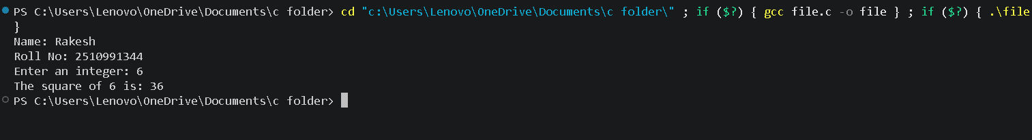

Experiment No. 3.
Aim: Write a program to add two numbers and display the sum.
Concept Used: The concept used is arithmetic addition of two integers with user input and output display.
Program: #include <stdio.h>

int main() {

printf("Name: Rakesh\n");
printf("Roll No: 2510991344\n");

int num1, num2, sum;

// Taking frist number from the user
printf("Enter the first number: ");
scanf("%d", &num1);

// Taking second number from the user
printf("Enter the second number: ");
scanf("%d", &num2);
sum = num1 + num2

// Displaying the result
printf("The sum of %d and %d is: %d\n", num1, num2, sum);
return 0;
}

Output Screenshot:

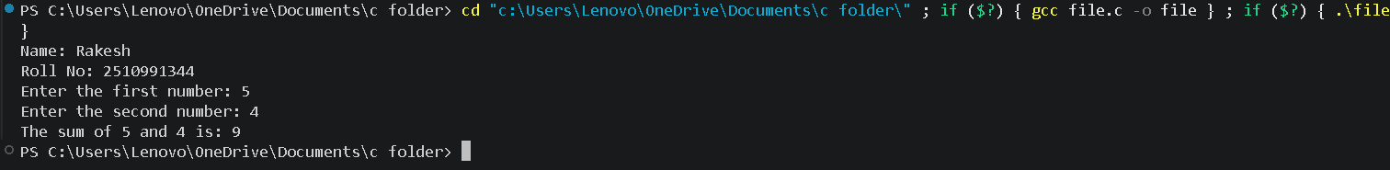

Experiment No. 4.
Aim: Write a program to calculate the area and the circumference of a circle by using radius as the input provided by the user.

Concept Used: The concept used is applying mathematical formulas to calculate area and circumference of a circle using floating-point arithmetic.
Program: #include <stdio.h>

int main() {
printf("Name: Rakesh\n");
printf("Roll No: 2510991344\n");

float radius, area, circumference;
// Taking radius as input
printf("Enter the radius of the circle: ");
scanf("%f", &radius);

// Calculating area and circumference
area = 3.14 * radius * radius;
circumference = 2 * 3.14 * radius;

// Displaying results
printf("Area of the circle = %.2f\n", area);
printf("Circumference of the circle = %.2f\n", circumference);
return 0;
}

Output Screenshot:
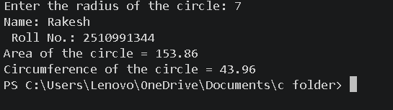

Experiment No. 5.
Aim: Write a Program to perform addition, subtraction, division and multiplication of two numbers given as input by the user.
Concept Used: The concept used is performing arithmetic operations (addition, subtraction, multiplication, division) on user-provided numbers.
Program: #include <stdio.h>
int main() {

printf("Name: Rakesh\n");
printf("Roll No: 2510991344\n");
float num1, num2;
float add, sub, mul, div;

// Take the first number from the user
printf("Enter the first number: ");
scanf("%f", &num1);

// Take the second number from the user
printf("Enter the second number: ");
scanf("%f", &num2);

// Perform the arithmetic operations
add = num1 + num2;
sub = num1 - num2;
mul = num1 * num2;
div = num1 / num2;

// Display the final results (%.2f limits the output to 2 decimal places)
printf("\n--- Results ---\n");
printf("Addition: %.2f\n", add);
printf("Subtraction: %.2f\n", sub);
printf("Multiplication: %.2f\n", mul);
printf("Division: %.2f\n", div);
return 0;
}
Output Screenshot:
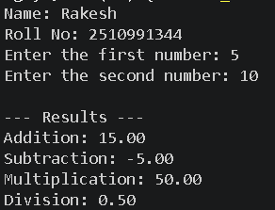

Experiment No. 6.
Aim: Write a program to evaluate each of the following equations.
(i) V = u + at. (ii) S = ut+1/2at² (iii) T=2*a+√b+9c (iv) H=√b²+p²
Concept Used: The concept used is evaluating mathematical equations using operators and <math.h> functions like sqrt.
Program: #include <stdio.h>
#include <math.h>
int main() {
printf("Name: Rakesh\n");
printf("Roll No: 2510991344\n");
float u, a, t, v, s;
float b, c, p, T, H;
// Input values
printf("Enter the values of u, a and t: ");
scanf("%f %f %f", &u, &a, &t);
printf("Enter the values of b, c and p: ");
scanf("%f %f %f", &b, &c, &p);
// (i) V = u + at
v = u + a * t;
// (ii) S = ut + 1/2at^2
s = (u * t) + (0.5 * a * t * t);
// (iii) T = 2*a + √b + 9c
T = (2 * a) + sqrt(b) + (9 * c);
// (iv) H = √(b^2 + p^2)
H = sqrt((b * b) + (p * p));
// Display results
printf("\nValue of V = %.2f\n", v);
printf("Value of S = %.2f\n", s);
printf("Value of T = %.2f\n", T);
printf("Value of H = %.2f\n", H);
return 0;
}
Output Screenshot:
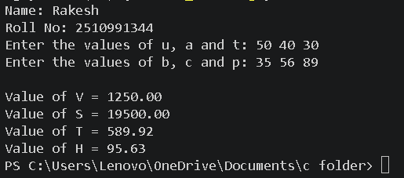

Experiment No. 7.
Aim: Write a program to swap two variables:
a) By using temporary variable.
b) Without using temporary variable
Concept Used: The concept used is swapping variables, both with a temporary variable and without using one (arithmetic swapping).
Program: #include <stdio.h>
int main() {
printf("Name: Rakesh\n");
printf("Roll No: 2510991344\n\n");
int num1, num2, temp;
int x, y;
// a) By using temporary variable
printf("--- a) Swap using temporary variable ---\n");
printf("Enter two numbers (num1 num2): ");
scanf("%d %d", &num1, &num2);
printf("Before swapping: num1 = %d, num2 = %d\n", num1, num2);
temp = num1;
num1 = num2;
num2 = temp;
printf("After swapping: num1 = %d, num2 = %d\n\n", num1, num2);
// b) Without using temporary variable
printf("--- b) Swap without using temporary variable ---\n");
printf("Enter two numbers (x y): ");
scanf("%d %d", &x, &y);
printf("Before swapping: x = %d, y = %d\n", x, y)
x = x + y;
y = x - y;
x = x - y;
printf("After swapping: x = %d, y = %d\n", x, y);
return 0;
}
Output Screenshot:
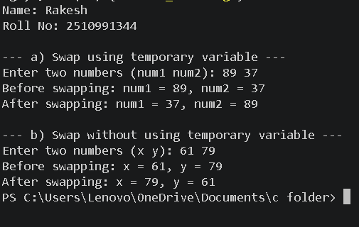

Experiment No. 8.
Aim: Write a Program to find the greatest among three numbers using:
• Conditional Operator
• If-Else statement
Concept Used: The concept used is finding the greatest among three numbers using conditional (ternary) operators and if-else statements.
Program: #include <stdio.h>
int main() {
printf("Name: Rakesh\n");
printf("Roll No: 2510991344\n\n");
int num1, num2, num3;
int max_conditional, max_ifelse;
// Take three numbers from the user
printf("Enter three numbers (separated by space): ");
scanf("%d %d %d", &num1, &num2, &num3);
// 1. Find greatest using Conditional (Ternary) Operator
max_conditional = (num1 > num2) ? ((num1 > num3) ? num1 : num3) : ((num2 > num3) ? num2 : num3);
// 2. Find greatest using If-Else statement
if (num1 >= num2 && num1 >= num3) {
max_ifelse = num1;
} else if (num2 >= num1 && num2 >= num3) {
max_ifelse = num2;
} else {
max_ifelse = num3;
}

// Display the final results
printf("\n--- Results ---\n");
printf("Greatest using Conditional Operator: %d\n", max_conditional);
printf("Greatest using If-Else statement: %d\n", max_ifelse);
return 0;
}
Output Screenshot:
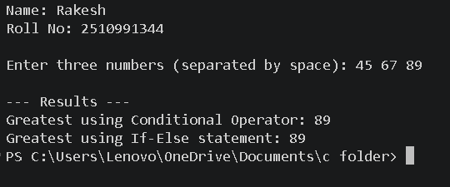

Experiment No. 9.
Aim: Write the following programs using switch case statement:
To check that an input alphabet is vowel or consonant
To check whether a number is positive, negative or zero
Concept Used: The concept used is decision-making with switch statements to check vowels/consonants and classify numbers as positive, negative, or zero.
Program: // Program to check if input is an consonant or an vowel
#include <stdio.h>
int main() {
printf("Name: Rakesh\n");
printf("Roll No: 2510991344\n\n");
char ch;
// Take an alphabet from the user
printf("Enter an alphabet: ");
scanf(" %c", &ch);
// Check for vowels using switch case
switch (ch) {
case 'a':
case 'A':
case 'e':
case 'E':
case 'i':
case 'I':
case 'o':
case 'O':
case 'u':
case 'U':
printf("%c is a Vowel.\n", ch);
break;
default:
printf("%c is a Consonant.\n", ch);
break;
}
return 0;
}
// Program to check whether the number is positive,negative or zero
#include <stdio.h>
int main() {
printf("Name: Rakesh\n");
printf("Roll No: 2510991344\n\n");
int num;
// Take a number from the user
printf("Enter a number: ");
scanf("%d", &num);
// Switch evaluates if the number is greater than 0 (1 for true, 0 for false)
switch (num > 0) {
case 1:
printf("%d is Positive.\n", num);
break;

case 0:
// Nested switch evaluates if the number is less than 0
switch (num < 0) {
case 1:
printf("%d is Negative.\n", num);
break;
case 0:
printf("The number is Zero.\n");
break;
}
break;
}
return 0;
}
Output Screenshot:
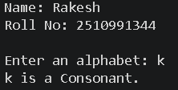
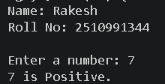

Experiment No. 10.
Aim: Write a program using while loop to print the sum of first n natural numbers.
Concept Used: The concept used is iterative computation using a while loop to sum natural numbers.
Program: #include <stdio.h>
int main() {
printf("Name: Rakesh\n");
printf("Roll No: 2510991344\n\n");
int n, i, sum = 0;
// Take the value of n from the user
printf("Enter a positive integer: ");
scanf("%d", &n);
// Calculate sum using a while loop
i = 1;
while (i <= n) {
sum = sum + i;
i++;
}
// Display the final sum
printf("The sum of the first %d natural numbers is: %d\n", n, sum);
return 0;
}
Output Screenshot:
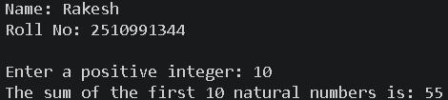

Experiment No. 11.

Aim: Write a program to check a number is Armstrong or not using For loop.
Concept Used: The concept used is checking Armstrong numbers using a for loop and modulus operator.
Program: #include <stdio.h>
int main() {
printf("Name: Rakesh\n");
printf("Roll No: 2510991344\n");
int num, originalNum, remainder;
int result = 0;
// Input from user
printf("Enter a number: ");
scanf("%d", &num);
originalNum = num;
// Using for loop
for (; num != 0; num = num / 10) {
remainder = num % 10;
result = result + (remainder * remainder * remainder);
}
// Checking Armstrong number
if (result == originalNum)
printf("%d is an Armstrong number.\n", originalNum);
else
printf("%d is not an Armstrong number.\n", originalNum);
return 0;
}
Output Screenshot:
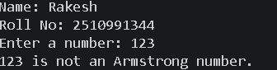

Experiment No. 12.
Aim: Write the program to count the digits in a number and then print the reverse of the number also.
Concept Used: The concept used is digit manipulation with loops to count digits and reverse a number.
Program: #include <stdio.h>
int main() {
printf("Name: Rakesh\n");
printf("Roll No: 2510991344\n\n");
int num, count = 0, reverse = 0, remainder;
// Take a number from the user
printf("Enter an integer: ");
scanf("%d", &num);
// Calculate the number of digits and the reverse
while (num != 0) {
remainder = num % 10;
reverse = reverse * 10 + remainder;
count++;
num /= 10;
}
// Display the final results
printf("\n--- Results ---\n");
printf("Number of digits: %d\n", count);
printf("Reversed number: %d\n", reverse);

return 0;
}
Output Screenshot:
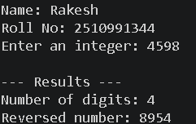

Experiment No. 13.
Aim: Write a program to generate the Fibonacci series.
Concept Used: The concept used is a loop to build the series step by step, storing previous values and adding them to get the next term.
Program: #include <stdio.h>
int main() {
printf("Name: Rakesh\n");
printf("Roll No: 2510991344\n\n")
int n, i;
int t1 = 0, t2 = 1, nextTerm;
// Take the number of terms from the user
printf("Enter the number of terms: ");
scanf("%d", &n)
printf("Fibonacci Series: ");
// Loop to generate and print the series
for (i = 1; i <= n; ++i) {
printf("%d ", t1);
nextTerm = t1 + t2;
t1 = t2;
t2 = nextTerm;
}
printf("\n");

return 0;
}
Output Screenshot:
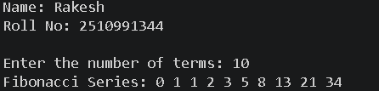

Experiment No. 14.
Aim: Write a program to print the following patterns:

a)
*
* *
* * *
* * * *
* * * * *
* * * * * *
b)
*
* *
* * *
* * * *
* * * * *
* * * * * *

Concept Used: The concept used is nested loops for printing star patterns (left-aligned and right-aligned).
Program: #include <stdio.h>
int main() {
printf("Name: Rakesh\n");
printf("Roll No: 2510991344\n\n");
int i, j, k;
int rows = 6;
// Pattern a) - Left-aligned
printf("Pattern a)\n");
for (i = 1; i <= rows; i++) {
for (j = 1; j <= i; j++) {
printf("* ");
}
printf("\n");
}
printf("\n");
// Pattern b) - Right-aligned
printf("Pattern b)\n");
for (i = 1; i <= rows; i++) {
// Print spaces
for (k = 1; k <= rows - i; k++) {
printf(" ");
}
// Print stars
for (j = 1; j <= i; j++) {
printf("* ");
}
printf("\n");
}
return 0;
}
Output Screenshot:
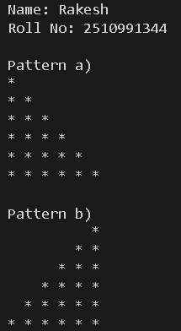
Experiment No. 15.

Aim: Write the program to print the following pattern:

1 2 3 4 5 6
2 4 6 8 10 12
3 6 9 12 15 18
4 8 12 16 20 24
5 10 15 20 25 30
6 12 18 24 30 36
Concept Used: The concept used is nested loops to print multiplication tables in a grid format.
Program:
#include <stdio.h>
int main() {
printf("Name: Rakesh\n");
printf("Roll No: 2510991344\n\n");
int i, j;
// Nested loops to print the multiplication pattern
for (i = 1; i <= 6; i++) {
for (j = 1; j <= 6; j++) {
// %4d ensures the numbers are right-aligned with a width of 4 characters for a clean grid
printf("%4d ", i * j);
}
printf("\n"); // Move to the next line after each row
}
return 0;
}

Output Screenshot:
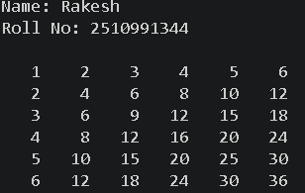

Experiment No. 16.
Aim: Write a program to perform the following operations on 1D-Array:
- Insert
- Update
- Delete
- Display
- Search
Concept Used: The concept used is array manipulation (insert, update, delete, display, search) using a menu-driven program.
Program: #include <stdio.h>
int main() {
printf("Name: Rakesh\n");
printf("Roll No: 2510991344\n\n");
int arr[100];
int size = 0, choice, pos, value, i, found;
// Initialize the array
printf("Enter initial number of elements: ");
scanf("%d", &size);

printf("Enter the elements: ");
for (i = 0; i < size; i++) {
scanf("%d", &arr[i]);
}
// Menu-driven loop for array operations
while (1) {
printf("\n--- Array Operations ---\n");
printf("1. Insert\n2. Update\n3. Delete\n4. Display\n5. Search\n6. Exit\n");
printf("Enter your choice: ");
scanf("%d", &choice);
switch (choice) {
case 1:
// Insert an element
printf("Enter position (1 to %d) and value: ", size + 1);
scanf("%d %d", &pos, &value);
if (pos >= 1 && pos <= size + 1) {
for (i = size; i >= pos; i--) {
arr[i] = arr[i - 1];
}
arr[pos - 1] = value;
size++;
printf("Element inserted.\n");
} else {
printf("Invalid position.\n");
}
break;
case 2:
// Update an element
printf("Enter position (1 to %d) and new value: ", size);
scanf("%d %d", &pos, &value);
if (pos >= 1 && pos <= size) {
arr[pos - 1] = value;
printf("Element updated.\n");
} else {
printf("Invalid position.\n");
}
break;
case 3:
// Delete an element
printf("Enter position (1 to %d) to delete: ", size);
scanf("%d", &pos);
if (pos >= 1 && pos <= size) {
for (i = pos - 1; i < size - 1; i++) {
arr[i] = arr[i + 1];
}
size--;
printf("Element deleted.\n");
} else {
printf("Invalid position.\n");
}
break;
case 4:
// Display all elements
printf("Array elements: ");
for (i = 0; i < size; i++) {
printf("%d ", arr[i]);
}
printf("\n");
break;
case 5:
// Search for an element
printf("Enter value to search: ");
scanf("%d", &value);
found = 0;
for (i = 0; i < size; i++) {
if (arr[i] == value) {
printf("Element found at position %d.\n", i + 1);
found = 1;
break;
}
}
if (found == 0) {
printf("Element not found.\n");
}
break;
case 6:
// Exit the program
return 0;
default:
printf("Invalid choice. Try again.\n");
}
}

return 0;
}
Output Screenshot:
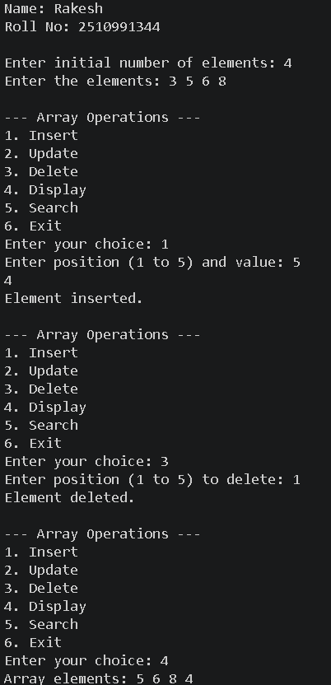
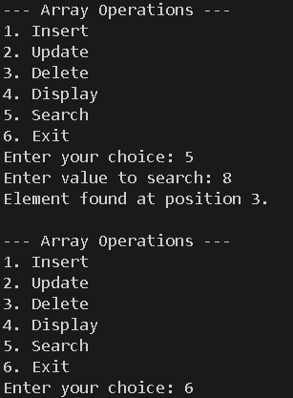

Experiment No. 17.
Aim: Write a program to calculate the sum of array elements by passing it to a function.
Concept Used: The concept used is passing arrays to functions to calculate the sum of elements.
Program: #include <stdio.h>
// Function to calculate the sum of array elements
int calculateSum(int arr[], int size) {
int sum = 0;
for (int i = 0; i < size; i++) {
sum += arr[i];
}
return sum;
}
int main() {
printf("Name: Rakesh\n");
printf("Roll No: 2510991344\n\n");
int arr[100];
int size, i, totalSum;
// Take the size of the array from the user
printf("Enter the number of elements: ");
scanf("%d", &size);
// Take array elements from the user
printf("Enter the elements: ");
for (i = 0; i < size; i++) {
scanf("%d", &arr[i]);
}
// Call the function and store the result
totalSum = calculateSum(arr, size);
// Display the final result
printf("The sum of the array elements is: %d\n", totalSum);
return 0;
}
Output Screenshot:
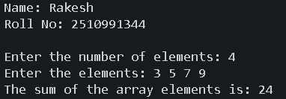

Experiment No. 18.
Aim: Write a program matrix multiplication using the concept of 2D array
Concept Used: The concept used is 2D arrays and nested loops for matrix multiplication.
Program: #include <stdio.h>
int main() {
printf("Name: Rakesh\n");
printf("Roll No: 2510991344\n\n");
int mat1[10][10], mat2[10][10], result[10][10];
int r1, c1, r2, c2, i, j, k;
// Take dimensions for the first matrix
printf("Enter rows and columns for first matrix: ");
scanf("%d %d", &r1, &c1);
// Take dimensions for the second matrix
printf("Enter rows and columns for second matrix: ");
scanf("%d %d", &r2, &c2);
// Check if matrix multiplication is possible
if (c1 != r2) {
printf("Error: Multiplication not possible. Columns of 1st matrix must equal rows of 2nd matrix.\n");
return 0;
}
// Input elements for the first matrix
printf("\nEnter elements of Matrix 1:\n");
for (i = 0; i < r1; i++) {
for (j = 0; j < c1; j++) {
scanf("%d", &mat1[i][j]);
}
}
// Input elements for the second matrix
printf("\nEnter elements of Matrix 2:\n");
for (i = 0; i < r2; i++) {
for (j = 0; j < c2; j++) {
scanf("%d", &mat2[i][j]);
}
}
// Initialize the result matrix to 0
for (i = 0; i < r1; i++) {
for (j = 0; j < c2; j++) {
result[i][j] = 0;
}
}
// Perform matrix multiplication
for (i = 0; i < r1; i++) {
for (j = 0; j < c2; j++) {
for (k = 0; k < c1; k++) {
result[i][j] += mat1[i][k] * mat2[k][j];
}
}
}
// Display the resultant matrix
printf("\n--- Resultant Matrix ---\n");
for (i = 0; i < r1; i++) {
for (j = 0; j < c2; j++) {
printf("%d\t", result[i][j]);
}
printf("\n");
}
return 0;
}
Output Screenshot:
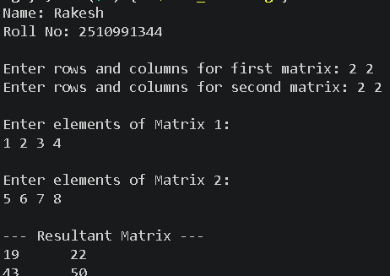

Experiment No. 19.
Aim: Write a program to transpose a given matrix.

Concept Used: The concept used is transposing a matrix using 2D arrays and nested loops.
Program: #include <stdio.h>
int main()
{
printf("Name: Rakesh\n");
printf("Roll No: 2510991344\n\n");
int rows, cols;
// Taking number of rows and columns from user
printf("Enter the number of rows and columns of the matrix: ");
scanf("%d %d", &rows, &cols);
// Declaring matrix
int arr[rows][cols];
// Input matrix elements
printf("Enter %d elements in the matrix:\n", rows * cols);
for(int i = 0; i < rows; i++)
{
for(int j = 0; j < cols; j++)
{
scanf("%d", &arr[i][j]);
}
}
// Displaying original matrix
printf("\nOriginal Matrix:\n");
for(int i = 0; i < rows; i++)
{
for(int j = 0; j < cols; j++)
{
printf("%d ", arr[i][j]);
}
printf("\n");
}
printf("\nTranspose Matrix:\n");
for(int i = 0; i < cols; i++)
{
for(int j = 0; j < rows; j++)
{
printf("%d ", arr[j][i]);
}
}
return 0;
}
Output Screenshot:
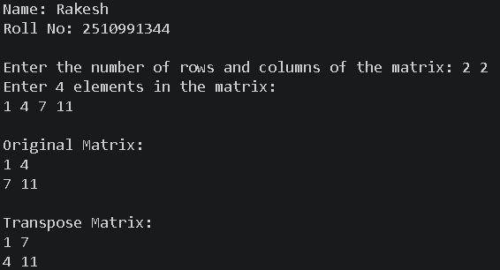
Experiment No. 20.
Aim: Write a menu driven C program to show the use of in-built string functions like strlen, strcat, strcpy, strcmp, strrev etc.
Concept Used: The concept used is string handling in C using built-in functions like strlen, strcat, strcpy, strcmp, and strrev.
Program:
#include <stdio.h>
#include <string.h>
int main(){
char str1[100], str2[100];
int choice;
// Taking input strings
printf("Enter first string: ");
gets(str1);
printf("Enter second string: ");
gets(str2);
// Menu Driven Program
printf("\n----- STRING FUNCTIONS MENU -----\n");
printf("1. Find Length of String\n");
printf("2. Concatenate Strings\n");
printf("3. Copy String\n");
printf("4. Compare Strings\n");
printf("5. Reverse String\n");
printf("\nEnter your choice: ");
scanf("%d", &choice);
switch(choice)
{
case 1:
// strlen() returns length of string
printf("\nLength of first string = %lu", strlen(str1));
printf("\nLength of second string = %lu", strlen(str2));
break;
case 2:
// strcat() joins two strings
strcat(str1, str2);
printf("\nConcatenated String = %s", str1);
break;
case 3:
// strcpy() copies one string into another
strcpy(str2, str1);
printf("\nAfter Copy, Second String = %s", str2);
break;
case 4:
// strcmp() compares two strings
if(strcmp(str1, str2) == 0)
printf("\nBoth strings are equal.");
else
printf("\nStrings are not equal.");
break;
case 5:
// strrev() reverses the string
printf("\nReverse of first string = %s", strrev(str1));
break;
default:
printf("\nInvalid Choice!");
}
return 0;
}
Output Screenshot:
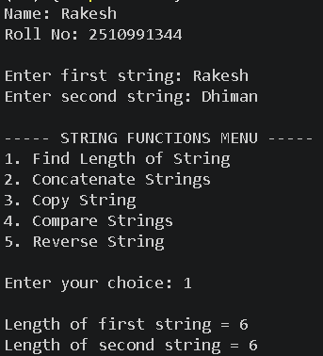

Experiment No. 21.
Aim: Write a program to check that the given number is prime, Armstrong or perfect using the concept of functions.
Concept Used: The concept used is user-defined functions to check prime, Armstrong, and perfect numbers.
Program: #include <stdio.h>
// Function to check Prime Number
void prime(int num)
{
int i, flag = 0;
if(num <= 1)
{
printf("%d is not a Prime number.\n", num);
return;
}
for(i = 2; i <= num / 2; i++)
{
if(num % i == 0)
{
flag = 1;
break;
}
}
if(flag == 0)
printf("%d is a Prime number.\n", num);
else
printf("%d is not a Prime number.\n", num);
}
// Function to check Armstrong Number
void armstrong(int num)
{
int temp, remainder, sum = 0;
temp = num;
while(temp != 0)
{
remainder = temp % 10;
sum = sum + (remainder * remainder * remainder);
temp = temp / 10;
}
if(sum == num)
printf("%d is an Armstrong number.\n", num);
else
printf("%d is not an Armstrong number.\n", num);
}
void perfect(int num)
{
int i, sum = 0;
for(i = 1; i < num; i++)
{
if(num % i == 0)
{
sum = sum + i;
}
}
if(sum == num)
printf("%d is a Perfect number.\n", num);
else
printf("%d is not a Perfect number.\n", num);
}
int main()
{
printf("Name: Rakesh\n");
printf("Roll No: 2510991344\n\n");
int num;
printf("Enter a number: ");
scanf("%d", &num);
prime(num);
armstrong(num);
perfect(num);
return 0;
}
Output Screenshot:
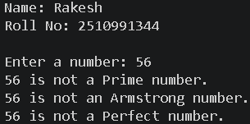
Experiment No. 22.
Aim: Write a program to calculate the area and circumference of a circle using functions.
Concept Used: This program is based on the concept of user-defined functions in C. A function is a block of code that performs a specific task and can be reused whenever needed.
Program: #include <stdio.h>
// Function to calculate area of circle
float area(float r)
{
return 3.14 * r * r;
}
// Function to calculate circumference of circle
float circumference(float r)
{
return 2 * 3.14 * r;
}
int main()
{
printf("Name: Rakesh\n");
printf("Roll No: 2510991344\n\n");
float radius, a, c;
// Taking radius as input
printf("Enter the radius of the circle: ");
scanf("%f", &radius);
// Function calls
a = area(radius);
c = circumference(radius);
// Displaying results
printf("\nArea of the circle = %.2f", a);
printf("\nCircumference of the circle = %.2f", c);
return 0;
}
Output Screenshot:
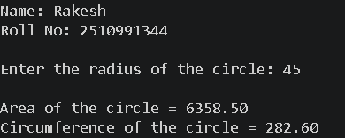

Experiment No. 23.
Aim: Write a program to swap two variables using the concept of call by value and call by reference.
Concept Used: This program is based on the concept of call by value and call by reference using functions in C. In call by value, a copy of variables is passed to the function, so original values do not change. In call by reference, the addresses of variables are passed using pointers, so the original values get changed after swapping. The program also uses functions, pointers, and swapping logic.
Program: #include <stdio.h>
// Function for Call by Value
void swapValue(int x, int y)
{
int temp;
temp = x;
x = y;
y = temp;
printf("\nAfter swapping in Call by Value:");
printf("\nx = %d y = %d\n", x, y);
}
// Function for Call by Reference
void swapReference(int *x, int *y)
{
int temp;
temp = *x;
*x = *y;
*y = temp;
printf("\nAfter swapping in Call by Reference:");
printf("\nx = %d y = %d\n", *x, *y);
}
int main()
{
printf("Name: Rakesh\n");
printf("Roll No: 2510991344\n\n");
int a, b;
// Input from user
printf("Enter two numbers: ");
scanf("%d %d", &a, &b);
// Original values
printf("\nBefore swapping:");
printf("\na = %d b = %d\n", a, b);
// Call by Value
swapValue(a, b);
// Values remain unchanged in main()
printf("\nValues in main after Call by Value:");
printf("\na = %d b = %d\n", a, b);

// Call by Reference
swapReference(&a, &b);
// Values changed in main()
printf("\nValues in main after Call by Reference:");
printf("\na = %d b = %d\n", a, b);
return 0;
}
Output Screenshot:
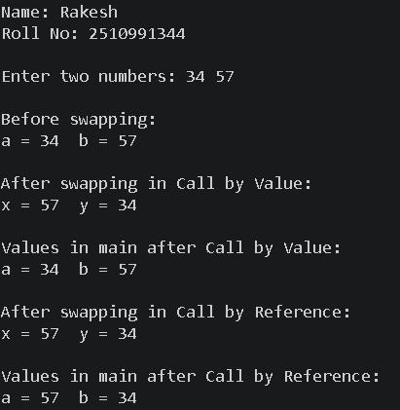

Experiment No. 24.
Aim: Write a program to show the use of passing pointer as arguments to the functions.
Concept Used: The concept used is passing pointers as function arguments to directly access and modify variable values.
Program: #include <stdio.h>
// Function that receives pointers as arguments
void display(int *a, int *b)
{
printf("\nValue of first number = %d", *a);
printf("\nValue of second number = %d", *b);
// Modifying values using pointers
*a = *a + 10;
*b = *b + 20;
}
int main()
{
printf("Name: Rakesh\n");
printf("Roll No: 2510991344\n\n");
int x, y;
// Input from user
printf("Enter two numbers: ");
scanf("%d %d", &x, &y);
// Function call by passing addresses
display(&x, &y);
// Displaying modified values
printf("\n\nAfter modification:");
printf("\nx = %d", x);
printf("\ny = %d", y);
return 0;
}
Output Screenshot:
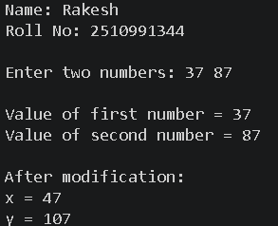

Experiment No. 25.
Aim: Write a program to find the factorial of a number by using the concept of recursion.
Concept Used: This program is based on the concept of recursion in C. In recursion, a function calls itself repeatedly until a stopping condition is reached. Here, the factorial() function calls itself to calculate the factorial of a number. It also uses functions, conditional statements, and multiplication operations.
Program: #include <stdio.h>
// Recursive function to find factorial
int factorial(int n)
{
if(n == 0 || n == 1)
return 1;
else
return n * factorial(n - 1);
}
int main()
{
printf("Name: Rakesh\n");
printf("Roll No: 2510991344\n\n");
int num;
int fact;
// Input from user
printf("Enter a number: ");
scanf("%d", &num);
// Function call
fact = factorial(num);
// Display result
printf("Factorial of %d = %d", num, fact);
return 0;
}
Output Screenshot:
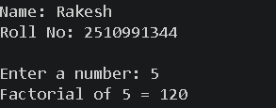

Experiment No. 26.
Aim: Write a Program in C to display the total number of appearances of a substring provided as input by the user in a given string.
Concept Used: The concept used is string handling and substring searching to count appearances of a substring.
Program: #include <stdio.h>
#include <string.h>
int main()
{
printf("Name: Rakesh\n");
printf("Roll No: 2510991344\n\n");
char str[100], sub[100];
int i, j, count = 0;
// Input main string
printf("Enter the main string: ");
gets(str);
// Input substring
printf("Enter the substring: ");
gets(sub);
int strLen = strlen(str);
int subLen = strlen(sub);
// Checking substring occurrences
for(i = 0; i <= strLen - subLen; i++)
{
for(j = 0; j < subLen; j++)
{
if(str[i + j] != sub[j])
break;
}
// If complete substring matches
if(j == subLen)
{
count++;
}
}
// Display result
printf("\nTotal occurrences of substring = %d", count);
return 0;
}
Output Screenshot:
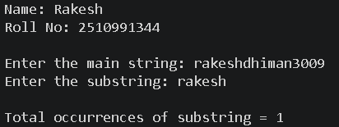

Experiment No. 27.
Aim: Write a program to display the sum of the digits of a number by using the concept of recursion.
Concept Used: The concept used is recursion to calculate the sum of digits of a number.
Program: #include <stdio.h>
// Recursive function to find sum of digits
int sumDigits(int n)
{
if(n == 0)
return 0;
else
return (n % 10) + sumDigits(n / 10);
}
int main()
{
printf("Name: Rakesh\n");
printf("Roll No: 2510991344\n\n");
int num, sum;
// Input from user
printf("Enter a number: ");
scanf("%d", &num);
// Function call
sum = sumDigits(num);
// Display result
printf("Sum of digits = %d", sum);
return 0;
}
Output Screenshot:
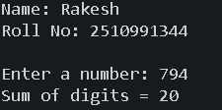

Experiment No. 28.
Aim: Write a C program to add two distances in inch & feet using the concept of structures.
Concept Used: The concept used is structures in C to add distances in feet and inches.
Program: #include <stdio.h>
// Structure declaration
struct Distance
{
int feet;
int inch;
};
int main()
{
printf("Name: Rakesh\n");
printf("Roll No: 2510991344\n\n");
struct Distance d1, d2, sum;
// Input first distance
printf("Enter first distance (feet and inch): ");
scanf("%d %d", &d1.feet, &d1.inch);
// Input second distance
printf("Enter second distance (feet and inch): ");
scanf("%d %d", &d2.feet, &d2.inch);
// Adding inches and feet
sum.inch = d1.inch + d2.inch;
sum.feet = d1.feet + d2.feet;
// Converting inches into feet if inches >= 12
if(sum.inch >= 12)
{
sum.feet = sum.feet + (sum.inch / 12);
sum.inch = sum.inch % 12;
}
// Display result
printf("\nSum of distances = %d feet %d inch",
sum.feet, sum.inch);
return 0;
}
Output Screenshot:
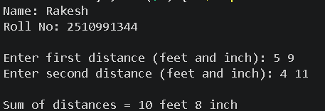

Experiment No. 29.
Aim: Write a C program to add two complex numbers using the concept of structures in C.
Concept Used: The concept used is structures in C to add complex numbers (real and imaginary parts).
Program: #include <stdio.h>
// Structure declaration for complex number
struct Complex
{
float real;
float imaginary;
};
int main()
{
printf("Name: Rakesh\n");
printf("Roll No: 2510991344\n\n");
struct Complex c1, c2, sum;
// Input first complex number
printf("Enter real and imaginary part of first complex number: ");
scanf("%f %f", &c1.real, &c1.imaginary);
// Input second complex number
printf("Enter real and imaginary part of second complex number: ");
scanf("%f %f", &c2.real, &c2.imaginary);
// Adding complex numbers
sum.real = c1.real + c2.real;
sum.imaginary = c1.imaginary + c2.imaginary;
// Display result
printf("\nSum = %.2f + %.2fi",
sum.real, sum.imaginary);
return 0;
}
Output Screenshot:
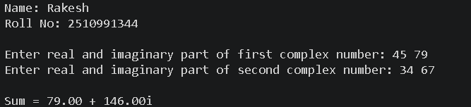

Experiment No. 30.
Aim: Write a program in C to store the information of five employees using both concepts i.e. array of structure and array within structure.
Concept Used: The concept used is arrays of structures and nested structures to store employee information.
Program: #include <stdio.h>
// Structure declaration
struct Employee
{
int id;
char name[50]; // Array within structure
float salary;
};
int main()
{
printf("Name: Rakesh\n");
printf("Roll No: 2510991344\n\n");
// Array of structures
struct Employee emp[5];
// Input employee details
for(int i = 0; i < 5; i++)
{
printf("\nEnter details of Employee %d\n", i + 1);
printf("Enter ID: ");
scanf("%d", &emp[i].id);
printf("Enter Name: ");
scanf("%s", emp[i].name);
printf("Enter Salary: ");
scanf("%f", &emp[i].salary);
}
// Display employee details
printf("\n----- Employee Details -----\n");
for(int i = 0; i < 5; i++)
{
printf("\nEmployee %d\n", i + 1);
printf("ID = %d\n", emp[i].id);
printf("Name = %s\n", emp[i].name);
printf("Salary = %.2f\n", emp[i].salary);
}
return 0;
}
Output Screenshot:
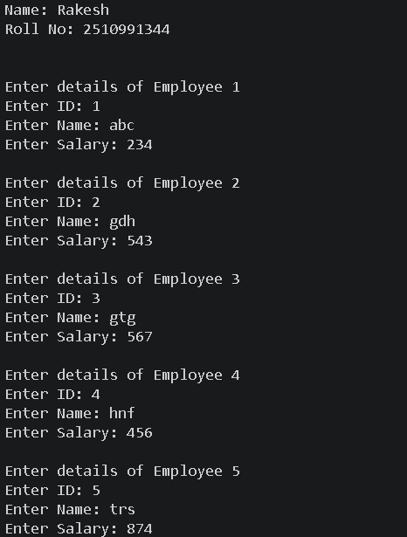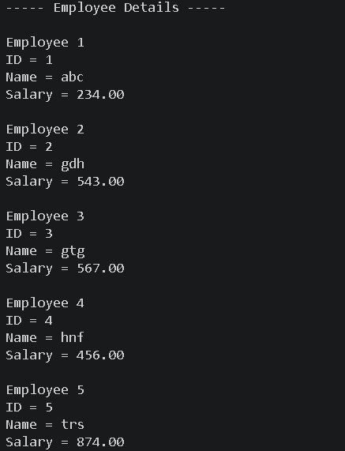

Experiment No. 31.
Aim: Write a Program in C to find and replace a specific string in a file and also display the total number of appearances of that string.

Concept Used: The concept used is file handling in C to find and replace strings in a file and count their occurrences.
Program: #include <stdio.h>
#include <string.h>
#include <stdlib.h>
int main()
{
printf("Name: Rakesh\n");
printf("Roll No: 2510991344\n\n");
FILE *fp1, *fp2;
char fileName[100];
char search[50], replace[50];
char line[200];
int count = 0;
printf("Enter file name: ");
scanf("%s", fileName);
printf("Enter string to search: ");
scanf("%s", search);
printf("Enter string to replace: ");
scanf("%s", replace);
fp1 = fopen(fileName, "r");
if(fp1 == NULL)
{
printf("Error opening file!\n");
return 1;
}
fp2 = fopen("temp.txt", "w");
// Read file line by line
while(fgets(line, sizeof(line), fp1) != NULL)
{
char *pos;
// Search and replace in each line
while((pos = strstr(line, search)) != NULL)
{
count++;
// Print part before found string
*pos = '\0';
fprintf(fp2, "%s", line);
// Print replacement string
fprintf(fp2, "%s", replace);
// Move pointer forward
strcpy(line, pos + strlen(search));
}
fprintf(fp2, "%s", line);
}
fclose(fp1);
fclose(fp2);
// Replace original file with updated file
remove(fileName);
rename("temp.txt", fileName);
printf("\nTotal occurrences of '%s' = %d\n", search, count);
printf("File updated successfully!\n");
return 0;
}
Output Screenshot:
