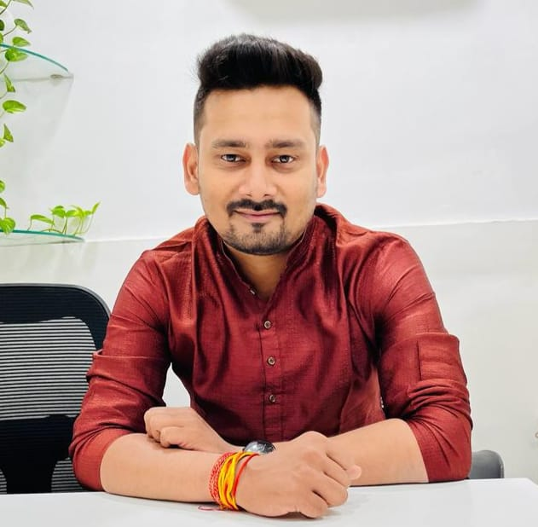

**OVERVIEW**

Wealth Manager: ICICI Bank

Raipur, India

Salary: Don’t want to specify.

**ABOUT ME**

I am kind, helpful and open-minded by nature. I enjoy social interaction with our close-knit family.

Thank you for your time if you wish to take thing ahead, please feel free to connect with me.

**CONTACT ME**

🏠 **Address**

South Park, Bistupur, Jamshedpur.

🖀**Phone**

**+91 9430720662 (Father)**

🌍 **Web**

contact@email.com

www.ownsite.com

**Family Details**

Father’s Name : Raj Kumar Singh

Father’s Occupation : Employee

Paternal origin : Bhagalpur, Bihar

Mother’s Name : M.B. Singh

Mother’s Occupation : Home Maker

Maternal Origin : Bhojpur, Bihar

Family Type : Joint

Family Status : Middle Class

Siblings : No Sibling

Gotra : Kashyap

**HOBBIES**

📽 Movie 🏍 Travel

📷 Photography 📾 Music

**EDUCATION**

**PUNE University (PUMBA)**

2016-2018

**Master in Business Administration**

Marketing and Finance

**JAIN University**

2014-2016

**Bachelors of Commerce**

Account (Hons)

**ABHISHEK KUMAR**

**Height: 5’10’’**

**D.O.B: 03.10.1994**