**Codes**

CREATE TABLE airport(

airport_ID INT NOT NULL UNIQUE,

airport_Name VARCHAR(50) PRIMARY KEY,

country VARCHAR(50),

type VARCHAR(50)

);

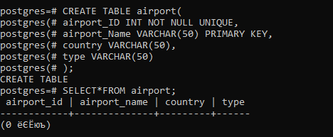

***Figure 1.* Creating table “airport”.**

CREATE TABLE aircraft(

airport_ID INT NOT NULL,

aircraft_id INT NOT NULL UNIQUE,

model VARCHAR(50),

FOREIGN KEY (airport_ID) REFERENCES airport(airport_ID)

);

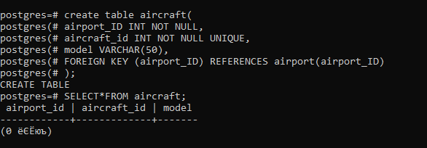

***Figure 2.* Creating table “aircraft”.**

CREATE TABLE flight(

flight_status_code INT NOT NULL UNIQUE,

flight_status VARCHAR(50) NOT NULL,

airport_ID INT,

FOREIGN KEY (airport_ID) REFERENCES airport(airport_ID)

);

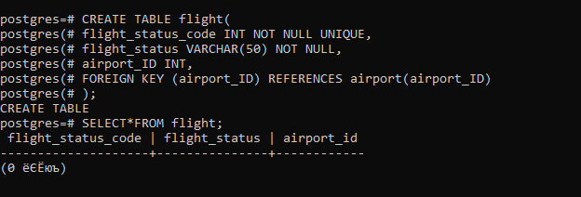

***Figure 3.* Creating table “Flight”**

CREATE TABLE Job(

job_id INT NOT NULL ,

job_name VARCHAR(50) NOT NULL UNIQUE,

job_address VARCHAR(50)

);

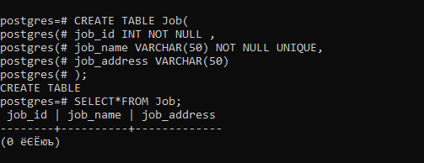

***Figure 4*. Creating table “Job”**

CREATE TABLE employee(

employee_ID INT NOT NULL,

employee_Name VARCHAR(50) NOT NULL,

airport_Name VARCHAR(50) NOT NULL,

job_Name VARCHAR(50) NOT NULL,

salary INT NOT NULL,

employee_address VARCHAR(50) NOT NULL,

hire DATE,

UNIQUE (employee_id,employee_address),

FOREIGN KEY (airport_Name) REFERENCES airport(airport_Name),

FOREIGN KEY (job_Name) REFERENCES Job(job_Name)

);

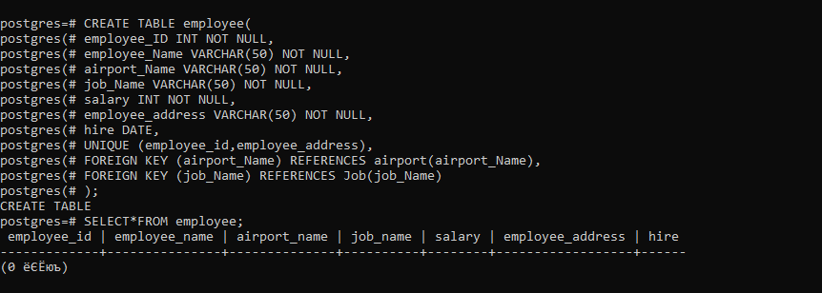

***Figure 5.* Creating table “employee”**

CREATE TABLE passengers(

airport_id INT NOT NULL,

passenger_id INT NOT NULL UNIQUE,

passenger_name VARCHAR (50) NOT NULL,

passenger_surname VARCHAR(50) NOT NULL,

FOREIGN KEY (airport_ID) REFERENCES airport(airport_ID)

);

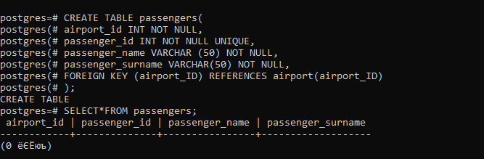

***Figure 6*. Creating table “passengers”**

CREATE TABLE tickets (

order_number INT NOT NULL,

passenger_id INT NOT NULL,

passenger_name VARCHAR(50),

passenger_surName VARCHAR(50),

total_price INT ,

seat INT NOT NULL,

from_city VARCHAR(50),

to_destination VARCHAR(50),

FOREIGN KEY (passenger_id) REFERENCES passengers(passenger_id)

);

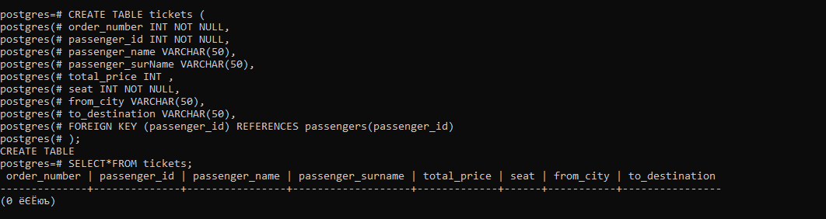

***Figure 7*. Creating table “Tickets”.**

**ALTER STATEMENTS**

ALTER TABLE employee RENAME COLUMN hire TO hire_date;

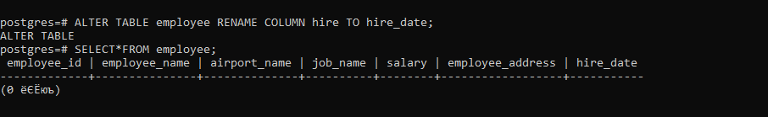

***Figure 8*. ALTER statements**

ALTER TABLE tickets RENAME TO TICKET;

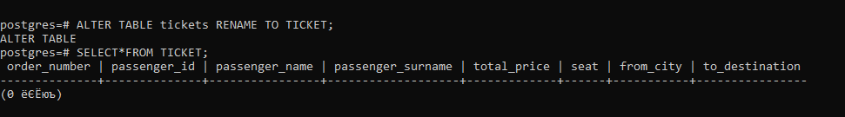

***Figure 9.* ALTER statements**

ALTER TABLE Job DROP COLUMN job_address;

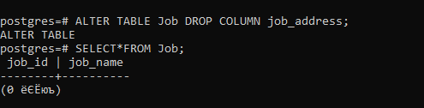

***Figure 10.* ALTER statements**

ALTER TABLE passengers ADD COLUMN age INT;



***Figure 11.* ALTER statements**

ALTER TABLE aircraft alter model SET NOT NULL;

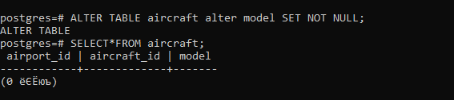

***Figure 12*. ALTER statements**

**INSERT**

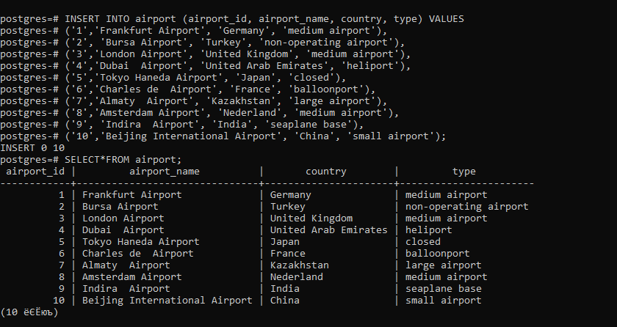

***Figure 13*. Inserting data to table “Airport”.**

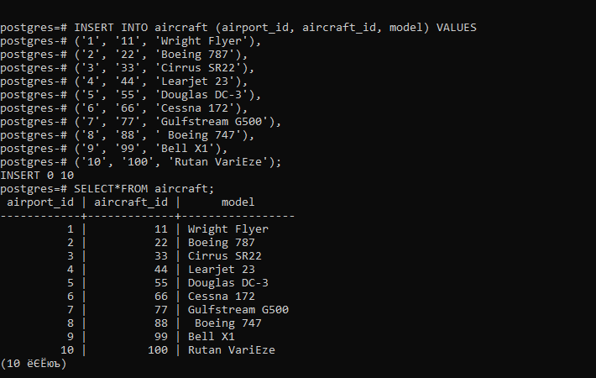

***Figure 14*. Inserting data to table “Aircraft”.**

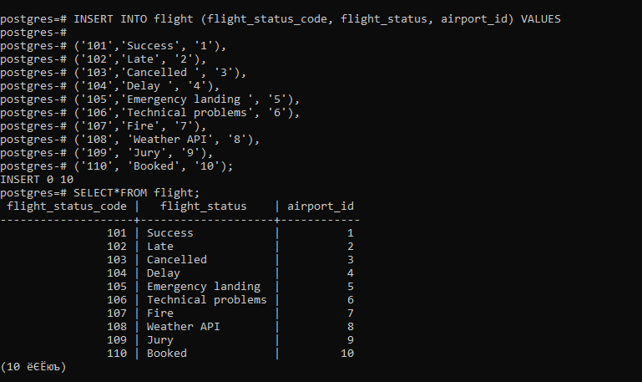

***Figure 15*. Inserting data to table “Flight.”**

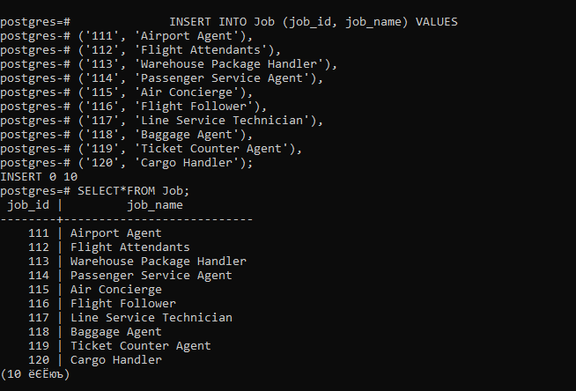

***Figure 16*. Inserting data to table “Job”.**

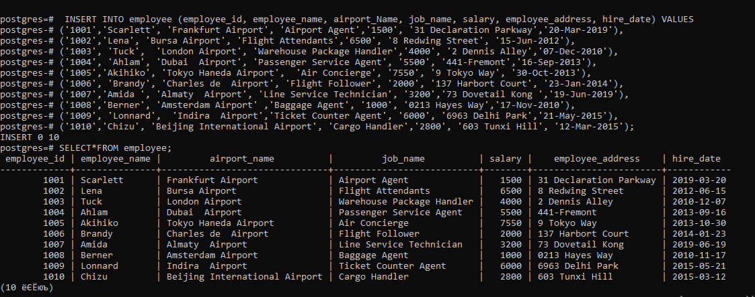

***Figure 17*. Inserting data to table “employee”.**

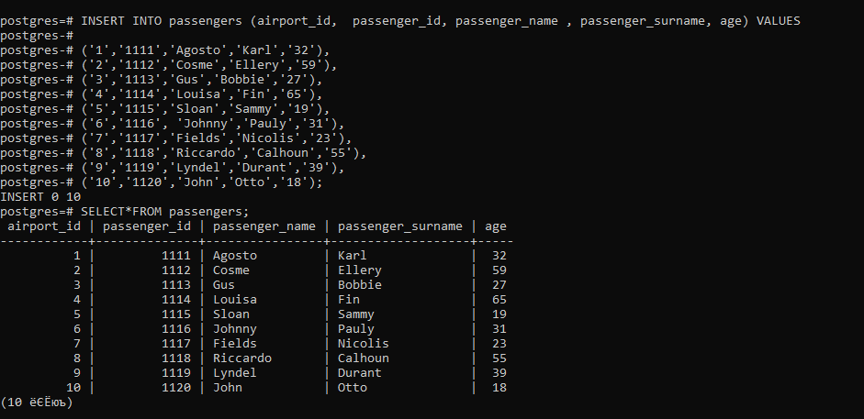

***Figure 18*. Inserting data to table “passengers”.**

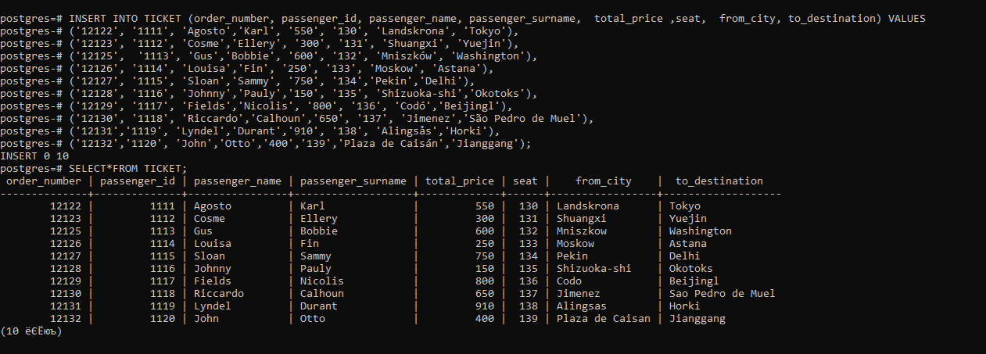

***Figure 19*. Inserting data to table “TICKET”.**

**UPDATE**

 UPDATE airport  
 SET country='Yordania'  
WHERE airport_name='Indira Airport';

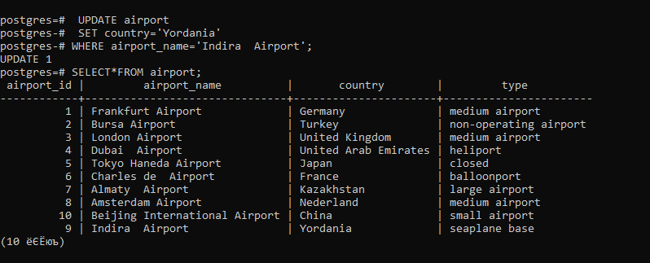

***Figure 20*. Update data of table “airport”.**

UPDATE aircraft

SET model='Boeing 787';

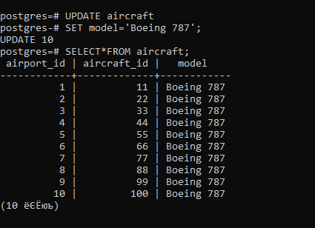

***Figure 21*. Update data of table “aircraft”.**

UPDATE flight

SET flight_status= 'Cancelled'

WHERE flight_status_code = 110;

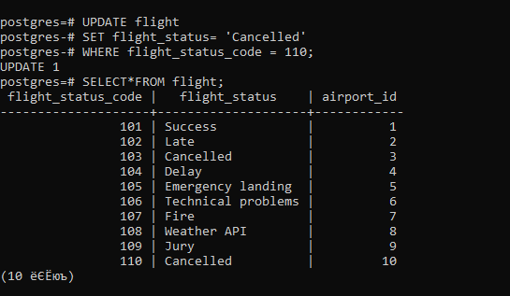

***Figure 22*. Update data of table “flight”.**

UPDATE employee  
SET salary = 7000.00;

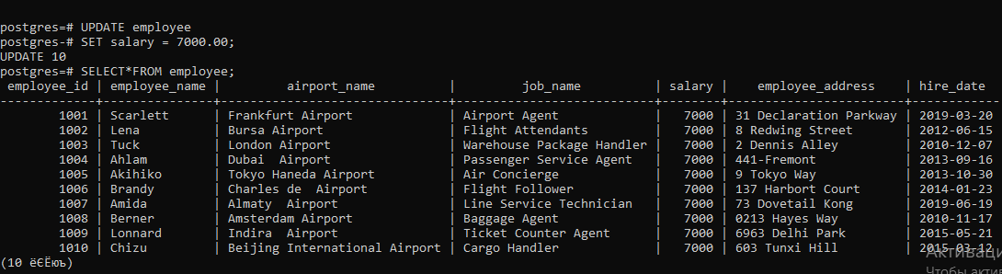

***Figure 23*. Update data of table “employee”.**

UPDATE passengers  
SET passenger_name = 'Alina', passenger_surname='Stephen'  
WHERE passenger_id= 1115;

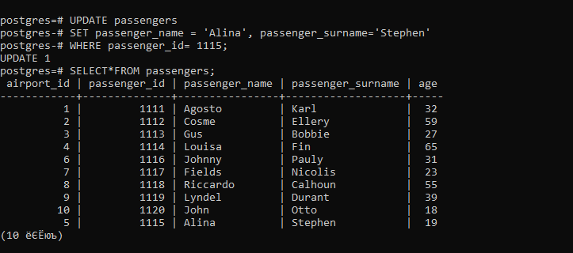

***Figure 24*. Update data of table “passengers”.**

UPDATE TICKET

SET from_city='Luxembourg', to_destination='Geneva';

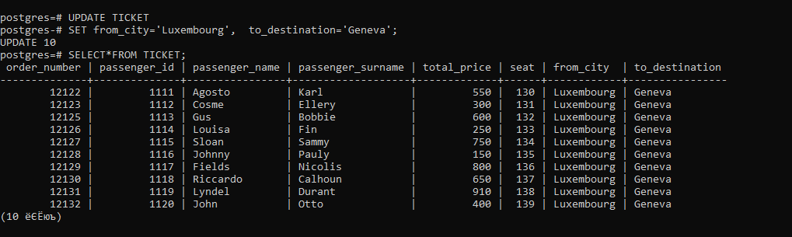

***Figure 25*. Update data of table “TICKET”.**

**DELETE**

DELETE FROM TICKET

WHERE order_number<=12123;

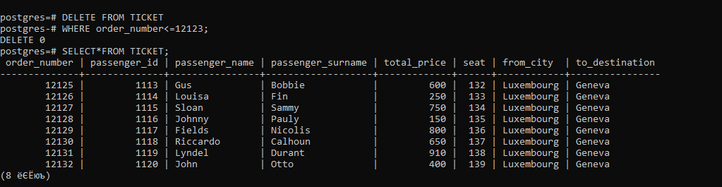

***Figure 26.* Delete data from table “TICKET”.**

DELETE FROM passengers

WHERE age=59;

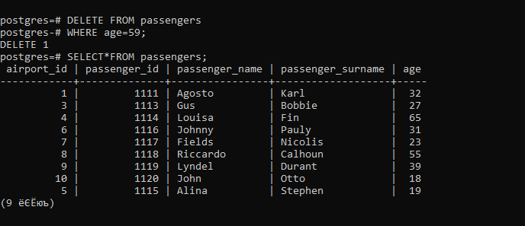

***Figure 27.* Delete data from table “passengers”.**

DELETE FROM employee

WHERE employee_id = 1009;

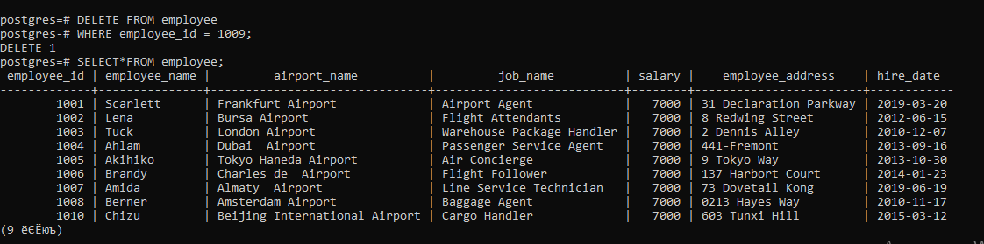

***Figure 28.* Delete data from table “employee”.**

DELETE FROM Job

WHERE job_name='Ticket Counter Agent';

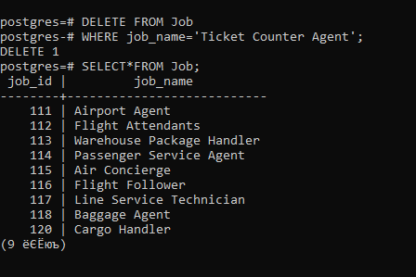

***Figure 29.* Delete data from table “Job”.**

DELETE FROM flight

WHERE flght_status_code<102;

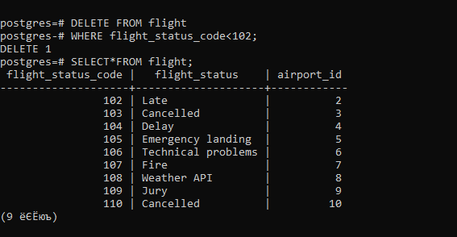

***Figure 30.* Delete data from table “flight”.**

DELETE FROM aircraft

WHERE aircraft_id=66;

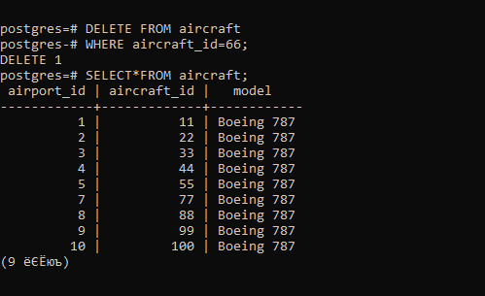

***Figure 31.* Delete data from table “aircraft”.**

**QUERIES**

SELECT*FROM airport  
WHERE airport_id BETWEEN 2 AND 10;

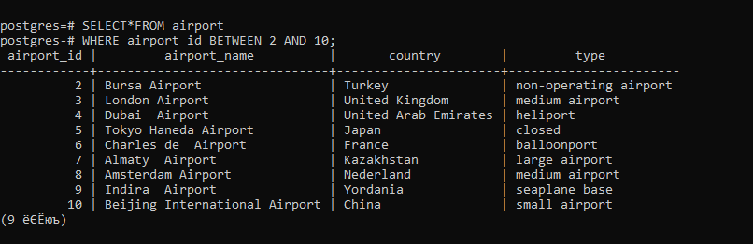

*Figure 32.* Query shows airport_id between 2 and 10

SELECT employee_id, employee_name, airport_name, job_name, salary, employee_address, hire_date FROM employee ORDER BY employee_name ASC;

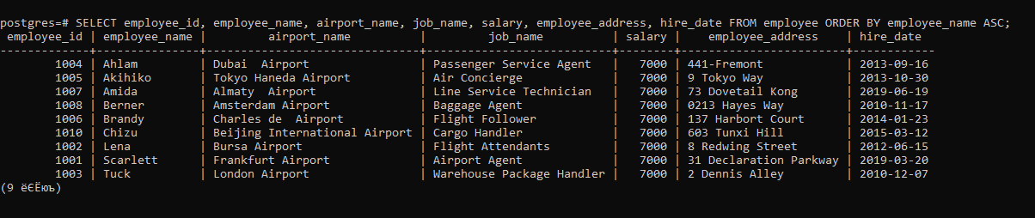

*Figure 33.* Query shows ASC each employee_name

SELECT SUM (age) FROM passengers;

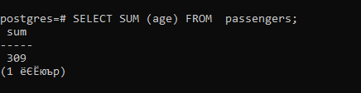

*Figure 34.* Query shows SUM(age) passengers

SELECT MAX(total_price)  
FROM TICKET;

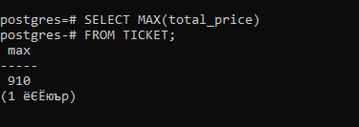

*Figure 35.* Query shows MAX salary in each TICKET

SELECT MIN (salary)

FROM employee;

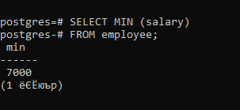

*Figure 36.* Query shows min salary in each employee

SELECT order_number, passenger_name, passenger_surname, seat

FROM TICKET

WHERE passenger_name LIKE 'Jo%'

ORDER BY passenger_surname ASC;

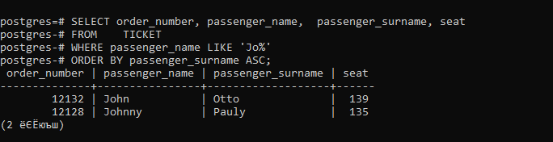

*Figure 37.* Query shows LIKE “JO%”

SELECT airport.airport_id, airport.airport_name, employee.employee_id, employee.employee_name  
FROM airport  
INNER JOIN employee ON airport.airport_name = employee.airport_name;

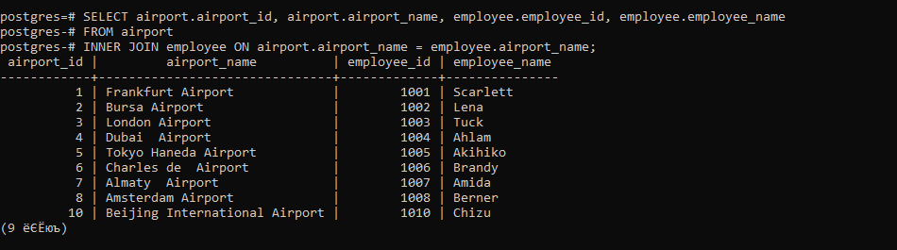

*Figure 38.* Query which shows information about airport of each employee.

SELECT passengers.passenger_id,passengers.passenger_name, passengers.passenger_surname, airport.airport_id, TICKET.order_number, TICKET.total_price,TICKET.seat  
FROM passengers  
LEFT JOIN airport ON passengers.airport_id =airport.airport_id  
LEFT JOIN TICKET ON TICKET.passenger_id=passengers.passenger_id;

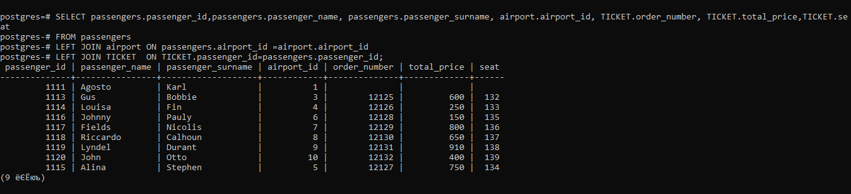

***Figure 39.* Query of showing passenger_name and passenger_id of each Ticket**

SELECT Job.job_id, Job.job_name, employee.employee_name, employee.salary, employee.hire_date  
FROM Job  
FULL OUTER JOIN employee ON Job.job_name=employee.job_name  
ORDER BY Job.job_name;

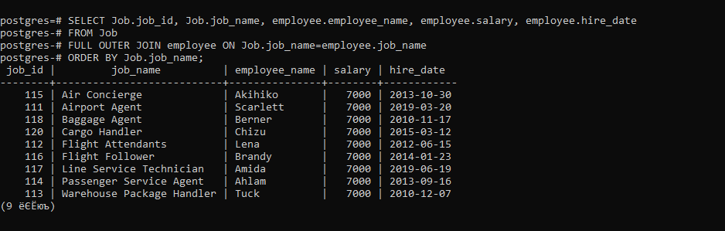

*Figure 40.* Query which shows information about Job of each employee.

**5 SUBQUERIES.**

SELECT job_id, job_name

FROM Job

WHERE job_id=

(SELECT job_id

FROM Job

WHERE job_name='Cargo Handler');

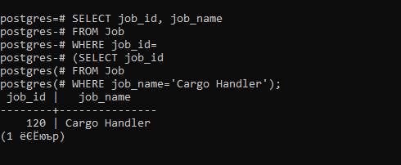

*Figure 41. 1st Result from Database Using SQL*

SELECT employee_id, employee_name, job_name, salary, hire_date

FROM employee

WHERE employee_id=

(SELECT employee_id

FROM employee

WHERE hire_date='17-Nov-2010');

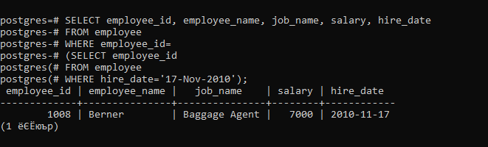

*Figure 42. 2nd Result from Database Using SQL*

SELECT order_number, total_price, seat, from_city, passenger_id

FROM TICKET

WHERE passenger_id IN(

SELECT passenger_id FROM passengers

WHERE age>25);

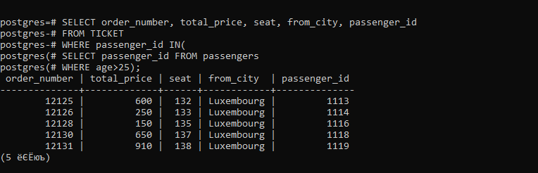

*Figure 43. 3RD Result from Database Using SQL*

SELECT * FROM flight

WHERE flight_status_code IN (SELECT flight_status_code

FROM flight

WHERE airport_id > 3);

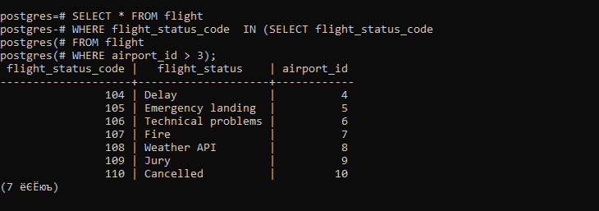

*Figure 44. 4th Result from Database Using SQL*

SELECT airport_id, passenger_id, passenger_name

FROM passengers

WHERE passenger_id IN (SELECT passenger_id FROM TICKET WHERE passenger_id<1116);

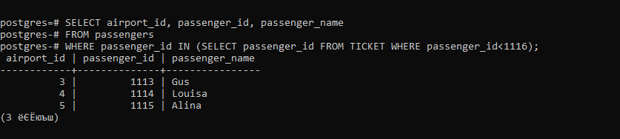

*Figure 45. 5th Result from Database Using SQL*