WORKLOG.

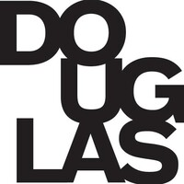

BY
ISRAEL OGUNSEYE -300368938
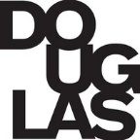
Table of Contents
1 WorkLog 2
2 Tools and App Overview 2

Introduction

Work Date / Hours Log
F25_4440_G12
Date | Student Name | Number of Hours | Description of Work
Oct. 28th | Israel Ogunseye | 3.5 hours | Researched novel tools for mobile app security analysis; Started installing MobSF on local machine; Installed APKTool and configured environment
Oct. 29th | Israel Ogunseye | 3 hours | Tested MobSF installation with sample APK; Learned MobSF dashboard and basic static analysis
Oct. 30th | Israel Ogunseye | 2 hours | Prepared project proposal template for submission; Documented tools and methodology in template
Nov. 2nd | Israel Ogunseye | 3 hours | Decompiled APK files using APKTool; Analyzed APK manifest and resources; Continued MobSF static analysis and noted vulnerabilities
Nov. 3rd | Israel Ogunseye | 1 hour | Reviewed MobSF scan results and recorded findings
Nov. 4th | Israel Ogunseye | 3 hours | Conducted deeper APK inspection with MobSF and additional tools; Updated proposal template with current progress and screenshots
Nov. 5th | Israel Ogunseye | 2 hours | Tested multiple APKs and documented results in report
Nov. 6th | Israel Ogunseye | 3 hours | Continued APK analysis and cross-referenced security issues; Organized and saved all work on GitHub repository
Nov. 7th | Israel Ogunseye | 3 hours | Prepared weekly progress report and added MobSF screenshots; Reviewed proposal template for submission formatting
Nov. 8th | Israel Ogunseye | 5 hours | Finalized MobSF and APKTool analysis; documented findings; Updated proposal template with final summary and timeline; Submitted weekly report and project proposal template

