**IOH SPECIFIC MOP**

«titlemop»



|  |  |  |  |
| --- | --- | --- | --- |
| Prepared by: | Medya P | Date: | **«predate»** |
| Reviewed by: | Shoim Ki Cahyo | Date: | **«predate»** |
| Approved by: | Shoim Ki Cahyo | Date: | **«predate»** |

This document is exclusively property of HUAWEI Technologies. Co., Ltd. and shall not be used copied or communicated to the third party without its prior authorization.

Contents

1 Description of Change

1.1 Description of Site

1.2 Purpose

1.3 Description of Change and Change Influence

2 Preparations for Change

2.1 Change Period

2.2 Composition of Change Team and Responsibility of Team Members

2.2.1 Change Team of Customer

2.2.2 Huawei On-site Change Team

2.2.3 Huawei Support & Guarantee Team

2.3 Check of Equipment Running

2.4 Change Risks and Countermeasures

2.5 Check Before Change

3 Operation Steps for Change

3.1 Change Steps

3.1.1 Overall Description

3.1.2 Operation Steps for Change

3.2 Test and Verification

3.3 Solution for Change back In the Case of Failure

3.3.1 Definition of Change Failure

3.3.2 Overall Description of Changeback

3.3.3 Information Collection Before Changeback

3.3.4 Changeback Steps

3.3.5 Equipment Status Check

3.3.6 Tests After Changeback

3.3.7 Changeback Risk Analysis

3.4 Change of Spare Parts and Emergency Workstation

4 Work After Change

4.1 Observation

4.2 Provision of Materials

4.3 Provision of Software

4.4 Training

4.5 Matters Needing Attention

# Description of Change

|  |  |  |  |
| --- | --- | --- | --- |
| **DUID** | **Qty** | **Dependency List** | **Data Source** |
| «duid» | «qty» | «list» | «source» |

Purpose and Requirements

In order to accommodate customer request of WL Expansion New PO 2016 NEFPA 312-This document describes how to Upgrade LTE2100n

Scenario of reconfiguration.

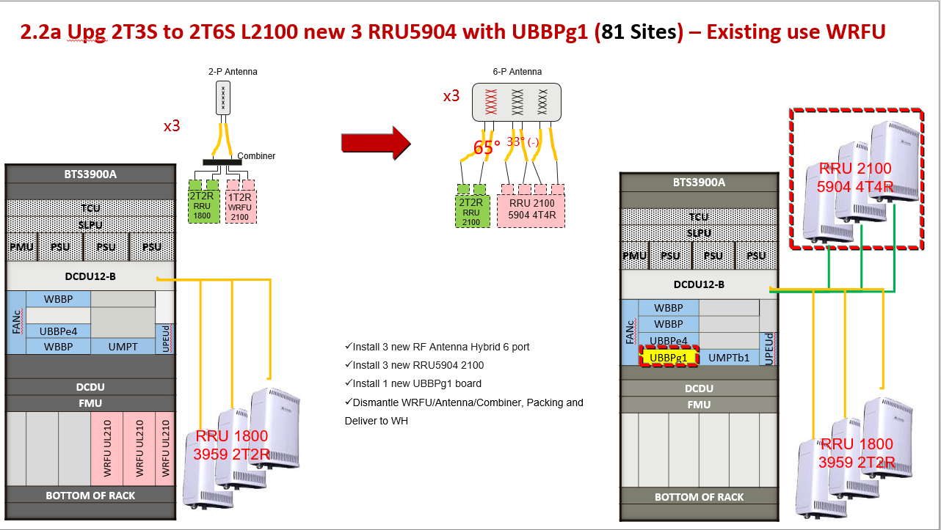

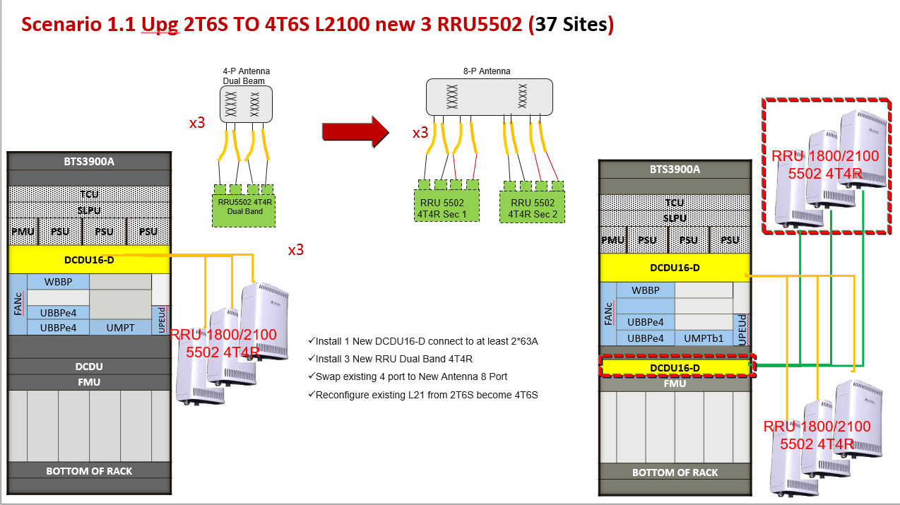

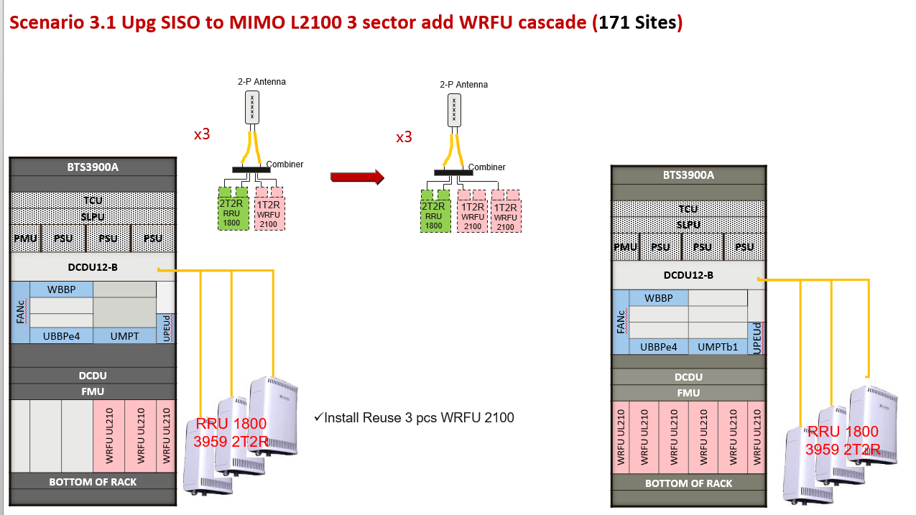

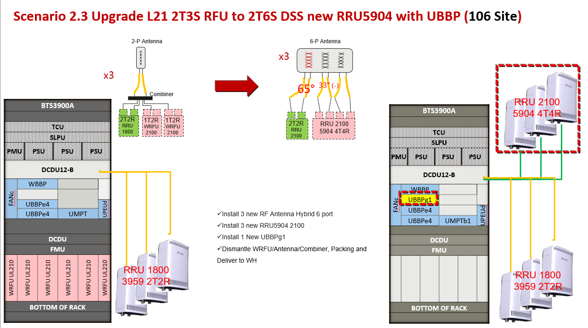

## Description of Change and Change Influence

There are 1 NE to be involved and informed in below document:

|  |  |  |  |
| --- | --- | --- | --- |
| IRO H3I SRAN9.0 | | | |
| Product Type | | Current Version | Target Version |
| BTS3900 | MBTS | BTS3900 V100R015C10SPC210 | BTS3900 V100R015C10SPC210 |
| Relative NE | | Relative Impact | |
| NodeB, eNodeB, BTS | | Before Execution, site must be monitored and in-service state. | |

# Preparations for Change

## Change Period

The change period is from **«date»** – **«date»**, **«time»**

## Composition of Change Team and Responsibility of Team Members

### Change Team of Customer

|  |  |  |
| --- | --- | --- |
| **Name** | **Responsibility** | **Telephone No.** |
| Amir Fattah | Chief Commander | 08990033305 |

### Huawei On-site Change Team

|  |  |  |
| --- | --- | --- |
| **Name** | **Responsibility** | **Telephone No.** |
| Medya | Wireless Engineer | 089603001586 |

### Huawei Support & Guarantee Team

|  |  |  |
| --- | --- | --- |
| **Name** | **Responsibility** | **Telephone No.** |
| Shoim | Supporting overall coordination as the technical expert | 089603009391 |
| Sediaman S | Product support contact person | 089603002021 |
| Bekti | Product support contact person | 089603004503 |

## 

## Check of Equipment Running

1). Existing site currently running in service condition and KPI is normal.

2). Backup Existing Data Configuration, CFGMML, CFGBCP, and Alarm is normal.

## Change Risks and Countermeasures

During Reconfiguration, no configuration change in existing BSC, RNC, NodeB or BTS. During activity, the service of 3G will down and dismantle change with new 4G 2100

|  |  |  |  |  |
| --- | --- | --- | --- | --- |
| **No.** | **Risk Description** | **Possibility** | **Impact** | **Countermeasure** |
| 1 | BCP and NE Backup Issue | Middle | Middle | BCP Backup and NE Backup before change |
| 2 | Transmission Link Failure | Middle | Middle | Transmission equipment check in advance |
| 3 | Long time change operation (downtime) | Middle | High | Transmission link must be stable as well as BTS script correctness. |
| 4 | Remote Connection Abnormal | High | High | If remote connection not restored in 2 hour, contact NOC RAN to continue rehoming.  If NOC also abnormal, notice customer troubleshooting |
| 5 | Hardware Abnormal / Fault | Middle | High | Spare part shall be prepared for replacement  Contact GTAC Hotline if cannot be solved |

## 2. 5 Check before Change

|  |  |  |  |
| --- | --- | --- | --- |
| **No.** | **Preparations Before Change** | **Owner** | **Completion Date** |
| 1 | Solution for change back in the case of failure | Medya |  |
| 2 | Test solution | Medya |  |
| 3 | Confirming change risks and emergency measures | Shoim, Sediaman |  |
| 4 | Readiness of mobile phone test card | Shoim |  |
| 5 | Readiness of change test personnel | Shoim |  |
| 6 | Readiness of relevant equipment maintenance personnel | Medya |  |
| 7 | Readiness of support & guarantee team | Medya |  |
| 8 | Readiness of remote log-in environment | MS |  |
| 9 | Readiness of BSC-RNC | Shoim |  |

# Operation Steps for Change

## Change Steps

### **Overall** **Description**

General change steps are as following:

We upgrade existing sites for LTE2100, Multisector and mimo

### **Operation Steps for Change**

# Make CR to MS Huawei and get approval from H3I.

# 13:00 – 13:10 Call NOC to check last status of 2G/3G/4G under sites will implement Mimo and multisector

# 13:10 - 13:15 Capture all alarm and configuration before execution

## 13:15 – 15:35 Install new hardware (RRU,Antenna UBBP and DCDU if have)

# 15.35 – 16.00 modify configuration with upgrade to MIMO,multisector with License / Sw L2100 base on scenario, update LTE license cell and RRC Connected

# 16.00- 16:15 Call NOC to check the current status of 2G/3G/4G as impacted sites.

# 16:25 - 17:00 In above step, if problem, execute the roll back plan

Details of operation steps for change described below.

* + - 1. Running script at eNodeB
      2. Check Service

## Verification

1. Equipment Running Status
2. Basic services
3. Alarm of eNodeB & NodeB
4. Monitoring KPI

|  |  |  |  |  |
| --- | --- | --- | --- | --- |
| **No.** | **Operation Item** | **Operation Method** | **Owner** | **Time** |
| 1 | Hardware | VSWR and RTWP check |  |  |
| 2 | Configuration | LST VER :;  DSP APP:;  DSP CELL:;  DSP LICENSE:;  DSP S1INTERFACE:;  DSP GLOCELL:;  DSP GTRX:;  LST ULOCELL:;  DSP LICINFO:; |  |  |
| 3 | Service | Conduct GSM, UMTS, and LTE service on site |  |  |

## Solution for Change back In the Case of Failure

### Definition of Change Failure

A change failure shall be recognized if the following major problems cannot be resolved before 01:00 a.m. (within the stipulated period of time) and back-off operations shall be finished.

(1) Have additional alarm after

(2) Hardware failures

(3) Frequent breakdown

(4) Main KPI degrade very badly

* + 1. Overall Description of Change back

In case failure occurs, change back will be conducted as existing configuration

* + 1. Information Collection Before Change back

ULD CFGFILE:; for backup GUL configuration file

EXP CFGMML:; and EXP CFGBCP:; for backup BSC and BTS configuration data

* + 1. Changeback Steps

If reconfiguration is not succeed, we will roll back to last config:

1. 16:25 Check, alarm status.
2. 16:30 Call NOC to check last status of 2G/3G/4G
3. 16:35 Call NOC Huawei and BSS engineer inform rollback action.
4. 16:35 Change config to become old configuration.
5. 16:50 Call NOC to Check the current status of 2G/3G as impacted sites.
6. This activity will take time 0,5-1 hours.

### Equipment Status Check

# DSP UNODEB / DSP UCELL to confirm 3G NodeB has been change back successfully.

# Monitor channel status / DSP GCELL to confirm 2G BTS has been change back successfully.

* + 1. Tests after Change back

# Users can normally make or receive calls.

# Data access normal.

3.3.7 Changeback Risk Analysis

|  |  |  |  |  |
| --- | --- | --- | --- | --- |
| **No.** | **Risk Description** | **Possibility** | **Impact** | **Countermeasure** |
| 1 | Script Failure/Error Issue | Middle | High | Backup all BCP on CME to remake script if any fail, if still failure contact GTAC Hotline |
| 2 | Transmission Link Failure | Middle | High | Need transmission engineer standby for precaution. Contact GTAC Hotline in case any high impact configuration fail |
| 3 | Long time change operation (downtime) | Middle | High | Transmission link must be stable as well as BTS script correctness.  After 05:00 still down contact GTAC Hotline |
| 4 | Remote Connection Abnormal | High | High | If remote connection not restored in 1 hour, contact NOC RAN to continue rehoming.  If NOC also abnormal, notice customer troubleshooting |
| 5 | Hardware Abnormal / Fault | Middle | High | Spare part shall be prepared for replacement  Contact GTAC Hotline if cannot be solved |

## Change of Spare Parts and Emergency Workstation

The change of spare parts and emergency workstation shall be finished within one week after successful change.

## 4 Work after Change

## 4.1 Observation

After Activity done, there will have a monitoring stage to ensure each services is running normal, no alarm appear and no cross feeder.

|  |  |  |  |  |  |
| --- | --- | --- | --- | --- | --- |
| No | Main Task | Operation Method | Expected Result | Responsibility | Time |
| 1 | Alarm and Hardware status check | * Query & Monitoring by Using U2000 | No new alarm , If there have new alarm it should not affect service | Medya and CSC Team (089603001586)  Deka ( (08988142402) | 10:00 – 17:00 |
| 2 | KPI monitoring after activity   * Availability (Cell) * cell average user, Cell DL throughput, Cell UL throughput | * Query & Monitoring by Using U2000 * Query by using WebLMT, FMA * Reports routine KPI | KPI Should be maintained without significant degradation | Vincent ( 085711882405)  Wahyu (089603009406) | 10:00,  13:00  17:00, |

## Provision of Materials

## Should there is material has to be replaced. New material will be processed by cargo problem Provision of Software

N/A

## Training

N/A

## Matters Needing Attention