Voice-Enabled Chatbot using Speech Recognition and Deep Learning
VoxSure: an error-aware, multilingual voice assistant for student support
Project Report - Lab Assessment
Submitted by: [Your Name] ([Reg. No.])
Live application: [live link: add after deployment]
Source code repository: [GitHub link: add after pushing the code]
1. Introduction
This project implements a voice-enabled chatbot for a student support and campus information domain. The user speaks (or types) a question; a Speech Recognition (ASR) module converts the speech to text; a fine-tuned deep learning model (DistilBERT) classifies the intent; and the system replies. Both the recognized speech and the chatbot response are displayed, and the reply can be read aloud. The main contribution is an error-aware recovery policy: instead of always guessing, the assistant underlines words the recogniser was unsure about, lets the user edit the transcript, asks a targeted clarification question when two intents compete, and declines honestly when a request is out of scope. The assistant replies in the language the user speaks, and non-campus questions can be answered by a clearly labelled AI model. The application is packaged for public hosting; the live link and source code are submitted for evaluation.
2. Objective
To design, implement and deploy an end-to-end voice interaction pipeline consisting of: (i) speech-to-text conversion, (ii) a deep learning model for understanding user intent with a measured confidence, (iii) a recovery layer that reduces confidently wrong answers, and (iv) a publicly accessible web interface that displays the transcribed speech and the chatbot reply, together with an in-app evaluation dashboard that shows real measured results.
3. Dataset
The intent classifier is trained on a domain dataset of 2,256 short utterances in 16 classes: 11 campus intents (library hours, library borrowing, academic calendar, exams, fee payment, hostel, IT helpdesk, placements, scholarships, certificates, campus services), greeting, thanks/goodbye, questions about the assistant, a what-can-you-do class, and an explicit out-of-scope class. The data was written by the project author (no scraped or third-party data): hand-written seed utterances were expanded with conversational fillers and plausible speech-recognition errors. Splits are made by seed group so near-duplicates never cross splits (zero exact overlap). The speech component needs no training data because a pre-trained Whisper model is used.
Split | Utterances | Notes
Train | 1,582 | fine-tuning (seed 42)
Validation | 337 | model selection, temperature scaling and policy thresholds
Test | 337 | held out; final results only
Ambiguous set | 25 + 25 | hand-written under-specified requests (validation + test), never trained on
Multilingual test | 47 x 4 languages | English, Hindi, Punjabi, German (typed text, never trained on)

Limitation: the data comes from a single author and the held-out phrasings per class are few, so real-user accuracy is expected to be lower. The dataset was revised several times after weak results were observed; this is disclosed in the full report.
4. Methodology / System Architecture
The system is organised as a pipeline:
Stage | Function | Technique / Tool
1. Voice input | Capture audio from the user's microphone in the browser (permission asked only on button press); live waveform; auto-stop after a pause | Browser MediaRecorder + Web Audio API
2. Speech recognition | Convert speech to text with a per-clip confidence; language auto-detected or chosen by the user | Whisper: faster-whisper 'small' (full build) or Whisper large-v3-turbo via the Groq API (free serverless build)
3. Language handling | Detect the language; translate non-English input to English for the classifier; reply in the user's language | Script/word-based detector; NLLB-200 or LLM translation; hand-written Hindi/Punjabi/German replies
4. Intent classification | Classify the text into an intent with a calibrated confidence | Fine-tuned DistilBERT (deep learning) + temperature scaling; int8 ONNX export for the serverless build
5. Recovery policy | Decide: answer, ask a targeted clarification, ask to re-check the transcript, or decline | Rules on confidence, margin and speech confidence (thresholds tuned on validation data only)
6. Response and output | Show recognized text and reply with source label and last-updated date; optionally speak the reply | Reviewed knowledge base; optional AI model for non-campus questions (labelled AI-generated); browser speech synthesis; React + FastAPI

4.1 Intent classification and recovery policy
Text is tokenised with the DistilBERT WordPiece tokenizer and passed to a fine-tuned distilbert-base-uncased classifier (6 epochs, learning rate 5e-05, batch size 16, seed 42). Raw softmax scores are over-confident, so temperature scaling (T = 1.04, fitted on validation data) is applied. The recovery policy then answers only when the top class is confident and clearly ahead of the runner-up; if two campus intents compete it asks "do you mean A or B?" with tap-to-choose options; if the speech recogniser was unsure it asks the user to check the transcript; out-of-scope requests receive an honest fallback. A TF-IDF + Logistic Regression model is used only as a baseline for comparison.
4.2 Deployment
The system is a FastAPI backend with a React + TypeScript + Tailwind frontend. Two builds share one code base: a full build (local Whisper, NLLB translation and PyTorch, packaged as a Docker image) and a lite build designed for free serverless hosting (hosted Whisper, LLM translation and an int8 ONNX copy of the same DistilBERT model). Secrets are provided through environment variables. The source code is maintained at the repository link above.
5. Results
All figures come from reproducible runs on held-out data (seed 42) and are also shown on the application's evaluation page.
5.1 Intent classification (text only, test set)
Model | Accuracy | Macro-F1 (95% bootstrap CI)
TF-IDF + Logistic Regression (baseline) | 0.519 | 0.502 (0.450 - 0.542)
Fine-tuned DistilBERT (proposed) | 0.795 | 0.795 (0.749 - 0.834)

The int8 ONNX export used by the serverless build (67.6 MB) reaches macro-F1 0.791 on the same test set (PyTorch 0.795); 96% of predictions are identical.
5.2 Effect of the error-aware recovery policy (test set, including 25 ambiguous requests)
Metric | Always answer | VoxSure (recovery policy)
Wrong-answer rate (95% CI) | 24.9% (20.7% - 29.0%) | 4.4% (2.5% - 6.4%)
Clarification rate | 0.0% | 33.1%
One-turn task completion (clear requests) | 79.5% | 65.9%

The policy greatly reduces confidently wrong answers, at the cost of more clarification questions: a real trade-off between safety and convenience.
5.3 Speech recognition (Whisper small)
Noise (white noise SNR) | Word error rate | Latency p50 / p95 (s)
Clean | 1.4% | 1.73 / 1.93
20 dB | 1.7% | 1.88 / 4.15
10 dB | 1.7% | 1.89 / 4.23
5 dB | 3.3% | 1.83 / 4.19

Measured on 76 synthetic text-to-speech utterances (two Windows voices), so these are lower bounds that say nothing about accents or real microphones. Latency was measured on a laptop CPU while other jobs were running.
5.4 Multilingual (typed text, test sentences written by the author)
Language | Intent accuracy | Language ID | Wrong answers (always answer to VoxSure) | Label
English | 95.7% | 100.0% | 4.3% to 0.0% | verified
Hindi | 95.7% | 100.0% | 4.3% to 0.0% | verified
Punjabi | 91.5% | 100.0% | 6.4% to 0.0% | verified
German | 83.0% | 95.7% | 14.9% to 6.4% | verified

A language is labelled verified only if it met criteria fixed in advance (accuracy at least 80%, wrong-answer rate at most 10%, language ID at least 95%). Other languages are best effort and not measured. Speech accuracy for Hindi, Punjabi and German is not measured: it needs human recordings.
5.5 The working application
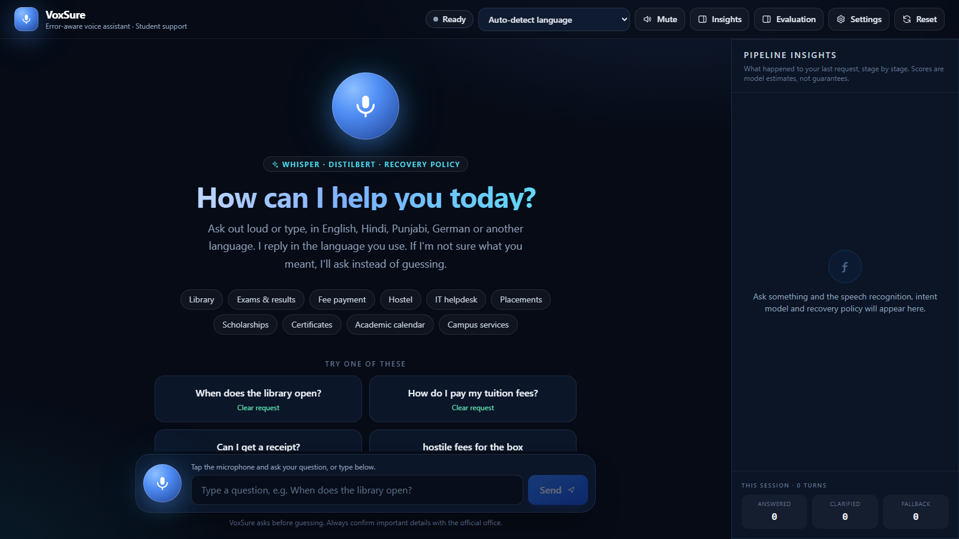
Desktop view: voice and text input, language picker, and the pipeline-insights panel (speech confidence, intent probabilities, policy decision). Live demo link: [live link: add after deployment]
6. Conclusion
The project delivers a working voice-enabled chatbot in which speech recognition, a fine-tuned deep learning intent classifier and a recovery policy are combined and evaluated honestly. DistilBERT clearly beats the TF-IDF baseline (macro-F1 0.795 vs 0.502), and the recovery policy cuts the wrong-answer rate from 24.9% to 4.4%. Limitations are stated plainly: a small author-written dataset, speech tested on synthetic voices only, multilingual sentences not native-verified, and some ambiguous requests still answered rather than clarified. The code, reports and live demo link are submitted for evaluation.

