PRE-DEFENSE 1 REPORT
Diploma Project Topic: Development of a System for Comprehensive Analysis and Evaluation of Scientific Information Using Digital and Intelligent Technologies
Students: Saltanat Sergeyeva, Alzira Kuanyshbekova, Meruert Khairgeldinova
Supervisor: Almas Myrzakhmetov
GitHub repository: https://github.com/Akua49/scientific-analysis-system
YouTrack: https://sergeyevasss.youtrack.cloud/projects/SCI
Prototype: https://www.figma.com/proto/Gu5Z6gvbep6zOqVz4ASxwa/Scirevia-%E2%80%94-Prototype?node-id=9-150&t=EZQoz7IviUS2yC53-1

Team and contribution
Member | Role | Area of responsibility | GitHub account
Saltanat Sergeyeva (SE-2403) | ML / Data engineer | Analysis service: text preprocessing, citation verification, summarisation, topic similarity, intelligent part of requirement checks, metadata from OpenAlex / Crossref / Semantic Scholar, quality evaluation | @ssaltuwwa
Alzira Kuanyshbekova (SE-2403) | Frontend developer, UX/UI designer | Scenarios and prototype, upload and check launch, requirements window, report visualisation, API integration | @Akua49
Meruert Khairgeldinova (SE-2414) | Backend developer | Server architecture and REST API, document upload and text/reference extraction, link checking (URLs, redirects, DOI), storage, business logic, integration with analysis service | @tw3tyy
Supervisor: Almas Myrzakhmetov, Senior Lecturer, School of Software Engineering | Supervisor | Consultation on architecture, task setting, documentation; review at checkpoints | —

Selected technologies
Layer | Technology
Client | HTML, CSS, JavaScript (ES modules), Chart.js; design in Figma
Server | Node.js, Express.js, MongoDB (Mongoose), REST API + OpenAPI (Swagger)
Analysis service | Python, FastAPI, spaCy / NLTK, scikit-learn, Hugging Face Transformers (multilingual sentence embeddings, NLI), Pandas; LLM API optional
External sources | Crossref, OpenAlex, Semantic Scholar API, doi.org
Infrastructure | Docker Compose, GitHub (+ Actions), YouTrack

1. Project Proposal

1.1 Problem statement
When diploma theses, projects, and scientific articles are prepared, the same problems recur:
- links in the reference list do not open or lead to a different source;
- quoted or paraphrased text does not correspond to the text of the cited source;
- the abstract does not reflect the actual content of the work;
- the document does not meet the established requirements;
- the topic repeats theses of previous years.
Today, supervisors and norm-control staff check these manually, which takes considerable time and depends on the reviewer. Plagiarism systems detect copied text but do not check whether citations and references are correct.

1.2 Aim
To develop a web system that automates checking references, citations, abstracts, user-defined requirements, and topic originality in scientific texts using NLP and open scholarly data, and produces a single report for the author and reviewer.

1.3 Objectives
- Collect and verify requirements through an online survey of students and academic staff (S-1, N = 26) and follow-up interviews with supervisors and norm-control staff; obtain the archive of past topics from the School.
- Review literature on reference rot, citation accuracy, reference parsing, semantic similarity, summarization, and factual-consistency evaluation.
- Compare existing tools (Turnitin, StrikePlagiarism, scite, Recite, SciSpace) against a consistent set of criteria.
- Specify functional and non-functional requirements with acceptance criteria.
- Design the architecture: client, server with REST API, analysis service, storage.
- Implement document upload and structure extraction, link and DOI checking (server).
- Implement citation verification, summarisation and abstract comparison, requirement checks and topic similarity (analysis service).
- Implement the user interface: upload, requirements window, report and visualisation (client).
- Evaluate quality on a control sample and measure processing time.

1.4 Expected outcomes
Working web system (client, server, analysis service) with documentation; evaluation results on the control sample; recommendations for use at the School.

1.5 Engineering complexity
- Extraction of document structure (abstract, body, in-text citations, reference list) from DOCX/PDF in different citation styles (GOST, APA, IEEE).
- Link checking with redirects, DOI resolution, timeouts, paywalls, and soft-404 pages; matching retrieved metadata to the reference entry.
- Semantic comparison of a citation with source text, including paraphrase and cross-lingual cases (RU / KZ / EN).
- Summarisation of long documents and assessment of abstract–content consistency.
- Checking user-defined requirements (rule-based + intelligent) and similarity search over the topic archive.
- Integration of three independently developed components (JS client, Node.js server, Python service) through agreed APIs.

1.6 Scope
In scope: DOCX and text-based PDF documents in Russian, Kazakh and English; five checks (references, citations, abstract, user-defined requirements, topic similarity); roles student / supervisor / admin; web client. Out of scope: plagiarism detection (covered by existing tools), retrieval of paywalled full texts, grammar and style checking, mobile app (Could). Pilot: theses of the School of Software Engineering, 2022–2026.

1.7 Assumptions and constraints
- Full texts of sources are available only for open-access works; otherwise, the abstract/metadata is used, and the result is marked accordingly.
- The archive of past topics is provided by the School (dependency D1).
- Documents are confidential: they are not sent to external LLM services without the user’s consent (NFR-05).

2. Evidence of Relevance
Status of each claim: V – verified (source given), A – assumption (verification method given); R – rejected after verification.

2.1 Evidence collection plan
# | Method | Participant / source | Date | Status
S-1 | Online survey (Google Forms, 9 questions, anonymous) | AITU students and academic staff; N = 26 (21 undergraduate, 1 master’s, 2 PhD, 1 lecturer, 1 other) | 23.10.2026 | Done
I-1 | Interview | Supervisor of diploma projects, School of SE | by 15.11.2026 | Planned
I-2 | Interview | Lecturer who reviews theses | by 15.11.2026 | Planned
I-3 | Interview | Norm-control / topic approval staff | by 15.11.2026 | Planned
O-1 | Observation | Supervisor checking a thesis reference list (time measured) | by 15.11.2026 | Planned
D-1 | Data analysis | 10 past theses: share of broken links, references without DOI, citation style | by 20.12.2026 (with E1) | Planned
D-2 | Data | Archive of past thesis topics from the School | 24.10.2026 | Requested
C-1 | Agreement | Supervisor / School confirms scope and access to control sample | 24.10.2026 | Requested
Questionnaire: Appendix B.1; interview guide: Appendix B.2. Raw anonymised responses: docs/evidence/survey-S1.csv. The survey was conducted under the working name SciCheck.

2.2 Claims register
ID | Claim | Status | Evidence / verification
C1 | A notable share of web references in scholarly texts become broken or point to changed content | V (literature + survey) | Klein et al. 2014; Jones et al. 2016; S-1 Q6: 58% (15/26) have encountered broken or unverifiable references; Q5: 46% (12/26) name broken links / incorrect DOIs as the hardest part
C2 | Citations frequently misrepresent the cited source | V (literature + survey) | Jergas & Baethge 2015; Mogull 2017; S-1 Q5: 58% (15/26) name “checking whether sources support citations” as the hardest task
C3 | LLM-assisted writing increases fabricated references | V (literature + survey) | Walters & Wilder 2023; S-1 Q6: 58% (15/26) met references that could not be verified
C4 | Supervisors spend significant time checking references and citations manually | V (survey, partial) | S-1 Q4: 65% (17/26) spend ≥15 min per document, 27% (7/26) more than 30 min; Q3: 62% (16/26) open links one by one; supervisor time to be measured in O-1
C5 | Abstracts of student theses often do not reflect the content | V (survey) | S-1 Q5: 35% (9/26) find abstract accuracy hard to check; Q8: 35% (9/26) want abstract-vs-content comparison
C6 | Requirements differ by programme / journal, so a fixed checklist is insufficient | A (weak support) | S-1 Q5: 23% (6/26) find requirement compliance hard; Q8: 27% (7/26) want it – to be confirmed in I-3
C7 | Repeated or very similar topics occur across years and are detected manually | A (weak support) | S-1 Q5: 19% (5/26); Q8: 23% (6/26) want similar-topic detection – to be confirmed in I-3 and D-2
C8 | Plagiarism systems used at AITU do not check citation correctness | V (survey, indirect) | S-1 Q7: respondents rely on manual checking, DOI lookup or plagiarism tools; none of these verifies citation support
C9 | Users trust results only if the system shows evidence (source fragment, link status) | A | Not covered by S-1; to be checked in the usability test (E7) and interviews I-1…I-3

2.3 Requirements traceability
Requirements | Supported by
FR-10…FR-13 (references) | C1, C3, C4 (S-1)
FR-20…FR-22 (citations) | C2, C4, C8 (S-1: hardest task for 58%)
FR-30…FR-31 (abstract) | C5 (S-1)
FR-40…FR-43 (requirements window) | Supervisor’s task (justification letter); C6 weakly supported by S-1, to be confirmed in I-3
FR-50…FR-51 (topics) | Supervisor’s task (justification letter); C7 weakly supported by S-1, to be confirmed in I-3 and D-2

2.4 Findings summary
- Confirmed: C1/C3 – 58% have met broken or unverifiable references; C4 – 65% spend 15+ minutes per document, mostly opening links manually; C5 – 35% struggle to check abstract accuracy; C8 – checking whether sources support citations is the most frequently named difficulty (58%), and no tool currently in use addresses it.
- Weak / not confirmed: C6 (requirements compliance, 23-27%) and C7 (similar topics, 19-23%). These checks remain in scope because they are part of the supervisor’s task, but they are to be confirmed with norm-control staff (I-3) before pre-defense 2. C9 was not covered by the survey.
- New needs (Q9): 10 of 26 open answers were substantive: (1) accuracy and source reliability (-> FR-10…FR-22); (2) explained reports with recommendations for fixes (-> FR-65); (3) multilingual support and detection of AI-generated text (-> NFR-06, FR-64).
- Priorities (Q8): DOI and metadata verification 54%; link checking 42%; citation-support checking 42%; abstract-vs-content comparison 35%; requirements compliance 27%; similar topics 23%; issue report 8%.
- Limitations: small convenience sample (N = 26, one university, one day); 81% undergraduates, staff represented by one lecturer and two PhD students. Staff-specific claims (C4, C6, C7) will be confirmed by O-1 and I-1…I-3 before pre-defense 2.

3. Literature Review
Scope. Five streams that correspond to the five checks of the system: (1) reference rot and link integrity; (2) reference extraction and scholarly metadata; (3) citation accuracy and claim verification; (4) summarisation and abstract-content consistency; (5) text/topic similarity and AI support in academic review. Totals: 26 sources – 23 scientific publications (14 from 2020-2025) and 3 technical/normative documents. Foundational works before 2020 are kept where current methods build on them.

3.1 Critical review

Stream 1 – Reference rot (-> reference check)
Klein et al. (2014) analysed over 3.5 million scholarly articles and found that about one in five articles with web references suffers from reference rot (links that no longer resolve). Jones et al. (2016) showed that even links that still resolve often lead to changed content: about three out of four URI references pointed to content that had drifted from what was originally cited. Implication: checking only the HTTP status is insufficient – the system must also compare what the link leads to with the reference entry (title/author/year match), handle redirects, and prefer DOIs (FR-10, FR-11). Baseline in E2 = status-code-only check.

Stream 2 – Reference parsing and metadata (-> structure extraction, DOI resolution)
Tkaczyk et al. (2018) compared ten open-source reference parsers; GROBID performed best out of the box, and retraining on domain data improved all ML-based parsers. GOST-style Russian references are not represented in their benchmark – a limitation we must test (E1). Crossref (Hendricks et al., 2020) is the authoritative registry of DOI metadata; OpenAlex (Priem et al., 2022) and Semantic Scholar (Kinney et al., 2023) add open abstracts, open-access locations and multilingual coverage. Walters & Wilder (2023) found that a large share of bibliographic citations generated by ChatGPT were fabricated (55 % for GPT-3.5, 18 % for GPT-4), and many real ones contained errors – a growing risk for student texts. Implication: every reference is resolved against at least two sources; a reference that cannot be found anywhere is flagged as “possibly non-existent” (FR-12).

Stream 3 – Citation accuracy and verification (-> citation check)
A systematic review and meta-analysis by Jergas & Baethge (2015) estimated that about a quarter of quotations in medical journal articles contain errors, with a substantial share being major errors; Mogull (2017) showed that estimates depend strongly on study methodology. Automatic verification is studied as scientific claim verification: SciFact (Wadden et al., 2020) retrieves rationale sentences from abstracts and labels claims as SUPPORTS / REFUTES. Semantic matching relies on sentence embeddings: Sentence-BERT (Reimers & Gurevych, 2019), its multilingual distillation (Reimers & Gurevych, 2020), LaBSE (Feng et al., 2022), and multilingual E5 (Wang et al., 2024) allow cross-lingual comparison (RU/KZ citation vs. EN source). Limitations: source full text is often unavailable; Kazakh is under-represented in training data. Implication: two-stage approach – embedding retrieval of the most similar source fragment, then entailment (NLI) classification; labels supported / partially supported / not supported / source unavailable; TF-IDF cosine as the baseline (E3).

Stream 4 – Summarisation and abstract consistency (-> abstract check)
Long scientific documents require discourse-aware or long-context models (Cohan et al., 2018; Beltagy et al., 2020). Lexical metrics such as ROUGE (Lin, 2004) correlate poorly with meaning; BERTScore (Zhang et al., 2020) compares texts in embedding space. For consistency between a summary and its source, NLI-based SummaC (Laban et al., 2022) and AlignScore (Zha et al., 2023) detect unsupported statements. Implication: the system (a) generates a reference summary of the body, (b) measures coverage of the body’s key points by the author’s abstract, and (c) flags abstract sentences not supported by the body; validated against expert ratings (E4).

Stream 5 – Similarity, topics and AI-assisted review (-> topic check, requirements check)
Foltýnek et al. (2019) reviewed academic plagiarism detection and distinguished lexical, syntactic, and semantic methods; semantic (embedding-based) methods detect paraphrased ideas that lexical methods miss – the same applies to topic similarity across years. Liang et al. (2024) found LLM feedback on papers overlaps with human reviewers at a level comparable to human–human overlap, but is less specific; Kousha & Thelwall (2024) conclude AI suits supporting tasks such as screening and format checks. Implication: requirement checks are rule-based where measurable and LLM-assisted (with quoted evidence) only for qualitative items; all results are advisory.

Gap
Plagiarism tools detect copied text; citation tools check formatting or retractions. No reviewed tool verifies, in one workflow, link validity, citation content, abstract consistency, custom requirements, and topic repetition – and none targets Russian/Kazakh student theses.

3.2 Analysis table
ID | Reference | Type | Method / content | Key finding | Limitation | Used for
L1 | Klein M., Van de Sompel H., Sanderson R., et al. (2014). Scholarly context not found: One in five articles suffers from reference rot. PLoS ONE, 9(12), e115253. doi:10.1371/journal.pone.0115253 | Journal | Large-scale link analysis | ~1 in 5 articles affected by reference rot | STM corpora, 2014 | C1; FR-10
L2 | Jones S.M., Van de Sompel H., Shankar H., et al. (2016). Scholarly context adrift: Three out of four URI references lead to changed content. PLoS ONE, 11(12), e0167475. doi:10.1371/journal.pone.0167475 | Journal | Content drift analysis | Working links often lead to changed content | Web archives needed | FR-11 metadata match; E2 baseline
L3 | Tkaczyk D., Collins A., Sheridan P., Beel J. (2018). Machine learning vs. rules and out-of-the-box vs. retrained: An evaluation of open-source bibliographic reference and citation parsers. JCDL ’18. https://doi.org/10.48550/arXiv.1802.01168 | Conference | Benchmark of 10 parsers | GROBID best; retraining helps | No GOST/RU styles | ADR-004; E1
L4 | Hendricks G., Tkaczyk D., Lin J., Feeney P. (2020). Crossref: The sustainable source of community-owned scholarly metadata. Quantitative Science Studies, 1(1), 414–427. doi:10.1162/qss_a_00022 | Journal | Metadata infrastructure | Authoritative open DOI metadata | Abstracts often missing | FR-11, FR-12
L5 | Priem J., Piwowar H., Orr R. (2022). OpenAlex: A fully-open index of scholarly works, authors, venues, institutions, and concepts. arXiv:2205.01833 | Preprint | Open scholarly graph | Free API, OA locations | Metadata gaps | Source text retrieval
L6 | Kinney R., Anastasiades C., Authur R., et al. (2023). The Semantic Scholar Open Data Platform. arXiv:2301.10140 | Preprint | Open data platform & API | Abstracts, OA PDFs, embeddings | Mostly English | Source text retrieval
L7 | Walters W.H., Wilder E.I. (2023). Fabrication and errors in the bibliographic citations generated by ChatGPT. Scientific Reports, 13, 14045. doi:10.1038/s41598-023-41032-5 | Journal | Evaluation of LLM-generated references | 55 % (GPT-3.5) / 18 % (GPT-4) fabricated | Specific model versions | C3; FR-12
L8 | Jergas H., Baethge C. (2015). Quotation accuracy in medical journal articles — a systematic review and meta-analysis. PeerJ, 3, e1364. doi:10.7717/peerj.1364 | Journal (meta-analysis) | Meta-analysis of quotation errors | ≈ 25 % of quotations erroneous | Medicine only | C2
L9 | Mogull S.A. (2017). Accuracy of cited “facts” in medical research articles: A review of study methodology and recalculation of quotation error rate. PLoS ONE, 12(9), e0184727. doi:10.1371/journal.pone.0184727 | Journal | Methodological review | Error rates depend on method | Medicine only | Annotation protocol E3
L10 | Wadden D., Lin S., Lo K., et al. (2020). Fact or fiction: Verifying scientific claims. EMNLP 2020, 7534–7550. doi:10.18653/v1/2020.emnlp-main.609 | Conference | Claim verification dataset & model | Rationale retrieval + labels feasible | Abstracts only, English | Citation-check pipeline
L11 | Reimers N., Gurevych I. (2019). Sentence-BERT: Sentence embeddings using Siamese BERT-networks. EMNLP-IJCNLP, 3982–3992. doi:10.18653/v1/D19-1410 | Conference | Sentence embeddings | Efficient semantic similarity | Monolingual | Similarity core
L12 | Reimers N., Gurevych I. (2020). Making monolingual sentence embeddings multilingual using knowledge distillation. EMNLP 2020, 4512–4525. doi:10.18653/v1/2020.emnlp-main.365 | Conference | Multilingual distillation | Cross-lingual similarity incl. RU | KZ quality unknown | Model candidate (E3)
L13 | Feng F., Yang Y., Cer D., Arivazhagan N., Wang W. (2022). Language-agnostic BERT sentence embedding. ACL 2022, 878–891. doi:10.18653/v1/2022.acl-long.62 | Conference | 109-language embeddings | Strong bitext retrieval incl. KZ | Less tuned for paraphrase | Model candidate (E3)
L14 | Wang L., Yang N., Huang X., et al. (2024). Multilingual E5 text embeddings: A technical report. arXiv:2402.05672 | Preprint | Multilingual retrieval embeddings | Strong multilingual retrieval | Large model sizes | Default model (ADR-005)
L15 | Cohan A., Dernoncourt F., Kim D.S., et al. (2018). A discourse-aware attention model for abstractive summarization of long documents. NAACL-HLT, 615–621. doi:10.18653/v1/N18-2097 | Conference | Long-document summarisation (arXiv/PubMed) | Section structure improves summaries | English | Summarisation design
L16 | Beltagy I., Peters M.E., Cohan A. (2020). Longformer: The long-document transformer. arXiv:2004.05150 | Preprint | Long-context transformer | Handles long scientific texts | Compute cost | Alternative (ADR-005)
L17 | Lin C.-Y. (2004). ROUGE: A package for automatic evaluation of summaries. Text Summarization Branches Out (ACL Workshop), 74–81 | Workshop – foundational | n-gram overlap metric | Standard metric | Lexical only | Baseline metric E4
L18 | Zhang T., Kishore V., Wu F., Weinberger K.Q., Artzi Y. (2020). BERTScore: Evaluating text generation with BERT. ICLR 2020. https://doi.org/10.48550/arXiv.1904.09675 | Conference | Embedding-based metric | Better correlation with humans | Not a consistency metric | Abstract coverage score
L19 | Laban P., Schnabel T., Bennett P.N., Hearst M.A. (2022). SummaC: Re-visiting NLI-based models for inconsistency detection in summarization. TACL, 10, 163–177. doi:10.1162/tacl_a_00453 | Journal | Sentence-level NLI consistency | Detects unsupported summary sentences | English | Abstract consistency (FR-31)
L20 | Zha Y., Yang Y., Li R., Hu Z. (2023). AlignScore: Evaluating factual consistency with a unified alignment function. ACL 2023. doi:10.18653/v1/2023.acl-long.634 | Conference | Unified alignment model | State-of-the-art consistency scoring | English | Alternative scorer (E4)
L21 | Foltýnek T., Meuschke N., Gipp B. (2019). Academic plagiarism detection: A systematic literature review. ACM Computing Surveys, 52(6), 112. doi:10.1145/3345317 | Journal (review) | Review of detection methods | Semantic methods catch paraphrase | Pre-LLM era | Topic similarity (FR-50)
L22 | Liang W., Zhang Y., Cao H., et al. (2024). Can large language models provide useful feedback on research papers? A large-scale empirical analysis. NEJM AI, 1(8). doi:10.1056/AIoa2400196 | Journal | GPT-4 vs. human reviews | Useful but generic feedback | Paper-level only | Scope of LLM use
L23 | Kousha K., Thelwall M. (2024). Artificial intelligence to support publishing and peer review: A summary and review. Learned Publishing, 37(1), 4–12. doi:10.1002/leap.1570 | Journal (review) | Review of AI tools | AI suited to supporting checks | Fast-changing | Positioning as decision support
T1 | GROBID documentation. https://grobid.readthedocs.io | Technical | PDF -> TEI structure | — | — | ADR-004
T2 | Crossref REST API documentation. https://api.crossref.org | Technical | Works search, DOI metadata | — | Rate etiquette | FR-11, FR-12
T3 | AITU diploma project formatting requirements / ГОСТ 7.1-2003 bibliographic description (School of Software Engineering, current academic year) | Normative | Requirements to check | — | — | FR-40 templates

4. Existing System Comparison
Systems (5): Turnitin, StrikePlagiarism, scite (Reference Check), Recite (ReciteWorks), SciSpace. Criteria (9) – the same for every system. Ratings: Yes full · Partly partial · No absent. Ratings were checked against vendor documentation on 23.10.2026.
# | Criterion | Linked requirement
K1 | Link availability check (URL status, redirects) | FR-10
K2 | DOI resolution and metadata match with the reference entry | FR-11, FR-12
K3 | Citation content verification against source text | FR-20…22
K4 | In-text citation <-> reference list consistency | FR-13
K5 | Summary vs. author’s abstract | FR-30, FR-31
K6 | User-defined requirements check | FR-40…43
K7 | Topic similarity with a local archive of past theses | FR-50
K8 | Russian / Kazakh language support | NFR-06
K9 | Cost and data privacy (self-hosting) | NFR-05

Criterion | Turnitin | StrikePlagiarism | scite Reference Check | Recite | SciSpace | Scirevia
K1 Links | No | No | No (not described in Reference Check documentation) | No | No | Yes
K2 DOI / metadata | No | No | Yes checks references for retractions and editorial notices | No | No | Yes
K3 Citation content | No | No | Partly shows how others cite a paper (supporting / contrasting), not whether your citation matches | No | No | Yes
K4 Citation <-> list | No | No | No | Yes matches in-text citations with reference list (APA/Harvard) | No | Partly (Should)
K5 Abstract vs. content | No | No | No | No | Partly generates summaries, no comparison with abstract | Yes
K6 Custom requirements | No | No | No | Partly style rules only | No | Yes
K7 Topic archive | Partly text similarity incl. institutional repository, not topic-level | Partly text similarity, institutional database (incl. institutional archives, vendor information) | No | No | No | Yes
K8 RU / KZ | Partly (multilingual; Kazakh not documented) | Yes (multilingual; used by Kazakhstani universities) | No mostly English corpus | No (English-language styles only) | Partly (multilingual interface, mainly English corpus) | Yes
K9 Cost / privacy | No institutional licence, cloud | No institutional licence, cloud | Partly freemium, cloud | Partly freemium, cloud | Partly freemium, cloud | Yes free, self-hosted at AITU

Conclusions:
- Plagiarism systems (Turnitin, StrikePlagiarism) answer “is the text copied?”, not “are the references and citations correct?”. Scirevia complements, not replaces them.
- scite and Recite each cover one aspect of references (retractions; formatting consistency) and are oriented to English-language texts.
- No tool covers K1, K3, K5, K6 and K7 together or supports RU/KZ theses – this justifies Scirevia.

Evidence:
- scite: How do I use the scite Reference Check? – help.scite.ai; Nature Index news on scite’s retraction-flagging bot.
- Recite: reciteworks.com – product tour and FAQ.
- Turnitin: turnitin.com/products/similarity · StrikePlagiarism: strikeplagiarism.com · SciSpace: typeset.io
- Tools currently used by respondents (S-1, Q7): manual checking, DOI lookup, and plagiarism-detection software; none of them verifies whether a source supports the citation.

5. Technology Comparison
Scores 1-3 (3 = best) against criteria derived from requirements. Final decisions: adr/.

D1. Server platform
Requirements: concurrent link checking with timeouts (FR-10, NFR-02), file upload (FR-01), REST API with documentation (NFR-07), team skills of the backend developer (JavaScript, REST, NoSQL).
Criterion | Node.js + Express | Python + FastAPI | NestJS (TypeScript)
Asynchronous I/O for hundreds of HTTP checks | 3 | 3 | 3
Team expertise (backend developer) | 3 | 2 | 1
Simplicity / learning curve | 3 | 3 | 1
Upload, validation, Swagger ecosystem | 3 (multer, joi, swagger-jsdoc) | 3 | 3
Access to ML libraries | 1 – not needed: ML is in a separate service (D3) | 3 | 1
Total | 13 | 14 | 9
Decision: Node.js + Express. FastAPI scores one point higher only because of ML libraries, which the server does not need (they are isolated in the analysis service); team expertise outweighs this. -> ADR-001

D2. Data storage
Requirements: documents and nested check reports of variable structure (FR-60), requirement templates (FR-43), topic archive (FR-51), history (FR-62).
Criterion | MongoDB | PostgreSQL | PostgreSQL + JSONB
Nested, evolving report structure | 3 | 1 | 3
Team expertise | 3 | 2 | 2
File storage (GridFS) or references | 3 | 2 | 2
Relational integrity (users–documents–reports) | 2 | 3 | 3
Vector search for topics | 2 (Atlas only; we keep vectors in analysis service) | 2 (pgvector) | 2 (pgvector)
Total | 13 | 10 | 12
Decision: MongoDB with Mongoose schemas for validation; topic embeddings are stored and searched inside the analysis service (corpus of a few thousand topics fits in memory / FAISS). -> ADR-002

D3. Interaction between components
Requirements: long checks (citation verification may take minutes, NFR-02), progress visible to user (FR-63), independent development of three components.
Criterion | Synchronous REST | REST + asynchronous jobs (job record in MongoDB, status polling, callback from analysis service) | Message broker (RabbitMQ / BullMQ + Redis)
No timeouts on long checks | 1 | 3 | 3
Progress per check | 1 | 3 | 3
Extra infrastructure | 3 | 3 | 1
Complexity for the team | 3 | 2 | 1
Total | 8 | 11 | 8
Decision: REST/JSON between all components; checks run as asynchronous jobs. Upgrade path: BullMQ if load grows. API contracts are fixed in OpenAPI before implementation. -> ADR-003

D4. Document structure extraction
Requirements: abstract, body, in-text citations, reference list from DOCX and PDF; GOST/APA/IEEE styles (FR-02).
Criterion | python-docx / PyMuPDF + rules | GROBID | Apache Tika
Reference list parsing into fields | 1 | 3 | 1
DOCX support | 3 | 1 (PDF only) | 3
GOST / Russian references | 2 (custom rules) | 1–2 (test in E1) | 1
Deployment | 3 | 2 (Java service) | 2
Total | 9 | 7–8 | 7
Decision: hybrid – python-docx for DOCX (most theses), GROBID for PDF and for parsing reference strings; rule-based fallback for GOST. Chosen by E1 F1-score. -> ADR-004 Rules + python-docx score highest in total (9) but cannot split reference strings into fields; GROBID covers exactly this gap, hence the hybrid.

D5. Semantic comparison (citations, topics)
Criterion | TF-IDF / BM25 | Multilingual sentence embeddings (multilingual-e5 / LaBSE / paraphrase-multilingual) | LLM API only
Detects paraphrase | 1 | 3 | 3
Cross-lingual RU/KZ <-> EN | 1 | 3 | 3
Cost / runs locally | 3 | 3 | 1
Explainability (fragment + score) | 3 | 2 | 2
Total | 8 | 11 | 9
Decision: embeddings for retrieval of the most similar source fragment + NLI cross-encoder for the label; TF-IDF kept as the baseline in E3/E5. LLM optional for borderline cases (with consent). -> ADR-005

D6. Summarisation and abstract comparison
Criterion | Extractive (TextRank) | Local abstractive model (mT5 / mBART) | LLM API (with consent) + extractive fallback
Summary quality on long RU/KZ text | 1 | 2 | 3
Cost / hardware | 3 | 1 (GPU) | 2
Privacy | 3 | 3 | 1 -> mitigated by consent / local fallback
Total | 7 | 6 | 6
Decision: LLM summary when the user consents; otherwise extractive summary. Abstract comparison uses embedding coverage + NLI consistency (independent of summariser). Extractive summarisation scores highest in total (7) because of cost and privacy, but lowest on quality for long RU/KZ texts; the hybrid keeps local processing by default (NFR-05) and uses the LLM only with consent.

D7. Client
Criterion | HTML/CSS/JavaScript + Chart.js | React | Flutter (web + mobile)
Team expertise (frontend developer) | 3 | 2 | 3
Complexity of report UI (tabs, tables, side-by-side) | 2 | 3 | 2
Build tooling / simplicity | 3 | 2 | 2
Mobile version | 1 | 1 | 3
Total | 9 | 8 | 10
Decision: HTML/CSS/JS (ES modules) for the web client; Flutter mobile version is optional (Could). Flutter scores one point higher only because of the mobile criterion, which is a Could requirement; for the Must web client, HTML/CSS/JS fits team expertise and has the simplest tooling.

6. Requirements Specification
Priority: M must · S should · C could. Every M requirement has an acceptance criterion (AC) verifiable by a test or experiment in the verification plan. Owner: SS – Sergeyeva (analysis), AK – Kuanyshbekova (client), MK – Khairgeldinova (server).

6.1 Functional requirements

Document upload and structure
ID | Requirement | Pr. | Acceptance criterion | Owner
FR-01 | Upload DOCX or text PDF (<= 20 MB) and select which checks to run | M | Valid files accepted; other types rejected with message; test with 10 files | MK, AK
FR-02 | Extract title, abstract, body, in-text citations and reference list | M | On control sample (E1): reference entries F1 >= 0.85, abstract found in >= 18/20 documents | MK, SS
FR-03 | Show extracted structure to the user and allow correcting abstract / reference boundaries | S | User edit is used in subsequent checks (E2E test) | AK

Reference check
ID | Requirement | Pr. | Acceptance criterion | Owner
FR-10 | For each URL: status (working / broken / redirected / access restricted / timeout), final URL, HTTP code | M | On 200 labelled links (E2): accuracy >= 0.90; timeout per link <= 10 s | MK
FR-11 | Resolve DOI and compare retrieved metadata (title, authors, year) with the reference entry; match score | M | On 100 labelled references: correct “matches / does not match” >= 0.90 | MK, SS
FR-12 | For references without DOI/URL, search Crossref / OpenAlex / Semantic Scholar; flag “not found in any source” | M | Recall of planted fabricated references >= 0.8 (E2b) | SS
FR-13 | Check consistency of in-text citations and reference list (unused entries, missing entries) | S | Synthetic test with 5 planted inconsistencies – all found | SS

Citation check
ID | Requirement | Pr. | Acceptance criterion | Owner
FR-20 | For each citation, retrieve source text (OA full text or abstract) | M | Retrieval attempt logged per citation; status “source unavailable” when not found | SS
FR-21 | Find the most similar source fragment and assign label: supported / partially supported / not supported / source unavailable, with score | M | E3: macro-F1 >= 0.70 and >= +0.10 over TF-IDF baseline | SS
FR-22 | Display citation and source fragment side by side with link to source | M | UI test: every label has fragment or reason | AK

Abstract check
ID | Requirement | Pr. | Acceptance criterion | Owner
FR-30 | Generate a summary of the document body | M | Summary produced for 20/20 control documents <= 2 min each | SS
FR-31 | Compare author’s abstract with content: coverage score, key points missing from the abstract, abstract sentences not supported by the body | M | E4: Spearman ρ >= 0.6 between system score and expert rating | SS

Requirements window
ID | Requirement | Pr. | Acceptance criterion | Owner
FR-40 | User enters requirements in a separate window: free text or structured items (sections, volume, number and age of references, style, keywords, abstract length) | M | Requirements saved with the check; UI test | AK, MK
FR-41 | Measurable requirements are checked by rules | M | 10 rule types; unit tests per rule; precision = recall = 1.0 on synthetic documents | SS
FR-42 | Qualitative requirements (e.g. “aim and objectives are stated”) are checked intelligently and each verdict includes a quote from the document | S | 100 % of verdicts contain a quote existing verbatim in the document | SS
FR-43 | Save and reuse requirement templates (e.g. “AITU diploma project”) | S | Template applied to a new check without re-entry | MK, AK

Topic check
ID | Requirement | Pr. | Acceptance criterion | Owner
FR-50 | Compare topic (title + abstract) with archive of past topics; show top-5 similar with score, year | M | E5: Precision@5 >= 0.6, MRR >= baseline + 0.1 | SS
FR-51 | Admin uploads / updates archive (CSV / XLSX) | M | 1 000-row file imported <= 1 min; index rebuilt | MK

Report, users, history
ID | Requirement | Pr. | Acceptance criterion | Owner
FR-60 | Single report: summary panel + section per check with statuses | M | All selected checks present; matches API data (E2E) | AK
FR-61 | Export report to PDF | S | PDF opens; content equals on-screen report | MK
FR-62 | History of checks per user; compare two versions of the same document | C | — | MK, AK
FR-64 | Flag passages that are possibly AI-generated for the reviewer (from S-1, Q9) | C | — | SS
FR-65 | For each detected issue, show a short recommendation on how to fix it (from S-1, Q9) | C | — | AK, SS
FR-63 | Progress of running checks | M | Status updates at least every 5 s | MK, AK
FR-70 | Roles: student, supervisor, admin; registration/login with AITU e-mail | M | Access matrix tests: forbidden actions -> 403 | MK
FR-71 | Supervisor sees reports of documents shared by students | S | Sharing test | MK, AK

6.2 Non-functional requirements
ID | Requirement | Pr. | Acceptance criterion
NFR-01 | Usability | M | SUS >= 70 with 5 users (E7)
NFR-02 | Performance: full check of 80-page thesis with <= 60 references | M | <= 5 min on target server (E6)
NFR-03 | Politeness to external services | M | Concurrency <= 10 per host; User-Agent with contact; Crossref/OpenAlex mailto set
NFR-04 | Reliability | S | Failure of one check does not fail the report (fault-injection test)
NFR-05 | Privacy | M | Documents not sent to external LLM without consent (network test); files deleted after 30 days (configurable)
NFR-06 | Languages | M | Documents in RU, KZ, EN processed; UI in RU/EN (KZ – Should)
NFR-07 | API documentation | M | OpenAPI for server and analysis service; contract tests pass
NFR-08 | Maintainability | S | Test coverage >= 60 % per component; CI on every PR
NFR-09 | Security | M | Passwords hashed (bcrypt), JWT, input validation, upload type checks; no secrets in Git

7. Architecture and Diagrams
Sources: diagrams/src/ (Mermaid .mmd, PlantUML .puml) · exports: diagrams/export/.

7.1 System context
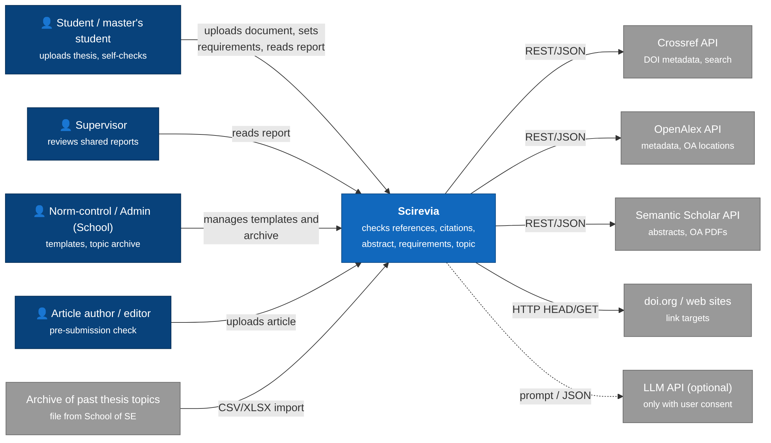
Scirevia is used by students, article authors, supervisors and norm-control/admin staff of the School. It calls Crossref, OpenAlex and Semantic Scholar for metadata and source texts, performs HTTP requests to link targets and doi.org, imports the archive of past thesis topics provided by the School, and calls an LLM API only when the user consents (NFR-05).

7.2 Use cases
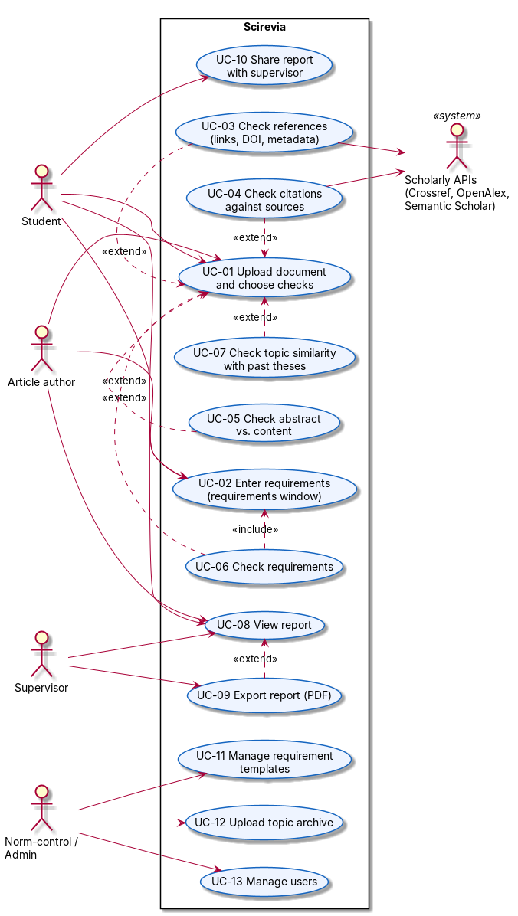
use cases
Use case | Requirements | Prototype screen | Owner
UC-01 Upload document, choose checks | FR-01, FR-02, FR-03 | New check | MK, AK
UC-02 Enter requirements | FR-40, FR-43 | New check -> Requirements window | AK
UC-03 Check references | FR-10…13 | Report -> References | MK, SS
UC-04 Check citations | FR-20…22 | Report -> Citations | SS
UC-05 Check abstract | FR-30, FR-31 | Report -> Abstract | SS
UC-06 Check requirements | FR-41, FR-42 | Report -> Requirements | SS
UC-07 Check topic similarity | FR-50 | Report -> Topic | SS
UC-08 View report | FR-60, FR-63 | Report -> Overview | AK
UC-09 Export PDF | FR-61 | Report -> Export | MK
UC-10 Share with supervisor | FR-71 | Report -> Share | MK, AK
UC-11 Templates · UC-12 Topic archive · UC-13 Users | FR-43, FR-51, FR-70 | Admin | MK

7.3 Components (draft)
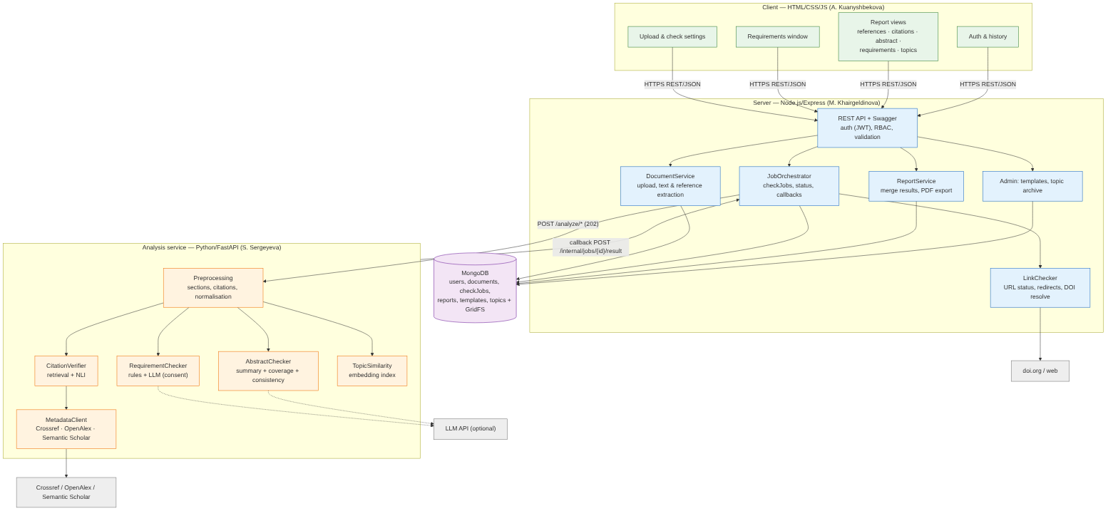
components
Component | Responsibility | Technology | Owner
Client | Upload, requirements window, report views, charts, history | HTML/CSS/JS, Chart.js | A. Kuanyshbekova
REST API | Auth (JWT), roles, validation, Swagger | Express, joi, swagger-jsdoc | M. Khairgeldinova
DocumentService | Upload, text extraction, reference list extraction | multer, mammoth / call to analysis preprocessing | M. Khairgeldinova
LinkChecker | URL status, redirects, timeouts, DOI resolution | undici/axios, p-limit | M. Khairgeldinova
JobOrchestrator | checkJobs, progress, callbacks, retries | Express, MongoDB | M. Khairgeldinova
ReportService | Merge results, PDF export | Puppeteer / pdfkit | M. Khairgeldinova
Preprocessing | Sections, in-text citations, reference parsing, normalisation | spaCy/NLTK, GROBID | S. Sergeyeva
MetadataClient | Crossref, OpenAlex, Semantic Scholar | httpx | S. Sergeyeva
CitationVerifier | Retrieval of source fragment + NLI label | sentence-transformers, Transformers | S. Sergeyeva
AbstractChecker | Summary, coverage, consistency | Transformers / LLM API | S. Sergeyeva
RequirementChecker | Rule checks + LLM checks with quotes | Python, LLM API | S. Sergeyeva
TopicSimilarity | Embedding index of past topics | sentence-transformers, FAISS / NumPy | S. Sergeyeva
MongoDB | users, documents, checkJobs, reports, templates, topics, GridFS | MongoDB 7 | M. Khairgeldinova

7.4 Additional views
- Data model: 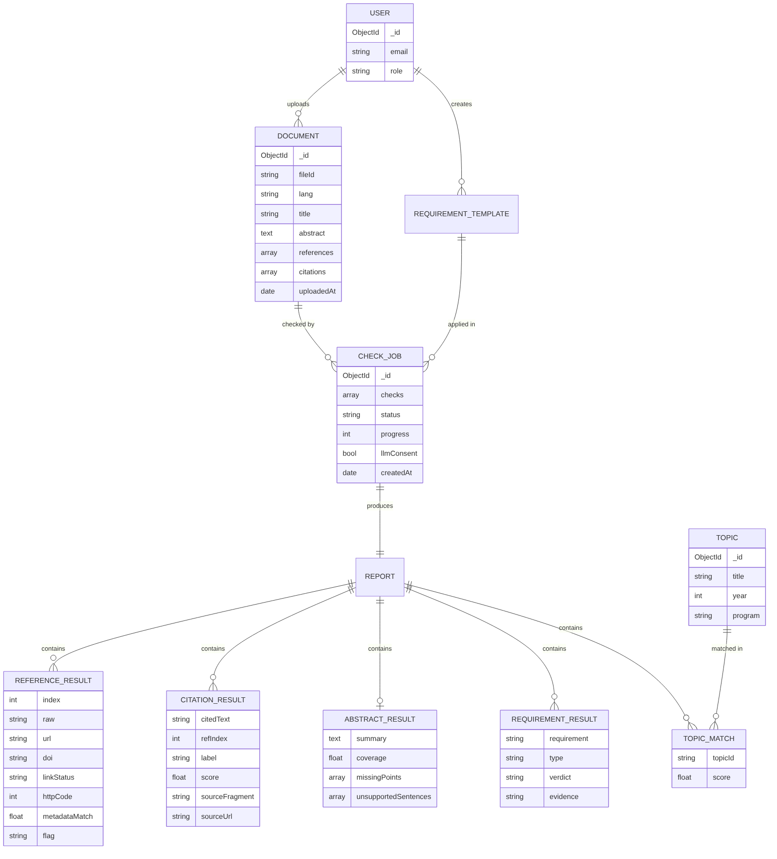
- Check run sequence: 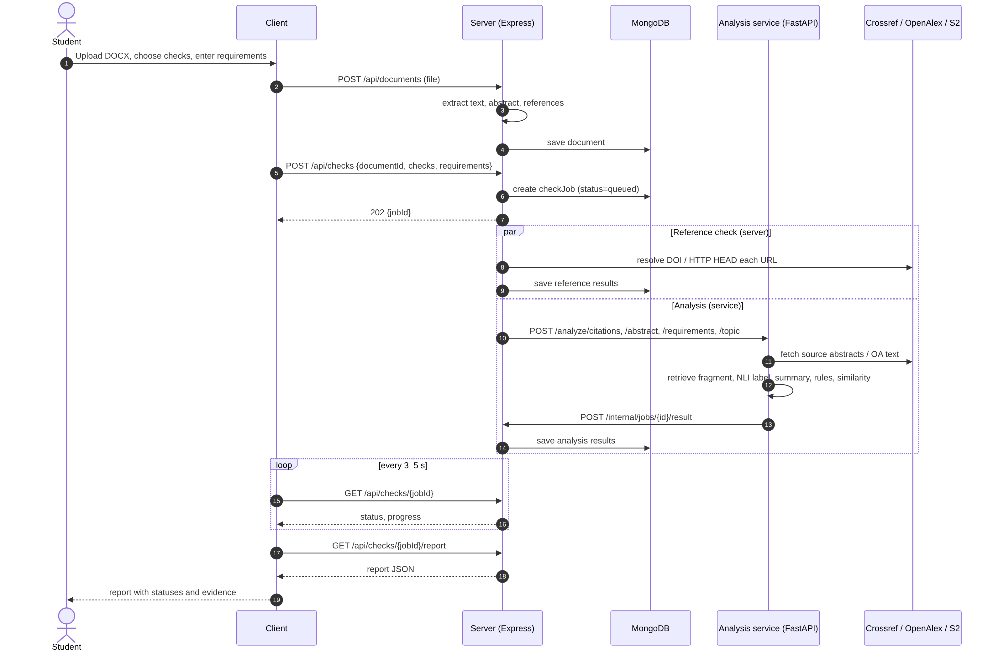

8. UX / Prototype
Clickable prototype in Figma (English version, 7 screens, fictional data) – link in the Project Card. Screenshots: prototype/screens/. Figma design: A. Kuanyshbekova.
Screen | Scenario | Use cases
New check | Upload -> choose checks -> requirements window (template + free text) -> consent for external AI -> start | UC-01, UC-02
Report overview | Summary of five checks -> export / share | UC-08…10
References | Status of each link / DOI, metadata match, possibly non-existent references | UC-03
Citations | Citation and closest source fragment side by side, label and score | UC-04
Abstract | Author’s abstract vs. generated summary, coverage, unsupported sentences | UC-05
Requirements | Rule and intelligent checks with evidence | UC-06
Topic | Top similar topics from the archive | UC-07

API examples (contract draft)
POST /api/checks
{ "documentId": "6531…", "checks": ["references","citations","abstract","requirements","topic"],
"templateId": "aitu-diploma", "customRequirements": ["Each objective has a result in the conclusion"],
"llmConsent": false }
→ 202 { "jobId": "j_812", "status": "queued" }
GET /api/checks/j_812
→ { "status": "running", "progress": { "references": "done", "citations": "running", "abstract": "queued", ... } }
POST /analyze/citations (server → analysis service)
{ "jobId": "j_812", "lang": "ru",
"citations": [{ "id": "c14", "text": "Sentence-BERT позволяет …", "refIndex": 3 }],
"references": [{ "index": 3, "doi": "10.18653/v1/D19-1410" }] }
→ 202
callback POST /internal/jobs/j_812/result
{ "check": "citations", "results": [
{ "id": "c14", "label": "supported", "score": 0.87,
"sourceFragment": "…derive semantically meaningful sentence embeddings…",
"sourceType": "abstract", "sourceUrl": "https://doi.org/10.18653/v1/D19-1410" } ] }

Usability test
5 participants (2 students, 2 supervisors, 1 norm-control), tasks: run a check with a template; find a broken reference; explain why a citation is “not supported”; add a custom requirement; export the report. Think-aloud + SUS. Results -> docs/evidence/usability-prototype.md.

Prototype screens
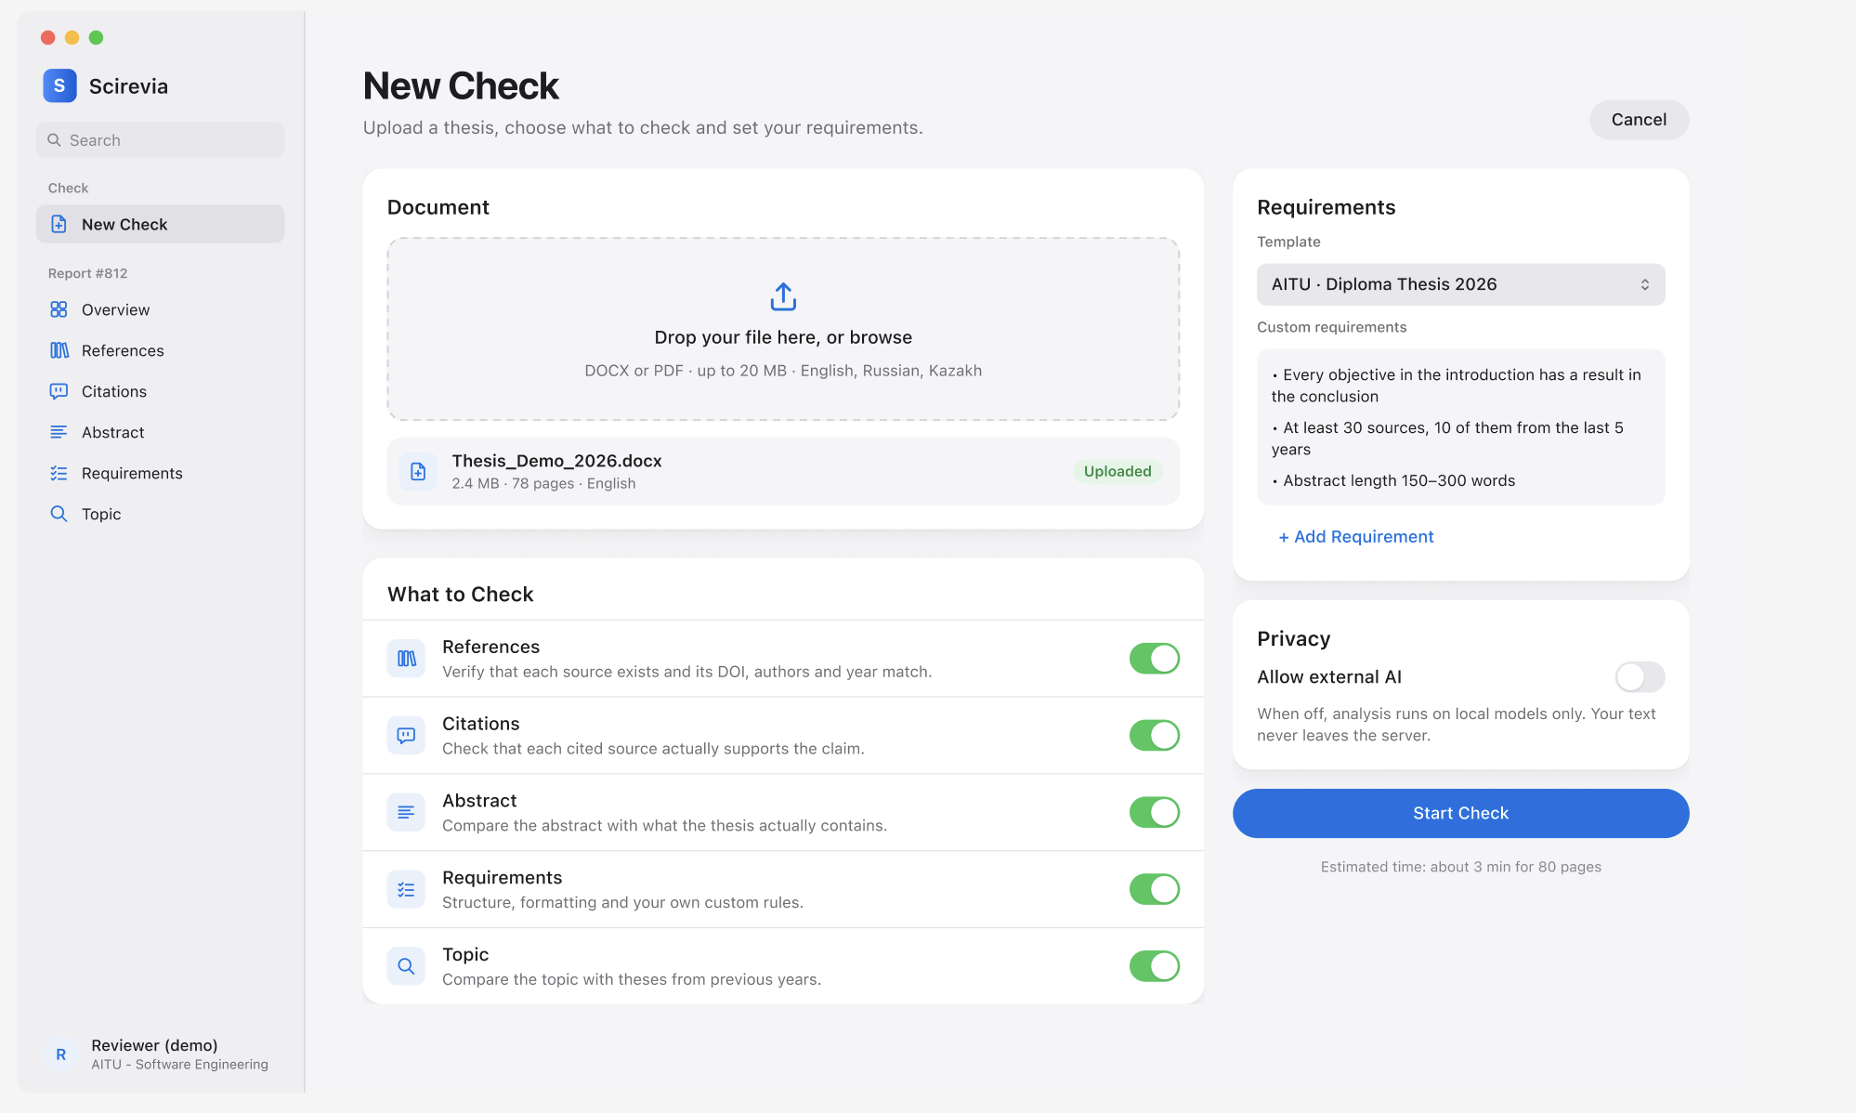
01-new
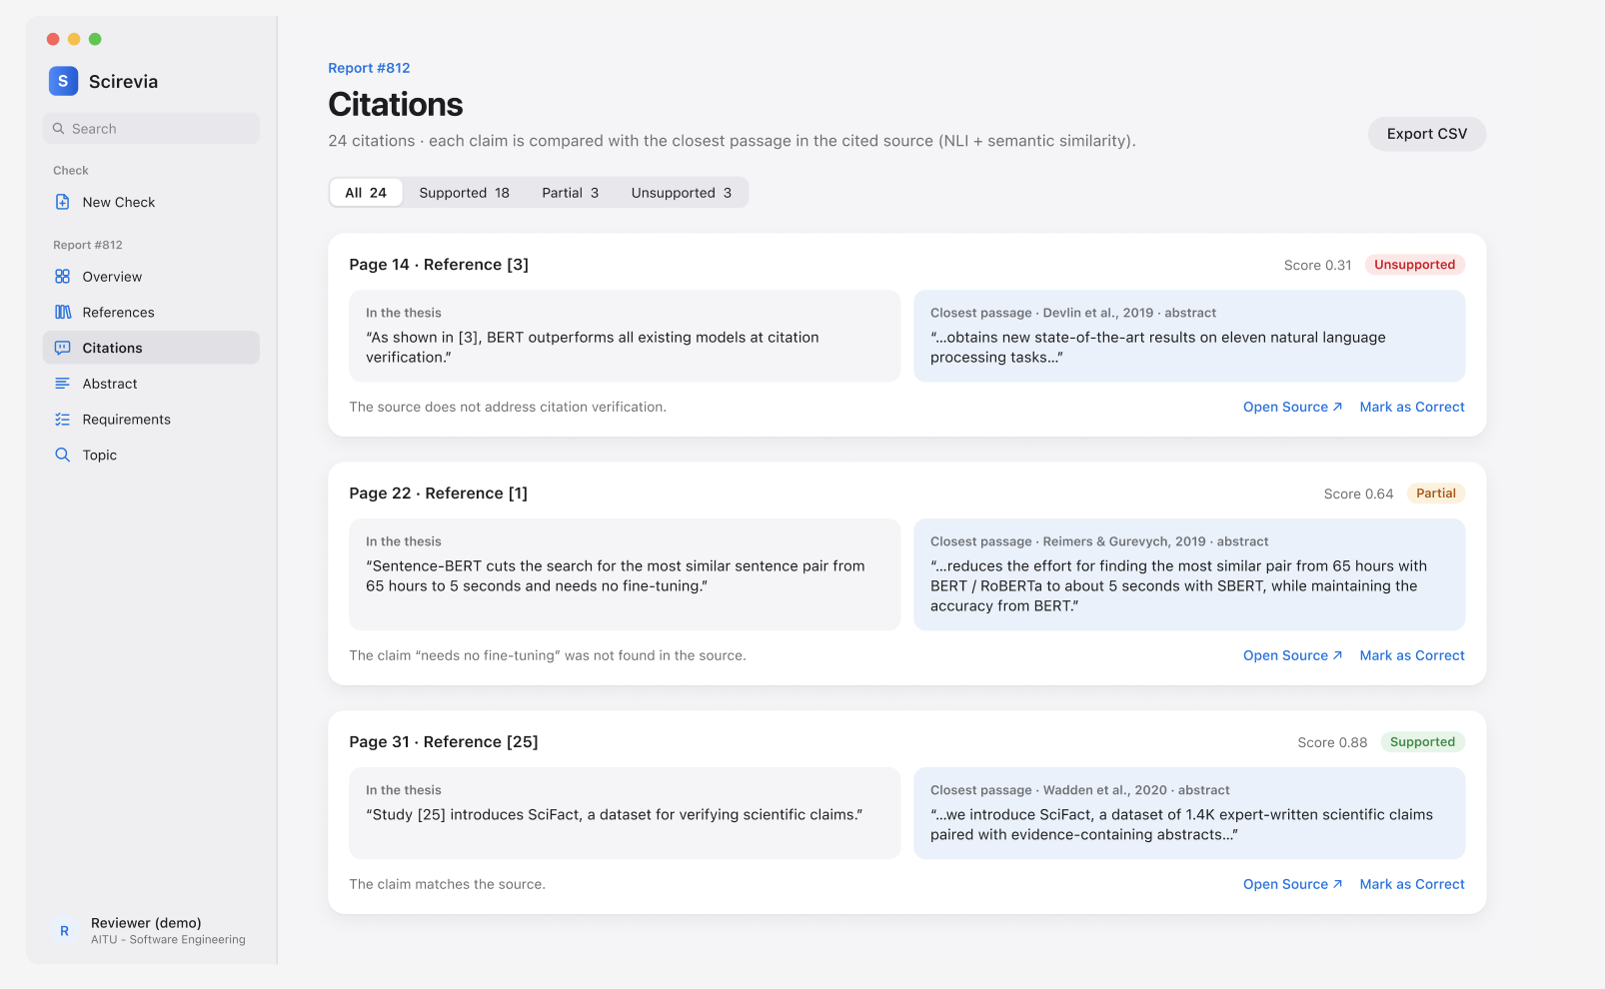
04-cites

9. Verification and Evaluation Plan

9.1 How the aim is demonstrated
The aim is achieved if, on a control sample of real theses, Scirevia (a) detects reference, citation, abstract, requirement and topic problems with accuracy above the defined thresholds and above simple baselines, (b) processes a thesis within the time limit, and (c) is usable and saves reviewers’ time compared with manual checking.

9.2 Testing levels
Level | Client (AK) | Server (MK) | Analysis service (SS)
Unit | Jest for UI logic | Jest: validation, link classifier, job state machine | pytest: parsers, rules, scoring
Integration | — | supertest + MongoDB test container; mocked analysis service | recorded API responses (Crossref/OpenAlex)
Contract | — | OpenAPI validation of requests/responses (both directions) | same
End-to-end | Playwright: 5 key scenarios from prototype | <- | <-
Performance | — | 10 concurrent checks (k6) | profiling per check
Security / privacy | — | OWASP ZAP baseline; auth matrix | network capture: no outbound text when llmConsent=false
CI: GitHub Actions on every pull request (NFR-08).

9.3 Control sample
- Documents: 20 theses of the School of SE (2022–2026, anonymised, with permission) + 5 published articles. (dependency: School / supervisor)
- Topic archive: list of past topics from the School (D-2).
- Annotation: two team members annotate independently, disagreements resolved with the supervisor; agreement reported as Cohen’s κ.

9.4 Experiments, metrics, baselines
# | What is measured | Ground truth | Metric | Baseline | Target
E1 | Structure extraction (FR-02) | Manually marked abstract, references, in-text citations in 20 docs | Precision / recall / F1 of reference entries; abstract found | GROBID only vs. rules only | F1 >= 0.85
E2 | Link & DOI check (FR-10, FR-11) | 200 links + 100 references labelled manually (working / broken / redirected-changed / wrong DOI) | Accuracy, per-class F1 | HTTP-status-only check | Accuracy >= 0.90 and > baseline
E2b | Non-existent references (FR-12) | 20 planted fabricated references + 80 real | Recall, precision | — | Recall >= 0.8
E3 | Citation verification (FR-21) | 150 citation–source pairs, labels: supported / partial / not supported | Macro-F1, confusion matrix; separately for RU, KZ, EN | TF-IDF cosine with tuned threshold | Macro-F1 >= 0.70 and >= baseline + 0.10
E4 | Abstract assessment (FR-31) | 2 experts rate abstract adequacy 1–5 for 20 theses | Spearman ρ between system score and mean expert rating | ROUGE-L between abstract and summary | ρ >= 0.6 and > baseline
E5 | Topic similarity (FR-50) | 30 query topics with labelled similar topics in archive | Precision@5, MRR | Jaccard similarity of keywords | P@5 >= 0.6; MRR >= baseline + 0.1
E6 | Processing time (NFR-02) | 20 docs, target server spec recorded | Median and max time per document | — | <= 5 min
E7 | Usability and time saved (NFR-01) | 5 users; reviewer checks references/citations of one thesis manually vs. with Scirevia | SUS; time on task; problems found | Manual check | SUS >= 70; >= 40 % time reduction

9.5 Conditions and threats to validity
Model versions and API snapshot dates are recorded; experiments repeated 3 times for LLM-based parts (temperature 0). Small sample from one School; annotators are team members (mitigated by supervisor adjudication and κ); limited open full texts -> “source unavailable” share is reported separately rather than counted as errors.

10. Project Management and Risks

10.1 Responsibilities
Area | S. Sergeyeva (ML/Data) | A. Kuanyshbekova (Frontend, UX/UI) | M. Khairgeldinova (Backend) | Supervisor
Requirements, interviews | R | R (scenarios) | C | A
Literature review | R | C | C | A
System & technology comparison | R (NLP) | R (client) | R (server, DB) | A
Architecture, API contracts | R (analysis API) | C | R (server API) | A
Prototype / Figma | C | R | C | I
Analysis service | R | I | C | C
Server, link check, storage | C | I | R | C
Client | I | R | C | I
Integration & testing, evaluation | R (quality) | R (usability) | R (E2E, perf.) | A
R – responsible; A – approves; C – consulted; I – informed.

10.2 Milestones (aligned with the supervisor’s plan)
# | Stage | Result | Date
M1 | Requirements and data analysis | Scenarios, survey S-1 (N = 26), request for topic archive and control sample; pre-defense 1 (tag pre-defense-1) | 24.10.2026
M2 | Design | Architecture, API specification, storage schema, UI mockups (Figma) | 15.11.2026
M3 | Base version | Upload, reference list extraction, link checking (E1, E2) | 20.12.2026
M4 | Text analysis | Citation check, summary and abstract comparison (E3, E4) | 15.02.2027
M5 | Requirements & topics | Requirements window, requirement checks, topic similarity (E5); pre-defense 2 | March 2027 (School schedule)
M6 | Integration & testing | Integrated system, evaluation on control sample (E6, E7) | 15.04.2027
M7 | Documentation | Explanatory note, presentation; final pre-defense | May 2027 (School schedule)

10.3 Risks
ID | Risk | P | I | Mitigation | Owner
R1 | Topic archive / control sample not provided in time by the School | M | H | Request at M1 via supervisor; fallback – topics from public AITU repository / own collection | SS
R2 | Open full texts unavailable for many sources | H | M | Use abstracts; explicit “source unavailable”; report share separately | SS
R3 | Low quality for Kazakh texts | M | M | Compare 3 multilingual models in E3; report per language | SS
R4 | GOST references parsed poorly | M | M | Rule-based fallback; retrain/adjust on 20 annotated docs | SS, MK
R5 | Integration problems between JS and Python components | M | H | OpenAPI contracts first (SCI-9); mocks; weekly integration build | all
R6 | Websites block automated link checks (403/429) | M | L | Browser-like UA, retries, class “access restricted” instead of “broken” | MK
R7 | Schedule slip in one component | M | H | Bi-weekly control; Must/Should priorities; reserve time before defence | supervisor
R8 | Confidentiality of student theses | L | H | Local processing by default, consent for LLM, retention 30 days, no theses in Git | all
R9 | LLM cost / API access | M | M | LLM only optional; local models for core checks | SS

10.4 Dependencies
- D1: archive of past topics and control sample from School of SE (blocks FR-50, E1–E5).
- D2: agreed API contracts (blocks parallel implementation).
- D3: server for deployment and model inference (to be requested from AITU IT at M2).
- D4: AITU official formatting requirements document (blocks template FR-43).
The full backlog (SCI-1…SCI-30) with assignees, priorities and due dates is maintained in YouTrack: https://sergeyevasss.youtrack.cloud/projects/SCI. Screenshots of the board and the issue list are submitted as a separate PDF.

11. Supervisor Feedback
The supervisor reviewed the project deliverables and considers the problem clearly defined, the scope realistic, and the engineering complexity sufficient. The claims register, requirements traceability, and the evaluation plan with baselines and target thresholds are the strongest parts of the work.
The main comments are as follows:
- In the technology comparison, criterion weights must be introduced so that the scores support the selected options.
- The literature review needs recent sources from 2025–2026.

Appendix A. Architecture Decision Records

ADR-001: Server on Node.js + Express
- Status: Accepted – Date: 22.10.2026 – Owner: M. Khairgeldinova – reviewed by supervisor
- Context: The server handles upload, storage, link/DOI checking (I/O-bound, many concurrent requests) and orchestration of checks. ML code lives in a separate Python service (ADR-003). Alternatives: FastAPI, NestJS (Section 5, D1).
- Decision: Node.js (LTS) + Express; multer (upload), joi/zod (validation), Mongoose, swagger-jsdoc + swagger-ui (OpenAPI), undici/axios with concurrency limit (p-limit) for link checks; Jest + supertest for tests.
- Consequences: + matches team expertise, efficient async I/O. − two languages in the system -> contracts must be explicit (OpenAPI, shared JSON schemas in docs/api/).

ADR-002: MongoDB as main storage
- Status: Accepted – Date: 22.10.2026 – Owner: M. Khairgeldinova
- Context: Check reports are nested and evolve as checks are added; requirement templates are user-defined. Alternatives: PostgreSQL, PostgreSQL+JSONB (Section 5, D2).
- Decision: MongoDB with collections users, documents, checkJobs, reports, requirementTemplates, topics; files in GridFS; Mongoose schemas enforce structure. Topic embeddings are kept in the analysis service index, rebuilt when topics changes.
- Consequences: + flexible reports, team familiarity. − referential integrity in application code; indexes on documents.userId, checkJobs.status required.

ADR-003: REST between components, asynchronous check jobs
- Status: Accepted – Date: 22.10.2026 – Owners: whole team
- Context: Three components are developed in parallel by different people in different languages; some checks take minutes. Alternatives: synchronous REST, message broker (Section 5, D3).
- Decision: Client <-> Server: REST/JSON. Server <-> Analysis service: REST/JSON; server creates a checkJob, calls POST /analyze/{check} on the analysis service, which returns 202 and later posts results to POST /internal/jobs/{id}/result (shared secret). Client polls GET /api/checks/{id}. Contracts in docs/api/openapi-*.yaml, agreed before coding (task SCI-9).
- Consequences: + independent development and testing with mocks; no extra infrastructure. − must handle lost callbacks (timeout -> retry/failed status).

ADR-004: Hybrid document structure extraction
- Status: Proposed (final after experiment E1) – Owners: M. Khairgeldinova (upload, text extraction), S. Sergeyeva (reference/citation parsing)
- Context: Reference lists in AITU theses use GOST, APA and IEEE styles; documents are DOCX or PDF.
- Decision: DOCX -> python-docx/mammoth; PDF -> GROBID (TEI) with PyMuPDF fallback; reference strings -> GROBID parser + rules for GOST; in-text citations -> regex for [n], (Author, Year), [n, p. x].
- Consequences: + best available parser for PDFs (Tkaczyk et al. 2018). − Java service in Docker Compose; GOST quality must be measured (E1, target F1 >= 0.85).

ADR-005: NLP approach for citation, abstract and topic checks
- Status: Proposed (model chosen after E3–E5) – Owner: S. Sergeyeva
- Context: Cross-lingual (RU/KZ/EN), paraphrase-aware comparison is required; documents are confidential.
- Decision:
  - Citation check: split source text into passages -> retrieve top-k by multilingual embeddings (candidates: multilingual-e5-base, LaBSE, paraphrase-multilingual-mpnet) -> NLI cross-encoder label (supported / partial / not supported) -> show fragment and score. Baseline: TF-IDF cosine.
  - Abstract check: summary (LLM with consent, else extractive) + coverage (BERTScore-style) + NLI consistency of each abstract sentence against the body.
  - Topic check: embedding of title + abstract vs. archive; top-5 with cosine score; threshold calibrated on labelled pairs.
  - LLM: provider-agnostic interface; disabled unless the user consents per document.
- Consequences: + local, explainable, multilingual. − Kazakh quality uncertain -> reported separately in evaluation.

Appendix B. Survey Questionnaire and Interview Guide

B.1 Survey S-1 (Google Forms, 23.10.2026, N = 26)
- What is your current role? (undergraduate student; master’s student; PhD student; university lecturer or professor; other)
- How often do you check references and citations in academic documents? (always; often; sometimes; rarely; never)
- How do you usually check references and citations in scientific documents? (manually; open links and verify sources individually; reference management software; plagiarism detection software; other digital tools; do not usually check; other)
- How much time do you usually spend checking references and citations in one scientific document? (less than 15 min; 15–30 min; 31–60 min; more than 1 hour; depends on the document; do not perform these checks)
- What is the most difficult part of checking an academic document? (broken links or incorrect DOIs; whether sources actually support citations; abstract accuracy; compliance with academic requirements; similar research topics; other)
- Have you ever encountered broken links or references that could not be verified? (yes; no; not sure)
- What tools do you currently use to check academic documents? (Turnitin or similar; DOI or reference lookup services; reference management tools; manual checking; other)
- Which features would be most useful to you in such a system? (link check; DOI and bibliographic metadata; citations support statements; abstract vs. content; academic requirements; similar research topics; report with detected issues; other)
- What additional features or improvements would you suggest? (open question)

B.2 Interview guide (I-1…I-3, before pre-defense 2)
Explain purpose; ask consent for notes; agree on anonymity.

Context
- Your role? How many theses / articles do you check or write per year?
- What do you check first in a thesis? What takes the most time?

References
- How do you check the reference list? Do you open links? How often are they broken or wrong?
- Have you seen references that do not exist (e.g. generated by ChatGPT)? How did you notice?

Citations
- Do you check whether a quotation or paraphrase matches the source? How often do you find mismatches?

Abstract
- How often does the abstract not reflect the content? What is typically wrong?

Requirements
- Which formal requirements do you check (structure, volume, number/age of references, formatting)? Are they the same for all programmes?

Topics
- How is a repeated topic detected today? Has it happened?

Tools
- Which tools do you use (Turnitin, StrikePlagiarism, others)? What do they not cover?
- What would make you trust an automatic report? What must it show?
- If the system could do only three things – which?

Protocol template (docs/evidence/I-n.md)
ID | Date | Role | Duration | Interviewer
Key quotes:
Pain points:
Measured values (time, counts):
Claims confirmed / contradicted (C#):
New requirements:

References
Astana IT University, School of Software Engineering. (2026). Diploma project formatting requirements; ГОСТ 7.1-2003. Библиографическая запись. Библиографическое описание. Общие требования и правила составления.
Beltagy, I., Peters, M. E., & Cohan, A. (2020). Longformer: The long-document transformer. arXiv. https://doi.org/10.48550/arXiv.2004.05150
Cohan, A., Dernoncourt, F., Kim, D. S., et al. (2018). A discourse-aware attention model for abstractive summarization of long documents. In Proceedings of NAACL-HLT 2018 (pp. 615–621). https://doi.org/10.18653/v1/N18-2097
Crossref. (n.d.). Crossref REST API documentation. Retrieved October 23, 2026, from https://api.crossref.org
Feng, F., Yang, Y., Cer, D., Arivazhagan, N., & Wang, W. (2022). Language-agnostic BERT sentence embedding. In Proceedings of ACL 2022 (pp. 878–891). https://doi.org/10.18653/v1/2022.acl-long.62
Foltýnek, T., Meuschke, N., & Gipp, B. (2019). Academic plagiarism detection: A systematic literature review. ACM Computing Surveys, 52(6), 112. https://doi.org/10.1145/3345317
GROBID. (n.d.). GROBID documentation. Retrieved October 23, 2026, from https://grobid.readthedocs.io
Hendricks, G., Tkaczyk, D., Lin, J., & Feeney, P. (2020). Crossref: The sustainable source of community-owned scholarly metadata. Quantitative Science Studies, 1(1), 414–427. https://doi.org/10.1162/qss_a_00022
Jergas, H., & Baethge, C. (2015). Quotation accuracy in medical journal articles — a systematic review and meta-analysis. PeerJ, 3, e1364. https://doi.org/10.7717/peerj.1364
Jones, S. M., Van de Sompel, H., Shankar, H., et al. (2016). Scholarly context adrift: Three out of four URI references lead to changed content. PLoS ONE, 11(12), e0167475. https://doi.org/10.1371/journal.pone.0167475
Kinney, R., Anastasiades, C., Authur, R., et al. (2023). The Semantic Scholar Open Data Platform. arXiv. https://doi.org/10.48550/arXiv.2301.10140
Klein, M., Van de Sompel, H., Sanderson, R., et al. (2014). Scholarly context not found: One in five articles suffers from reference rot. PLoS ONE, 9(12), e115253. https://doi.org/10.1371/journal.pone.0115253
Kousha, K., & Thelwall, M. (2024). Artificial intelligence to support publishing and peer review: A summary and review. Learned Publishing, 37(1), 4–12. https://doi.org/10.1002/leap.1570
Laban, P., Schnabel, T., Bennett, P. N., & Hearst, M. A. (2022). SummaC: Re-visiting NLI-based models for inconsistency detection in summarization. Transactions of the Association for Computational Linguistics, 10, 163–177. https://doi.org/10.1162/tacl_a_00453
Liang, W., Zhang, Y., Cao, H., et al. (2024). Can large language models provide useful feedback on research papers? A large-scale empirical analysis. NEJM AI, 1(8). https://doi.org/10.1056/AIoa2400196
Lin, C.-Y. (2004). ROUGE: A package for automatic evaluation of summaries. In Text Summarization Branches Out (ACL Workshop) (pp. 74–81). https://aclanthology.org/W04-1013
Mogull, S. A. (2017). Accuracy of cited “facts” in medical research articles: A review of study methodology and recalculation of quotation error rate. PLoS ONE, 12(9), e0184727. https://doi.org/10.1371/journal.pone.0184727
Priem, J., Piwowar, H., & Orr, R. (2022). OpenAlex: A fully-open index of scholarly works, authors, venues, institutions, and concepts. arXiv. https://doi.org/10.48550/arXiv.2205.01833
Reimers, N., & Gurevych, I. (2019). Sentence-BERT: Sentence embeddings using Siamese BERT-networks. In Proceedings of EMNLP-IJCNLP 2019 (pp. 3982–3992). https://doi.org/10.18653/v1/D19-1410
Reimers, N., & Gurevych, I. (2020). Making monolingual sentence embeddings multilingual using knowledge distillation. In Proceedings of EMNLP 2020 (pp. 4512–4525). https://doi.org/10.18653/v1/2020.emnlp-main.365
Tkaczyk, D., Collins, A., Sheridan, P., & Beel, J. (2018). Machine learning vs. rules and out-of-the-box vs. retrained: An evaluation of open-source bibliographic reference and citation parsers. In Proceedings of the 18th ACM/IEEE Joint Conference on Digital Libraries (JCDL ’18). https://doi.org/10.48550/arXiv.1802.01168
Wadden, D., Lin, S., Lo, K., et al. (2020). Fact or fiction: Verifying scientific claims. In Proceedings of EMNLP 2020 (pp. 7534–7550). https://doi.org/10.18653/v1/2020.emnlp-main.609
Walters, W. H., & Wilder, E. I. (2023). Fabrication and errors in the bibliographic citations generated by ChatGPT. Scientific Reports, 13, 14045. https://doi.org/10.1038/s41598-023-41032-5
Wang, L., Yang, N., Huang, X., et al. (2024). Multilingual E5 text embeddings: A technical report. arXiv. https://doi.org/10.48550/arXiv.2402.05672
Zha, Y., Yang, Y., Li, R., & Hu, Z. (2023). AlignScore: Evaluating factual consistency with a unified alignment function. In Proceedings of ACL 2023. https://doi.org/10.18653/v1/2023.acl-long.634
Zhang, T., Kishore, V., Wu, F., Weinberger, K. Q., & Artzi, Y. (2020). BERTScore: Evaluating text generation with BERT. In International Conference on Learning Representations (ICLR 2020). https://doi.org/10.48550/arXiv.1904.09675

