|  |  |  |
| --- | --- | --- |
| Icon | Present Notification format | Correct Format |
| New User Registration |  |  |
| New Tailor Registration |  |  |
| New Vendor Registration |  |  |
| New Order Notification |  |  |
| New Shipping Notification |  |  |
|  |  |  |
| Out Of Stock |  | PMD-564 has 0 quantity.  09-02-2017 |
| New Products Added By Vendor |  | VMD-123 added a new fabric product. 09-02-2017 |
|  |  |  |

Common bugs in notification section

1. Date and time are missing from notifications.

2. Setting button is not working.

3. Maximum 2 notifications should shown in drop down And other new notifications shown after click on View All button.

5. View all option is missing.

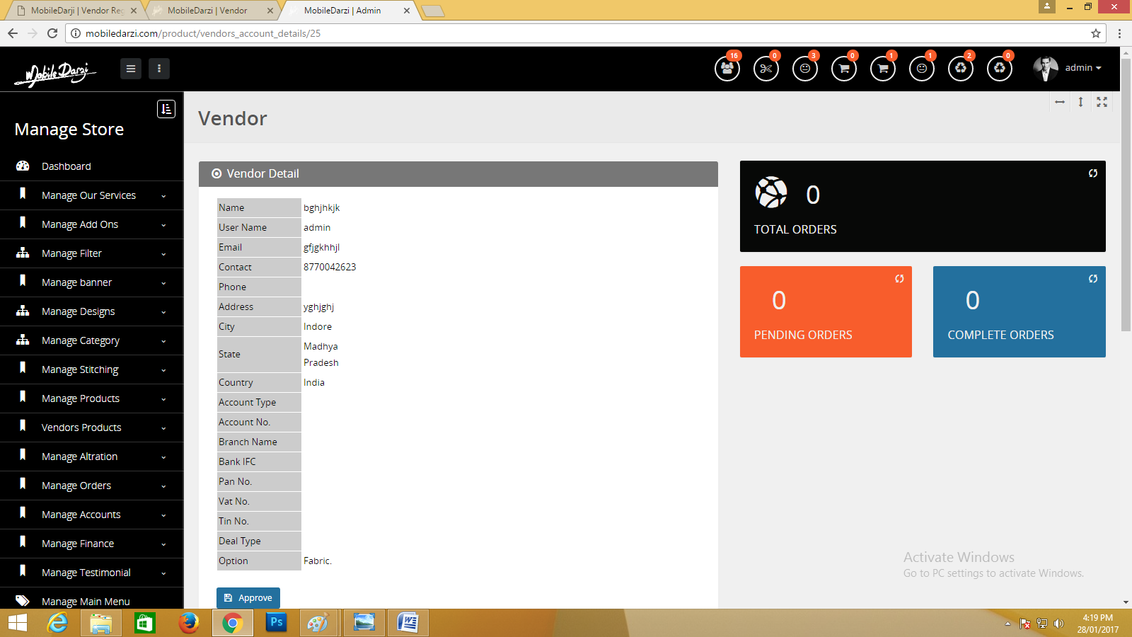

Notification Corrections on admin panel