AI CODING

## ASSIGNMENT-4.4

**2403A51269**

**A.DHANALAXMI**

**TASK-1:**

**CODE:**

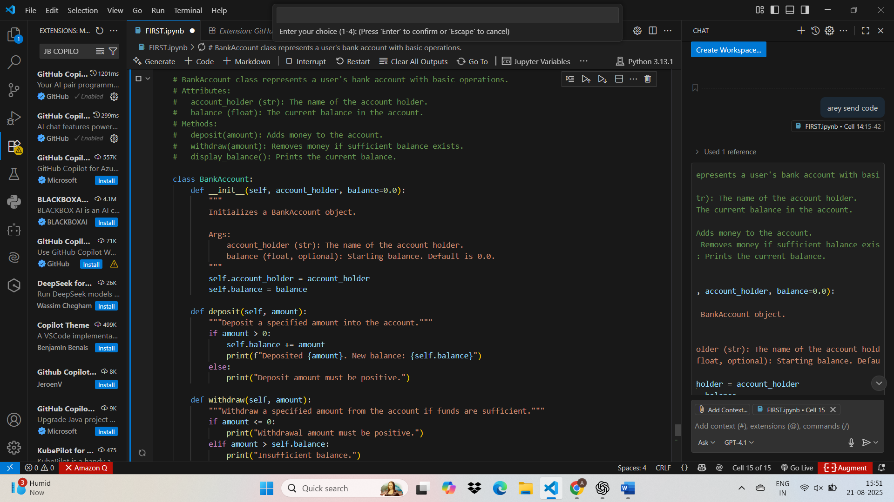

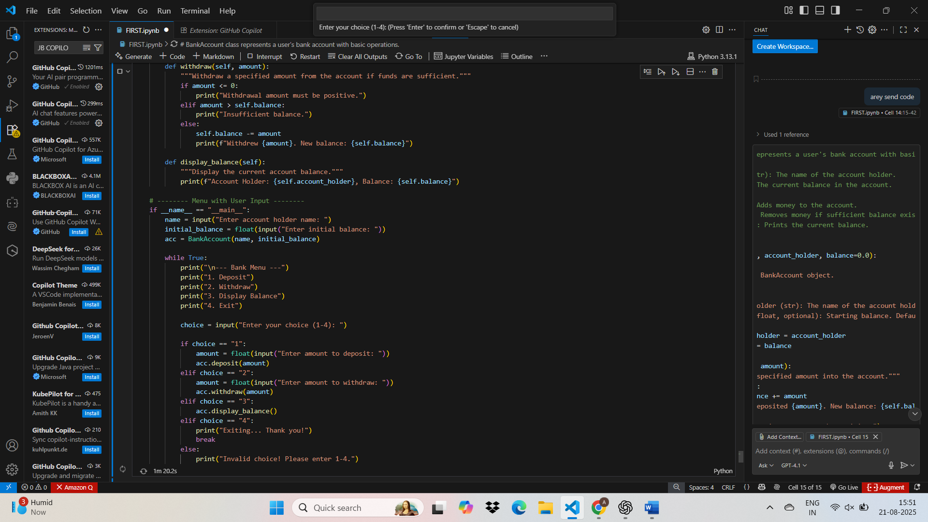

**OUTPUT:**

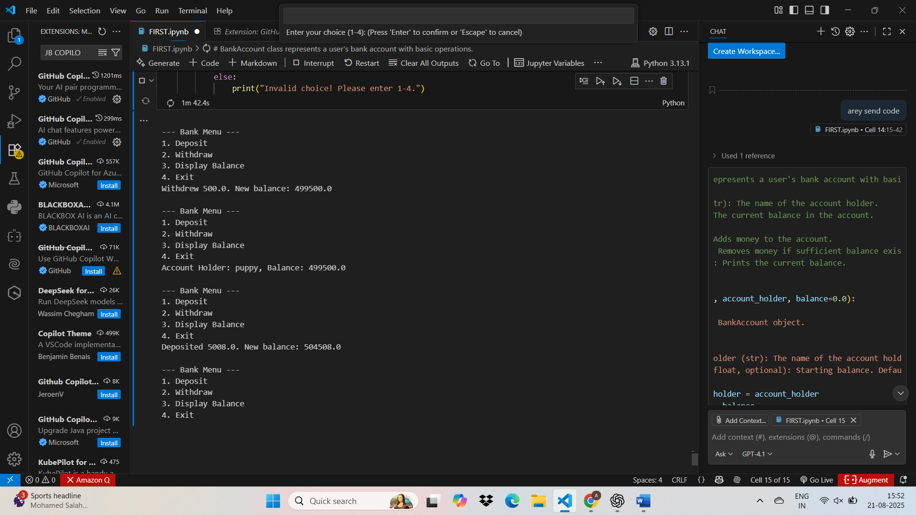

**TASK-2**

**CODE WITH OUTPUT:**

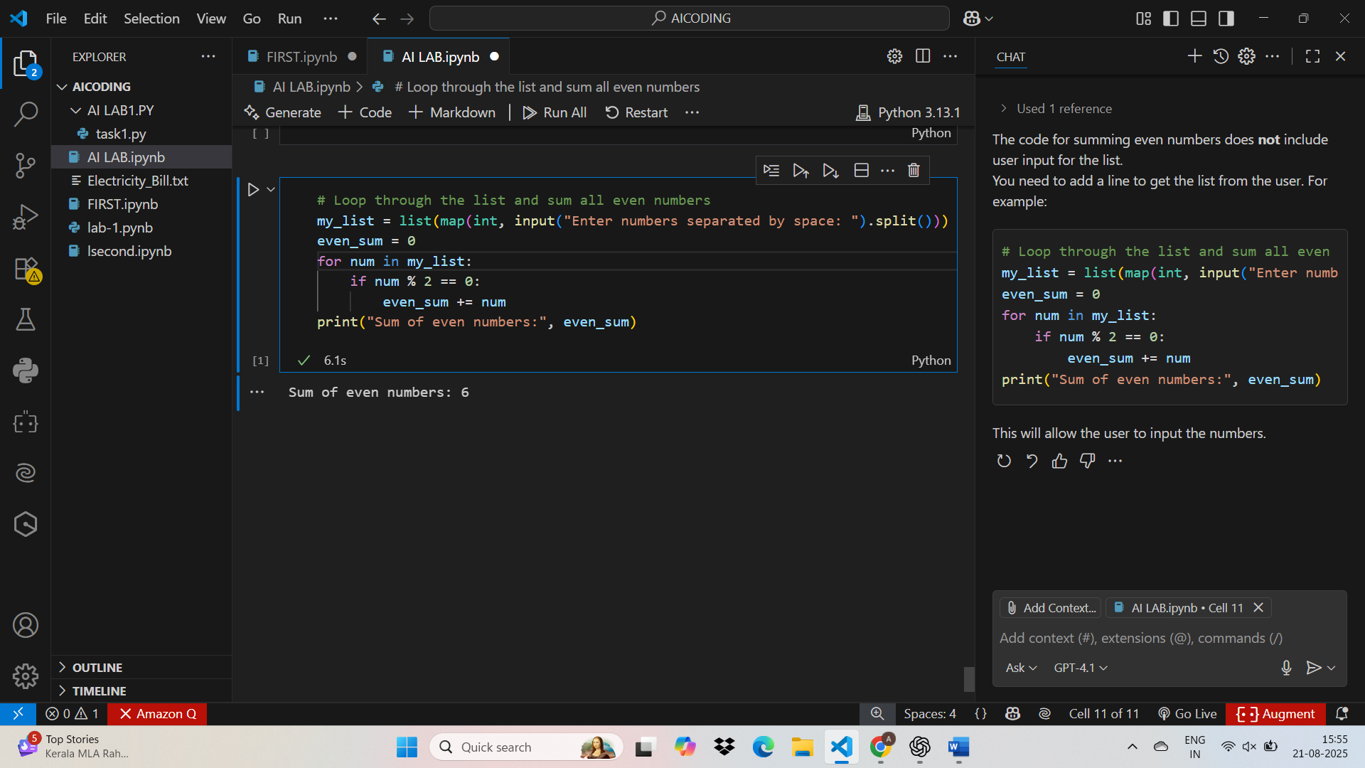

**TASK3:**

**CODE WITH OUTPUT:**

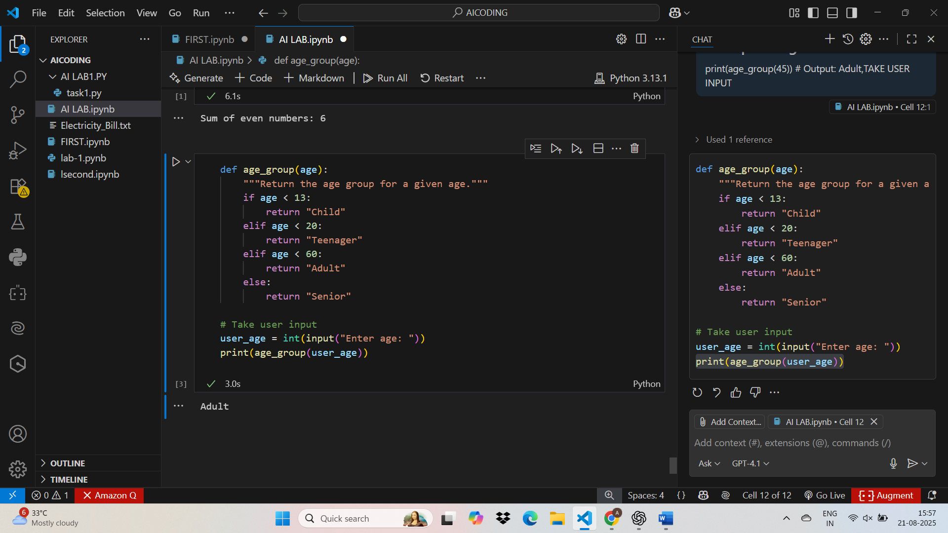

**TASK-4:**

**CODE WITH OUTPUT**

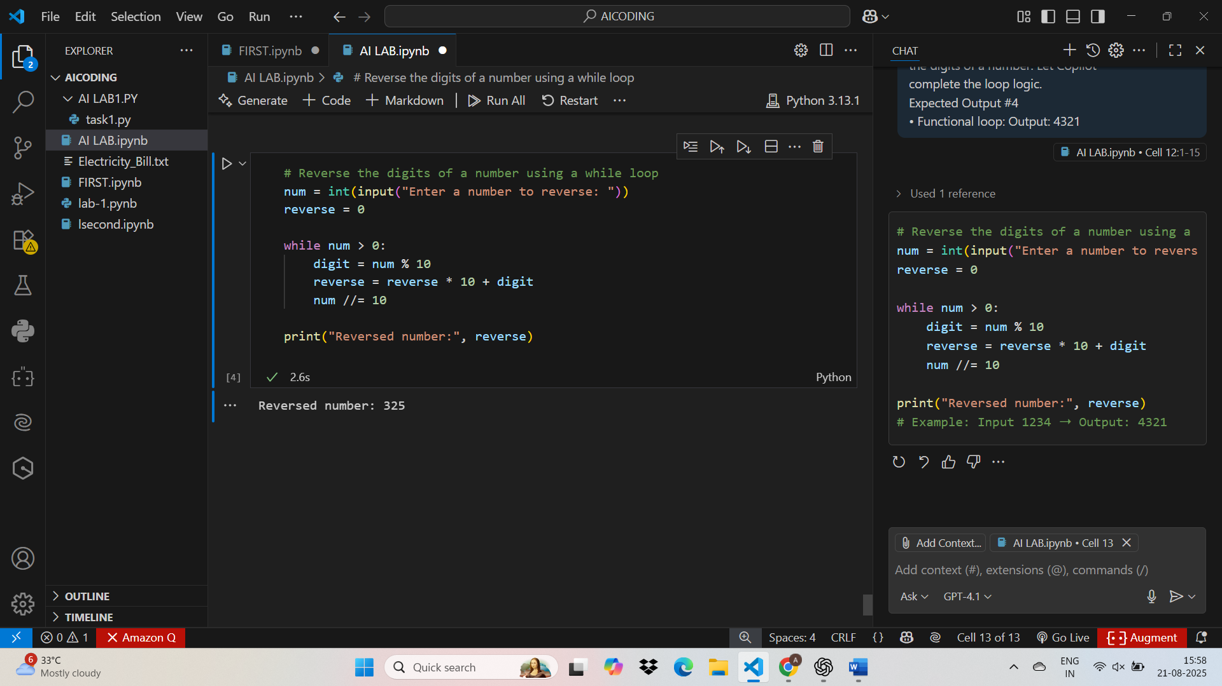

**TASK 5:**

**Code with output:**

