AI ASSISTED CODING

LAB-EXAM:1

2403A51269 A.DHANALAXMI

Q1:



Few-short Prompt:

Prompt:

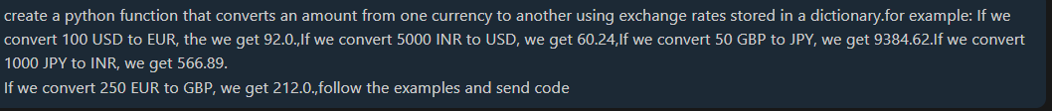

Code:

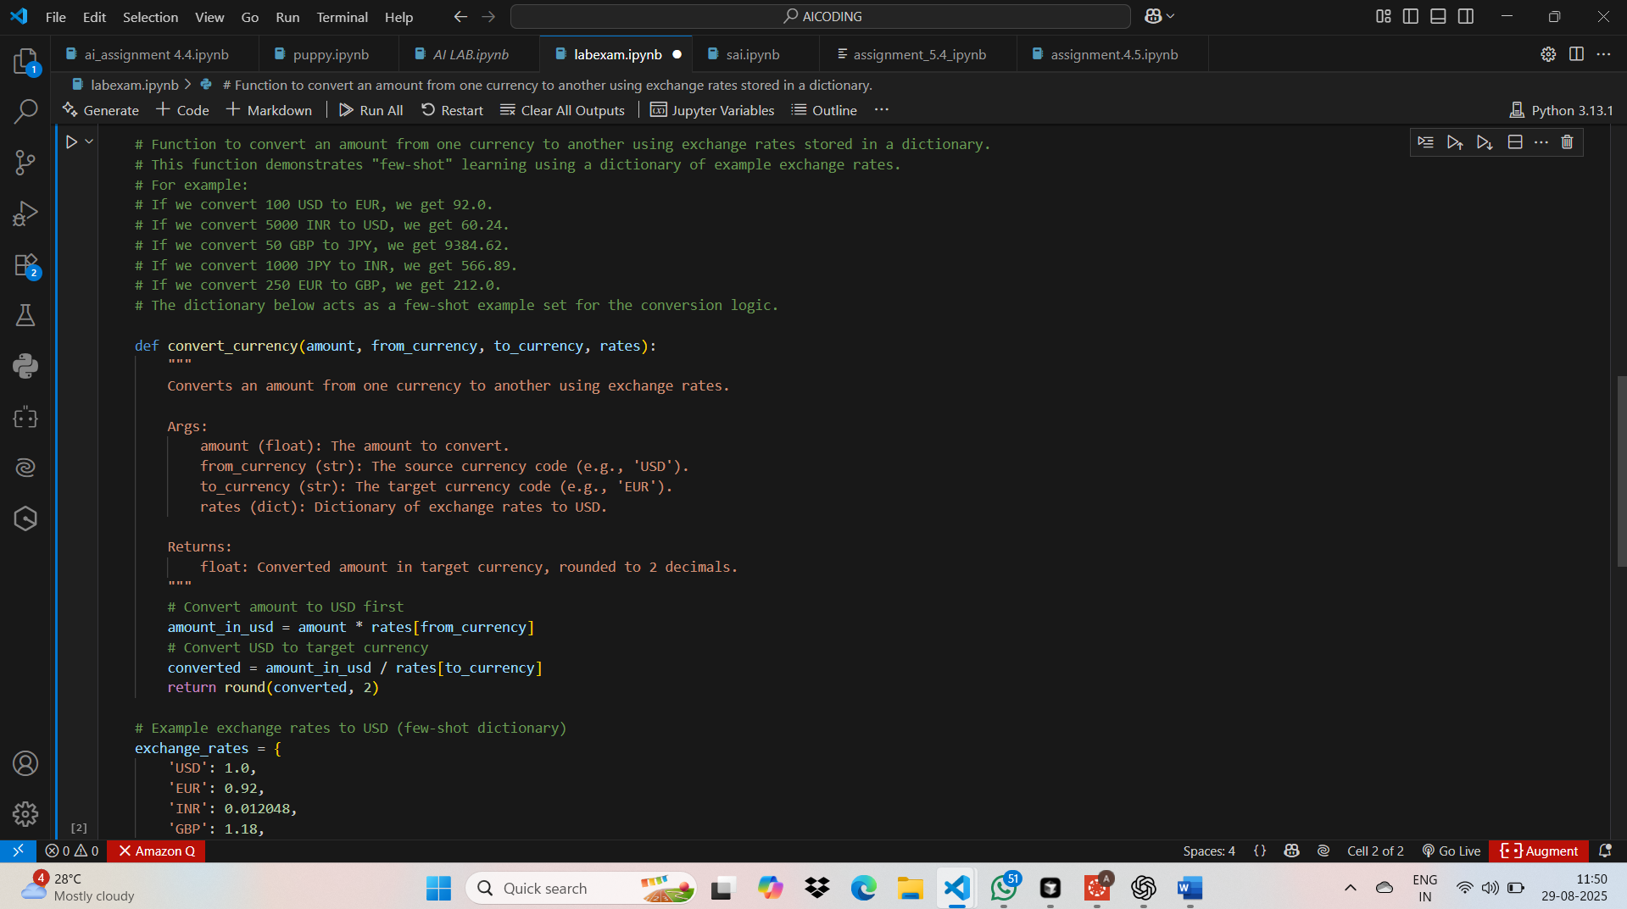

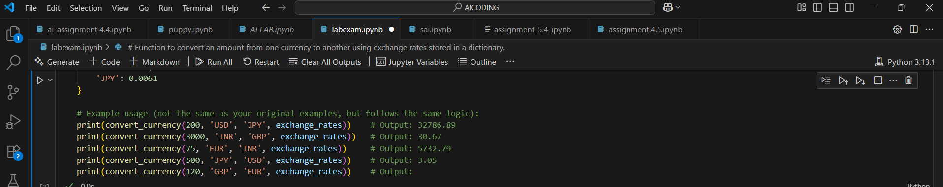

Output:

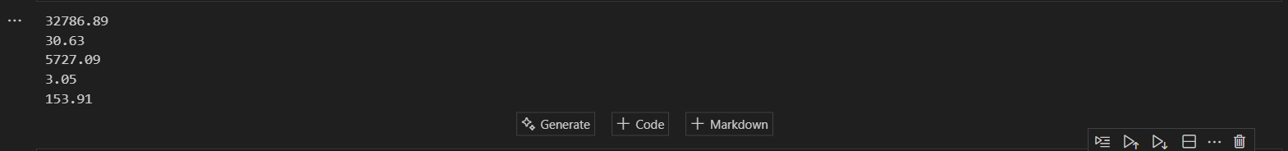

Q2:



Zero-Short Prompting:

Prompt:

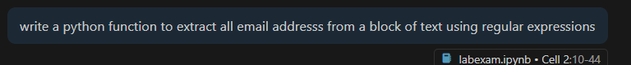

Code:

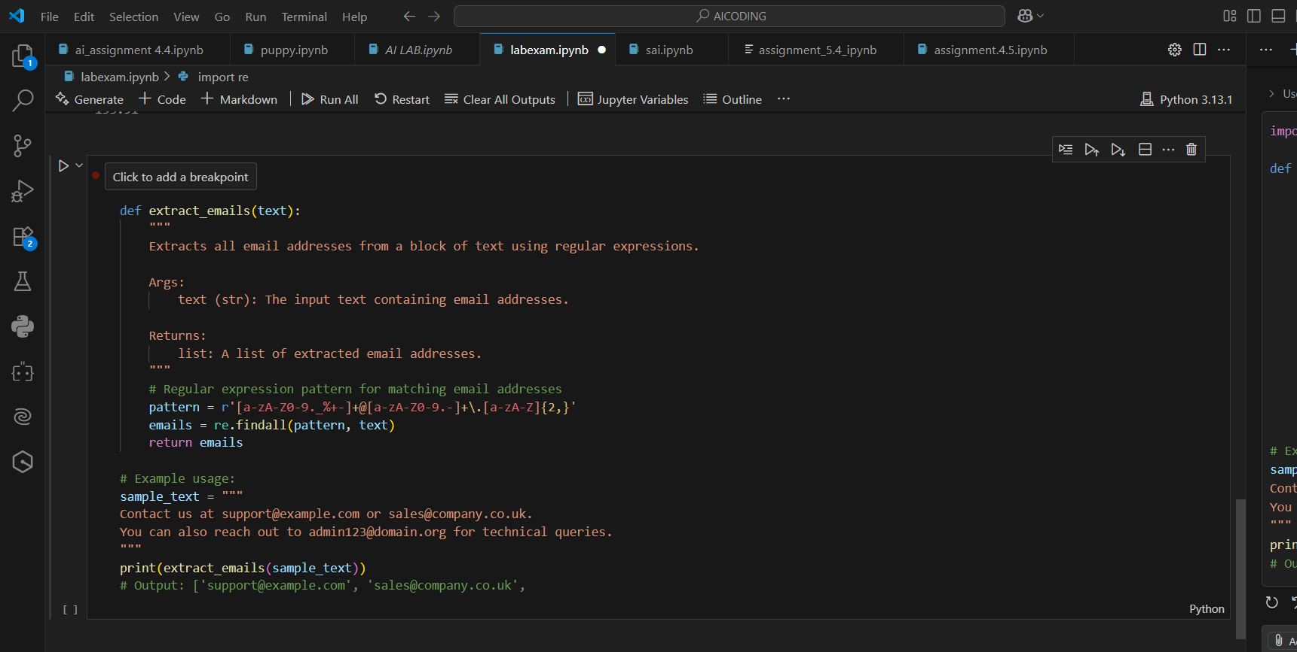

Output:



Q3:



Prompt:

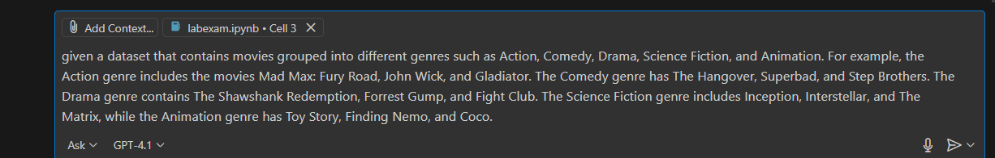



Code:

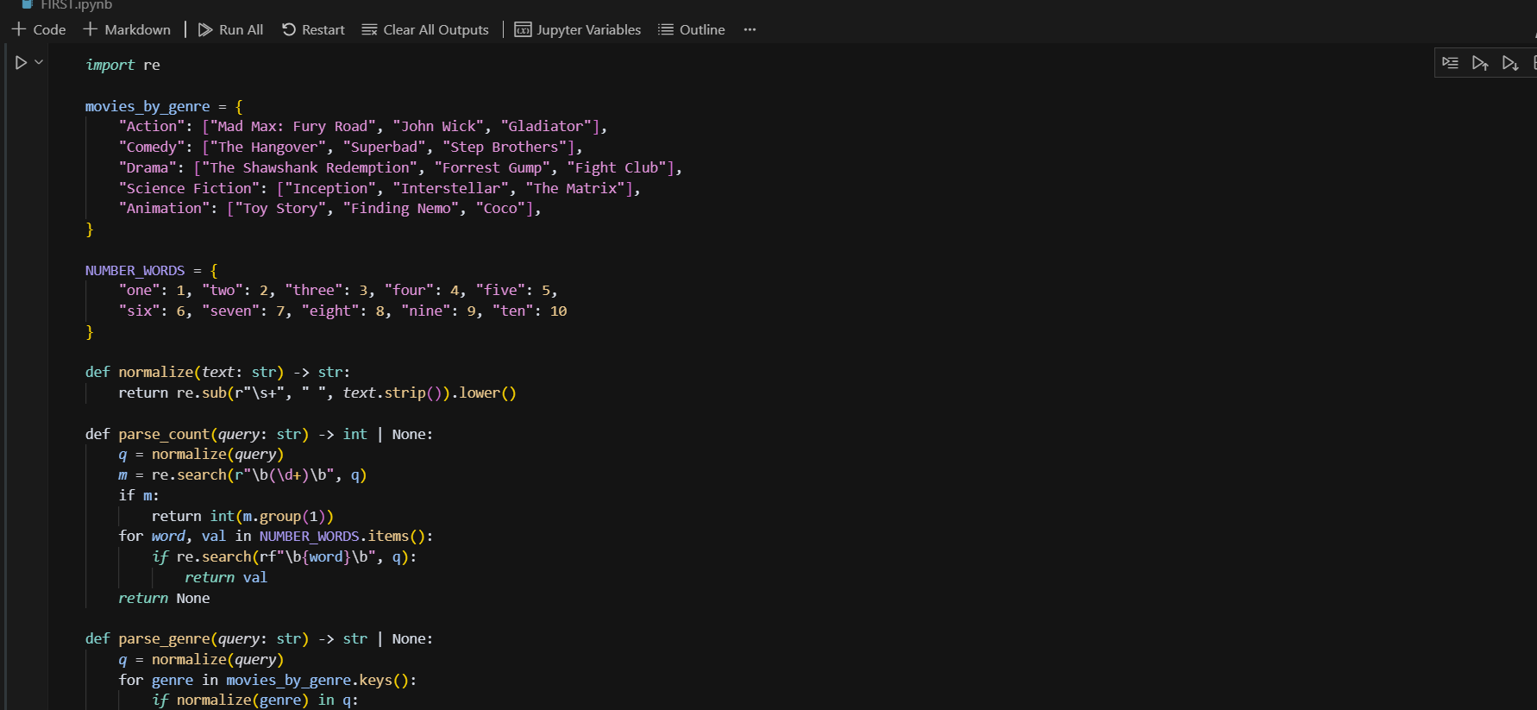

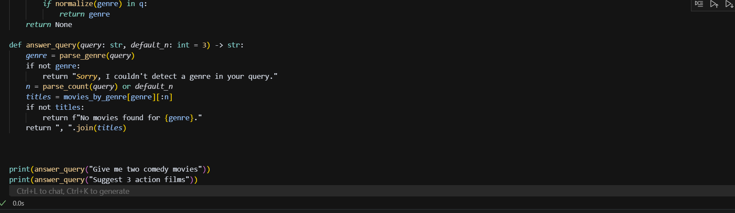

Output:



Q4:



Prompt:



Code:

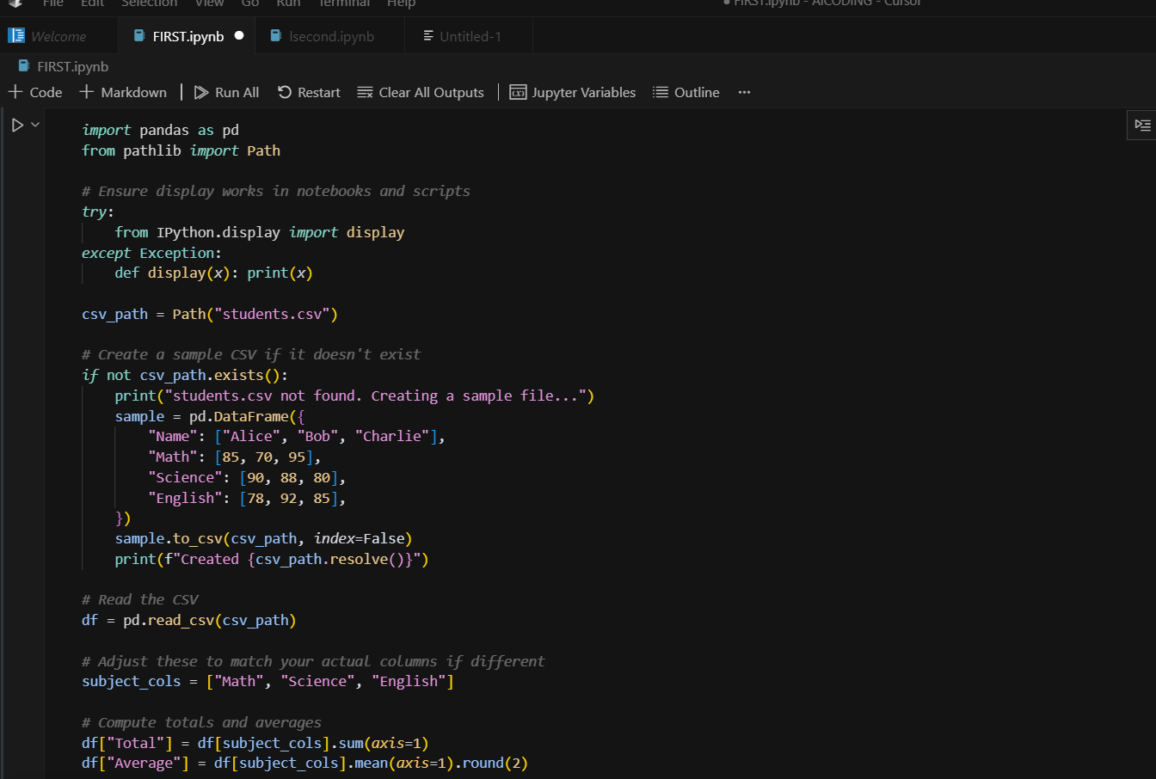

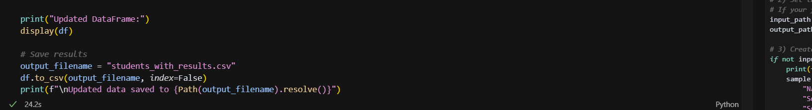

Output:

