AI CODING

ASSIGNMENT-4.4
2403A51269
A.DHANALAXMI

TASK-1:
CODE:
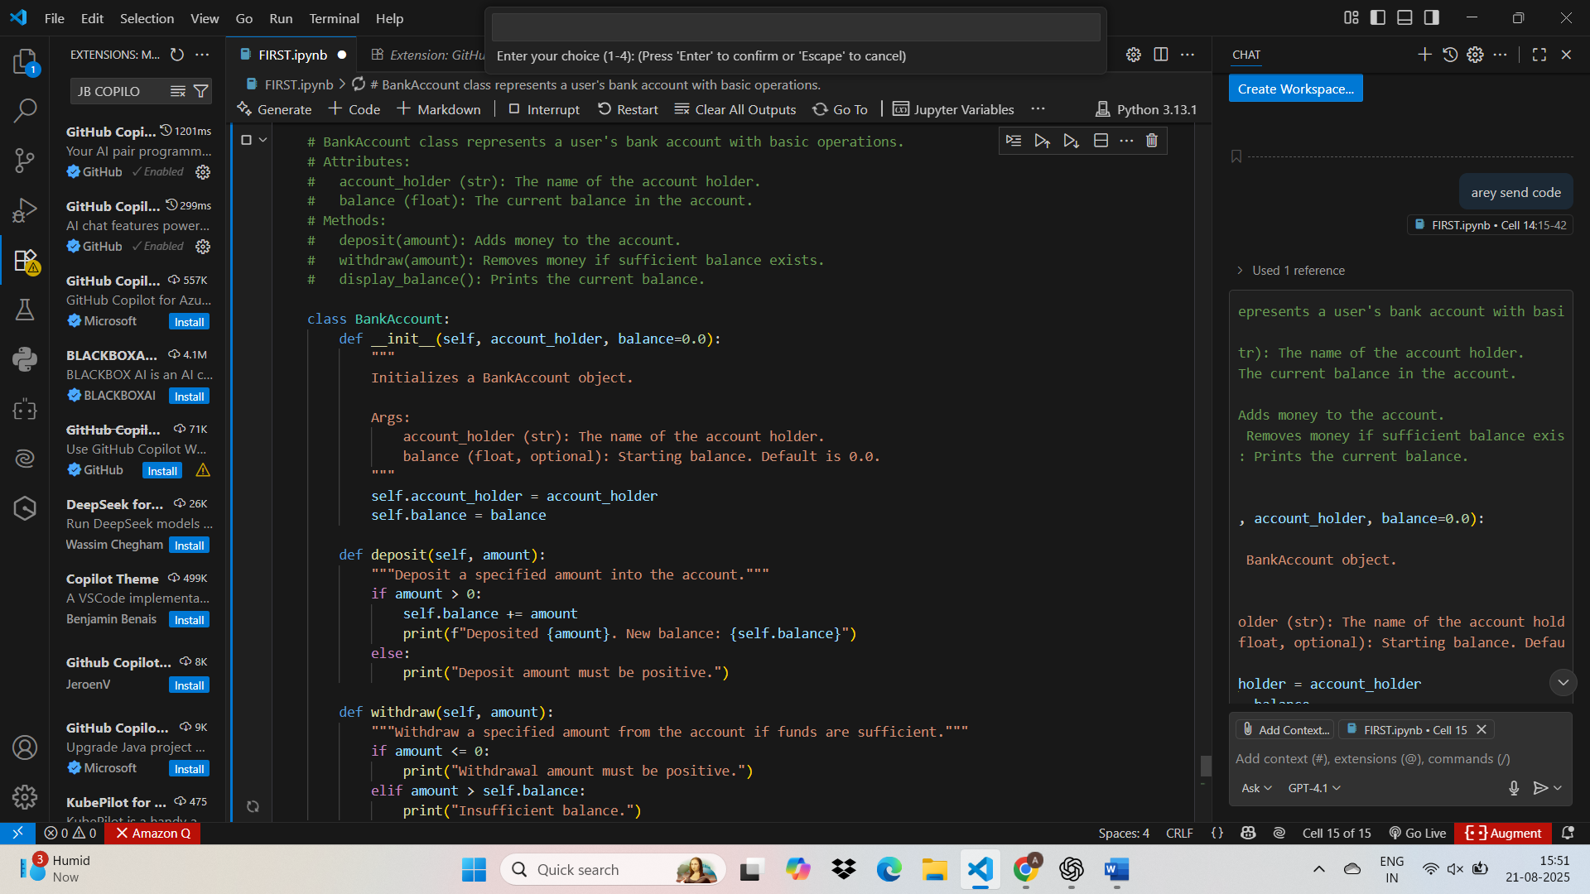
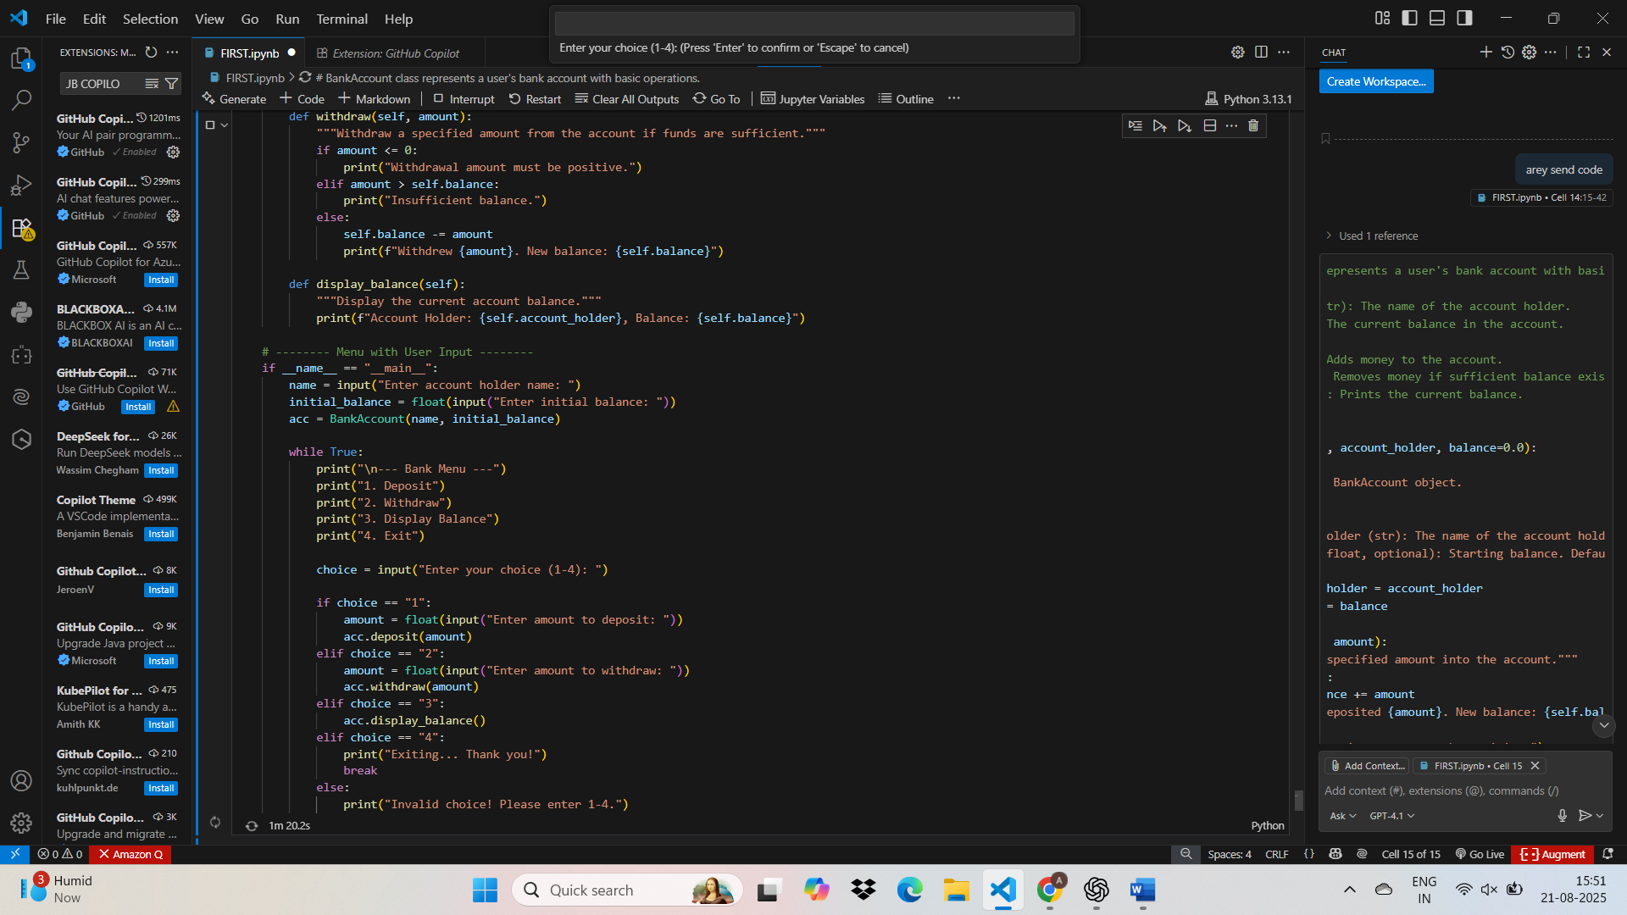
OUTPUT:
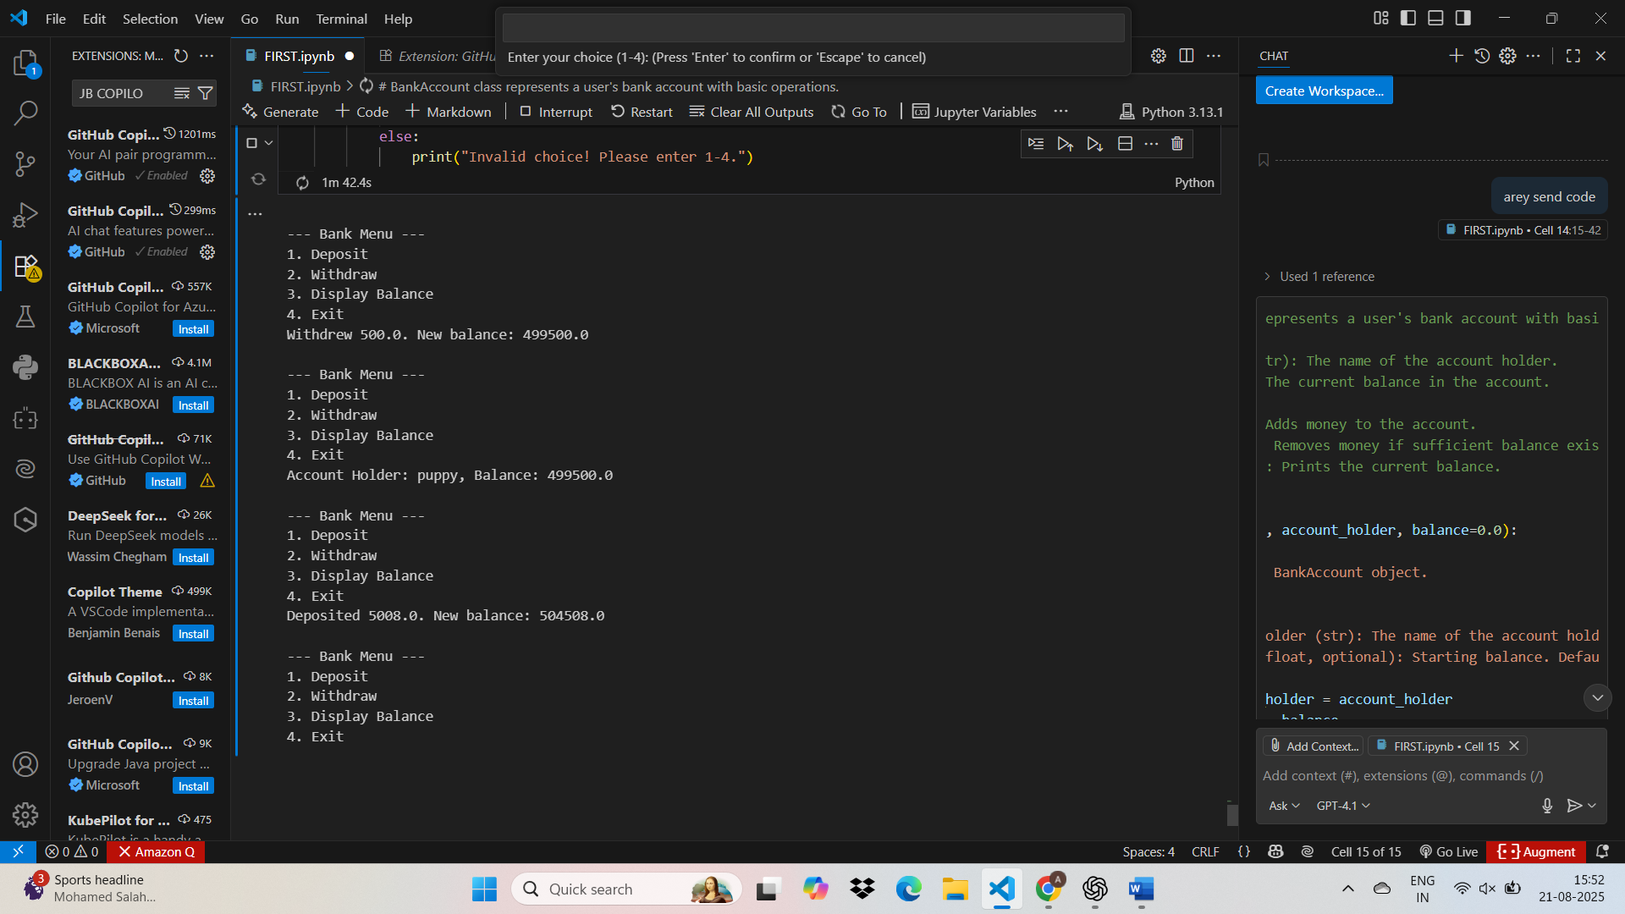

TASK-2
CODE WITH OUTPUT:
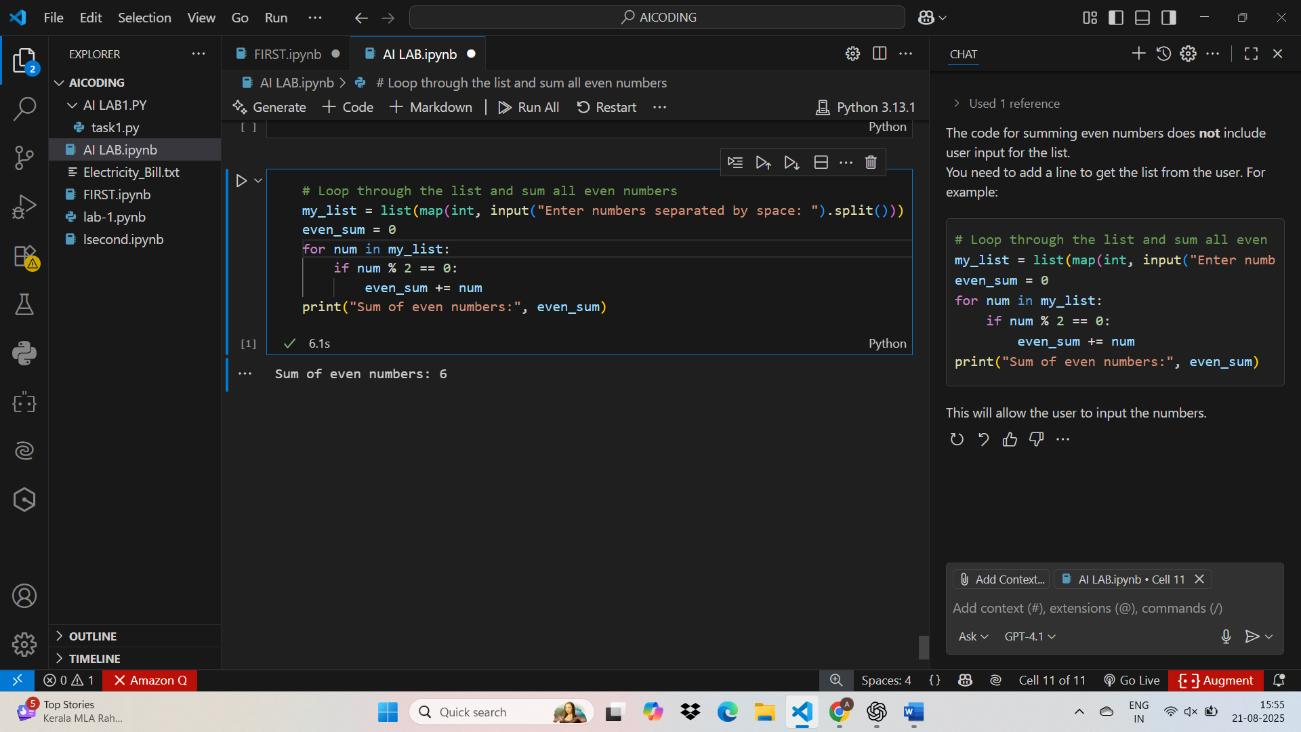

TASK3:
CODE WITH OUTPUT:

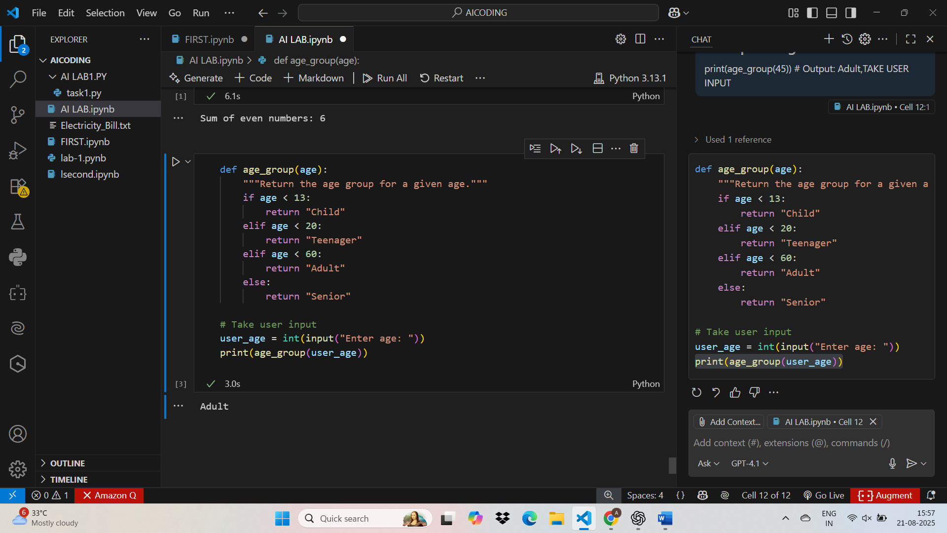
TASK-4:
CODE WITH OUTPUT
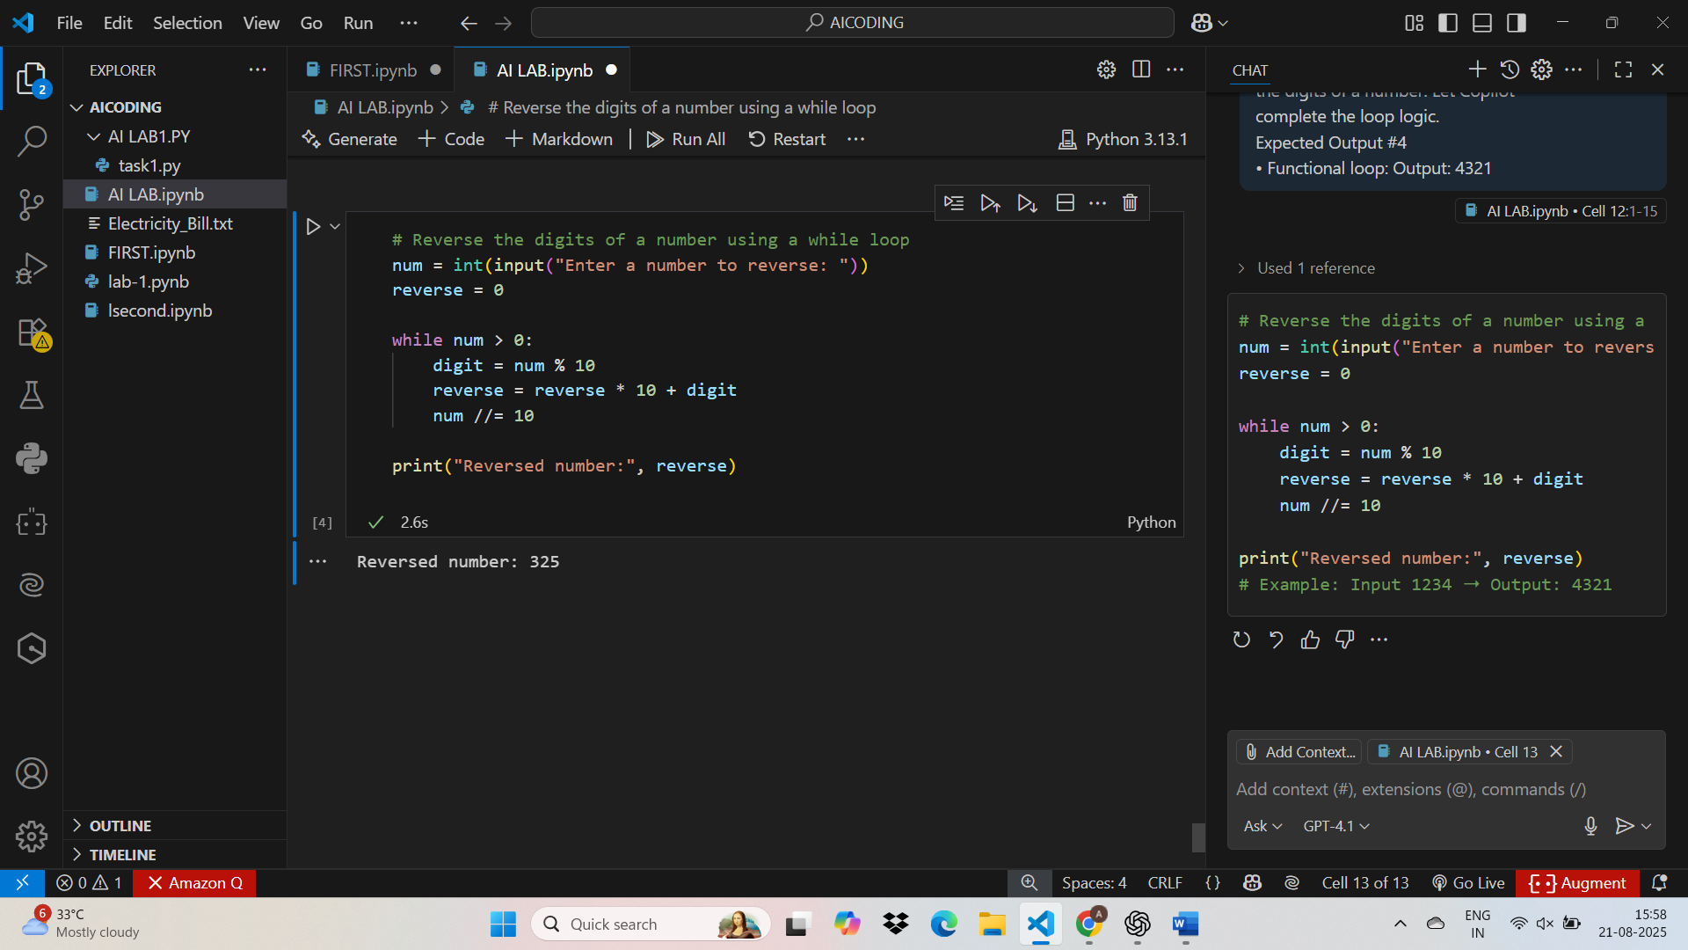

TASK 5:
Code with output:
