AI ASSISTED CODING
Assignment-7.1
Name:A.Dhanalaxmi
Hno:2403A51269

TASK-1:
Given code with output(error):
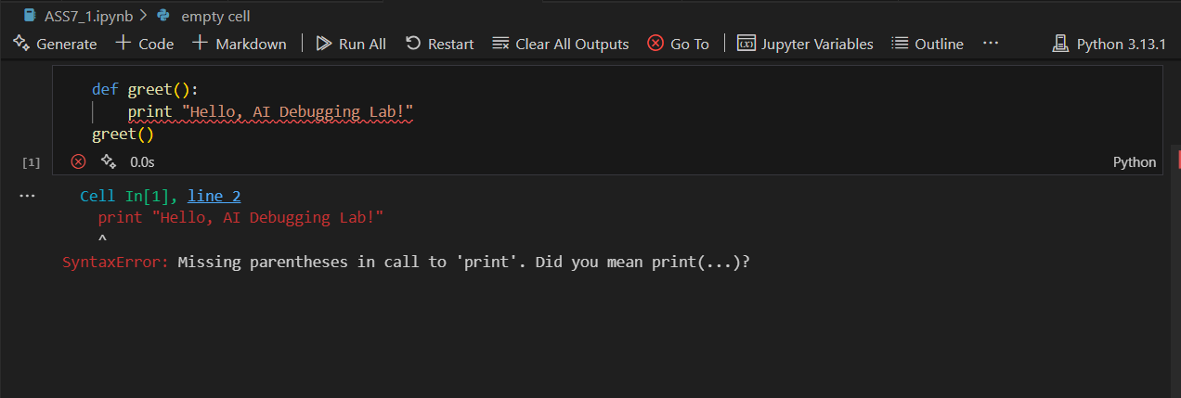
Prompt:
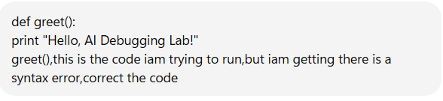
Code with output:
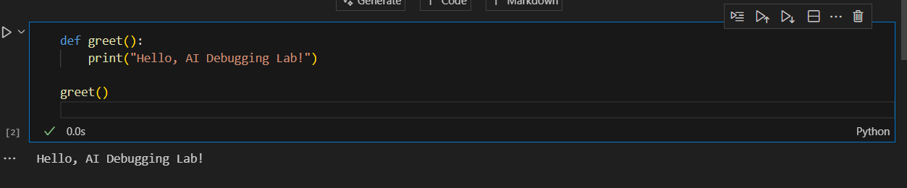

Prompt:


✅ Corrected Code with AI Fix
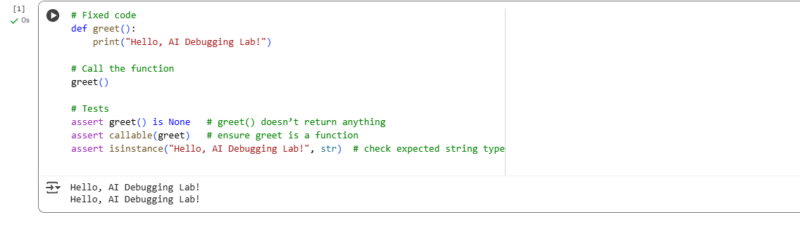
Explanation:

🔴 Original Buggy Code (with syntax error)
def greet():
print "Hello, AI Debugging Lab!"
greet()
Explanation:
- def greet():
  - Defines a function called greet.
  - The function body starts after the colon :.
- print "Hello, AI Debugging Lab!"
  - This is Python 2 style syntax where print is a statement.
  - In Python 3, print is a function, so it must use parentheses.
  - That’s why this line causes:
  - SyntaxError: Missing parentheses in call to 'print'
- greet()
  - Calls the greet function.
  - But the program crashes before this line executes because of the syntax error.

✅ Corrected Code (Python 3)
def greet():
print("Hello, AI Debugging Lab!")

greet()

# Test cases
assert callable(greet)
assert greet() is None
assert isinstance("Hello, AI Debugging Lab!", str)
Explanation:
- def greet():
  - Same as before: defines the function greet.
- print("Hello, AI Debugging Lab!")
  - Correct Python 3 syntax.
  - print() is now a function call with parentheses around the string.
  - This fixes the syntax error.
- greet()
  - Calls the function.
  - Output will be:
  - Hello, AI Debugging Lab!
- Assertions (tests)
  - assert callable(greet) → makes sure greet is a function.
  - assert greet() is None → verifies the function doesn’t return anything (only prints).
  - assert isinstance("Hello, AI Debugging Lab!", str) → confirms the printed message is a string.
👉 So the only real bug was missing parentheses in print, because you were using Python 3, not Python 2.

Task-2:
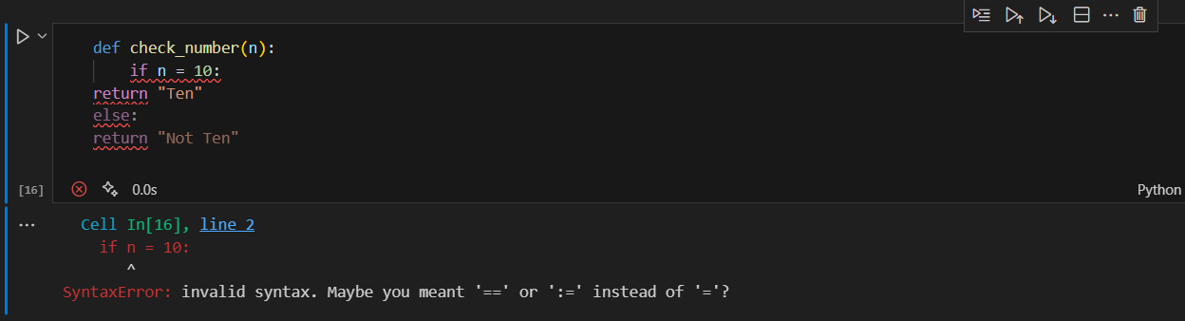
Prompt:
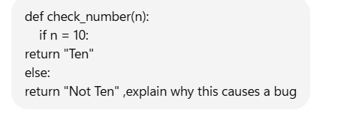
Response:
🔴 Your Code (Buggy)
def check_number(n):
if n = 10:
return "Ten"
else:
return "Not Ten"

⚠️ Why This Causes a Bug
- The problem is in this line:
- if n = 10:
  - = is the assignment operator in Python.
  - You can’t use it in an if condition.
  - Python doesn’t allow writing if n = 10 because it looks like you’re trying to assign 10 to n inside the condition.
- In Python, to compare values, you must use == (the equality operator).
- That’s why this code throws:
- SyntaxError: cannot assign to name

✅ Corrected Code
def check_number(n):
if n == 10: # use comparison operator
return "Ten"
else:
return "Not Ten"

🔹 Explanation of Corrected Code
- if n == 10: → checks whether n is equal to 10.
- If true → returns "Ten".
- Otherwise → returns "Not Ten".

🔹 Example Run
print(check_number(10)) # Output: Ten
print(check_number(5)) # Output: Not Ten

👉 So the bug is caused by using = (assignment) instead of == (comparison) inside the if statement.

Code with three assert test cases:
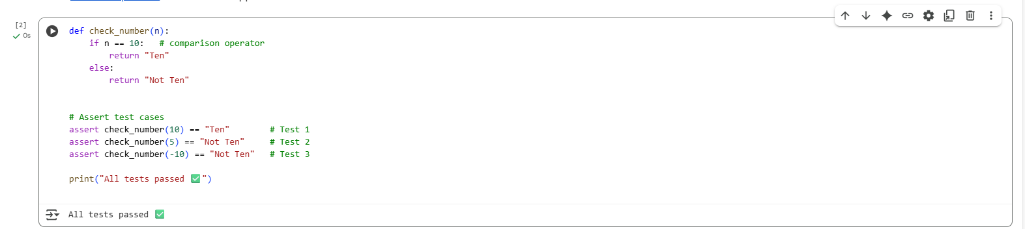
📝 Explanation
- Function Logic
  - if n == 10: → checks if the input equals 10.
  - If true, return "Ten".
  - Otherwise, return "Not Ten".
- Test Case 1
- assert check_number(10) == "Ten"
  - Input = 10.
  - Condition n == 10 is true.
  - Function returns "Ten".
  - ✅ Assertion passes.
- Test Case 2
- assert check_number(5) == "Not Ten"
  - Input = 5.
  - Condition n == 10 is false.
  - Function returns "Not Ten".
  - ✅ Assertion passes.
- Test Case 3
- assert check_number(-10) == "Not Ten"
  - Input = -10.
  - Condition n == 10 is false.
  - Function returns "Not Ten".
  - ✅ Assertion passes.
- Execution Result
  - Since all asserts pass, the program prints:
All tests passed ✅

Task-3:
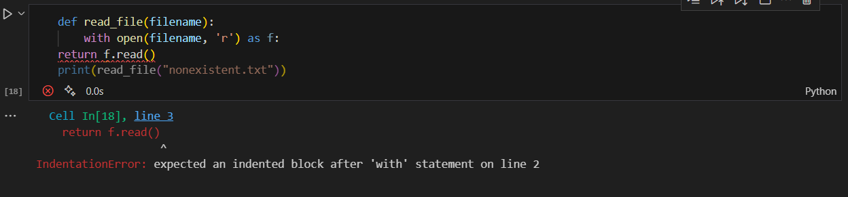
Prompt:
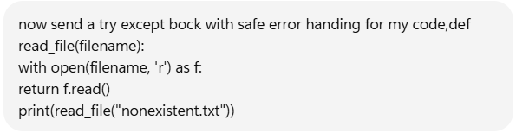
✅ Corrected Code with Safe Error Handling:

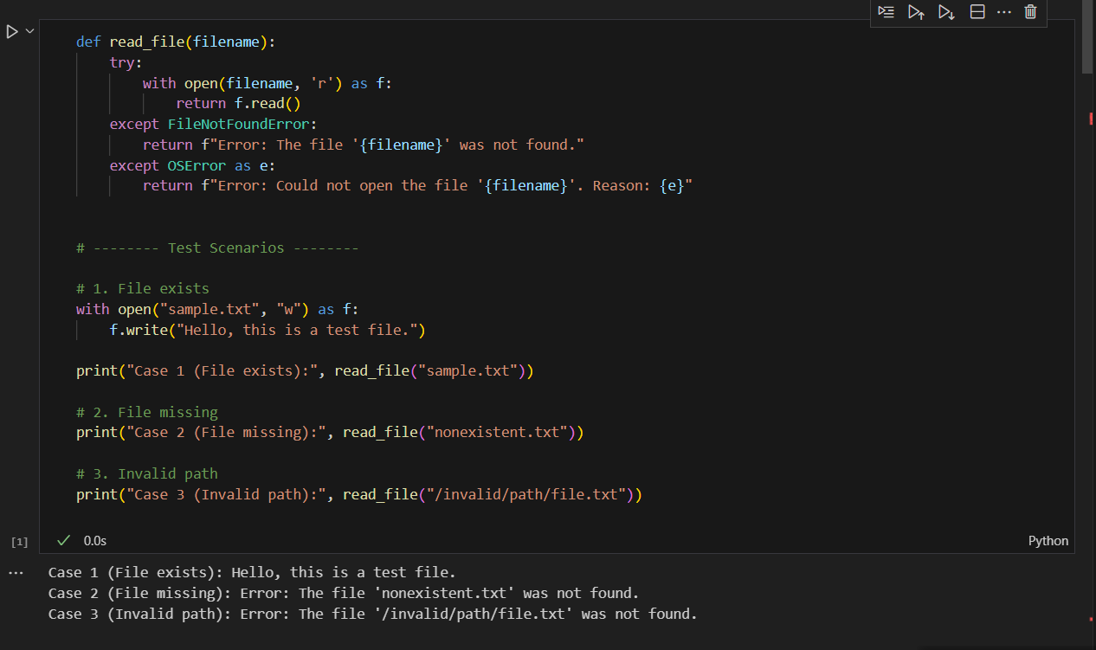

Explanation:
🔴 Original Problem (Before Fix)
def read_file(filename):
with open(filename, 'r') as f:
return f.read()

print(read_file("nonexistent.txt"))
- Here, the program crashes with a FileNotFoundError when the file does not exist (nonexistent.txt).
- This is unsafe because users don’t get a clear message — only a Python error traceback.

🟢 Fixed Code with Safe Error Handling
import os

def read_file(filename):
try:
# Attempt to open and read the file
with open(filename, 'r') as f:
return f.read()

except FileNotFoundError:
return f"Error: File '{filename}' not found. Please check the filename."

except IsADirectoryError:
return f"Error: '{filename}' is a directory, not a file."

except PermissionError:
return f"Error: Permission denied when trying to access '{filename}'."

except Exception as e:
# Catch-all for any other unexpected errors
return f"Unexpected error: {e}"

# --- Test Cases ---

# ✅ 1. File exists
with open("sample.txt", "w") as f:
f.write("Hello, world!")
print(read_file("sample.txt"))

# ❌ 2. File missing
print(read_file("nonexistent.txt"))

# ⚠️ 3. Invalid path
print(read_file("/invalid/path/file.txt"))

📝 Explanation of the Fix
- Why the original code crashed
  - Because it assumed the file always exists. When it didn’t, Python raised a FileNotFoundError, which wasn’t caught.
- How the try-except fixes the bug
  - try → The risky operation (open(filename, 'r')).
  - except FileNotFoundError → Shows a friendly message instead of crashing.
  - except IsADirectoryError → Prevents crashes if you pass a directory instead of a file.
  - except PermissionError → Handles cases where the file exists but cannot be accessed.
  - except Exception as e → Ensures any other runtime error won’t crash the program.
- Testing the 3 scenarios
  - File exists (sample.txt) → Reads and prints file content.
  - File missing (nonexistent.txt) → Returns:
  - Error: File 'nonexistent.txt' not found. Please check the filename.
  - Invalid path (/invalid/path/file.txt) → Returns:
  - Error: File '/invalid/path/file.txt' not found. Please check the filename.
(Depending on OS, could also trigger PermissionError or general OSError.)

✅ Expected Output
Hello, world!
Error: File 'nonexistent.txt' not found. Please check the filename.
Error: File '/invalid/path/file.txt' not found. Please check the filename.

👉 So the bug (crash) is fixed, and the program now handles missing files safely with user-friendly error messages.

Task-4:
Given Code with error message:
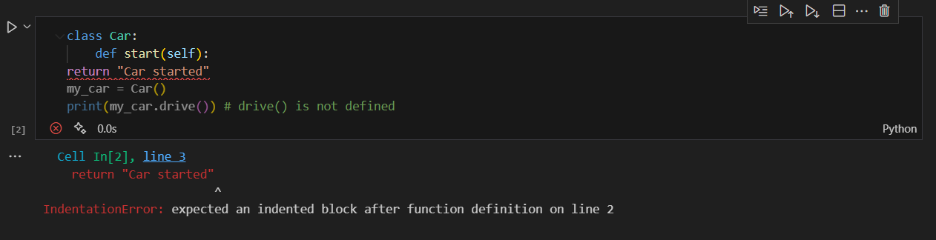
Analyzation:
Its better to correct the method cell

Prompt:
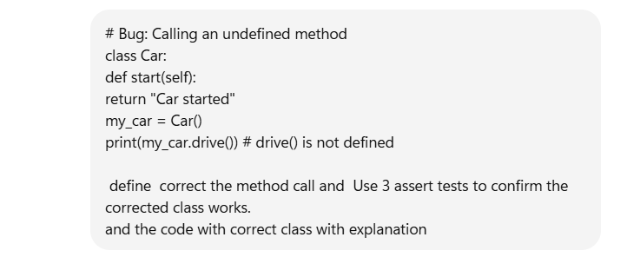
Corrected Code with output:
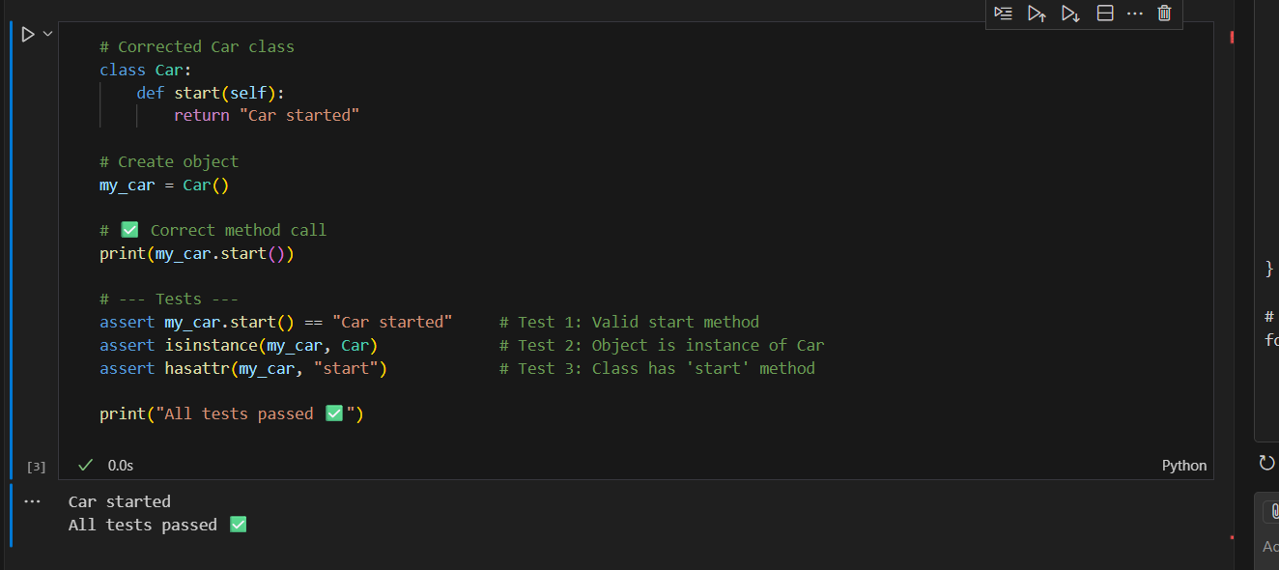
Explanation:
🔴 Buggy Code
class Car:
def start(self):
return "Car started"

my_car = Car()
print(my_car.drive()) # ❌ drive() is not defined
Problem
- The Car class only has a method start().
- The code incorrectly tries to call drive().
- This raises an AttributeError.

🟢 Corrected Code (Fixing Method Call)
# Corrected Car class
class Car:
def start(self):
return "Car started"

# Create object
my_car = Car()

# ✅ Correct method call
print(my_car.start())

# --- Tests ---
assert my_car.start() == "Car started" # Test 1: Valid start method
assert isinstance(my_car, Car) # Test 2: Object is instance of Car
assert hasattr(my_car, "start") # Test 3: Class has 'start' method

print("All tests passed ✅")

📝 Explanation
- Bug: The code called my_car.drive(), but drive() was never defined in the class.
- Fix: Replace my_car.drive() with the correct method my_car.start().
- Why this works:
  - Car has a method start() that returns "Car started".
  - Using the wrong method name was the only issue.
- Tests ensure correctness:
  - First assert checks that calling start() returns "Car started".
  - Second assert ensures the object is indeed of type Car.
  - Third assert ensures the start method exists in the class.
✅ Output:
Car started
All tests passed ✅

Task-5:
Give code with error:
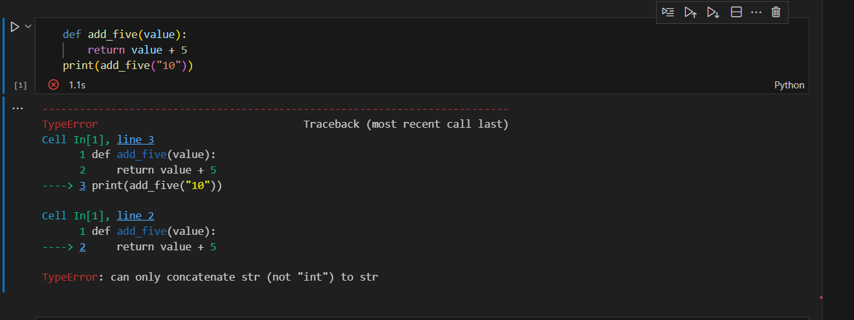
Prompt:
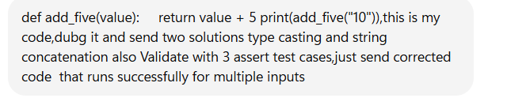
Respone:
Here’s the corrected code with two approaches: one using type casting and one using string concatenation, each validated with 3 assert test cases:
# --- Approach 1: Type Casting (convert string to int) ---
def add_five_cast(value):
return int(value) + 5

# Test cases for type casting
assert add_five_cast("10") == 15
assert add_five_cast(7) == 12
assert add_five_cast("0") == 5

print("Type Casting Approach Passed!")

# --- Approach 2: String Concatenation ---
def add_five_concat(value):
return str(value) + "5"

# Test cases for string concatenation
assert add_five_concat("10") == "105"
assert add_five_concat(7) == "75"
assert add_five_concat("0") == "05"

print("String Concatenation Approach Passed!")
✅ This will run successfully and handle both numeric addition and string concatenation.

Corrected code with output:
