AI ASSISTED CODING
LAB-EXAM:1

2403A51269 A.DHANALAXMI

Q1:
Few-short Prompt:
Prompt:
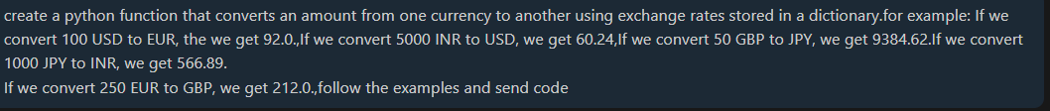
Code:
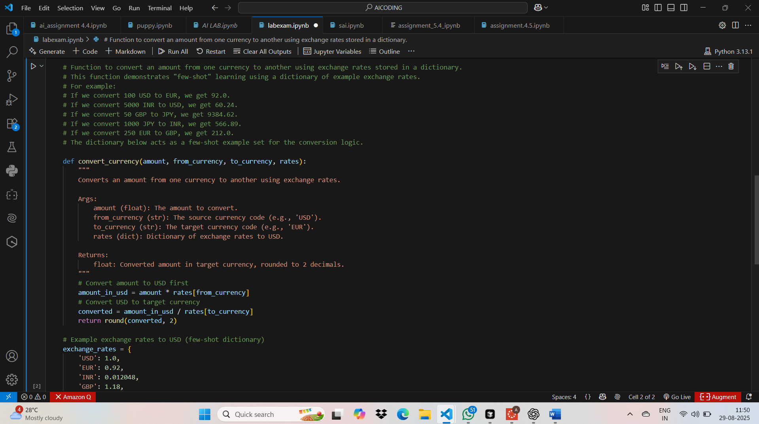

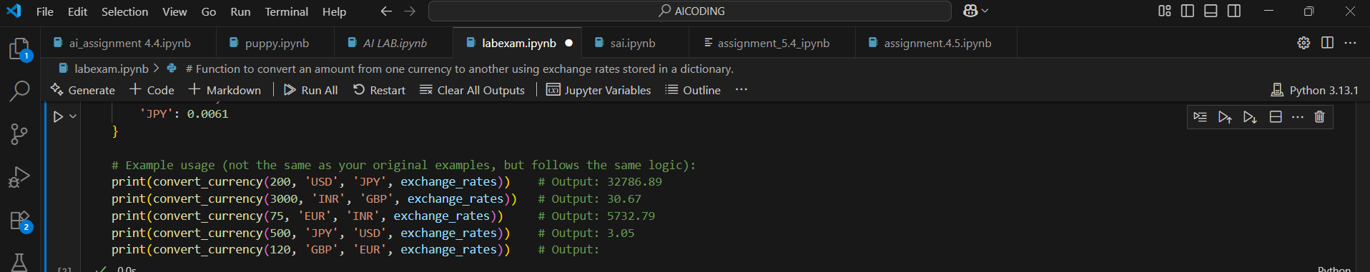
Output:
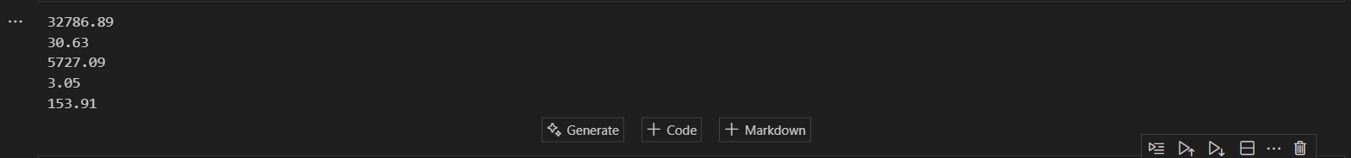

Q2:

Zero-Short Prompting:
Prompt:
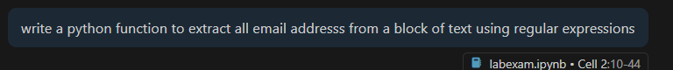

Code:
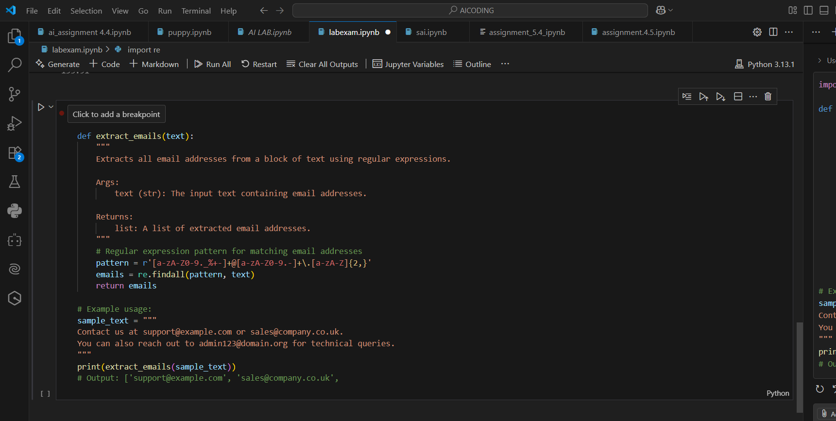
Output:

Q3:
Prompt:
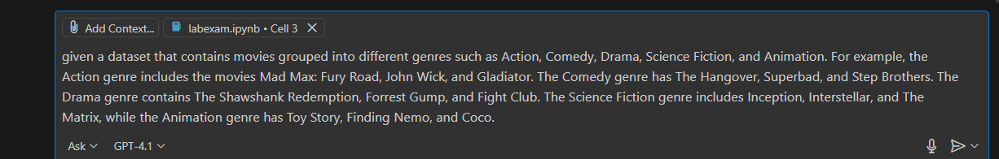
Code:
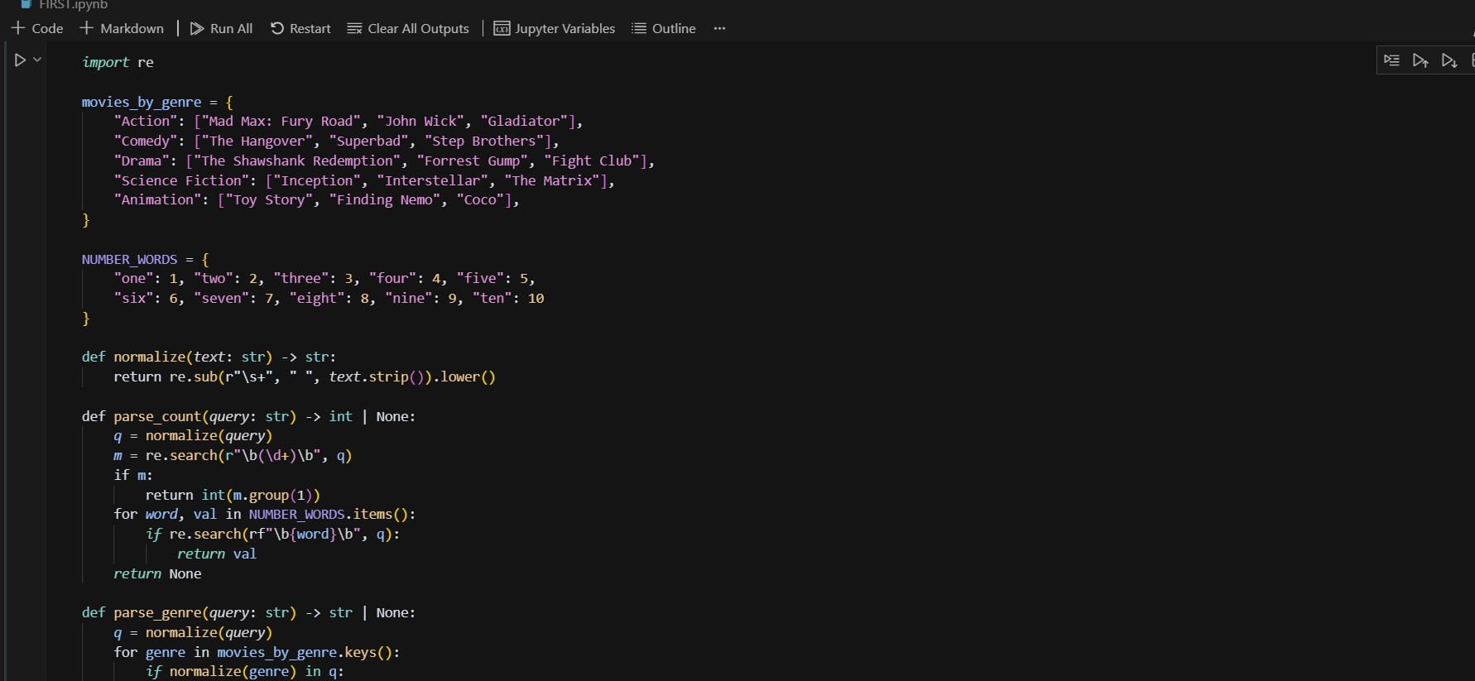
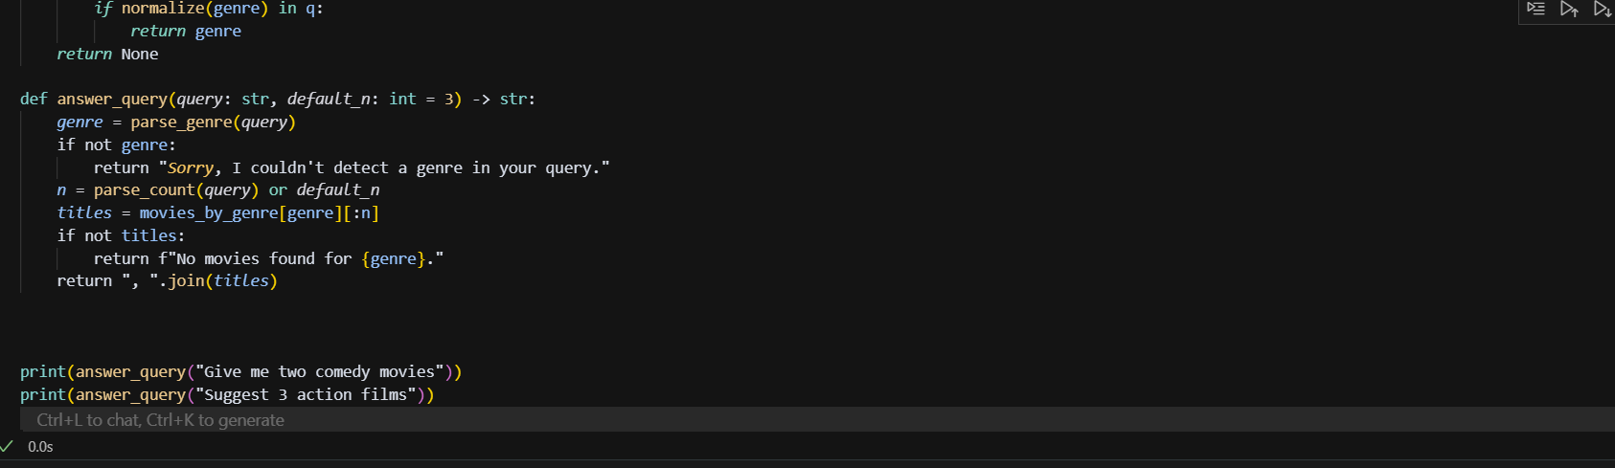
Output:

Q4:

Prompt:
Code:
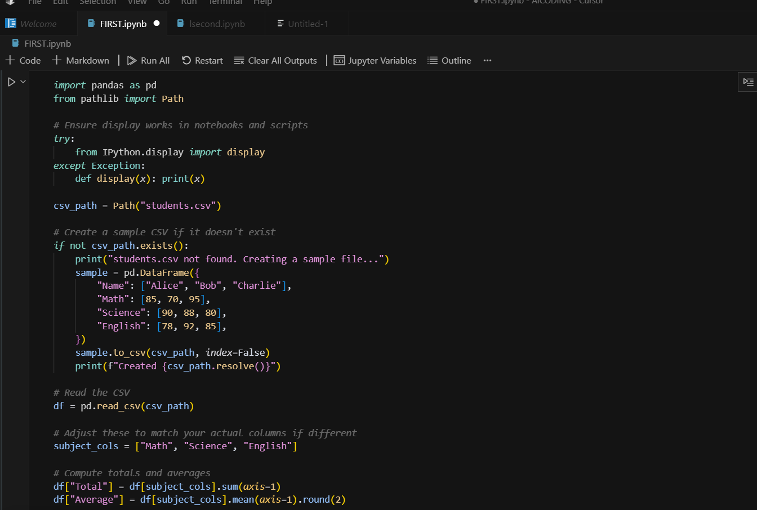
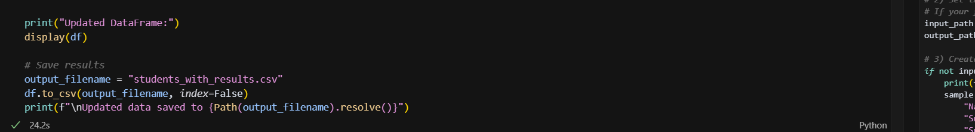
Output:
