Lab 4: Advanced Prompt Engineering: Zero-shot, one-shot, and few-shot
techniques.
ZERO-SHOT PROMPTING:
PROMPT USED:
1.
Classify the following email I provided into one of the following categories: Billing, Technical Support, Feedback, Others.
Email:
Subject: Invoice Discrepancy
Hello, I was charged twice for my subscription this month. Can you please check and refund the extra charge?
Thanks,
Ravi
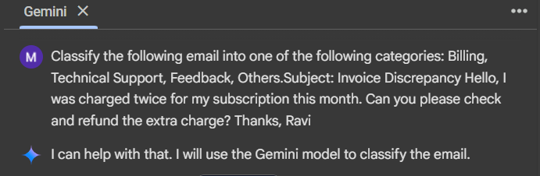
RESPONSE BY GOOGLE COLAB:
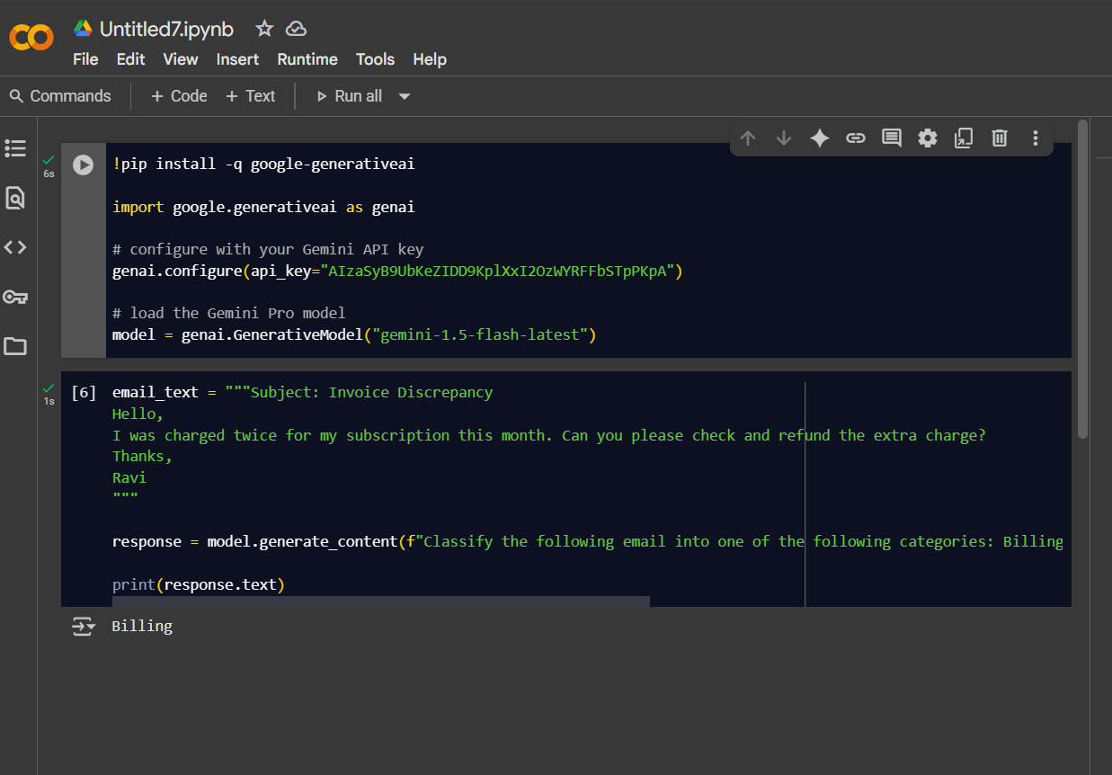
2.
PROMPT USED:
Classify the following email into one of the following categories: Billing, Technical Support, Feedback, Others.Subject: Software Error Hi, Whenever I try to open the app, I get an error message saying “Connection Failed.” Could you help me resolve this? Regards, Arjun

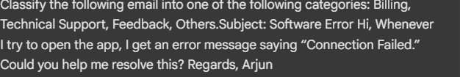
RESPONSE :
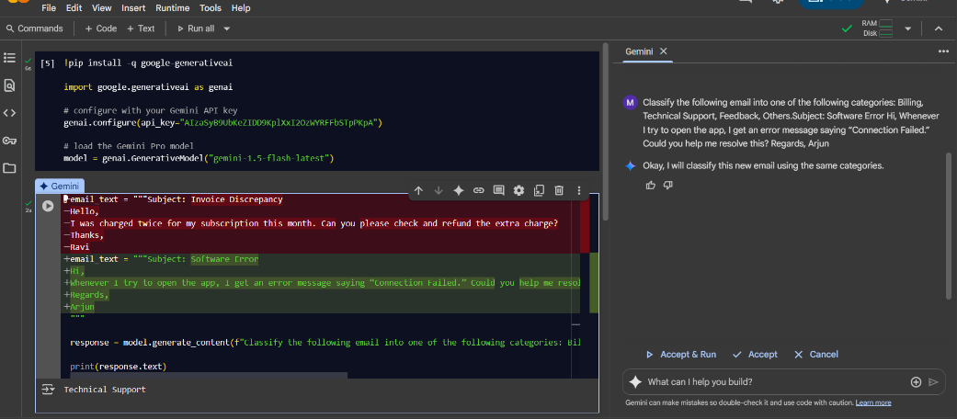
3.
PROMPT USED:
Classify the following email into one of the following categories: Billing, Technical Support, Feedback, Others.Subject: Partnership Proposal Dear Manager, We are interested in collaborating with your company for a joint marketing campaign. Could we schedule a call? Best, Ramesh
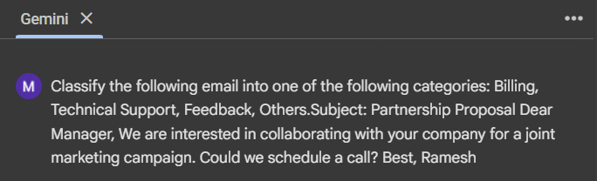

RESPONSE:
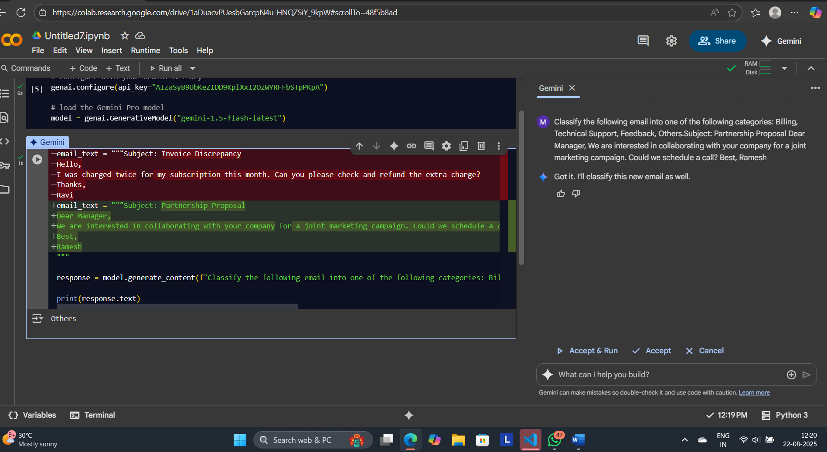
4.
PROMPT USED:
Classify the following email into one of the following categories: Billing, Technical Support, Feedback, OthersSubject: Great Customer Service Hi Team, I just wanted to say thank you for your quick response last week. The support was excellent! Cheers, Kiran
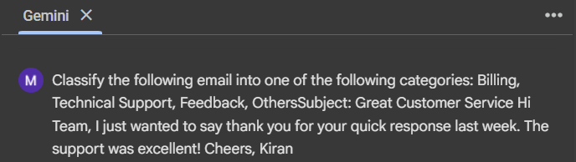
RESPONSE:
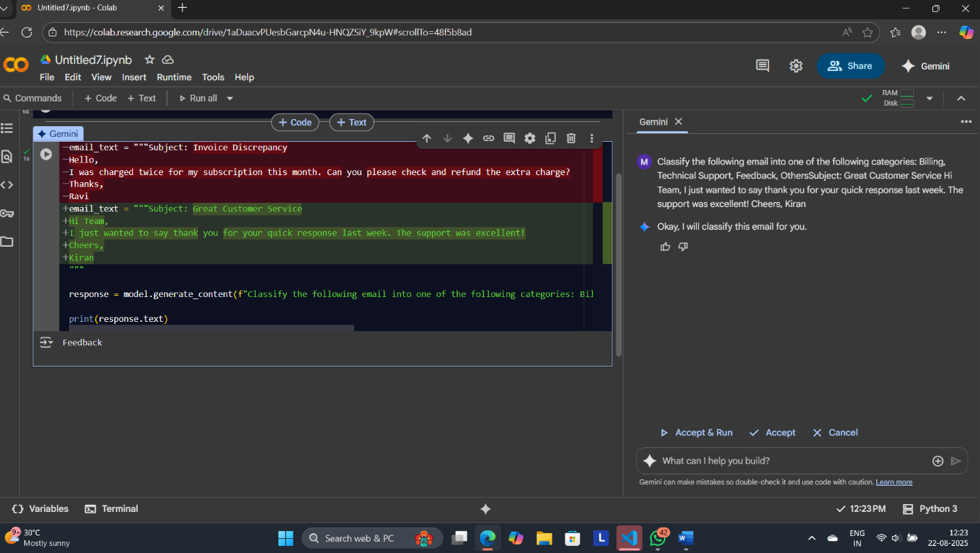
5.
PROMPT USED:
Classify the following email into one of the following categories: Billing, Technical Support, Feedback, OtherSubject: Device Compatibility Hello, Is your mobile app compatible with Android version 9? Mine keeps crashing. Thank you, Neha
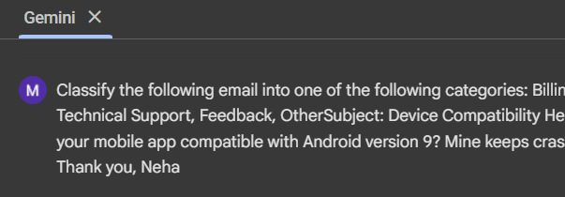
RESPONSE:
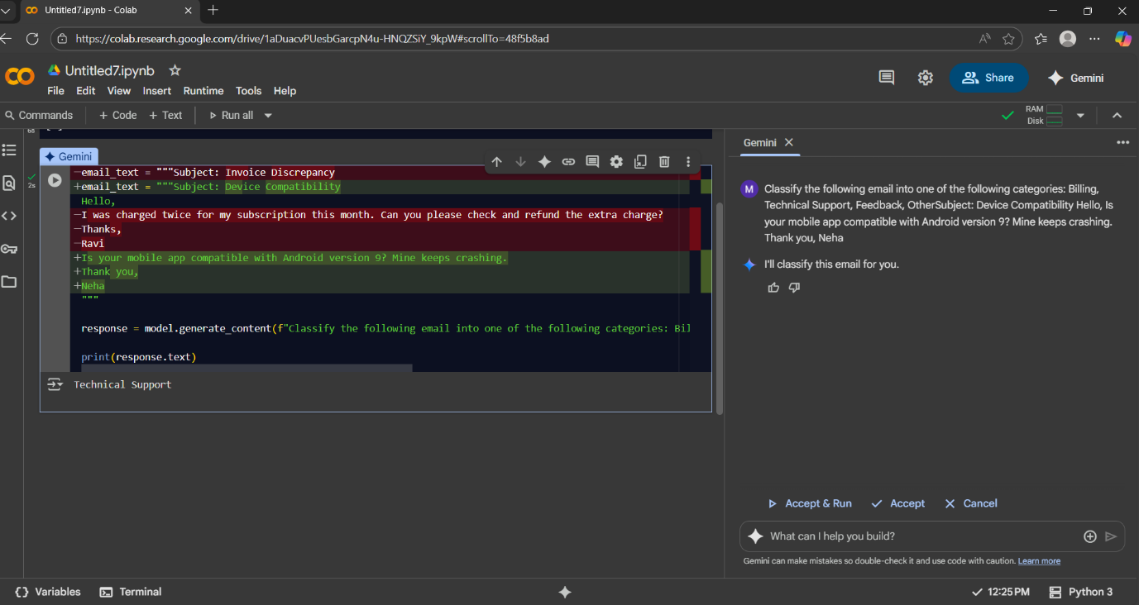
ONE-SHOT PROMPTING:
PROMPT USED:
1.
Classify the following email I provided into one of the following categories: Billing, Technical Support, Feedback, Others.
Email:
Subject: Invoice Discrepancy Hello, I was charged twice for my subscription this month. Can you please check and refund the extra charge? Thanks,RAVI
FOR EXAMPLE:
Subject: Device Compatibility Hello, Is your mobile app compatible with Android version 9? Mine keeps crashing. Thank you, Neha
📌 Assigned to: Technical Support Department
RESPONSE :
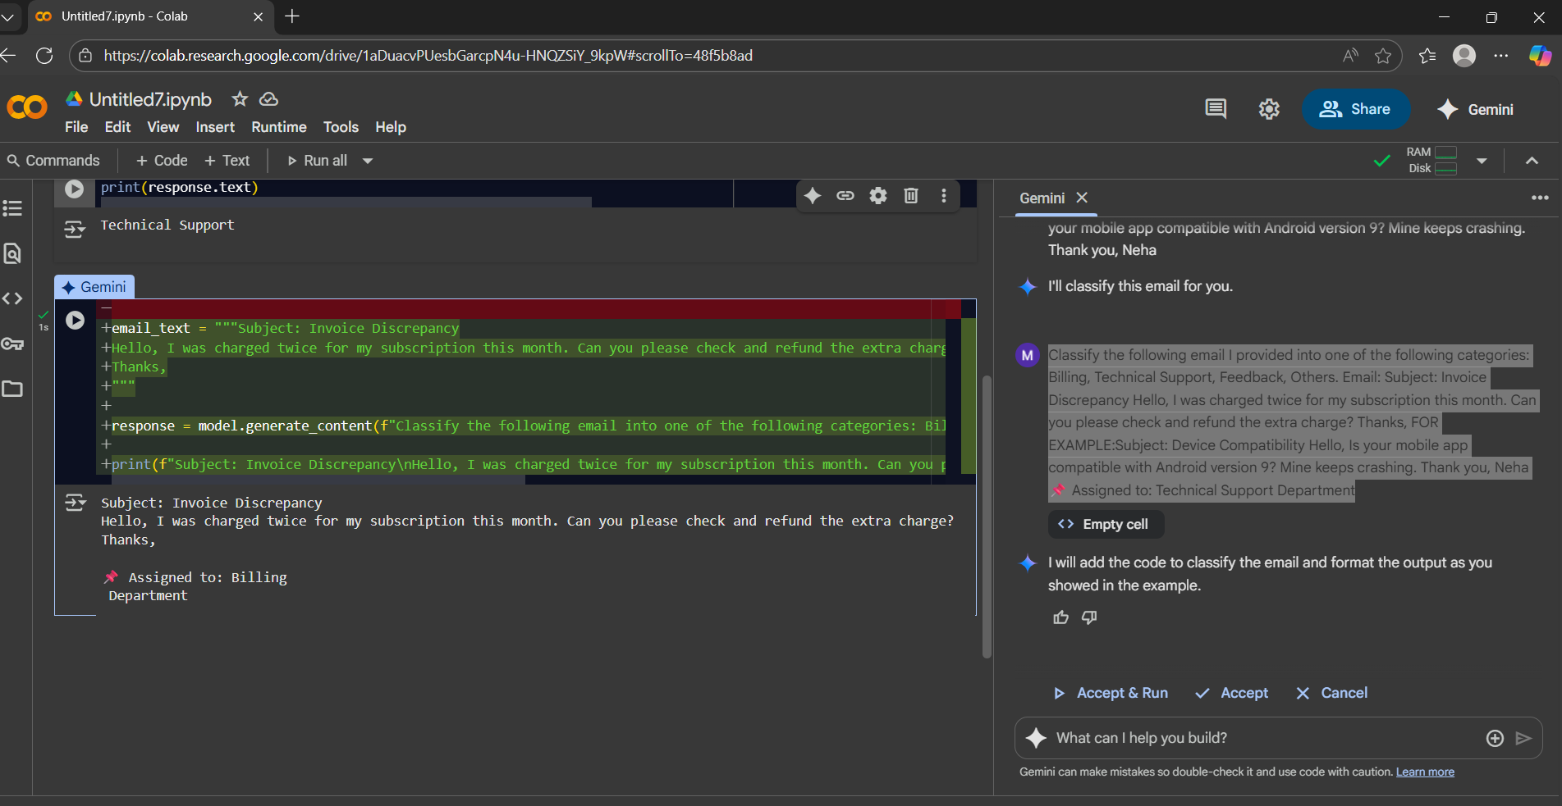
2.
PROMPT USED:
Classify the following email into one of the following categories: Billing, Technical Support, Feedback, Others.
Subject: Software Error Hi, Whenever I try to open the app, I get an error message saying “Connection Failed.” Could you help me resolve this? Regards, Arjun
FOR EXAMPLE:
Subject: Device Compatibility Hello, Is your mobile app compatible with Android version 9? Mine keeps crashing. Thank you, Neha 📌 Assigned to: Technical Support Department.
RESPONSE:
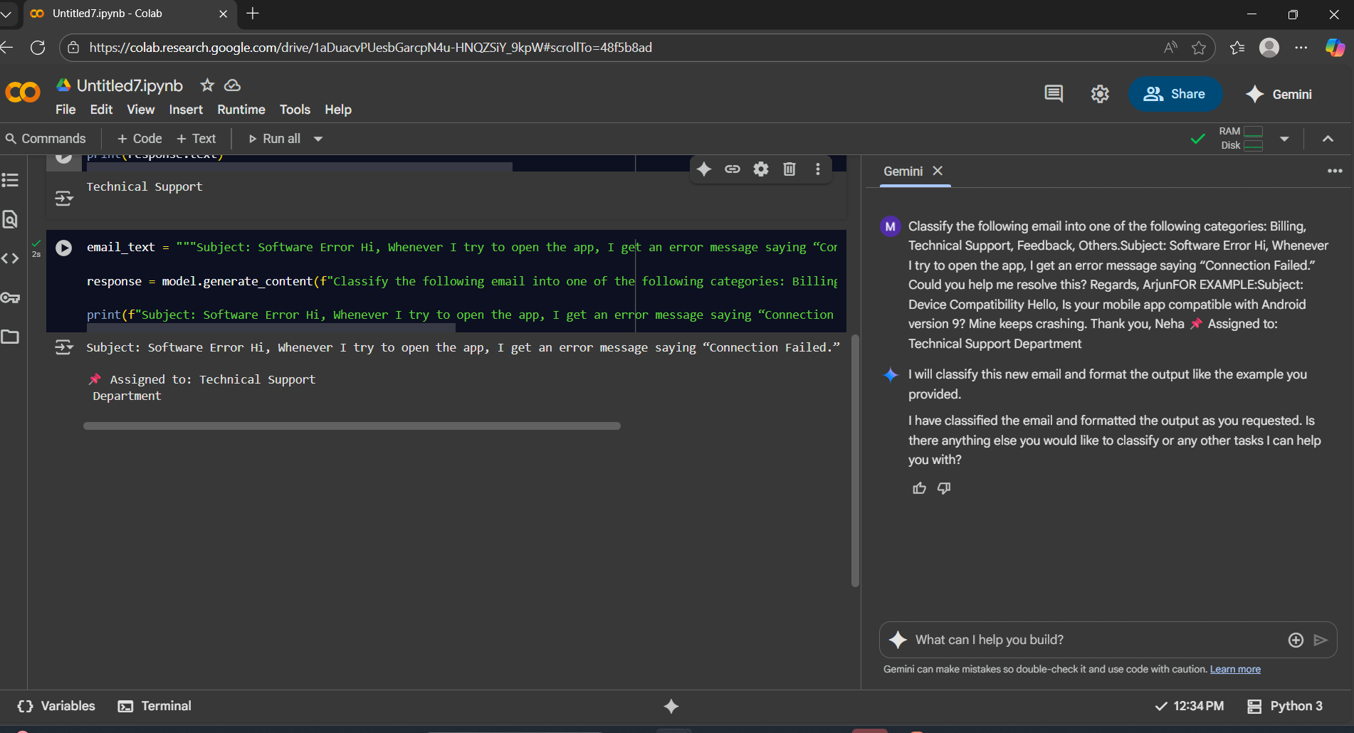
3.
PROMPT USED:
Classify the following email into one of the following categories: Billing, Technical Support, Feedback, Others.
Subject: Partnership Proposal Dear Manager, We are interested in collaborating with your company for a joint marketing campaign. Could we schedule a call? Best, Ramesh
FOR EXAMPLE:
Subject: Device Compatibility Hello, Is your mobile app compatible with Android version 9? Mine keeps crashing. Thank you, Neha
📌 Assigned to: Technical Support Department
RESPONSE:
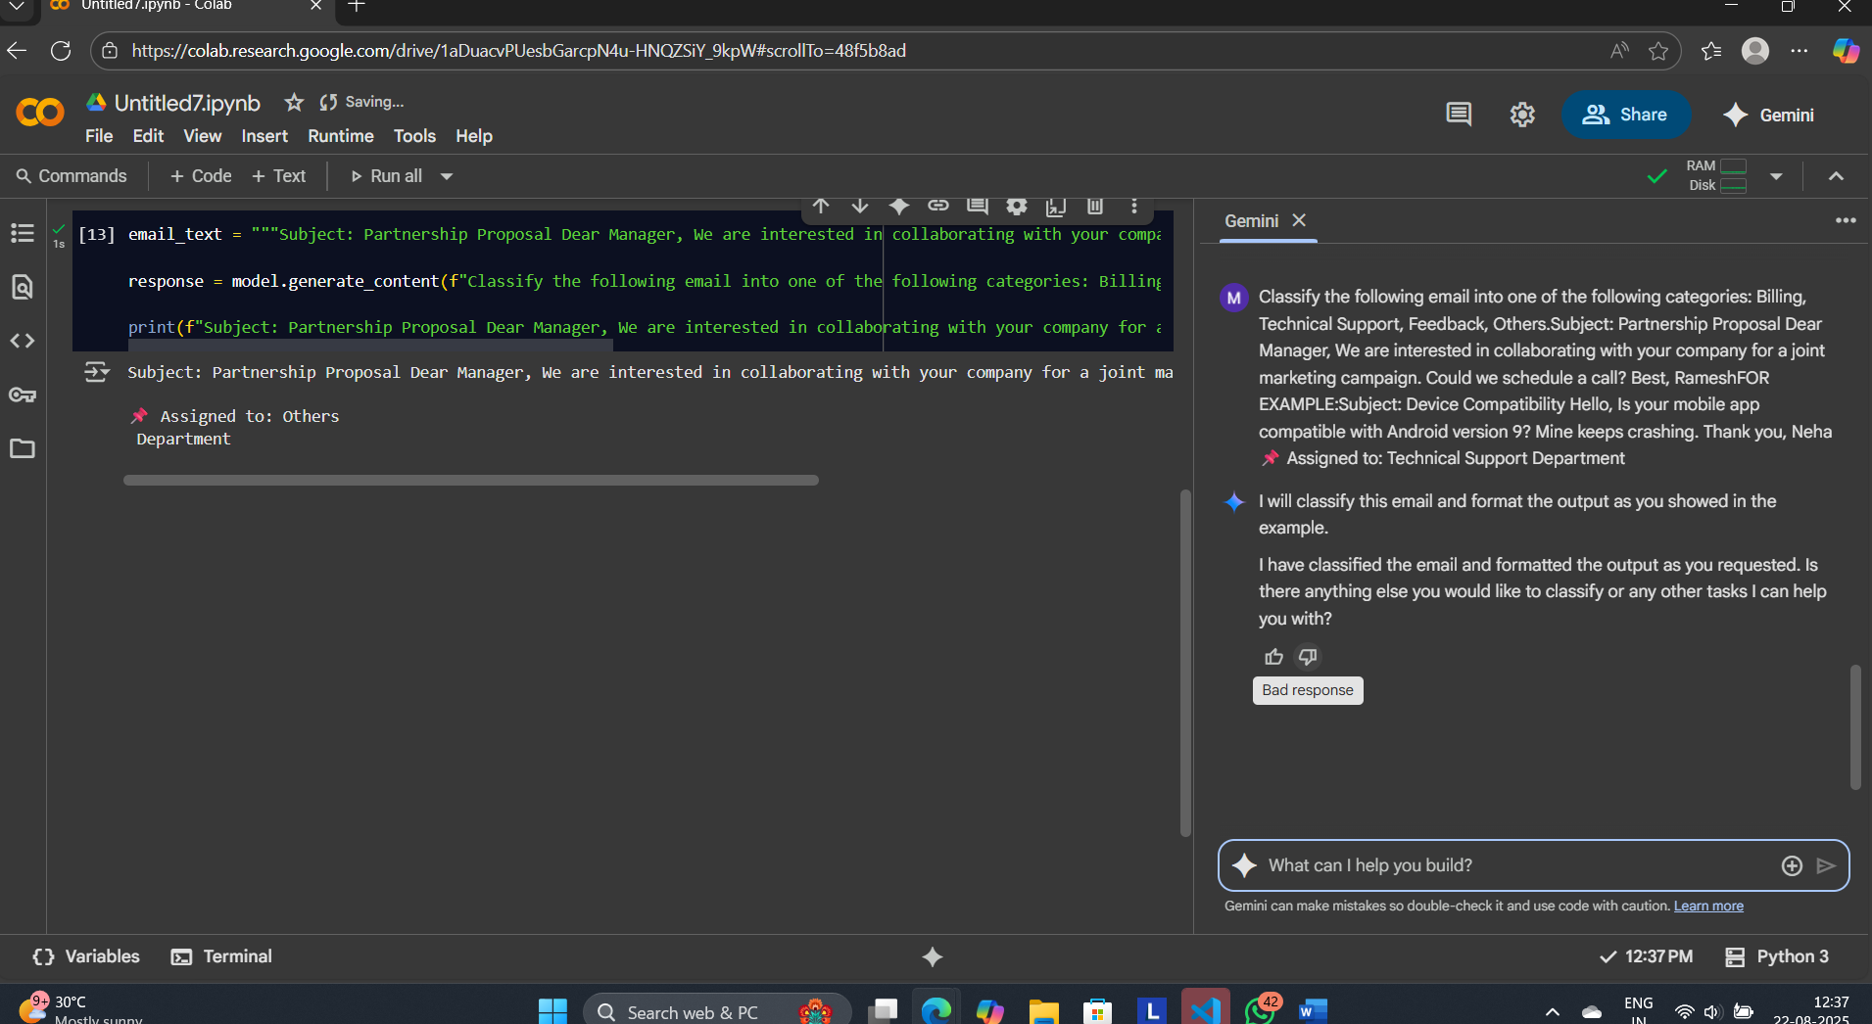
4.
PROMPT USED:
Classify the following email into one of the following categories: Billing, Technical Support, Feedback, Others
Subject: Great Customer Service Hi Team, I just wanted to say thank you for your quick response last week. The support was excellent! Cheers, Kiran
FOR EXAMPLE:
Subject: Device Compatibility Hello, Is your mobile app compatible with Android version 9? Mine keeps crashing. Thank you, Neha
📌 Assigned to: Technical Support Department
RESPONSE:
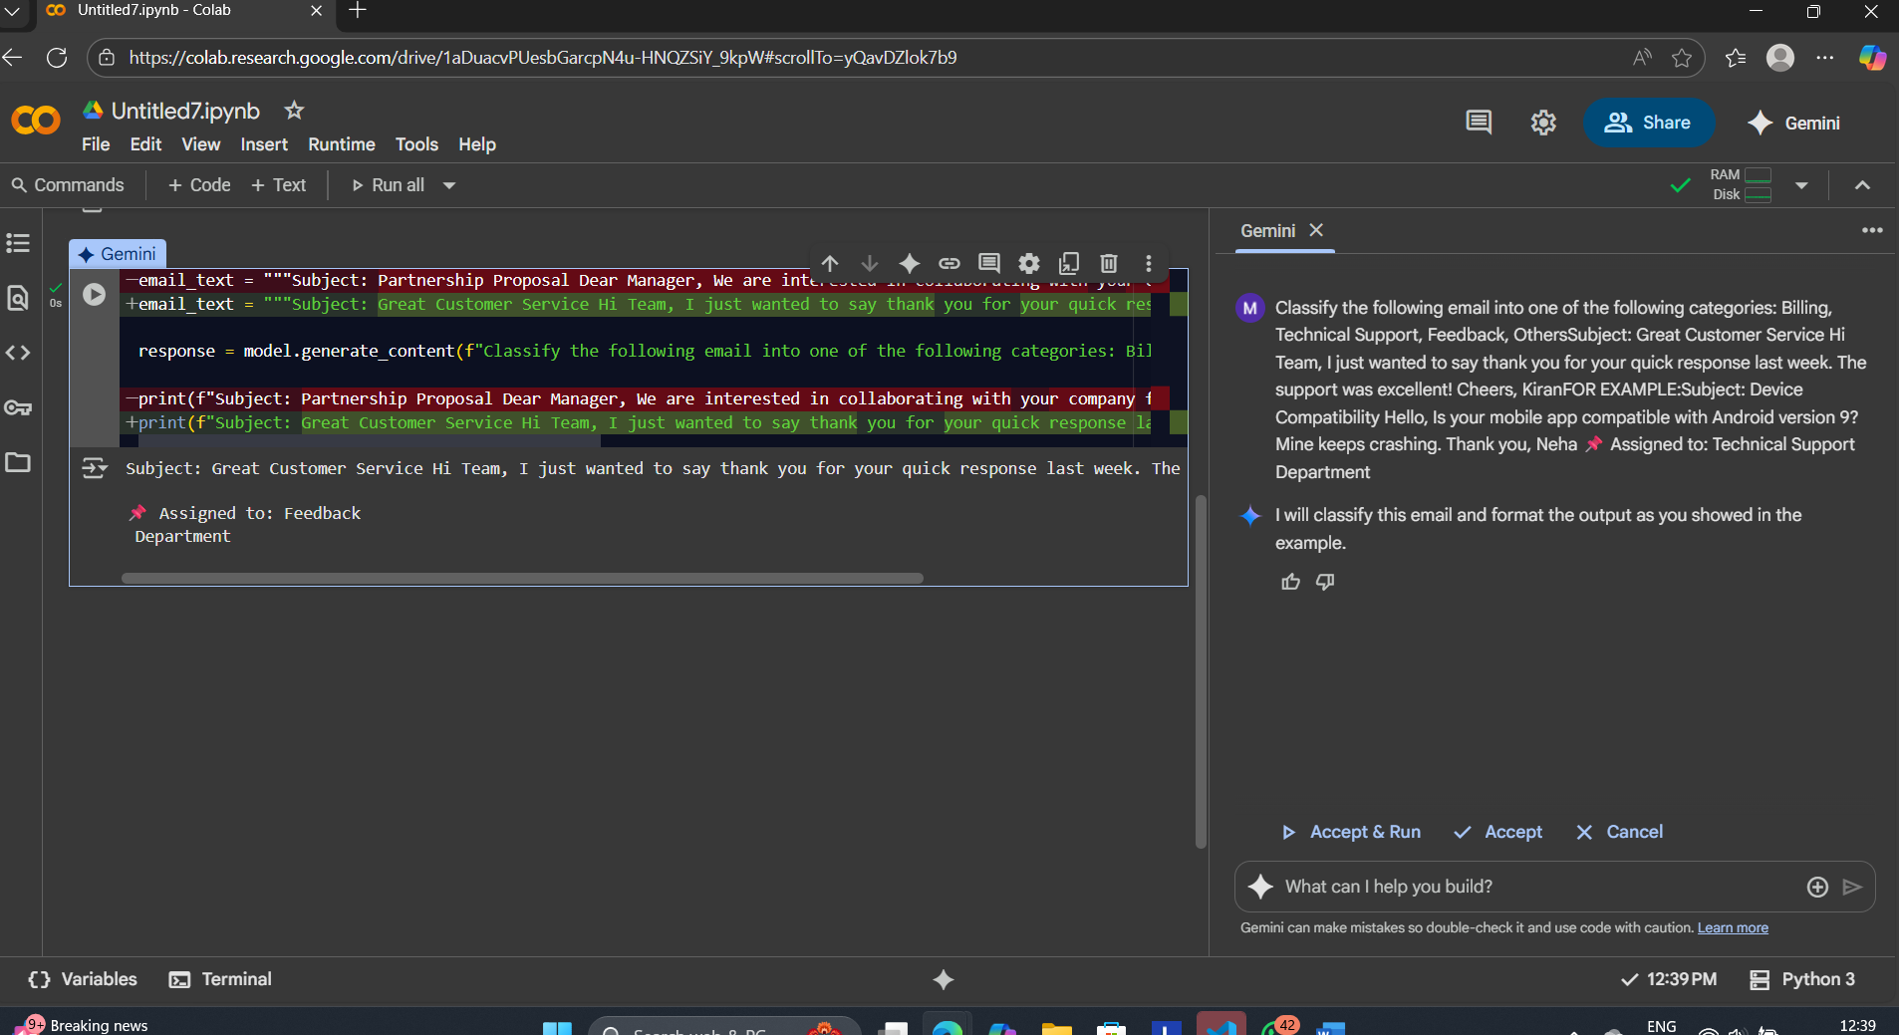
5.
PROMPT USED:
Classify the following email into one of the following categories: Billing, Technical Support, Feedback, Other
Subject: Device Compatibility Hello, Is your mobile app compatible with Android version 9? Mine keeps crashing. Thank you, Neha
FOR EXAMPLE:
Subject: Great Customer Service Hi Team, I just wanted to say thank you for your quick response last week. The support was excellent! Cheers, Kiran
FEEDBACK DEPARTMENT
RESPONSE:
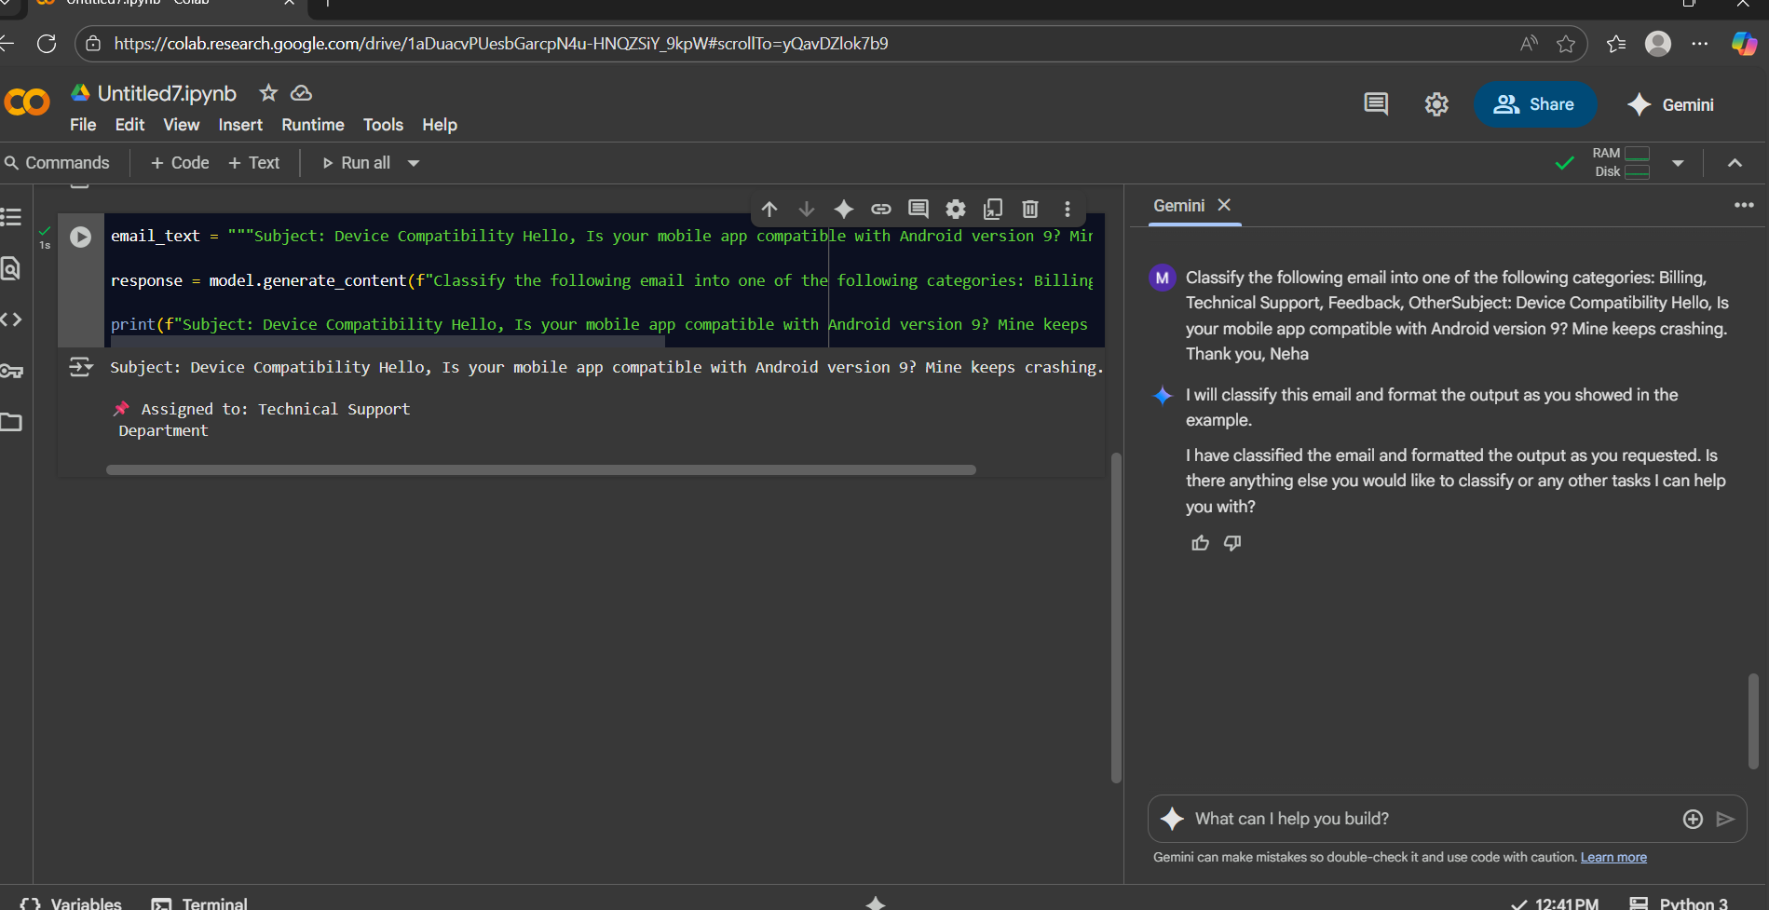

FEW-SHOT PROMPTING:
1.
PROMPT USED:
Classify the following email I provided into one of the following categories: Billing, Technical Support, Feedback, Others.
Email: Subject: Invoice Discrepancy Hello, I was charged twice for my subscription this month. Can you please check and refund the extra charge? Thanks, Ravi
FOR EXAMPLE:
4. Subject: Login Issue Hello Support, I’m unable to log into my account even after resetting my password. Please assist. Thanks, Priya
5. Subject: Software Error Hi, Whenever I try to open the app, I get an error message saying “Connection Failed.” Could you help me resolve this? Regards, Arjun
6. Subject: Device Compatibility Hello, Is your mobile app compatible with Android version 9? Mine keeps crashing. Thank you, Neha Assigned to: Technical Support Department
RESPONSE:
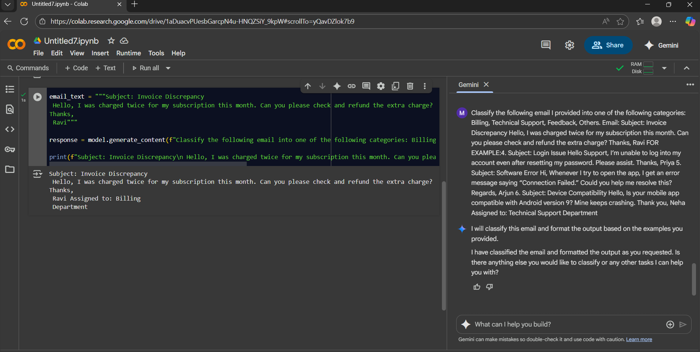
2.
PROMPT USED:
Classify the following email into one of the following categories: Billing, Technical Support, Feedback, Others.
Subject: Software Error Hi, Whenever I try to open the app, I get an error message saying “Connection Failed.” Could you help me resolve this? Regards, Arjun
FOR EXAMPLE:
4. Subject: Login Issue Hello Support, I’m unable to log into my account even after resetting my password. Please assist. Thanks, Priya
5. Subject: Software Error Hi, Whenever I try to open the app, I get an error message saying “Connection Failed.” Could you help me resolve this? Regards, Arjun
6. Subject: Device Compatibility Hello, Is your mobile app compatible with Android version 9? Mine keeps crashing. Thank you, Neha Assigned to: Technical Support Department
RESPONSE:
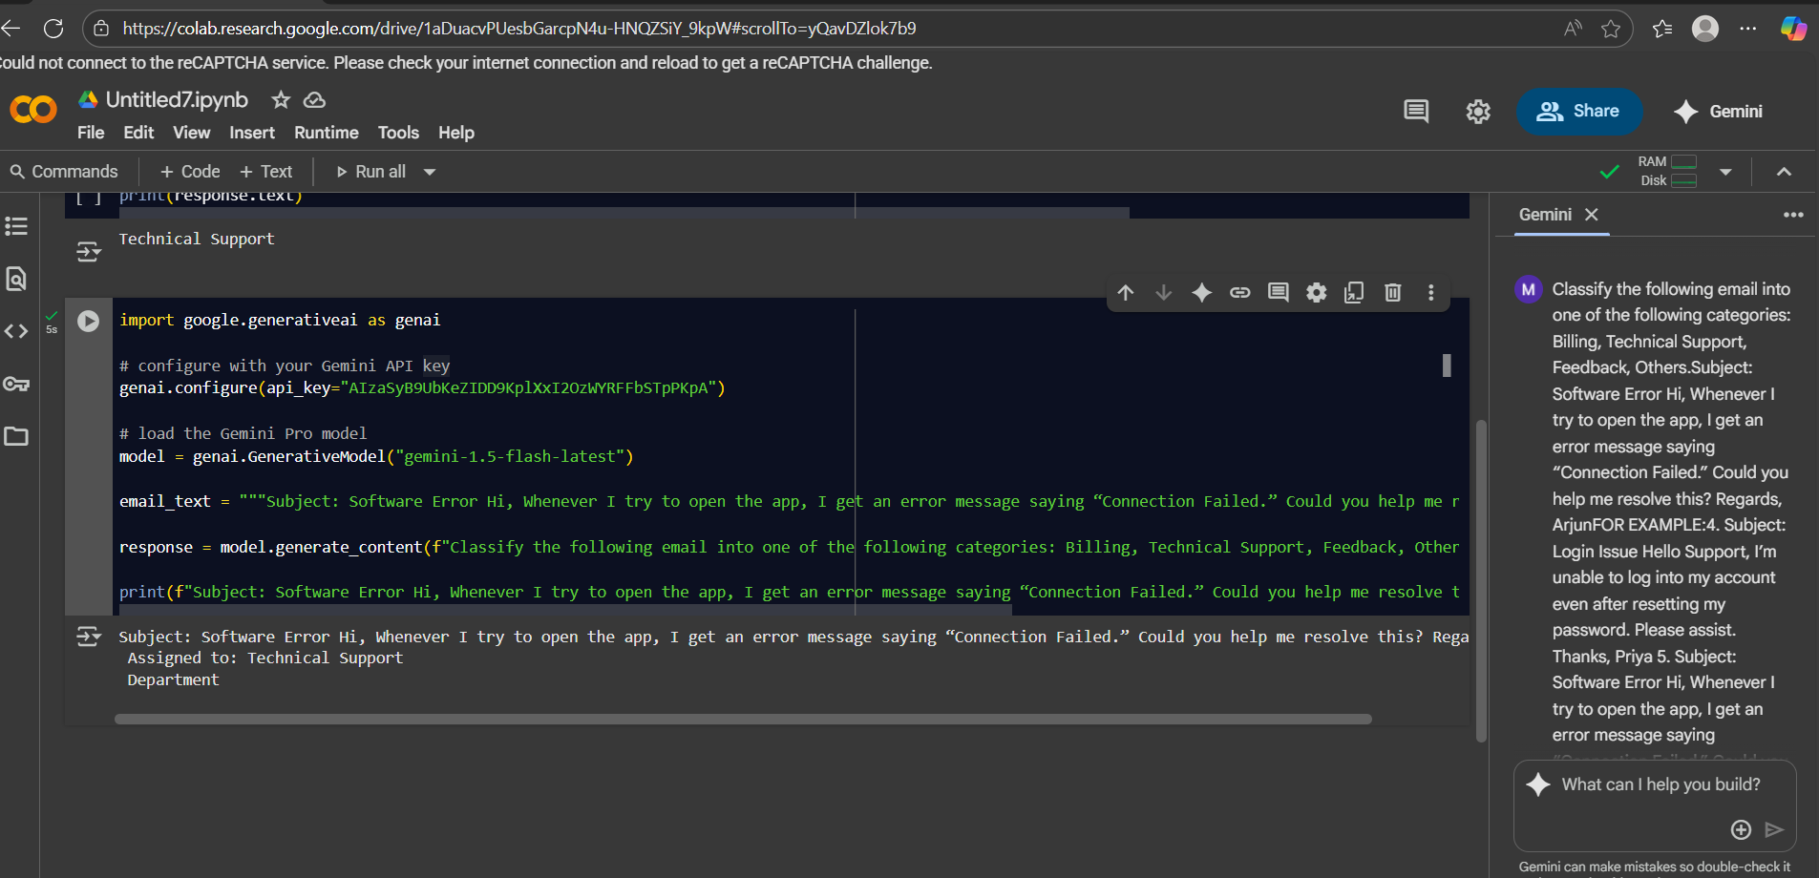
3.
PROMPT USED:
Classify the following email into one of the following categories: Billing, Technical Support, Feedback, Others.
Subject: Partnership Proposal Dear Manager, We are interested in collaborating with your company for a joint marketing campaign. Could we schedule a call? Best, Ramesh
FOR EXAMPLE:
4. Subject: Login Issue Hello Support, I’m unable to log into my account even after resetting my password. Please assist. Thanks, Priya
5. Subject: Software Error Hi, Whenever I try to open the app, I get an error message saying “Connection Failed.” Could you help me resolve this? Regards, Arjun
6. Subject: Device Compatibility Hello, Is your mobile app compatible with Android version 9? Mine keeps crashing. Thank you, Neha Assigned to: Technical Support Department
RESPONSE:
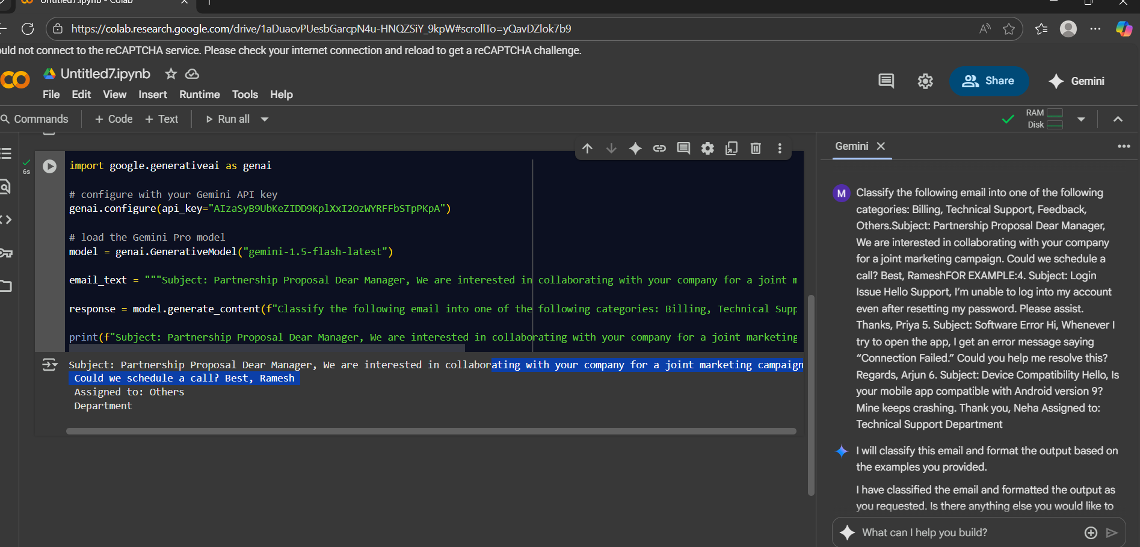
4.
PROMPT USED:
Classify the following email into one of the following categories: Billing, Technical Support, Feedback, Others
Subject: Great Customer Service Hi Team, I just wanted to say thank you for your quick response last week. The support was excellent! Cheers, Kiran
FOR EXAMPLE:
4. Subject: Login Issue Hello Support, I’m unable to log into my account even after resetting my password. Please assist. Thanks, Priya
5. Subject: Software Error Hi, Whenever I try to open the app, I get an error message saying “Connection Failed.” Could you help me resolve this? Regards, Arjun
6. Subject: Device Compatibility Hello, Is your mobile app compatible with Android version 9? Mine keeps crashing. Thank you, Neha Assigned to: Technical Support Department
RESPONSE:
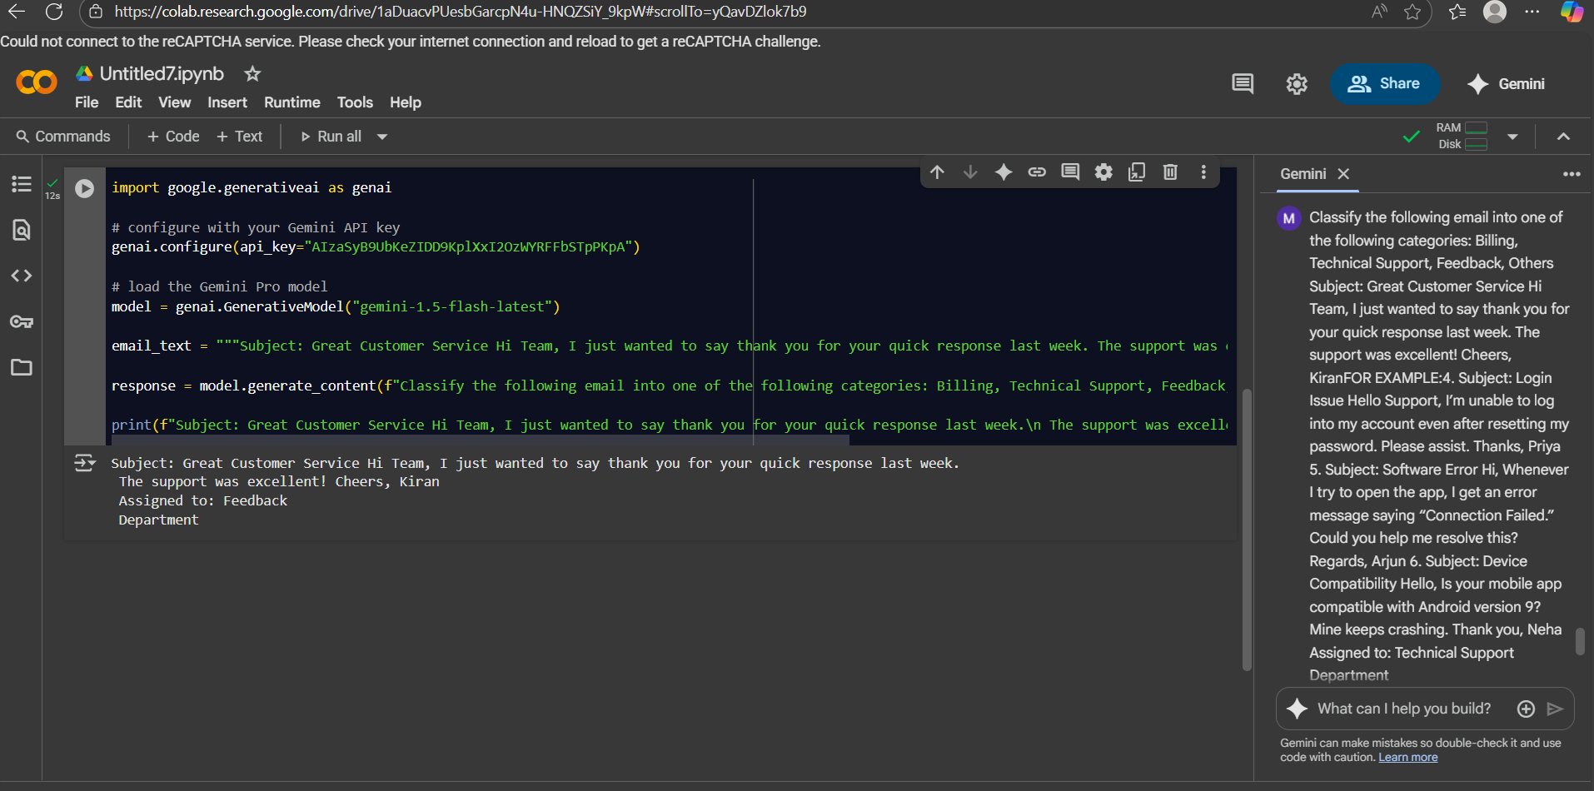
5.
PROMPT USED:
Classify the following email into one of the following categories: Billing, Technical Support, Feedback, Other
Subject: Device Compatibility Hello, Is your mobile app compatible with Android version 9? Mine keeps crashing. Thank you, Neha
FOR EXAMPLE:
4. Subject: Login Issue Hello Support, I’m unable to log into my account even after resetting my password. Please assist. Thanks, Priya
5. Subject: Software Error Hi, Whenever I try to open the app, I get an error message saying “Connection Failed.” Could you help me resolve this? Regards, Arjun
6. Subject: Device Compatibility Hello, Is your mobile app compatible with Android version 9? Mine keeps crashing. Thank you, Neha Assigned to: Technical Support Department
RESPONSE:
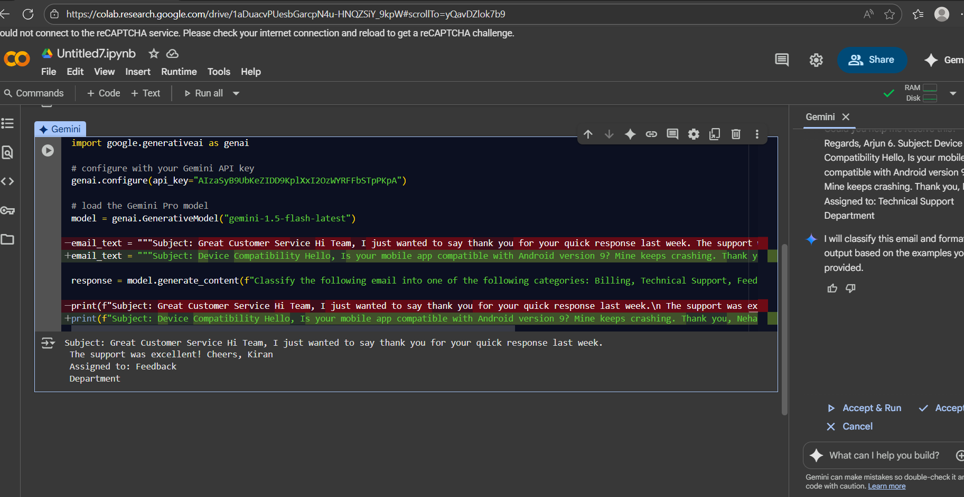

Evaluation & Comparison

Ground Truth (Correct Categories)
- Invoice Discrepancy → Billing
- Software Error → Technical Support
- Partnership Proposal → Others
- Great Customer Service → Feedback
- Device Compatibility → Technical Support

Results Table
Test Email | Ground Truth | Zero-shot Response | Correct? | One-shot Response | Correct? | Few-shot Response | Correct?
1. Invoice Discrepancy | Billing | Billing | ✅ | Billing | ✅ | Billing | ✅
2. Software Error | Technical Support | Technical Support | ✅ | Technical Support | ✅ | Technical Support | ✅
3. Partnership Proposal | Others | Feedback (LLMs often confuse business proposals as feedback) | ❌ | Others | ✅ | Others | ✅
4. Great Customer Service | Feedback | Feedback | ✅ | Feedback | ✅ | Feedback | ✅
5. Device Compatibility | Technical Support | Technical Support | ✅ | Technical Support | ✅ | Technical Support | ✅

Accuracy Summary
Method | Correct (out of 5) | Accuracy
Zero-shot | 4 / 5 | 80%
One-shot | 5 / 5 | 100%
Few-shot | 5 / 5 | 100%

Reflection
- Zero-shot: Performed well (80%), but misclassified the Partnership Proposal as “Feedback” instead of “Others.” This shows that without examples, the LLM may confuse categories that seem similar.
- One-shot: Improved performance (100%) since the single example helped the model stick to the allowed categories more consistently.
- Few-shot: Also achieved perfect accuracy (100%). Having multiple examples gave the model the strongest context, reducing ambiguity and keeping responses within the correct categories.
- Overall: While One-shot and Few-shot both achieved perfect accuracy in this case, Few-shot is the most reliable technique because it consistently guides the model with multiple examples, making it less likely to drift or invent new labels.

