**Unveiling the Future: Machine Learning's Power in Predicting Customer Churn in Subscription-Based Enterprises**

**Introduction:**

****Customer churn a significant challenge for subscription-based businesses, as it directly impacts their revenue and growth. Predicting customer churn becomes crucial for businesses to proactively address the issues leading to attrition and take necessary actions to retain their valuable customers.

In this regard, machine learning has emerged as a powerful predictive tool that leverages data analysis and algorithms to accurately forecast customer churn.

**The Basics of Customer Churn**

****Customer churn refers to the phenomenon where customers discontinue their subscriptions or cease doing business with a company. Understanding the concept of customer churn involves analyzing the factors that influence customers' decisions to abandon a service. These factors can vary, including poor customer experience, lack of value, competitive offers, or changes in personal circumstances. The impact of customer churn on subscription-based enterprises is profound, as it not only affects their revenue streams but also hurts their brand reputation and market position.

**Traditional Approaches to Predicting Customer Churn**

In the past, businesses relied on manual analysis or statistical models to predict customer churn. However, these traditional methods have limitations, such as a time-consuming process, potential biases, and a lack of accuracy. Manual analysis requires exhaustive efforts to analyze customer behavior and extract insights. Statistical models, although more accurate than manual analysis, still face challenges in capturing complex patterns and adapting to changing customer dynamics.

The Rise of Machine Learning in Customer Churn Prediction

Machine learning, a branch of artificial intelligence, has revolutionized customer churn prediction. It automates the process of learning and improving from data without being explicitly programmed, making it capable of handling vast amounts of information and uncovering hidden patterns. Machine learning algorithms excel in predicting customer churn by utilizing historical data, understanding complex relationships, and adapting to changing patterns, empowering businesses with actionable insights to reduce churn rates effectively.

**Data Collection and Preparation**

To achieve accurate predictions, high-quality data plays a vital role. Gathering relevant customer data becomes paramount for conducting churn analysis.

Data points such as customer demographics, transaction history, interaction patterns, and customer sentiment are essential for creating predictive models. Moreover, thorough data cleaning and preparation are necessary to remove inconsistencies, handle missing data, and outliers that could potentially impact the accuracy of the churn prediction models.

**Building Churn Prediction Models**

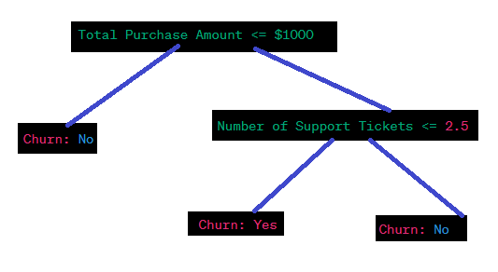Machine learning algorithms offer various approaches for predicting customer churn. Logistic regression, a popular algorithm, assesses the relationship between the dependent variable (churn) and independent variables (customer attributes). Decision trees and random forests, on the other hand, create hierarchical structures to classify customers based on different characteristics.

Support Vector Machines (SVM) construct hyperplanes to separate churn and non-churn customers effectively.

**Feature Engineering for Churn Prediction**

Feature engineering involves selecting relevant features and transforming them to enhance the performance of churn prediction models. Choosing the right variables, such as customer tenure, purchase frequency, and usage patterns, can significantly influence prediction accuracy.

|  |  |  |  |  |  |  |  |
| --- | --- | --- | --- | --- | --- | --- | --- |
| **Customer ID** | **Purchase Frequency** | **Purchase Recency (Days)** | **Total Purchase Amount ($)** | **Average Purchase Amount ($)** | **Number of Unique Products** | **Number of Transactions** | **Churn Status** |
| 1001 | 0.5 | 14 | 235.78 | 47.16 | 5 | 8 | 0 |
| 1002 | 0.2 | 42 | 186.29 | 37.26 | 3 | 5 | 1 |
| 1003 | 0.8 | 7 | 423.50 | 47.06 | 7 | 12 | 0 |
| 1004 | 0.6 | 25 | 319.75 | 53.29 | 4 | 7 | 0 |
| 1005 | 0.3 | 60 | 150.00 | 50.00 | 2 | 3 | 1 |

Feature transformation and scaling techniques, such as normalization and standardization, help ensure that different features are weighted appropriately. Additionally, handling missing data and outliers is crucial to prevent biases and improve the overall effectiveness of churn prediction models.

**Model Training, Validation, and Evaluation**

To validate the performance of churn prediction models, the data is split into training and testing sets.

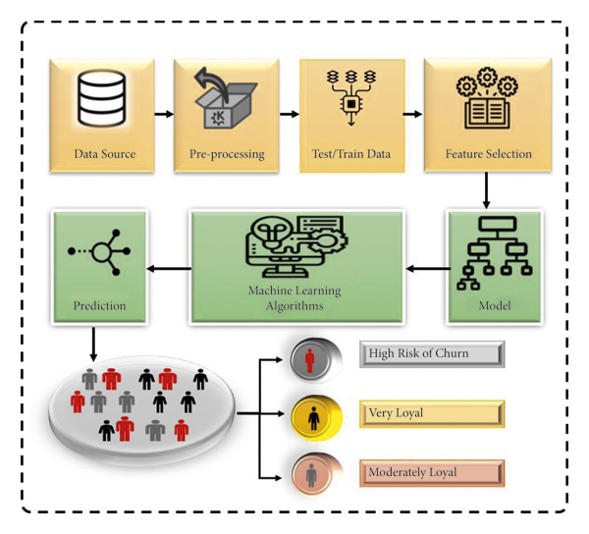

By training the models with the training data, they learn to recognize patterns and make predictions.

Simulation -1 With Decision Tree

Accuracy: 0.901760113555713

Confusion Matrix:

[[843 193]

[190 183]]

Cross-validation techniques, such as k-fold cross-validation, allow for robust evaluation of the models' performance and assess their ability to generalize to unseen data. Performance metrics like accuracy, precision, recall, and F1-score provide insights into the effectiveness of the churn prediction models.

**Case Studies: Successful Implementations of Machine Learning in Churn Prediction**

Real-world examples demonstrate the power of machine learning in churn prediction. Company A successfully leveraged machine learning algorithms to identify key churn factors, enabling them to offer personalized retention strategies to at-risk customers.

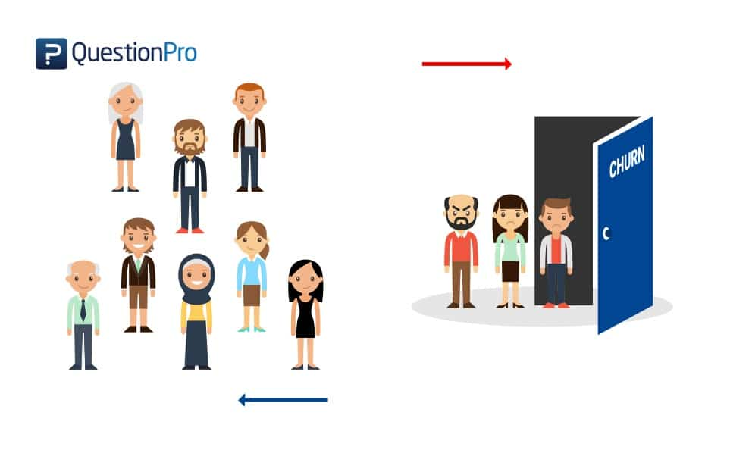

Similarly, Company B improved its churn prediction accuracy with the help of advanced machine learning techniques, reducing churn rates significantly. These success stories elucidate the potential of machine learning in tackling customer churn effectively.

**Overcoming Challenges in Machine Learning-based Churn Prediction**

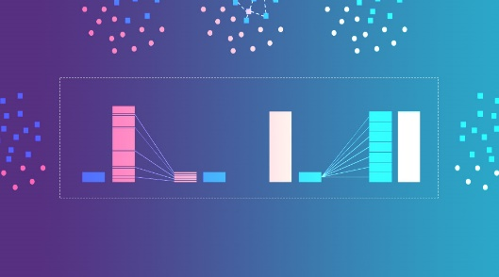Challenges within machine learning-based churn prediction include dealing with class imbalance, where the number of churned customers is significantly smaller than non-churned ones.

Addressing overfitting and underfitting issues is crucial to avoid models that are either too complex or too simplistic. Furthermore, the interpretability and explainability of machine learning models are essential to gain trust from stakeholders and ensure transparency in decision-making processes.

**Ethical Considerations in Churn Prediction**

Although machine learning algorithms provide powerful tools for churn prediction, ethical concerns arise from their potential biases and discrimination. Biased models can disproportionately impact certain customer groups, leading to unfair practices. Ensuring fairness and transparency in churn prediction models should be a priority for businesses. Likewise, the ethical implications of using sensitive customer data in churn prediction raise concerns regarding privacy and data protection, further emphasizing the need for responsible and ethical practices.

**Future Trends and Innovations in Churn Prediction**

The future of churn prediction lies in advancements in machine learning algorithms, enabling more accurate predictions and a deeper understanding of customer behavior. Integration of artificial intelligence (AI) in churn prediction will enhance the automation of data analysis and decision-making processes. Predictive analytics will continue to evolve, incorporating real-time churn analysis, enabling businesses to take immediate action and proactively retain customers.

**Summary and Conclusion**

Predicting customer churn is of paramount importance to subscription-based businesses. Machine learning offers unparalleled power in addressing this challenge by leveraging data analysis and algorithms to accurately forecast churn. With the ability to handle complex patterns and adapt to changing customer dynamics, machine learning empowers businesses with actionable insights, leading to effective churn reduction strategies. The transformation brought by machine learning in subscription-based enterprises will shape the future of customer retention and success.

FAQs (Frequently Asked Questions)

A. What is customer churn, and why is it significant for businesses?

Customer churn refers to the phenomenon where customers discontinue their subscriptions or cease doing business with a company. It is significant for businesses as it directly impacts their revenue streams, brand reputation, and market position.

B. How does machine learning improve customer churn prediction?

Machine learning improves customer churn prediction by leveraging historical data, identifying complex patterns, and adapting to changing customer dynamics. Its predictive algorithms provide businesses with accurate insights to proactively address churn issues.

C. What challenges can companies face when implementing machine learning for churn prediction?

Companies may face challenges such as class imbalance in churn datasets, overfitting or underfitting issues, and the interpretability and explainability of machine learning models.

D. Are there any ethical concerns associated with machine learning-based churn prediction?

Yes, there are ethical concerns related to potential biases and discrimination in machine learning algorithms, fairness and transparency in model implementation, and the ethical implications of using sensitive customer data. Businesses should adopt responsible and ethical practices to address these concerns.