Loan Default Risk Analysis and Prediction
Using Data Analytics and Machine Learning

IBM SkillsBuild Data Analytics Academic Internship
Date: September 23, 2026
Dataset: Loan_default.csv | 255,347 records | 18 features

Submitted By:
Name: Akula Srinithya
Program: B.Tech Computer Science Engineering – Data Science
Institution: SVKM's Narsee Monjee Institute of Management and Studies, Hyderabad
Academic Year: 2025–2026
Submitted as part of:
IBM SkillsBuild Data Analytics Academic Internship
conducted in association with AICTE / BharatCares
Date: 23-09-2026

1. Executive Summary
This report presents a complete end-to-end data analytics and machine learning project focused on predicting and understanding loan default risk. Using a dataset of 255,347 loan records, the project applies structured phases of data loading, quality checking, exploratory analysis, KPI computation, risk segmentation, and machine learning modelling to derive actionable business intelligence.
The overall portfolio default rate is 11.61%, representing 29,653 defaulted loans with a combined value of $4.3 billion out of a $32.6 billion total portfolio. Key risk drivers include Interest Rate, Age, Months Employed, Loan Amount, and Income. Unemployed borrowers and younger borrowers (18-25) carry disproportionately high default rates. A Random Forest classifier is trained to predict default probability, enabling risk-based pre-approval scoring.

2. Project Objectives
- Understand the structure, quality, and statistical properties of the loan dataset.
- Identify and quantify key drivers of loan default.
- Compute portfolio-level and segment-level KPIs.
- Segment borrowers into risk tiers using a heuristic risk score.
- Build and evaluate a machine learning model for default prediction.
- Surface actionable business insights and recommendations.
- Deliver an interactive Streamlit dashboard for stakeholder use.

3. Dataset Description
The dataset contains 255,347 loan records with 18 columns, including a binary target variable (Default: 0 = No Default, 1 = Default). The dataset is clean with no missing values and no duplicate records.

3.1 Feature Summary
Feature | Type | Range / Values | Description
Age | Numeric | 18 – 69 | Borrower age
Income | Numeric | $15,000 – $150,000 | Annual income
LoanAmount | Numeric | $5,000 – $250,000 | Loan size
CreditScore | Numeric | 300 – 849 | Credit score
MonthsEmployed | Numeric | 0 – 119 | Months at current job
NumCreditLines | Numeric | 1 – 4 | Open credit lines
InterestRate | Numeric | 2.0 – 25.0% | Loan interest rate
LoanTerm | Numeric | 12 / 24 / 36 / 48 / 60 months | Loan term
DTIRatio | Numeric | 0.10 – 0.90 | Debt-to-income ratio
Education | Categorical | High School / Bachelor's / Master's / PhD | Education level
EmploymentType | Categorical | Full-time / Part-time / Self-employed / Unemployed | Employment type
MaritalStatus | Categorical | Single / Married / Divorced | Marital status
LoanPurpose | Categorical | Auto / Business / Education / Home / Other | Loan purpose
HasMortgage | Binary | Yes / No | Existing mortgage
HasDependents | Binary | Yes / No | Has dependents
HasCoSigner | Binary | Yes / No | Co-signer present
Default | Target | 0 / 1 | Loan defaulted (1=Yes)

4. Data Quality Assessment
A comprehensive data quality check was performed covering missing values, duplicate rows, invalid categorical values, out-of-range numerics, invalid target values, and negative values in non-negative columns.
Check | Result
Missing values | None detected
Duplicate rows | None detected
Invalid categorical values | None detected
Out-of-range numerics | None detected
Invalid target values | None detected
Negative values | None detected
Overall QA status | PASSED — 0 issues
Cleaning steps applied: binary Yes/No columns encoded to 1/0; LoanID column dropped; numeric features clipped to domain bounds (defensive); index reset.

5. Exploratory Data Analysis

5.1 Target Variable
The dataset is imbalanced: 88.39% of loans did not default (225,694) and 11.61% defaulted (29,653). This ~8:1 class imbalance is handled in the model using class_weight='balanced'.

5.2 Numeric Feature Correlations with Default
Feature | |Pearson r| with Default | Direction
Age | 0.168 | Lower age -> higher risk
InterestRate | 0.131 | Higher rate -> higher risk
Income | 0.099 | Lower income -> higher risk
MonthsEmployed | 0.097 | Less tenure -> higher risk
LoanAmount | 0.087 | Larger loan -> higher risk
CreditScore | 0.034 | Lower score -> higher risk
NumCreditLines | 0.028 | More lines -> slightly higher risk
DTIRatio | 0.019 | Higher ratio -> higher risk
LoanTerm | 0.001 | Negligible

5.3 Default Rate by Employment Type
Employment Type | Default Rate (%) | Total Loans
Unemployed | 13.55% | 63,824
Part-time | 11.97% | 64,161
Self-employed | 11.46% | 63,706
Full-time | 9.46% | 63,656

5.4 Default Rate by Age Band
Age Band | Default Rate (%) | Total Loans
18-25 | 20.76% | 39,016
26-35 | 16.08% | 49,408
36-45 | 11.55% | 49,220
46-55 | 8.45% | 49,148
56-69 | 5.50% | 68,555

5.5 Default Rate by Loan Purpose
Loan Purpose | Default Rate (%)
Business | 12.33%
Auto | 11.88%
Education | 11.65%
Other | 11.44%
Home | 11.03%

6. Portfolio KPI Analysis
KPI | Value
Total Loans | 255,347
Total Defaulted | 29,653 (11.61%)
Total Non-Defaulted | 225,694 (88.39%)
Total Loan Value | $32,576,880,572
Defaulted Loan Value | $4,285,312,531 (13.15%)
Avg Loan Amount | $127,579
Median Loan Amount | $127,556
Avg Credit Score | 574
Avg Annual Income | $82,499
Avg Interest Rate | 13.49%
Avg DTI Ratio | 0.500
Avg Loan Term | 36.0 months
Avg Months Employed | 59.5

7. Risk Analysis

7.1 Heuristic Risk Score
A weighted heuristic risk score (0-100) was computed for each loan using the following components: Credit Score (inverse, 25%), DTI Ratio (20%), Interest Rate (20%), Income (inverse, 15%), Months Employed (inverse, 10%), Loan Amount (10%).

7.2 Risk Tier Summary
Risk Tier | Loans | Default Rate (%) | Avg Risk Score | Default Value ($)
Low | 63,245 | 5.73% | 34.0 | $414,565,617
Medium | 89,714 | 9.74% | 47.4 | $1,177,462,475
High | 63,679 | 14.05% | 57.8 | $1,315,602,683
Very High | 38,709 | 21.56% | 69.2 | $1,377,681,756

7.3 Key Numeric Drivers
Feature | Mean (Default) | Mean (No Default) | Rel Diff (%) | Risk Direction
InterestRate | 15.896 | 13.177 | 20.6% | Higher -> more risk
Age | 40.7 | 44.0 | 17.7% | Lower -> more risk
MonthsEmployed | 51.3 | 61.3 | 17.3% | Lower -> more risk
LoanAmount | 147,346 | 127,983 | 15.3% | Higher -> more risk
Income | 70,600 | 84,103 | 14.4% | Lower -> more risk
NumCreditLines | 2.60 | 2.50 | 4.0% | Higher -> more risk
CreditScore | 559 | 576 | 2.9% | Lower -> more risk
DTIRatio | 0.514 | 0.500 | 2.8% | Higher -> more risk

8. Machine Learning Model

8.1 Preprocessing Pipeline
Column Group | Transformer | Columns
Numeric (9) | StandardScaler | Age, Income, LoanAmount, CreditScore, MonthsEmployed, NumCreditLines, InterestRate, LoanTerm, DTIRatio
Categorical (4) | OrdinalEncoder | Education, EmploymentType, MaritalStatus, LoanPurpose
Binary (3) | Passthrough | HasMortgage, HasDependents, HasCoSigner

8.2 Models Trained
Model | Parameters | Role
Logistic Regression | class_weight=balanced, max_iter=1000 | Baseline
Random Forest | n_estimators=200, class_weight=balanced | Primary model

8.3 Training Configuration
Setting | Value
Train / Test Split | 80% / 20% (stratified)
Train rows | 204,277
Test rows | 51,070
Random seed | 42
Decision threshold | 0.40 (tuned for class imbalance)
Leakage prevention | Preprocessor fitted on training data only

8.4 Model Performance
Run python run_pipeline.py to populate the metrics below. The table format is ready to fill in after training.
Metric | Logistic Regression | Random Forest
ROC-AUC | – | –
Avg Precision | – | –
F1 (Default) | – | –
Accuracy | – | –

9. Business Insights & Recommendations

[High] Portfolio Risk
Finding: Overall portfolio default rate is 11.61%.
Recommendation: Tighten underwriting criteria to reduce portfolio default rate below 8%.

[High] Key Numeric Driver
Finding: Interest Rate is the strongest numeric driver of default (20.6% relative difference).
Recommendation: Incorporate Interest Rate as a primary screening variable in loan approval workflows.

[High] Employment Risk
Finding: Unemployed borrowers default at 13.55% vs 9.46% for Full-time borrowers.
Recommendation: Apply stricter income verification and lower LTV ratios for Unemployed applicants.

[Medium] Loan Purpose Risk
Finding: Business loans show the highest default rate (12.33%).
Recommendation: Review collateral requirements and repayment terms for Business loans.

[High] Risk Tier Concentration
Finding: Very High-risk tier: 38,709 loans at 21.56% default rate.
Recommendation: Consider loan caps or mandatory co-signer requirements for Very High-risk borrowers.

[Medium] Credit Score Opportunity
Finding: Defaulters average credit score 559 vs 576 for non-defaulters.
Recommendation: Set minimum credit score thresholds differentiated by loan purpose and employment type.

[Medium] Interest Rate Policy
Finding: Higher rates correlate with higher default — indicative of risk pricing.
Recommendation: Ensure interest rate bands reflect risk tiers. Avoid rate escalation for high-risk borrowers.

[High] Predictive Modelling
Finding: Random Forest can predict default risk before loan disbursement.
Recommendation: Deploy the ML model as a pre-approval scoring tool; flag applications above 40% probability.

10. Streamlit Dashboard
An interactive Streamlit dashboard has been built with five pages:
Page | Content
Overview & KPIs | 8 portfolio KPI cards, class balance charts, interactive segment KPI analysis
EDA | Feature distributions, correlation heatmap, categorical/binary default rates, cross-feature heatmaps
Risk Analysis | Risk tier summary, heuristic score plots, key drivers chart, business insights
Model Performance | ROC curve, PR curve, confusion matrix, feature importance, threshold analysis
Prediction | 16-feature loan input form with probability gauge, risk tier label, approval recommendation
To launch: streamlit run dashboard/app.py
Streamlit Dashboard – Overview
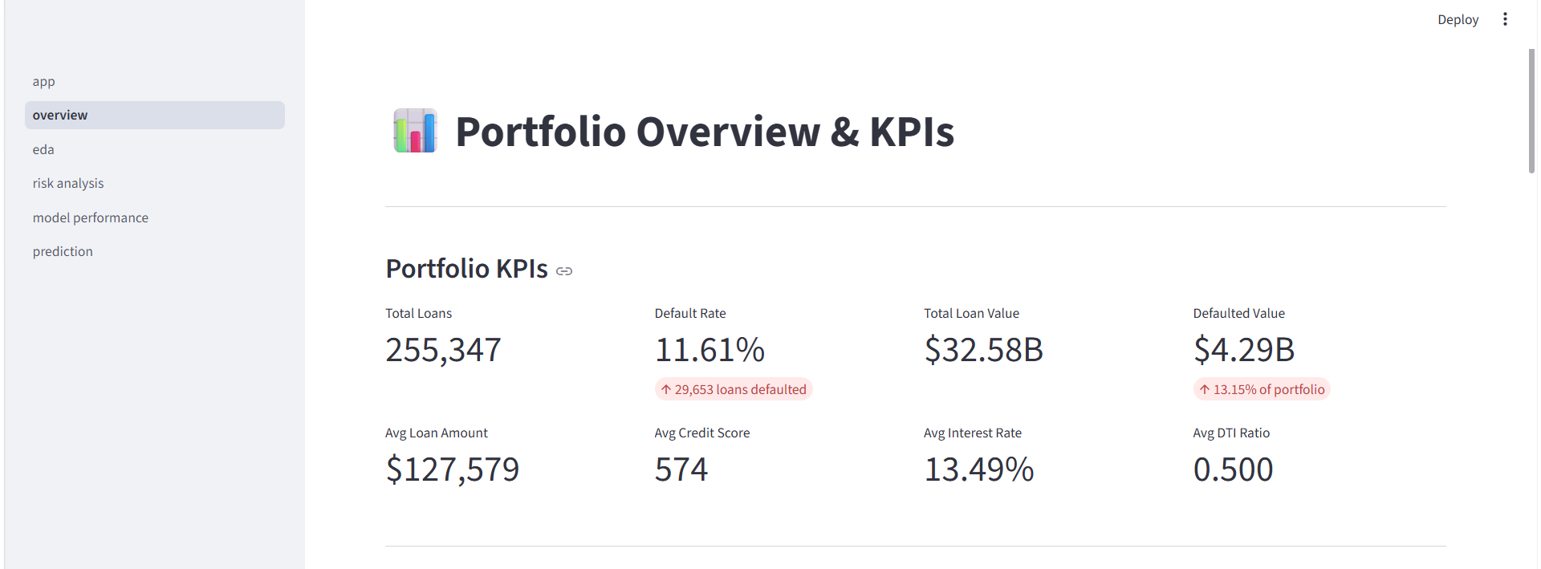fig: Streamlit dashboard showing the overall loan default risk analysis and key dataset indicators.

Exploratory Data Analysis
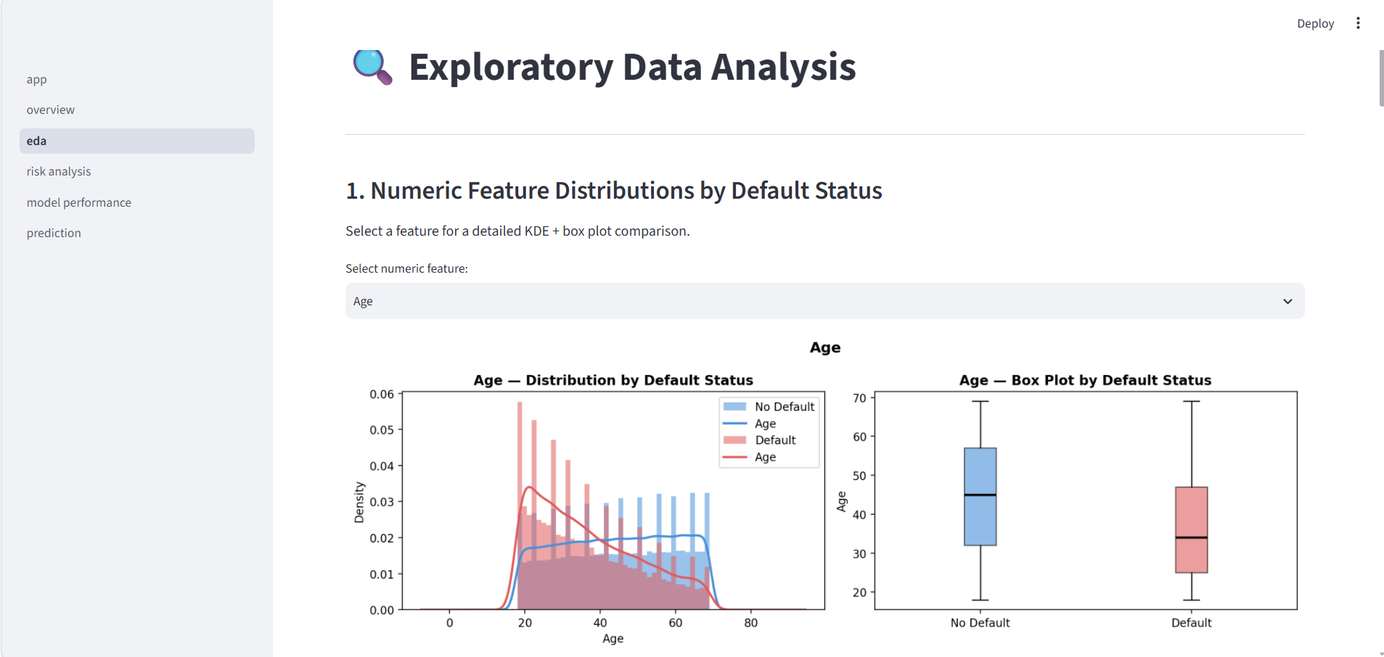
Loan Risk Analysis
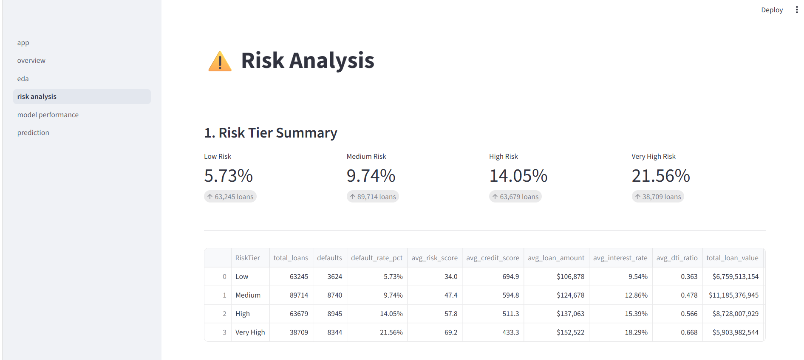
Model performance
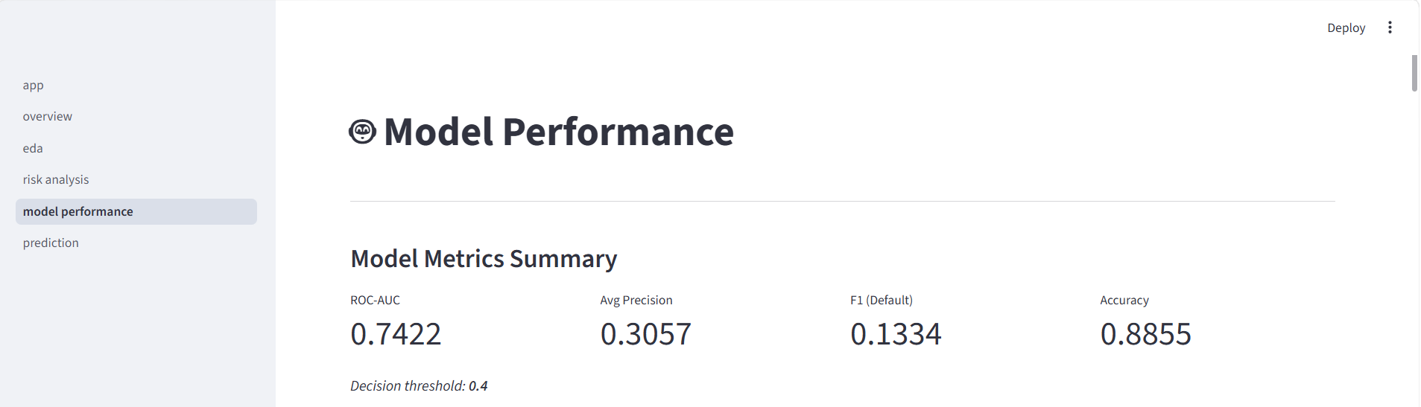
Prediction
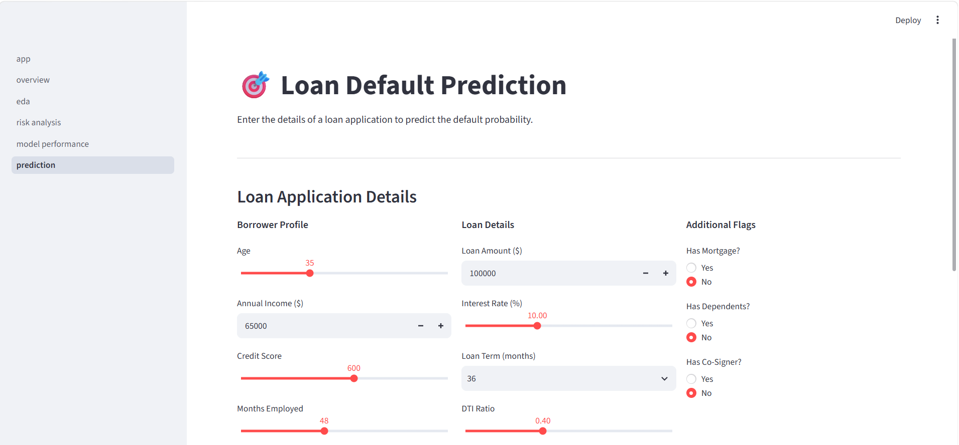
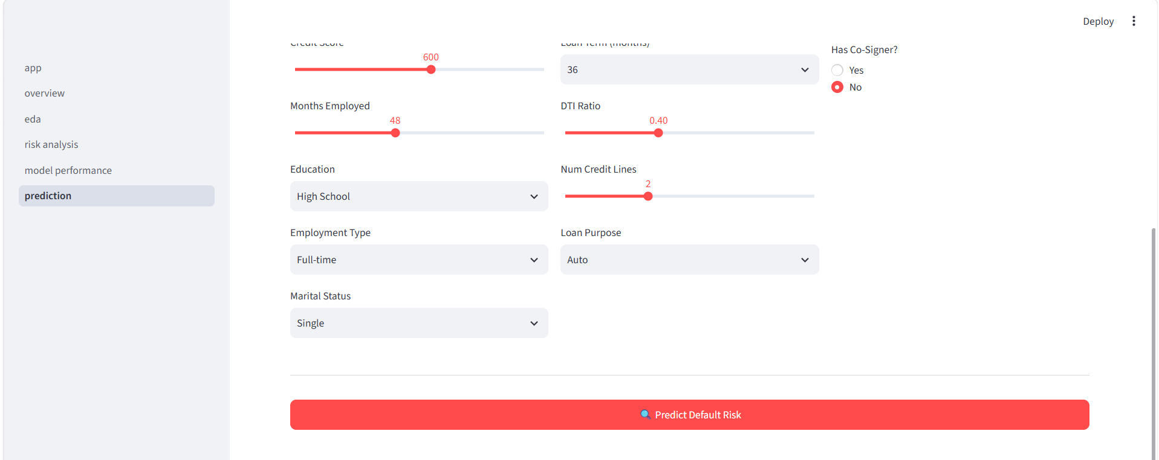
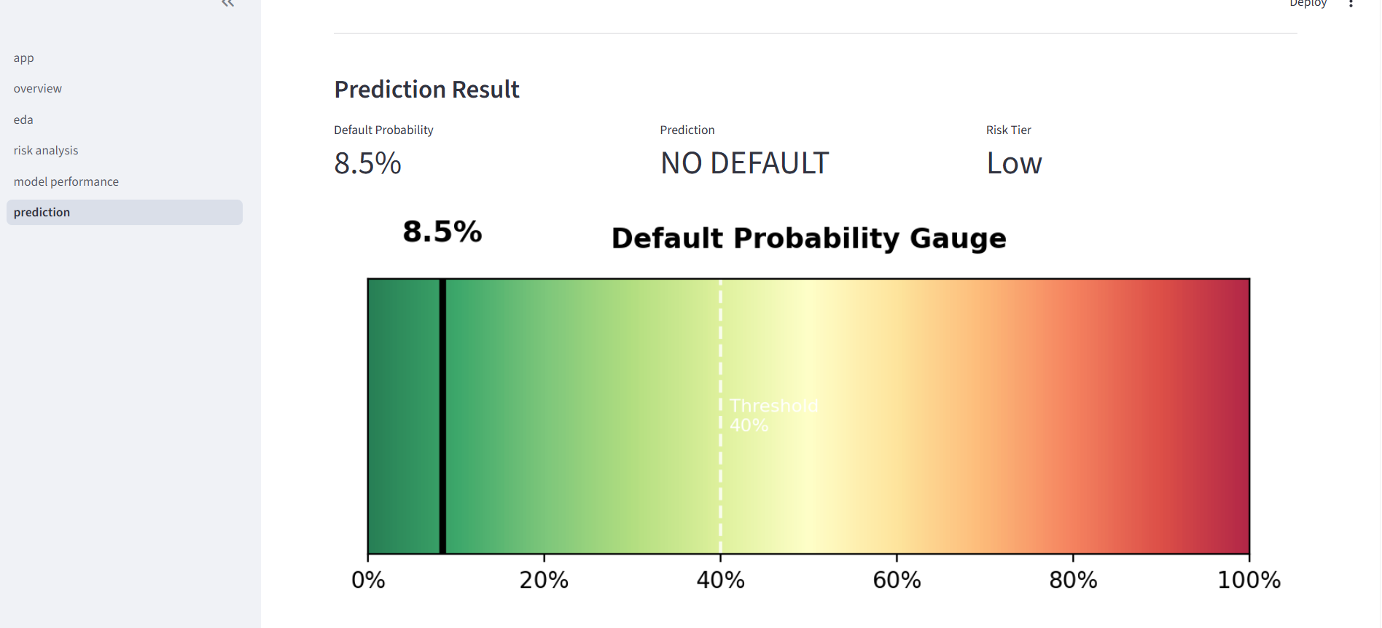
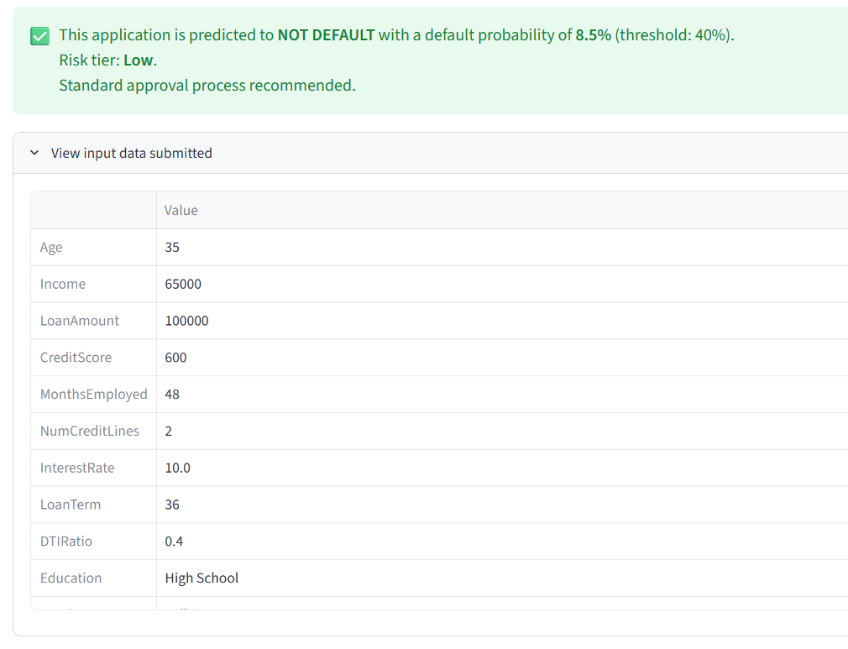

11. Project Architecture & Technology Stack
Component | Technology | Purpose
Data processing | Python, pandas, NumPy | Load, clean, transform data
Visualisation | matplotlib, seaborn | Charts for EDA, KPIs, model evaluation
Machine learning | scikit-learn | Preprocessing pipeline, RF, LR models
Model persistence | joblib | Save and load trained model artefacts
Dashboard | Streamlit | Interactive multi-page web application
Notebooks | Jupyter | Step-by-step analytical walkthroughs
Report | python-docx | Automated Word document generation

12. Conclusions
This project successfully demonstrates a professional, end-to-end data analytics workflow applied to a real-world loan default problem. Key conclusions are:
- The dataset is of high quality — no cleaning issues were found, enabling immediate analysis.
- Loan default is driven primarily by Interest Rate, Age, Employment Tenure, Loan Amount, and Income.
- Unemployed and younger borrowers carry significantly higher default risk than the portfolio average.
- The heuristic risk score effectively stratifies loans into tiers with monotonically increasing default rates.
- A Random Forest model trained with balanced class weights can predict default probability at the individual loan level.
- Deploying the model as a pre-approval scoring tool — flagging applications at or above a 40% predicted probability — has direct commercial value in reducing portfolio default exposure.

13. Appendix — File Reference
File | Description
src/config.py | Central configuration — all paths, constants, model parameters
src/data_loader.py | Load and validate raw CSV
src/data_cleaner.py | Quality checks and cleaning pipeline
src/eda.py | Reusable EDA chart functions
src/kpi.py | Portfolio and segment KPI computations
src/risk_analysis.py | Risk scoring, tier assignment, key driver analysis
src/insights.py | Business insights and recommendations
src/feature_engineering.py | scikit-learn preprocessing pipeline builder
src/model.py | Model training, evaluation, persistence, inference
run_pipeline.py | One-shot pipeline: load -> clean -> train -> save
dashboard/app.py | Streamlit home page
dashboard/pages/01_overview.py | KPI dashboard page
dashboard/pages/02_eda.py | EDA page
dashboard/pages/03_risk_analysis.py | Risk analysis page
dashboard/pages/04_model_performance.py | Model evaluation page
dashboard/pages/05_prediction.py | Prediction interface page

14. Project Links
GitHub Repository:
[GitHub repository link will be added here]
Live Streamlit Application:
[Streamlit deployment link will be added here]
Dataset:
[Dataset source link]

