**Assignment 2**

**Task: Logical Error Resolution**

**Objective**: Find and fix a logical error using GDB.

**Answer:**

* 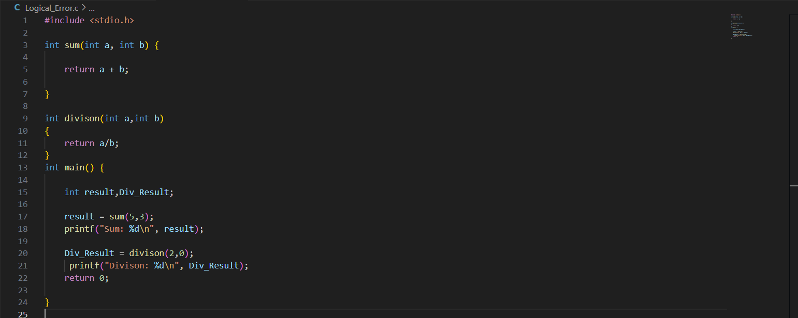In the below code there is a logical error with the function division as any number divided by zero is not possible it returns to infinity
* 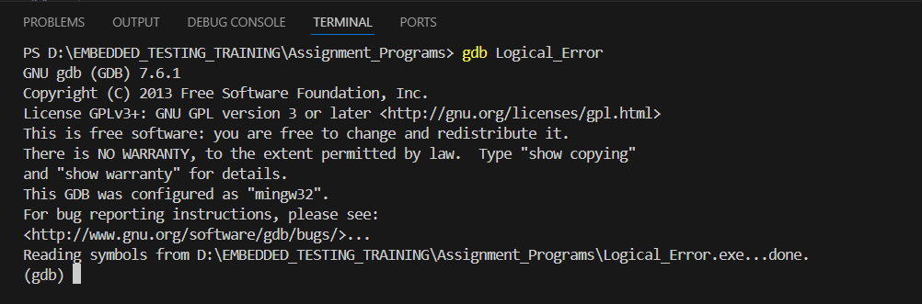Now building the program and starting GDB
* 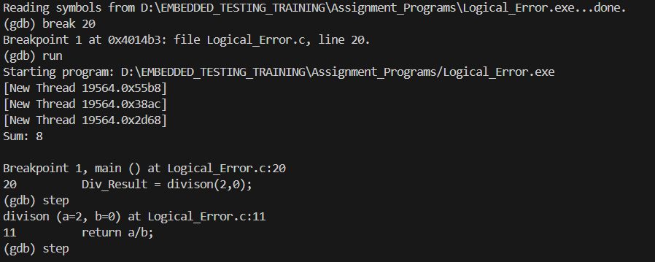Now Setting break point at result variable and trying printing the result.
  + As we can see in the above result it mention that there is a logical error line no 20 as 2/0 is not possible.
  + Now we will try to correct the logic and run again
* 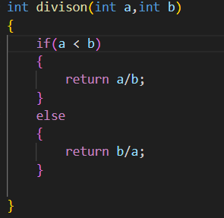Corrected Logic is given blow
* Now Executing the program we get

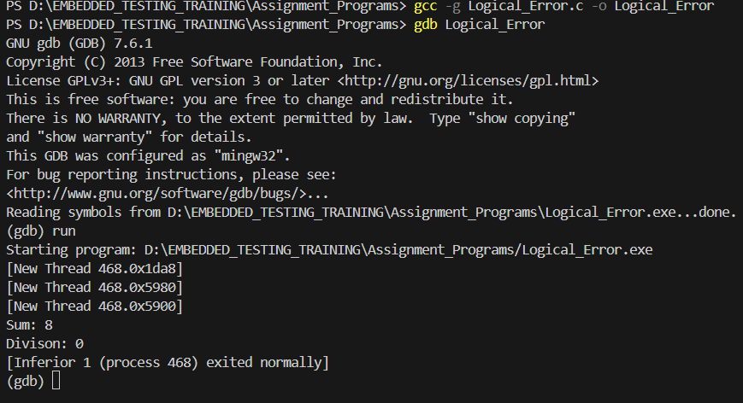

**Conclusion**

* Now we can see that our new logical is able to handle division logical error which was there earlier.
* So we have handled logical error and debugged through GDB.