**Assignment 3**

**Task 3: Segmentation Fault Analysis**

**Objective:** Identify the cause of a segmentation fault in a C program using GDB.

**Answer:**

1. We have installed MinGW and GDB
2. We have created a segment fault code which is given below

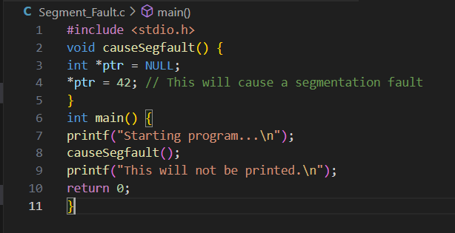

1. Now we have tried to build and run the code and attached output below.

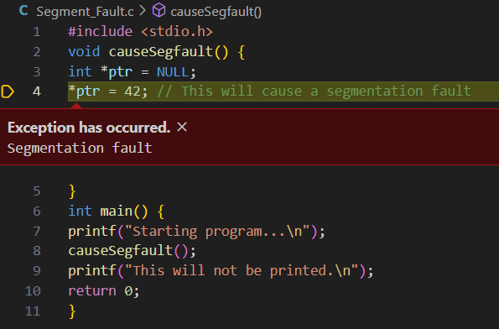

1. On running in GDB and back trace we got the following output.
   * 1. 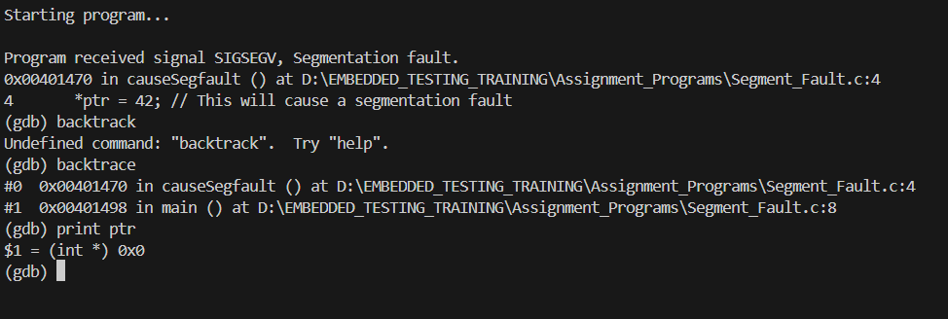
2. Now we have identified the segment fault case now let us fix and correct the code.

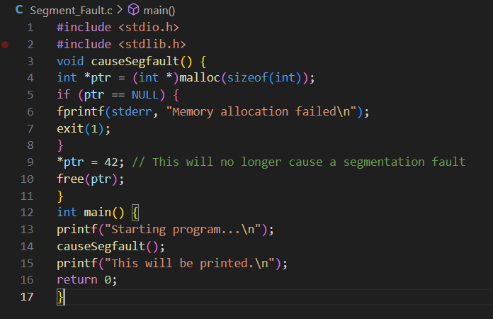

1. Now we have built and run the corrected code and the code executed successfully without any error.

