**Assignment 1**

**Task**: Basic Debugging with GDB.

**Objective**: Use GDB to step through a simple program.

**Answer:**

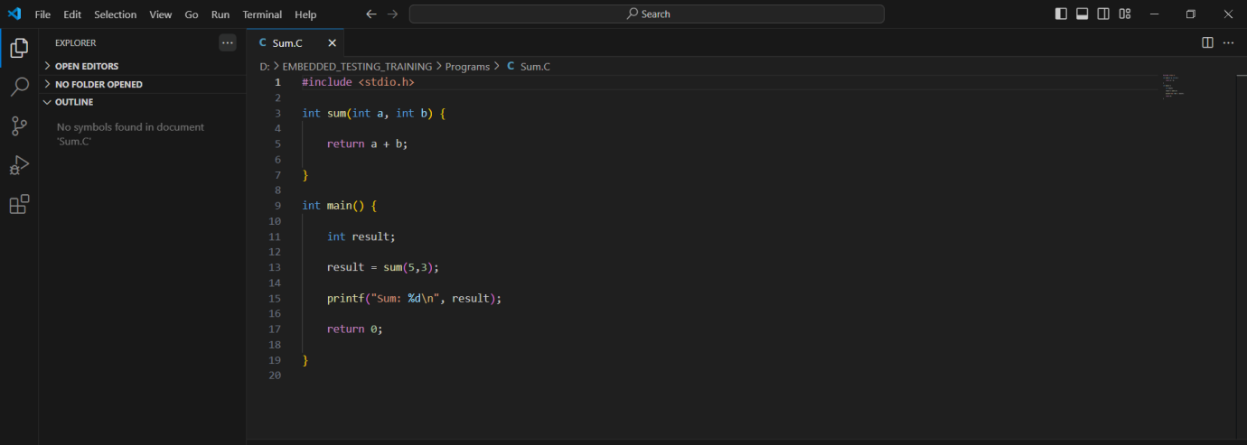**Steps1:** Write a basic C sum function

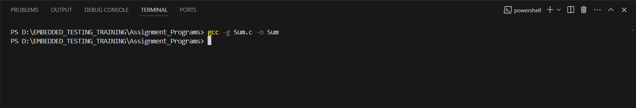

**Step2:** Compile with -g, start GDB.

**Step3:** Start Gdb.

* In the command prompt, navigate to the directory where your executable is located.
* 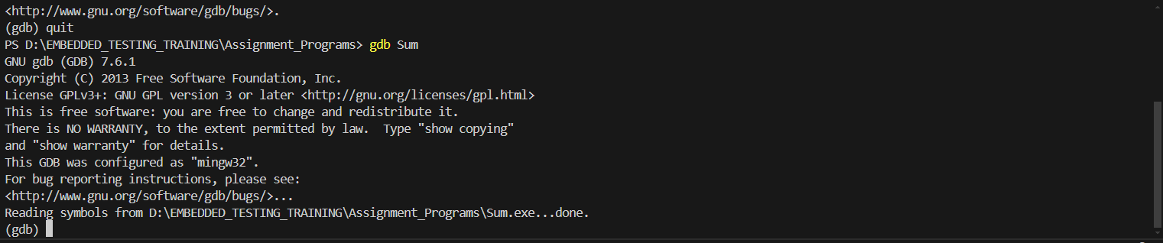Type gdb Sum to launch GDB with your program

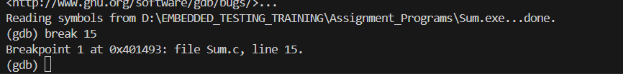**Step4:** Set Break Point

**Step5:** Print Variable, Step and Run

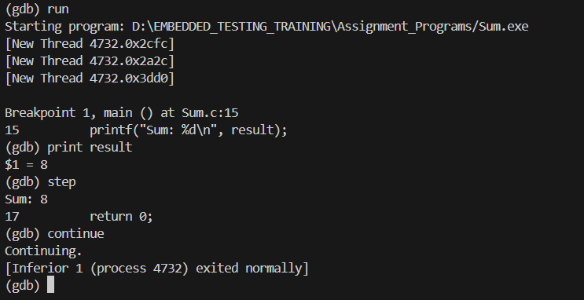

**Step6:** Quit the gdb

