**Assignment 1**

**Task 1: Reverse Debugging with GDB**

**Objective:** Practice reverses debugging in GDB.

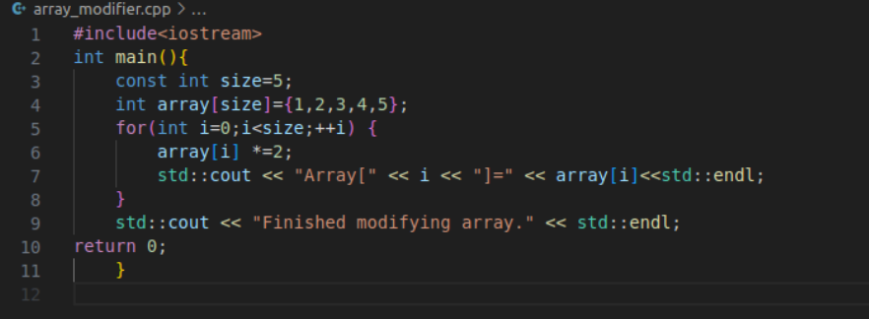**Answer**



