**Assignment 3**

**Task 3: RTOS Stack Analysis**

**Objective:** Analyze stack in an RTOS environment.

**Answers:**

1. We have Create main.c and CmakeFIle.txt

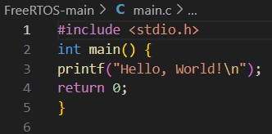

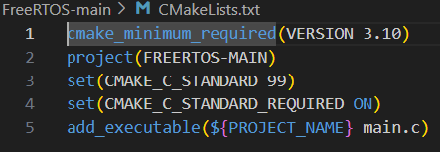

2. Configured the Project with cmake command

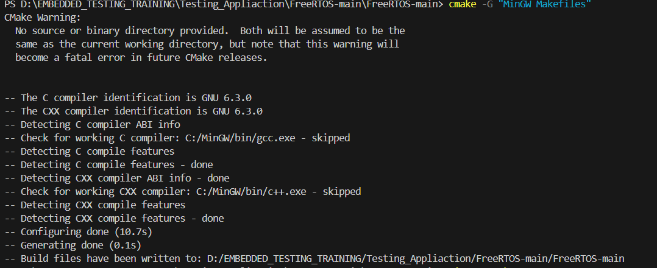

3.Now builded the application.



4. Now runned the executable.



**Conclusion:**

* We have run the RTOS Stack analysis successfully and we got the desired output

**Theory**

**Step 1: Create a new project directory**

Create a new directory called RTOS Simple in your preferred location (e.g.,

C:\Users\Avengers\Documents\Project).

**Step 2: Create a main.c file**

Create a new file called main.c in the RTOS Simple directory. This file will contain the entry

point for your executable.

main.c:

#include <stdio.h>

int main() {

printf("Hello, World!\n");

return 0;

}

**Step 3: Create a CMakeLists.txt file**

Create a new file called CMakeLists.txt in the RTOS Simple directory. This file will contain

the configuration settings for your project.

CMakeLists.txt:

cmake_minimum_required(VERSION 3.10)

project(RTOS_Simple)

set(CMAKE_C_STANDARD 99)

set(CMAKE_C_STANDARD_REQUIRED ON)

add_executable(${PROJECT_NAME} main.c)

**Step 4: Configure the project using CMake**

Open a Command Prompt or PowerShell and navigate to the RTOS Simple directory. Run the

following command to configure the project using CMake:

cmake -G "MinGW Makefiles" .

**Step 5: Build the project**

Run the following command to build the project:

mingw32-make

This should compile and link your main.c file, creating an executable file called

RTOS_Simple.exe in the RTOS Simple directory.

**Step 6: Run the executable**

Run the following command to execute the RTOS_Simple.exe file:

./RTOS_Simple.exe

This should print "Hello, World!" to the console.

**Conclusion:**

In this lab, you created a simple RTOS project using CMake and MinGW. You configured the

project using CMake, built the project using MinGW, and executed the resulting executable

file.