**Assignment 4**

**Task: Data Watch point and Trace**

**Objective:** Use DWT for system monitoring.

**Answer:**

1. First we have to write sample code to apply watch point.

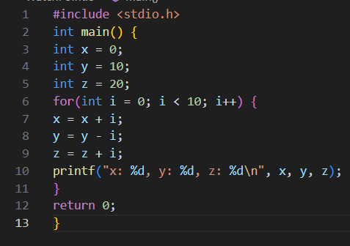

1. Now we have to compile the program create the executable.
2. Now let us open gdb and apply breakpoint at main.

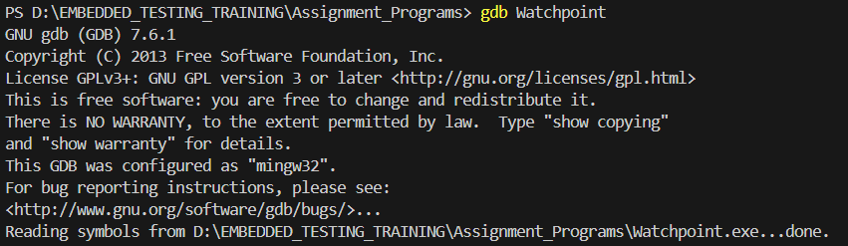



1. Now lets us run the code and apply watch point at variable x and watch the values.

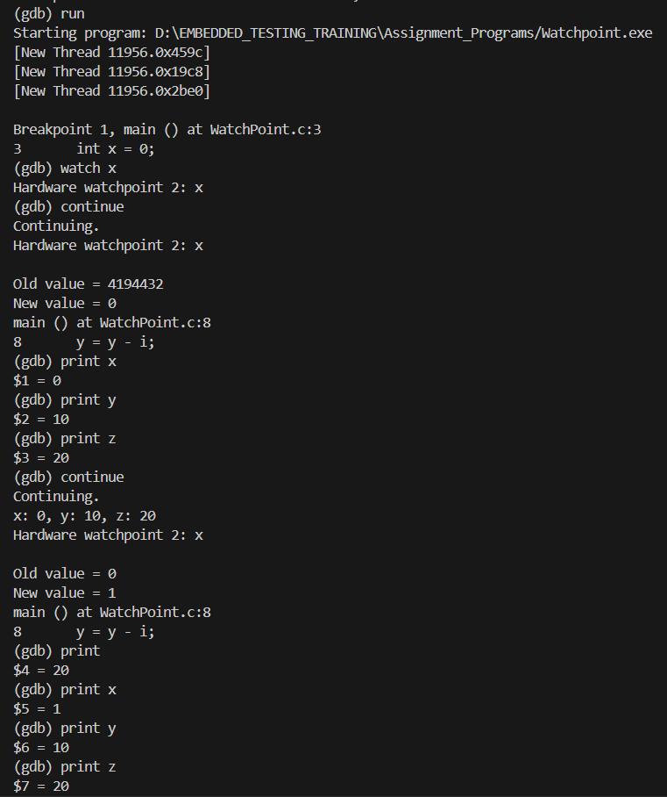

* So we have seen that as soon as the value of x changes the debugger stops the program and displays the values and waits for user confirmation to proceed.

**Conclusion:**

* We have successfully applied watch point and executed the program
* We have also monitored the variable behavior.