**Case Study 4: ABC Inc.**

This application should be maintain the employee and project details. An employee can update their personal details only, while admin can add, update all details delete employees and project. Each employee must be associated with any one project running in the organization. Admin can add a new project and update project duration. Admin can also change employee’s project.

Design the database schema for the above case study and integrate it with the application.

**Analysis:**

1. We will go for **water fall model** as the requirements is clearly understood form the problem statement.

**Requirements.**

* **Front-End:** Aspx, JavaScript.
* **Backend:** C#.
* **Database:** Sql Server.

**Design**

1. Login Page.
   1. Administrator Login.
      1. **Privileges**: Update, Delete, Insert
      2. **Pages Access:** User details, Project Registration, Project Update page.
   2. User Login (Employee Login).
      1. **Privileges:** Update (Only).
      2. **Page Access :** User Details Only,
2. User details page.
3. Project Registration page.
4. Project Update Page.

**Database Design**

1. **User Table**
   1. User Id (Primary Key)
   2. Username
   3. Password
   4. User Type
2. **Employee Details**
   1. Name
   2. Employment Number(Primary Key)
   3. Department
   4. Designation
   5. Email
   6. Phone No
   7. Address
3. **Project Details**
   1. Employment Number(Foreign Key)
   2. Project id(Primary Key)
   3. Project Name
   4. Start Date
   5. End Date
   6. Description
   7. Status
4. **Project Count**
   1. Employment Number
   2. No of project assigned

**Work Flow of Application**

1. **Admin Workflow:**
2. Log in to the admin portal.
3. View list of employees and projects.
4. Add a new employee or project.
5. Update employee details or project details including duration.
6. Reassign an employee to a different project.
7. Delete an employee or project if necessary.
8. **Employee Workflow:**
9. Log in to the employee portal.
10. View personal details.
11. Update personal details if needed.
12. View details of the assigned project.

**NOTE :**

1. **If there is no project count against the user id of Employee type login in Project count Table the it will throw alert to link at least with one project.**

**2) Admin cannot delete project if employee is linked to one project only. For that he has to first assign new project and then delete old project.**

**FLOW DIAGRAM**

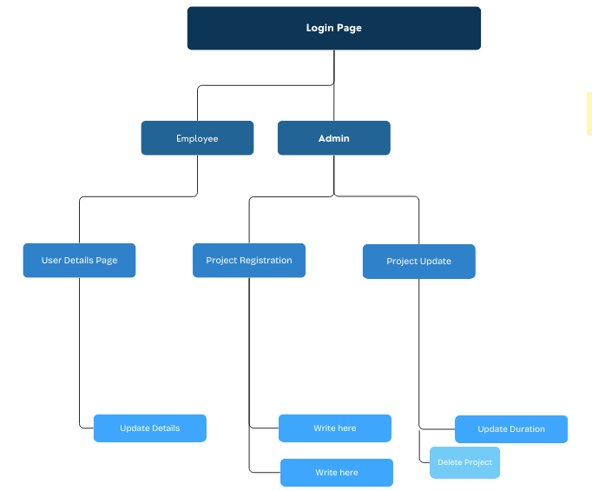

**DATABASE SCHEMA**

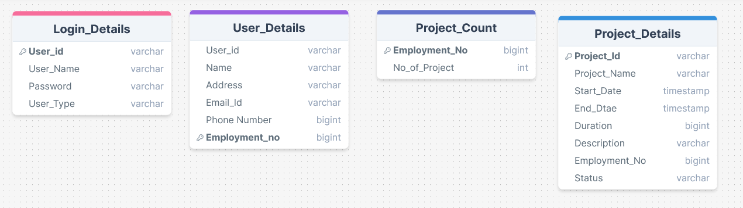

1. Trigger to be applied on project details page. As soon as any new record is inserted it will increase project count and if any row is deleted then it will decrease project count in Project_Count Table.

**ER DIAGRAM**

User Name

Description

End Date

Duration

Emp No

**Project ID**

Start Date

Project Name

Project Details

Desgistnation

Department

Address

Name

Phone no

Mail

**Emp No**

USER DETAILS

MANAGE

MANAGE

User

Admin

HAS

Password

Log In