### Scrum Activities

Scrum is an agile process framework that includes following four activities

1. **Planning**- establishes a broad description of project, overall expectations and a business sponsorship
2. **Staging**- gathers requirements and establishes priorities
3. **Development**- implements a complete application in series of iteration that scrums calls as Sprints
4. **Release**- deploys the system to user community

### Scrum Practices

Scrum do not prescribe specific methods to complete the activities but recommends following set of practices

* **Self-directed and self-organizing team structure**

- self organizing team (Members are inter-dependent and collaboration is the best way to achieve goals)

- shape their approach and accept responsibility (Rely less on management but on team for success)

* **Once an iteration begins, no external changes can be requested**

- So how can we request changes? Scrum has a practice called "**Backlog**" to do just that

* **Duration of each iteration to be of 30 days or less**

- Get product increment delivered in customer hands quickly

* **All team communication to be through short, stand-up meetings**

- Daily scrum helps keep all team members focus on objective and help them avoid going off-track

- The meetings are short and referred as stand-up meeting

* **Demo to stakeholders at the end of each iteration**

- Development of product occurs in series of increment that culminate into sprint demo

- The product increment (sprint demo) is the final output of an Iteration (sprint) that is presented to the Customer as a demonstration of the progress and as a feedback mechanism.

- The demo is **an Incremental Delivery**.

* **Adaptive planning as the iteration proceeds**

- Everyday work continues as the team learn something.

- That information is factored into sprint plan which is adopted as new information is obtained.

### Features of Scrum

* '**Packets**'

- Scrum delivers software incrementally

- **Backlog items** - Breaking down a large problem into manageable pieces, scrum can deliver product in timely manner

- Packets are collections of objects that are required to implement a backlog item

* **Testing and documentation are on-going as the product is constructed**

- Scrum requires frequent Builds. Software is assembled and tested on daily basis.

- Daily integration and regression testing is run on the Build.Automated tests are preferred.

* **Sprints derived from requirements**

- **Product Backlog** (managed by customer - Product Owner)

Master list of all functionality desired in the product. It grows over time as more is learned about the requirements of Product.

- **Sprint Backlog** (managed by team)

It is the list of tasks that the team has committed to complete in the current development sprint

* **Demos**

- Each iteration is fixed in duration ex 14 days, 21 days or 1 month

- Time boxing : **Forces the team to vary the scope of delivery rather than duration or the cost**

### The Scrum Team

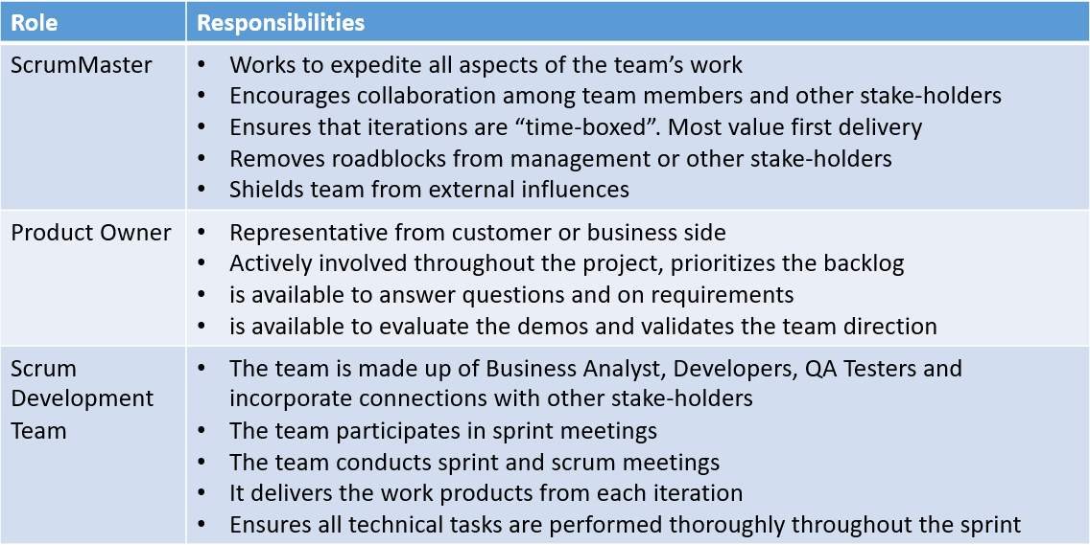

### The Scrum Process Flow

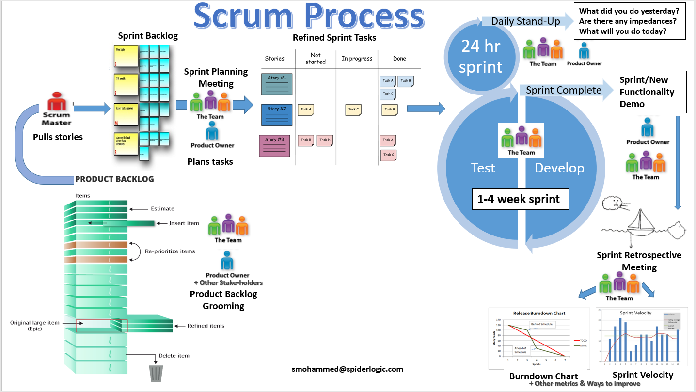

### The Scrum Ceremonies

1. **Backlog Grooming**- Along with Product Owner, other Stake-holders, Scrum Master and if needed the Team meets to groom the backlog
2. **Sprint Planning**- The team meets to break up stories into task and divide task among themselves
3. **Daily Scrum or Daily Stand-up** - The team meets daily to share what they did and what they plan to do next and any impedance that they may be facing
4. **Sprint Demo/Review** - The team gives demo to Product Owner and Stake-holders of the deliverables they promised at the start of sprint
5. **Sprint Retro** - The team meets to retrospective the past sprint and share ways to improve the product and process

### Daily Scrum Meeting

The meeting is very short and is conducted every day preferably at same time. The team stands in circle or in a way that each one can see other team member.

Every team member gives their updates on 3 points to the team:

1. What did you do since last meeting?
2. What will you do till next meeting?
3. Are there any impedance or obstruction hindering you in completion of your work?

### Benefits of Daily Scrum Meeting

* **Social promise** - When team members describe what they will accomplish in next 24 hrs, they make a social promise to their colleagues in the team
* **Adaptive response by the team**
* **Understand progress or impediments on a daily basis -**Scrum Master takes notes of this and helps in removing impediments.
* **Sharing information**- A subtle way to have team's backup as everyone gets to learn what other person is doing
* **Shared knowledge** - Helps to gel the team