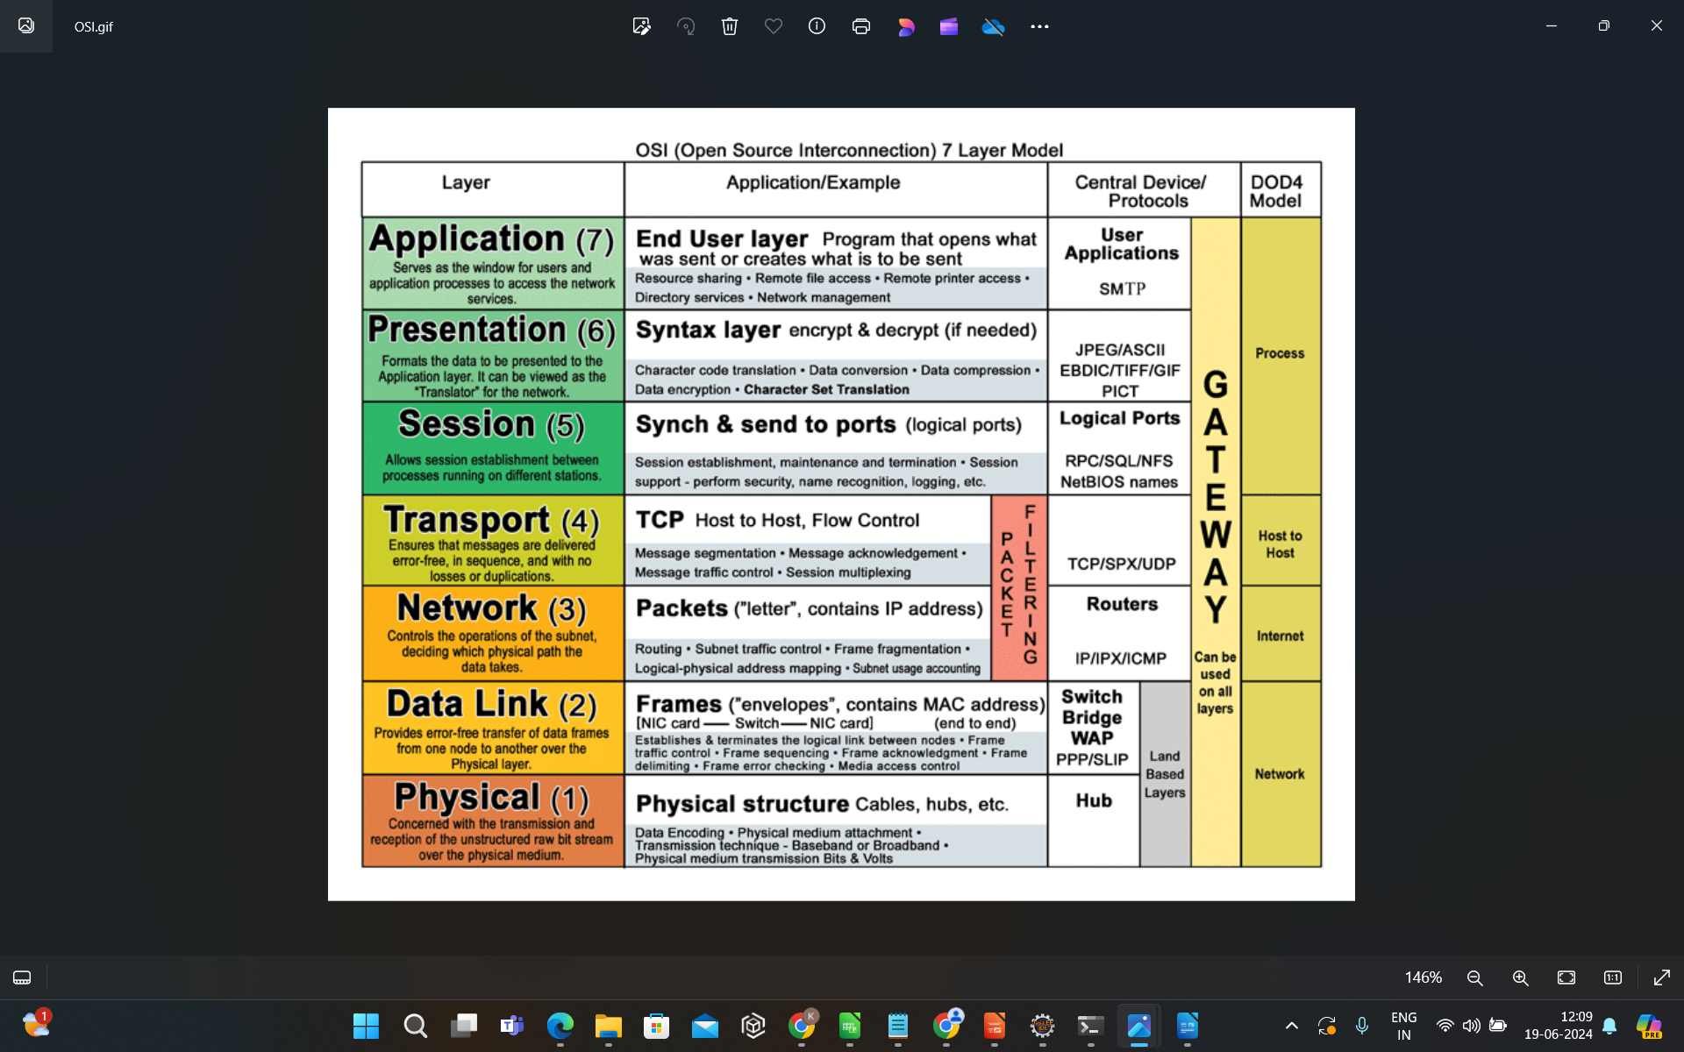

Layer 1 (Physical layer): Twisted pair, Wi-Fi in 2.4Ghz or 5Ghz

Layer 2 (Link layer): Ethernet, 802.11a/b/…

Layer 2.5 (Forwarding plane): MPLS

Layer 3 (Network): IPv4, IPv6

Layer 3+ (Routing protocols): BGP, OSPF, IS-IS

Layer 3.5 (Tunnel): GRE, LISP, IPsec

Layer 4 (Transport): UDP, TCP, QUIC

Layer 5 (Application): FTP, HTTP(s), SMTP, IMAP, POP, …

=====================================

|  |  |  |  |
| --- | --- | --- | --- |
| **LAYER** | **EXAMPLE** | | **FUNCTION/ACTIVITY** |
| **APPLICATION** | [**Web Browser**](https://www.inetdaemon.com/tutorials/www/web_browser/index.shtml) | | A [web](https://www.inetdaemon.com/tutorials/www/index.shtml) [browser](https://www.inetdaemon.com/tutorials/www/web_browser/index.shtml) such as [Internet Explorer](https://www.inetdaemon.com/tutorials/www/web_browser/index.shtml) or [Netscape](https://www.inetdaemon.com/tutorials/www/web_browser/index.shtml) provides the means for your [computer](https://www.inetdaemon.com/tutorials/computers/index.shtml) to contact a [web](https://www.inetdaemon.com/tutorials/www/index.shtml)[server](https://www.inetdaemon.com/tutorials/www/web_server/index.shtml) and download several files that go together to produce a single [web](https://www.inetdaemon.com/tutorials/www/index.shtml) [page](https://www.inetdaemon.com/tutorials/www/web_pages/index.shtml).  You can request a [web page](https://www.inetdaemon.com/tutorials/www/web_pages/index.shtml) by typing in a [web address](https://www.inetdaemon.com/tutorials/www/general_concepts/url.shtml) (a [URL](https://www.inetdaemon.com/tutorials/www/general_concepts/url.shtml)) or by clicking a link in an open web page. The [web](https://www.inetdaemon.com/tutorials/www/index.shtml) [browser](https://www.inetdaemon.com/tutorials/www/web_browser/index.shtml) is an **APPLICATION.** The [web](https://www.inetdaemon.com/tutorials/www/index.shtml) [browser](https://www.inetdaemon.com/tutorials/www/web_browser/index.shtml) application gives you the means to select a[web](https://www.inetdaemon.com/tutorials/www/index.shtml) [server,](https://www.inetdaemon.com/tutorials/www/web_server/index.shtml) contact the server and request a [web page](https://www.inetdaemon.com/tutorials/www/web_pages/index.shtml). The [web browser](https://www.inetdaemon.com/tutorials/www/web_browser/index.shtml) handles the process of finding the [web](https://www.inetdaemon.com/tutorials/www/index.shtml)[server](https://www.inetdaemon.com/tutorials/www/web_server/index.shtml)(the remote computer that has the [web page](https://www.inetdaemon.com/tutorials/www/web_pages/index.shtml) you want stored on it) , requesting the desired [web page](https://www.inetdaemon.com/tutorials/www/web_pages/index.shtml) and displaying all the files contained within the [web page](https://www.inetdaemon.com/tutorials/www/web_pages/index.shtml). |
| **PRESENTATION** | [**HTTP**](https://www.inetdaemon.com/tutorials/www/web_server/http/index.shtml) | | The [web](https://www.inetdaemon.com/tutorials/www/index.shtml) [browser](https://www.inetdaemon.com/tutorials/www/web_browser/index.shtml) handles **PRESENTATION** of the [web](https://www.inetdaemon.com/tutorials/www/index.shtml) [page](https://www.inetdaemon.com/tutorials/www/web_pages/index.shtml) to the user by converting the files stored at the [web](https://www.inetdaemon.com/tutorials/www/index.shtml)[server](https://www.inetdaemon.com/tutorials/www/web_server/index.shtml) into formats used to display them on your [computer](https://www.inetdaemon.com/tutorials/computers/index.shtml).  Your [web](https://www.inetdaemon.com/tutorials/www/index.shtml) [browser](https://www.inetdaemon.com/tutorials/www/web_browser/index.shtml) supports varous text formats (UNICODE and ASCII), image file formats (JPG, GIF, PNG, BMP), audio file formats (WAV, MP3, AIFF) as well as [Hypertext Markup Language](https://www.inetdaemon.com/tutorials/www/web_pages/html/index.shtml) [(HTML)](https://www.inetdaemon.com/tutorials/www/web_pages/html/index.shtml) and one or more scripting languages ([JavaScript](https://www.inetdaemon.com/tutorials/scripting/languages/JavaScript/index.shtml), JScript, VBScript). Conversion of data from one format to another is the job of the **PRESENTATION** layer. A [web](https://www.inetdaemon.com/tutorials/www/index.shtml) [browser](https://www.inetdaemon.com/tutorials/www/web_browser/index.shtml) can convert these file formats into the local formats used on the local [computer](https://www.inetdaemon.com/tutorials/computers/index.shtml) for displaying images, playing sounds and displaying text; if it cannot, it often can launch an application which does understand the format. Much of the **PRESENTATION** layer conversions are handled in the program you're running. |
| **SESSION** | When you request a [web](https://www.inetdaemon.com/tutorials/www/index.shtml) [page](https://www.inetdaemon.com/tutorials/www/web_pages/index.shtml), a the [web](https://www.inetdaemon.com/tutorials/www/index.shtml) [browser](https://www.inetdaemon.com/tutorials/www/web_browser/index.shtml) opens a [TCP](https://www.inetdaemon.com/tutorials/internet/tcp/index.shtml) connection to the [web](https://www.inetdaemon.com/tutorials/www/index.shtml) [server](https://www.inetdaemon.com/tutorials/www/web_server/index.shtml). The [web](https://www.inetdaemon.com/tutorials/www/index.shtml) [server](https://www.inetdaemon.com/tutorials/www/web_server/index.shtml) sends back the [web](https://www.inetdaemon.com/tutorials/www/index.shtml) [page](https://www.inetdaemon.com/tutorials/www/web_pages/index.shtml) and closes the connection. Your [web](https://www.inetdaemon.com/tutorials/www/index.shtml) [browser](https://www.inetdaemon.com/tutorials/www/web_browser/index.shtml) then parses the [HTML](https://www.inetdaemon.com/tutorials/www/web_pages/html/index.shtml) of the [web](https://www.inetdaemon.com/tutorials/www/index.shtml) [page](https://www.inetdaemon.com/tutorials/www/web_pages/index.shtml). Within the [web](https://www.inetdaemon.com/tutorials/www/index.shtml) [page](https://www.inetdaemon.com/tutorials/www/web_pages/index.shtml) are instructions written in [HTML](https://www.inetdaemon.com/tutorials/www/web_pages/html/index.shtml) [tags](https://www.inetdaemon.com/tutorials/www/web_pages/html/tags.shtml) which tell the [browser](https://www.inetdaemon.com/tutorials/www/web_browser/index.shtml) where to find additional files to be displayed within the [web](https://www.inetdaemon.com/tutorials/www/index.shtml) [page](https://www.inetdaemon.com/tutorials/www/web_pages/index.shtml) such as style sheets, sound files, images, movies, Flash files and applets. Your [web](https://www.inetdaemon.com/tutorials/www/index.shtml) [browser](https://www.inetdaemon.com/tutorials/www/web_browser/index.shtml) automatically opens additional [TCP](https://www.inetdaemon.com/tutorials/internet/tcp/index.shtml) connections to the [web](https://www.inetdaemon.com/tutorials/www/index.shtml) [server](https://www.inetdaemon.com/tutorials/www/web_server/index.shtml). Each [TCP](https://www.inetdaemon.com/tutorials/internet/tcp/index.shtml) connection is a **SESSION**. |
| **TRANSPORT** | [**TCP**](https://www.inetdaemon.com/tutorials/internet/tcp/index.shtml) | | To communicate with a [web](https://www.inetdaemon.com/tutorials/www/index.shtml) [server](https://www.inetdaemon.com/tutorials/www/web_server/index.shtml) your [computer](https://www.inetdaemon.com/tutorials/computers/index.shtml) must open a [TCP](https://www.inetdaemon.com/tutorials/internet/tcp/index.shtml) connection to the [web](https://www.inetdaemon.com/tutorials/www/index.shtml) [server](https://www.inetdaemon.com/tutorials/www/web_server/index.shtml) and request a [web](https://www.inetdaemon.com/tutorials/www/index.shtml) [page](https://www.inetdaemon.com/tutorials/www/web_pages/index.shtml). The [TCP](https://www.inetdaemon.com/tutorials/internet/tcp/index.shtml) connection breaks up the[web](https://www.inetdaemon.com/tutorials/www/index.shtml) [page](https://www.inetdaemon.com/tutorials/www/web_pages/index.shtml) into managable chunks, lables them with numbers so they can be reassembled in the correct order and **TRANSPORTS** the pieces across the correct **SESSION**. |
| **NETWORK** | [**IP**](https://www.inetdaemon.com/tutorials/internet/ip/index.shtml)[**ARP**](https://www.inetdaemon.com/tutorials/networking/lan/arp.shtml) | | [Internet Protocol](https://www.inetdaemon.com/tutorials/internet/ip/index.shtml) ([IP](https://www.inetdaemon.com/tutorials/internet/ip/index.shtml)) is a **NETWORK**layer protocol that uses unique addresses for the [web](https://www.inetdaemon.com/tutorials/www/index.shtml) [server](https://www.inetdaemon.com/tutorials/www/web_server/index.shtml) and for your [computer](https://www.inetdaemon.com/tutorials/computers/index.shtml). [IP](https://www.inetdaemon.com/tutorials/internet/ip/index.shtml) provides the means for your [computer](https://www.inetdaemon.com/tutorials/computers/index.shtml) to determine whether the [web](https://www.inetdaemon.com/tutorials/www/index.shtml) [server](https://www.inetdaemon.com/tutorials/www/web_server/index.shtml) is a local [computer](https://www.inetdaemon.com/tutorials/computers/index.shtml) or a [computer](https://www.inetdaemon.com/tutorials/computers/index.shtml) located somewhere on the [Internet](https://www.inetdaemon.com/tutorials/internet/index.shtml). To reach a [web](https://www.inetdaemon.com/tutorials/www/index.shtml) [server](https://www.inetdaemon.com/tutorials/www/web_server/index.shtml) on the [Internet](https://www.inetdaemon.com/tutorials/internet/index.shtml), [IP](https://www.inetdaemon.com/tutorials/internet/ip/index.shtml) protocol also allows your [computer](https://www.inetdaemon.com/tutorials/computers/index.shtml) to figure out how to reach the [Internet](https://www.inetdaemon.com/tutorials/internet/index.shtml) [web](https://www.inetdaemon.com/tutorials/www/index.shtml) [server](https://www.inetdaemon.com/tutorials/www/web_server/index.shtml) via your [default gateway](https://www.inetdaemon.com/tutorials/internet/ip/routing/default_gateway.shtml). Your [computer](https://www.inetdaemon.com/tutorials/computers/index.shtml) creates a message addressed to the [web](https://www.inetdaemon.com/tutorials/www/index.shtml) [server](https://www.inetdaemon.com/tutorials/www/web_server/index.shtml) with your [computer](https://www.inetdaemon.com/tutorials/computers/index.shtml)'s return [IP](https://www.inetdaemon.com/tutorials/internet/ip/index.shtml) [address](https://www.inetdaemon.com/tutorials/internet/ip/addresses/index.shtml). Your [computer](https://www.inetdaemon.com/tutorials/computers/index.shtml) uses [ARP](https://www.inetdaemon.com/tutorials/networking/lan/arp.shtml) to figure out the [physical MAC address](https://www.inetdaemon.com/tutorials/networking/lan/ethernet/mac.shtml) of the [default gateway](https://www.inetdaemon.com/tutorials/internet/ip/routing/default_gateway.shtml) and then passes the data to the **NETWORK** layer. |
| **DATA LINK** | [**E T H E R N E T**](https://www.inetdaemon.com/tutorials/networking/lan/ethernet/index.shtml) | [**LLC**](https://www.inetdaemon.com/tutorials/networking/lan/ethernet/llc.shtml) | Once the request from your [web](https://www.inetdaemon.com/tutorials/www/index.shtml) [browser](https://www.inetdaemon.com/tutorials/www/web_browser/index.shtml) has been created it is sent to the network card. Once it reaches your network card it must be converted into a message that is sent from your [computer](https://www.inetdaemon.com/tutorials/computers/index.shtml) to the [default gateway](https://www.inetdaemon.com/tutorials/internet/ip/routing/default_gateway.shtml) which will forward the message to the Internet. At the **DATA LINK**layer, the [web](https://www.inetdaemon.com/tutorials/www/index.shtml) [request](https://www.inetdaemon.com/tutorials/www/web_server/http/request/index.shtml) is inserted inside a network request to the [default gateway](https://www.inetdaemon.com/tutorials/internet/ip/routing/default_gateway.shtml). |
| [**MAC**](https://www.inetdaemon.com/tutorials/networking/lan/ethernet/mac.shtml) |
| **PHYSICAL** | [**CSMA/CD**](https://www.inetdaemon.com/tutorials/networking/lan/ethernet/CSMA-CD.shtml) | The **physical** layer provides the means to transmit the [web](https://www.inetdaemon.com/tutorials/www/index.shtml) page request to the [default gateway](https://www.inetdaemon.com/tutorials/internet/ip/routing/default_gateway.shtml). |

