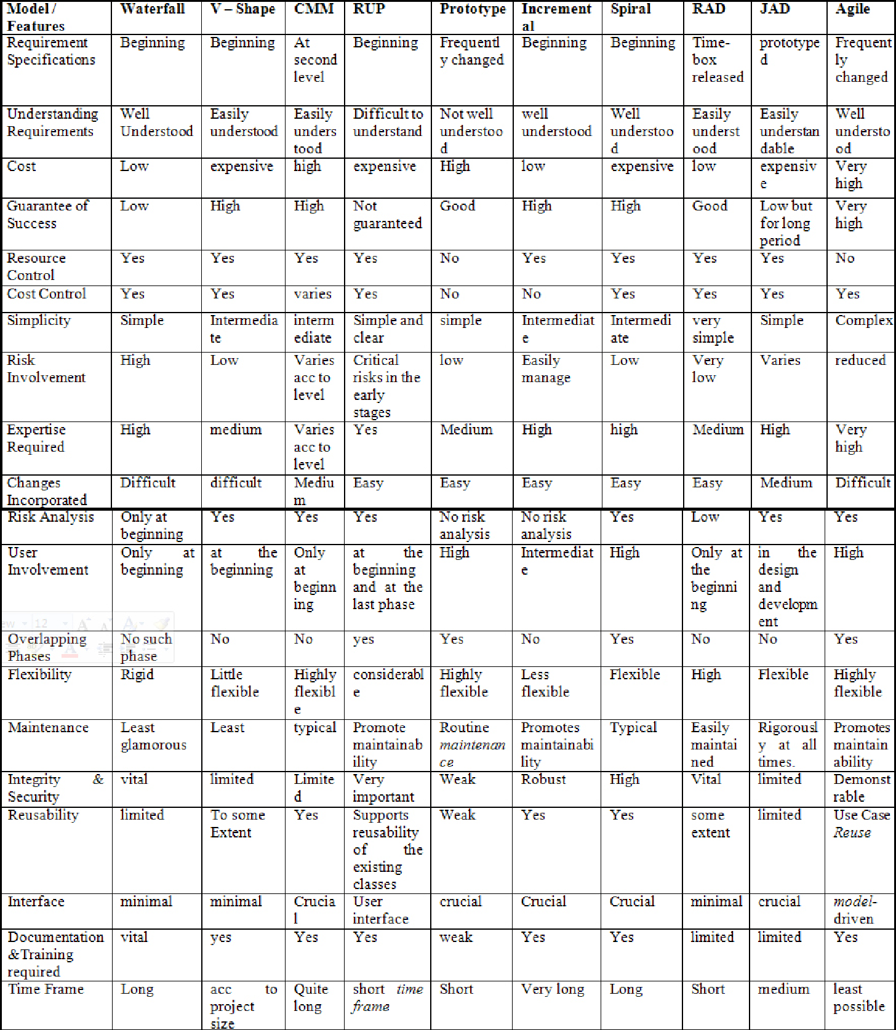

## 1. Waterfall Model

Waterfall model is a famous and good version of[SDLC(System Development Life Cycle)](https://www.geeksforgeeks.org/software-development/)for software engineering. The waterfall model is a linear and sequential model, which means that a development phase cannot begin until the previous phase is completed. We cannot overlap phases in waterfall model.

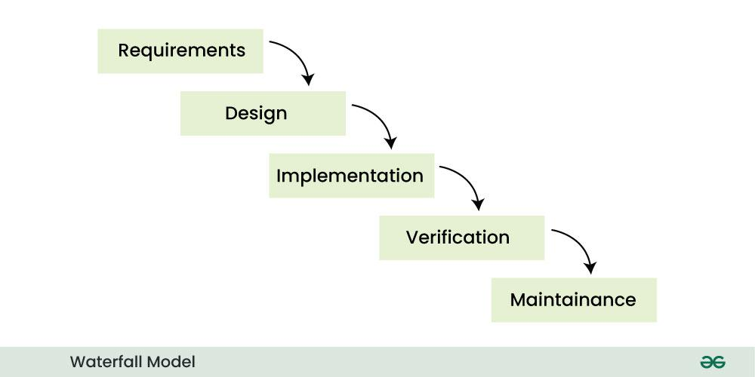

### Advantages of Waterfall Model

* This model is simple and easy to understand.
* This is very useful for small projects.
* This model is easy to manage.
* The end goal is determined early.
* Each phase of this model is well explained.
* It provides a structured way to do things.
* This is a base model, all the SDLC models that came after this were created keeping this in mind, although they worked to remove its shortcomings.
* In this model, we can move to the next phase only after the first phase is successfully completed so that there is no overlapping between the phases.

### Disadvantages of Waterfall Model

* In this model, complete and accurate requirements are expected at the beginning of the development process.
* Working software is not available for very long during the development life cycle.
* We cannot go back to the previous phase due to which it is very difficult to change the requirements.
* Risk is not assessed in this, hence there is high risk and uncertainty in this model.
* In this the testing period comes very late.
* Due to its sequential nature this model is not realistic in today’s world.
* This is not a good model for large and complex projects.

## 2. V-Model

V-Model is an SDLC model, it is also called Verification and Validation Model. V-Model is widely used in the [software development process,](https://www.geeksforgeeks.org/software-development-process/) and it is considered a disciplined model. In V-Model, the execution of each process is sequential, that is, the new phase starts only after the previous phase ends.

It is based on the association of testing phase with each development phase that is in V-Model with each development phase, its testing phase is also associated in a V-shape in other words both [software development](https://www.geeksforgeeks.org/software-development/) and testing activities take place at the same time.

So in this model, Verification Phase will be on one side, Validation Phase will be on the other side that is both the activities run simultaneously and both of them are connected to each other in V-Shape through Coding Phase, hence it is called V-Model.

**V-Design:** In V-Design the left side represents the development activity, the right side represents the testing activity.

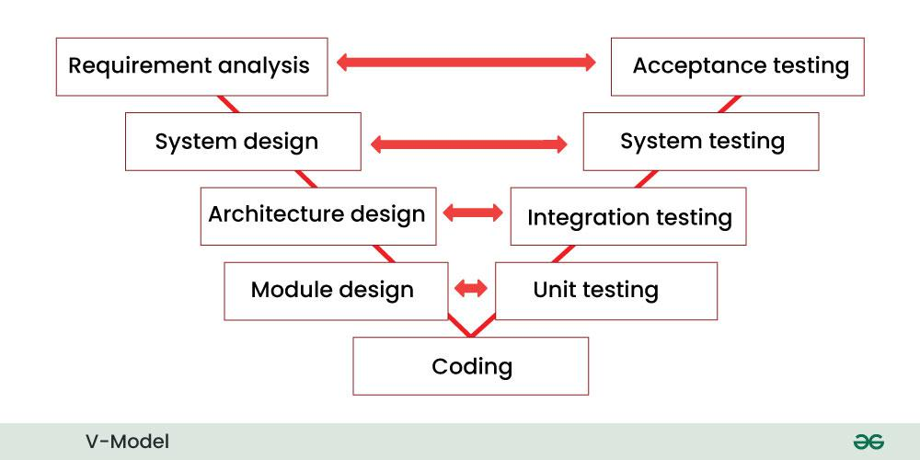

### Advantages of V-Model

* This is a simple and easy to use model.
* Planning, testing and designing tests can be done even before coding.
* This is a very disciplined model, in which phase by phase development and testing goes on.
* Defects are detected in the initial stage itself.
* Small and medium scale developments can be easily completed using it.

### Disadvantages of V-Model

* This model is not suitable for any complex projects.
* There remains both high risk and uncertainty.
* This is not a suitable model for an ongoing project.
* This model is not at all suitable for a project which is unclear and in which there are changes in the requirement.

## 3. Incremental Model

In Incremental Model, the [software development process](https://www.geeksforgeeks.org/software-development-process/) is divided into several increments and the same phases are followed in each increment. In simple language, under this model a complex project is developed in many modules or builds.

For example, we collect the customer’s requirements, now instead of making the entire software at once, we first take some requirements and based on them create a module or function of the software and deliver it to the customer. Then we take some more requirements and based on them add another module to that software.

Similarly, modules are added to the software in each increment until the complete system is created. However, the requirements for making a complex project in multiple iterations/parts should be clear.

If we understand the entire principle of Incremental methodology, then it starts by developing an initial implementation, then user feedback is taken on it, and it is developed through several versions until an accepted system is developed. Important functionalities of the software are developed in the initial iterations.

Each subsequent release of a software module adds functions to the previous release. This process continues until the final software is obtained.

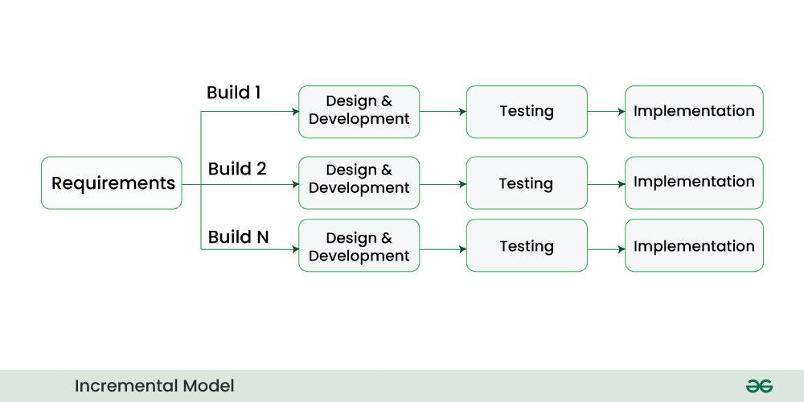

### Advantages of Incremental Model

* Important modules/functions are developed first and then the rest are added in chunks.
* Working software is prepared quickly and early during the [software development life cycle (SDLC)](https://www.geeksforgeeks.org/software-development/).
* This model is flexible and less expensive to change requirements and scope.
* The customer can respond to each module and provide feedback if any changes are needed.
* Project progress can be measured.
* It is easier to test and debug during a short iteration.
* Errors are easy to identify.

### Disadvantages of Incremental Model

* Management is a continuous activity that must be handled.
* Before the project can be dismantled and built incrementally,
* The complete requirements of the software should be clear.
* This requires good planning and designing.
* The total cost of this model is higher.

## 4. RAD Model

RAD model stands for rapid application development model. The methodology of RAD model is similar to that of incremental or waterfall model. It is used for small projects.

If the project is large then it is divided into many small projects and these small projects are planned one by one and completed. In this way, by completing small projects, the large project gets ready quickly.

In RAD model, the project is completed within the given time and all the requirements are collected before starting the project. It is very fast and there are very less errors in it.

The main objective of RAD model is to reuse code, components, tools, processes in project development.

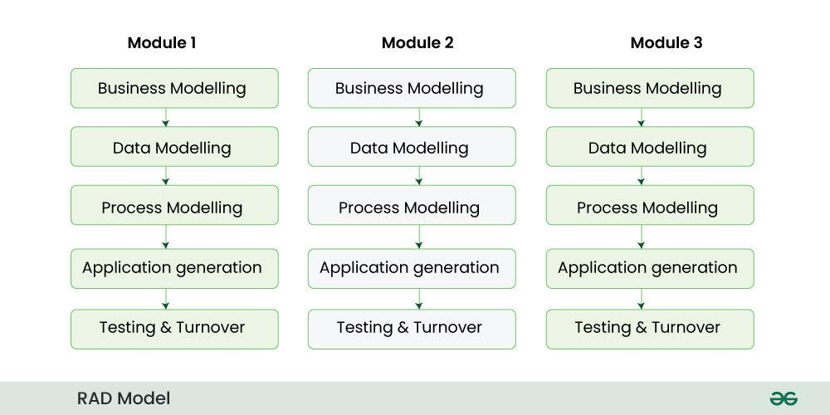

### Advantage of RAD Model:-

* It reduces the time taken in development.
* In this the components are reused.
* It is flexible and it is easy to make any changes in it.
* It is easy to transfer like scripts because high level abstraction and intermediate codes are used in it.
* There are very few defects in it because it is a prototype by nature.
* In this, productivity can be increased in less time with less people.
* It is cost effective.
* It is suitable for small projects.

### Disadvantages of RAD Model:-

* In this we need highly skilled developers and designers.
* It is very difficult to manage.
* It is not suitable for project that are complex and takes long time.
* In this, feedback from the client is required for the development of each phase.
* Automated code generation is very expensive.
* This model is suitable only for component based and scalable systems.

## 5. Iterative Model

In Iterative model we start developing the software with some requirements and when it is developed, it is reviewed. If there are requirements for changes in it, then we develop a new version of the software based on those requirements. This process repeats itself many times until we get our final product.

So, in Iterative model a software is developed by following several iterations. Iteration means that we are repeating the [development process](https://www.geeksforgeeks.org/software-development-process/) again and again. For example, we develop the first version of the software following the SDLC process with some software requirements. We can call this Iteration 1.

After the first version is developed, if there is a need to change the software , then a new version is developed with the second iteration. Now again we will see if the new version is enough, if not then we will make changes in it with the third iteration. The iteration will be repeated until the complete software is ready.

The basic concept of Iterative model is that the software should be developed through repeated cycles or what we also call iteration and only a small part of it should be developed at a time. This model was developed to overcome the drawbacks of the classical waterfall model.

Through this diagram you can understand the Interactive model.:-

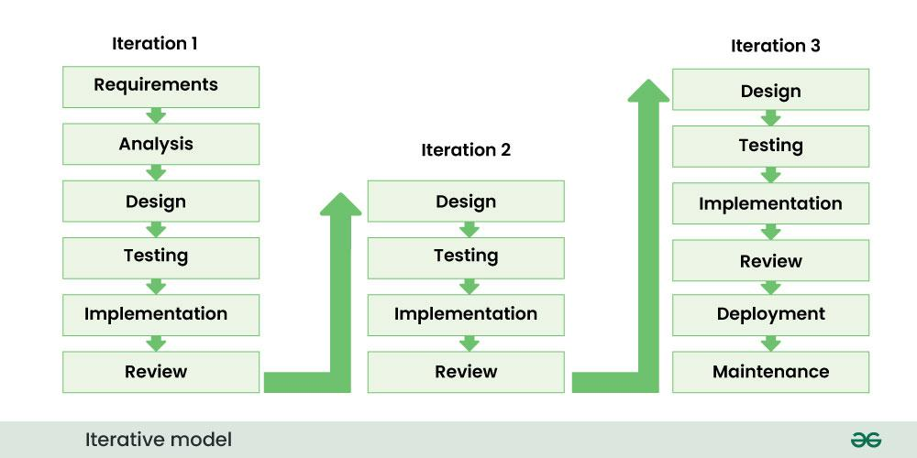

### Advantage of Iterative model:-

* In iterative models, bugs and errors can be identified quickly.
* Under this model, software is prepared quickly with some specifications.
* Testing and debugging the software becomes easier during each iteration.
* We get reliable feedback from users along with blueprints.
* This model is easily adaptable to constantly changing needs.
* During the software development process, additional time is devoted to development and limited time to documentation.
* Risks are identified and resolved during iteration.

### Disadvantage of Iterative model:-

* Iterative model is not suitable for small projects.
* Since we have to repeat iterations many times in the software development process due to which we require more resources.
* Since the requirements are constantly changing, we have to make frequent changes in the software.
* Due to constantly changing requirements, the budget of the project also increases and it takes more time to complete it.
* In this model, it is complicated to control the entire process of software development.
* It is very difficult to tell by what date the complete software will be ready.

## 6. Spiral Model

Spiral model is a [software development process](https://www.geeksforgeeks.org/software-development-process/) model. This model has characteristics of both iterative and waterfall models. This model is used in projects which are large and complex. This model was named spiral because if we look at its figure, it looks like a spiral, in which a long curved line starts from the center point and makes many loops around it. The number of loops in the spiral is not decided in advance but it depends on the size of the project and the changing requirements of the user. We also call each loop of the spiral a phase of the software development process.

A software project goes through these loops again and again in iterations. After each iteration a more and more complete version of the software is developed. The most special thing about this model is that risks are identified in each phase and they are resolved through prototyping. This feature is also called Risk Handling.

Since it also includes the approaches of other SDLC models, it is also called Meta Model. It was first developed by Barry Boehm in 1986.

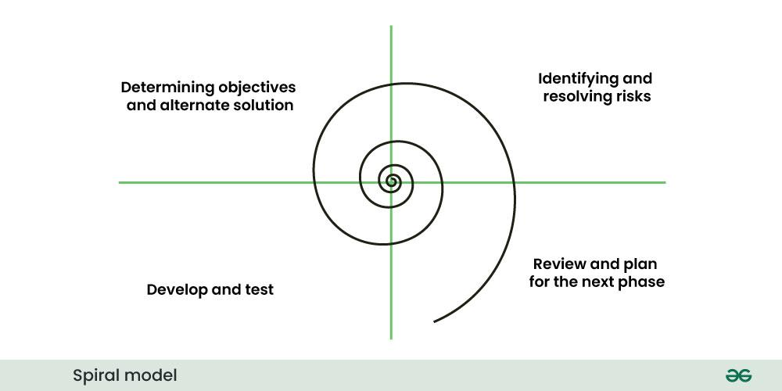  
Advantages of Spiral Model:-

* If we have to add additional functionality or make any changes to the software, then through this model we can do so in the later stages also.
* Spiral model is suitable for large and complex projects.
* It is easy to estimate how much the project will cost.
* Risk analysis is done in each phase of this model.
* The customer can see the look of his software only in the early stages of the development process.
* Since continuous feedback is taken from the customer during the development process, the chances of customer satisfaction increases.

### Disadvantage of Spiral Model:-

* This is the most complex model of SDLC, due to which it is quite difficult to manage.
* This model is not suitable for small projects.
* The cost of this model is quite high.
* It requires more documentation than other models.
* Experienced experts are required to evaluate and review the project from time to time.
* Using this model, the success of the project depends greatly on the risk analysis phase.

## 7. Prototype model

Prototype model is an activity in which prototypes of software applications are created. First a prototype is created and then the final product is manufactured based on that prototype.

* The prototype model was developed to overcome the shortcomings of the waterfall model.
* This model is created when we do not know the requirements well.
* The specialty of this model is that this model can be used with other models as well as alone.

One problem in this model is that if the end users are not satisfied with the prototype model, then a new prototype model is created again, due to which this model consumes a lot of money and time.

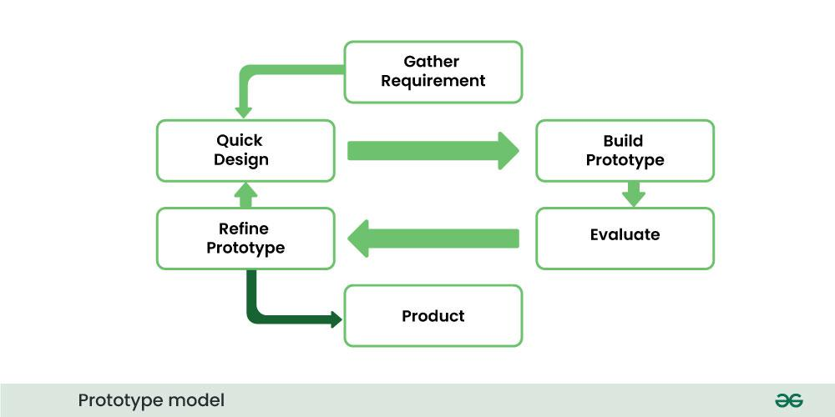

### Advantages of Prototype model :-

* Prototype Model is suggested to create applications whose prototype is very easy and which always includes human machine interaction within it.
* When we know only the general objective of creating software, but we do not know anything in detail about input, processing and output. Then in such a situation we make it a Prototype Model.
* When a software developer is not very sure about the capability of an algorithm or its adaptability to an operating system, then in this situation, using a prototype model can be a better option.

### Disadvantages of Prototype model :-

* When the first version of the prototype model is ready, the customer himself often wants small fixes and changes in it rather than rebuilding the system. Whereas if the system is redesigned then more quality will be maintained in it.
* Many compromises can be seen in the first version of the Prototype Model.
* Sometimes a software developer may make compromises in his implementation, just to get the prototype model up and running quickly, and after some time he may become comfortable with making such compromises and may forget that it is completely inappropriate to do so.

## Agile Model

Agile model is a combination of iterative and incremental models, that is, it is made up of iterative and incremental models.

In Agile model, focus is given to process adaptability and customer satisfaction.

In earlier times, iterative waterfall model was used to create software. But in today’s time developers have to face many problems. The biggest problem is that in the middle of software development, the customer asks to make changes in the software. It takes a lot of time and money to make these changes.

So to overcome all these shortcomings, the agile model was proposed in the 1990s.

The agile model was created mainly to make changes in the middle of [software development](https://www.geeksforgeeks.org/software-development/) so that the software project can be completed quickly.

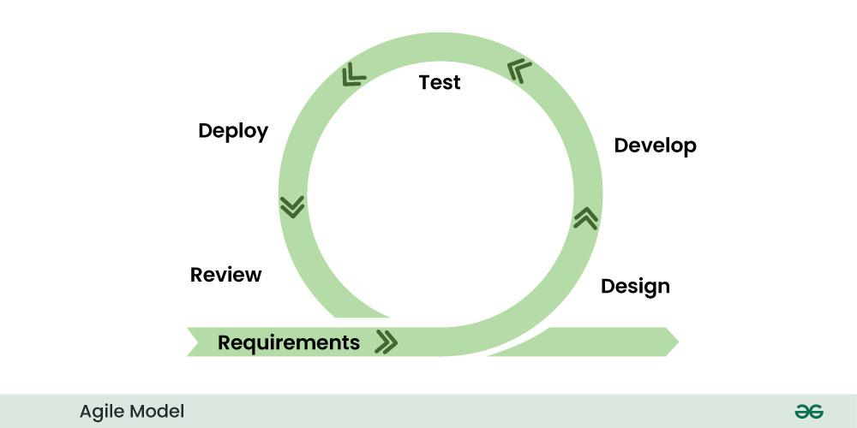

In the agile model, the software product is divided into small incremental parts. In this, the smallest part is developed first and then the larger one.

And each incremental part is developed over iteration.

Each iteration is kept small so that it can be easily managed. And it can be completed in two-three weeks. Only one iteration is planned, developed and deployed at a time.

### Principles of Agile model:-

* There is a customer representative in the development team to maintain contact with the customer during[software development](https://www.geeksforgeeks.org/software-development/) and to understand the requirement. When an iteration is completed, stakeholders and customer representatives review it and re-evaluate the requirements.
* Demo of working software is given to understand the customer’s requirements. That is, it does not depend only on documentation.
* Incremental versions of the software have to be delivered to the customer representative after a few weeks.
* In this model it is advised that the size of the development team should be small (5 to 9 people) so that the team members can communicate face to face.
* Agile model focuses on the fact that whenever any changes have to be made in the software, it should be completed quickly.
* In agile development, two programmers work together. One programmer does the coding and the other reviews that code. Both the programmers keep changing their tasks, that is, sometimes one does coding and sometimes someone reviews.

### Agile has the following models:-

1. Scrum
2. Crystal methods
3. DSDM
4. Feature driven development (FDD
5. Lean [software development](https://www.geeksforgeeks.org/software-development/)
6. Extreme programming (xp)

### Advantages of Agile Model:-

* In this, two programmers work together due to which the code is error free and there are very few mistakes in it.
* In this the software project is completed in a very short time.
* In this the customer representative has an idea of ​​each iteration so that he can easily change the requirement.
* This is a very realistic approach to software development.
* In this, focus is given on teamwork.
* There are very few rules in this and documentation is also negligible.
* There is no need for planning in this.
* It can be managed easily.
* It provides flexibility to developers.

### Disadvantages of Agile Model:-

* It cannot handle complex dependencies.
* Due to lack of formal documentation in this, there is confusion in development.
* It mostly depends on the customer representative, if the customer representative gives any wrong information then the software can become wrong.
* Only experienced programmers can take any decision in this. New programmers cannot take any decision.
* In the beginning of software development, it is not known how much effort and time will be required to create the software.