Assignment 2 : Craft a query using an inner join to combine orders and customer table for customer in specific region and a left join to display all customer those without orders also

Answer:

Tables and their values
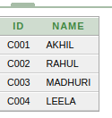
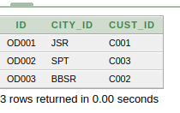
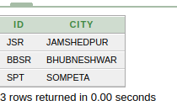

Customer table Orders Table City Table

1) Query for inner join
- SELECT A.ID,B.ID,B.NAME,C.CITY FROM ORDERS A,CUSTOMER B,CITY C WHERE B.ID = A.CUST_ID AND A.CITY_ID = C.ID;

Output:

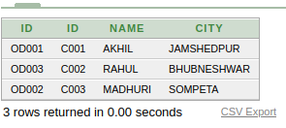

2) Query for left join

SELECT CUSTOMER.NAME,ORDERS.ID FROM CUSTOMER LEFT JOIN ORDERS ON CUSTOMER.ID = ORDERS.CUST_ID;

Output
