Assignment 2 : Utilize a sub query to find the customers who have palced orders above the average order value and write a union query to combine two SELECT statement with the same number of columns.

Tables and their data
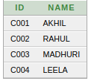
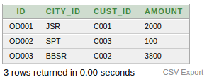
Customer Table Orders Tables

Note: The average amount of orders is 1967.

1) Subquery to fetch customer placing order more than average amount

SELECT A.ID,A.NAME,B.AMOUNT FROM CUSTOMER A INNER JOIN ORDERS B ON A.ID = B.CUST_ID WHERE B.AMOUNT > (SELECT ROUND(AVG(AMOUNT)) FROM ORDERS) ;

Output
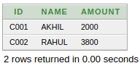
2) Union to combinde two sql statement with same number of columns

SELECT ID FROM CUSTOMER
UNION
SELECT ID FROM ORDERS;

Output
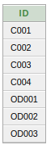

- It returned all values of id from customer and all values of id from orders as a single result set

