Assignment 3 : Design a database schema for library system including tables,feilds and constraints like not null,unoqu and check ,including primary and foreign key to establish relationship between tables.

Answer:

1) Creating books table

Query : CREATE TABLE BOOK(ID VARCHAR2(20) PRIMARY KEY,BOOK_NAME VARCHAR2(30));

- In this book id is a primary key
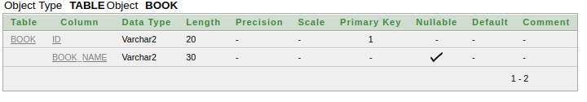
2) Creating Author tables

Query :
CREATE TABLE AUTHOR(ID VARCHAR2(20),AUTHOR VARCHAR2(20));

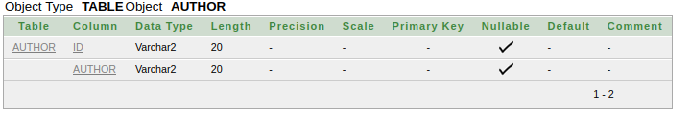
3) Creating Student table

Query

CREATE TABLE STUDENT(ID VARCHAR2(20) PRIMARY KEY,STUD_NAME VARCHAR2(20) NOT NULL,AGE NUMBER CHECK ( AGE > 18)) ;

- Student id has a constraint primary key
- Student Name can not be null
- Student Age column has check constraint i.e student age should be greater than 18.

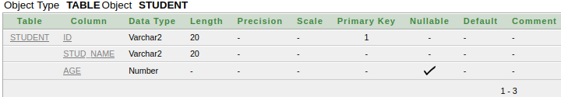
4) Creating Borrower table
Query :

CREATE TABLE BORROW(ID VARCHAR2(20) PRIMARY KEY,STUD_ID VARCHAR2(20) NOT NULL,BOOK_ID VARCHAR2(20) NOT NULL,AUTHOR_ID VARCHAR2(20) NOT NULL,ISSUE_DATE TIMESTAMP,RETURN_DATE TIMESTAMP);

ALTER TABLE BORROW ADD CONSTRAINT FK_AUT_ID FOREIGN KEY (AUTHOR_ID) REFERENCES AUTHOR(ID);

ALTER TABLE BORROW ADD CONSTRAINT FK_STUD_ID FOREIGN KEY (STUDENT_ID) REFERENCES STUDENT(ID);

ALTER TABLE BORROW ADD CONSTRAINT FK_BOOK_ID FOREIGN KEY (BOOK_ID) REFERENCES BOOK(ID);

- Borrow id is a primary key.
- Student id contains constraint foreign key refering to student table id column.
- Book id contains constraint foreign key refering to Book table id column.
- Author id contains constraint foreign key refering to Author table id column.
