Assignment 2
Task: Lauterbach TRACE32 Configuration
Objective: Configure TRACE32 for debugging.
Answers:
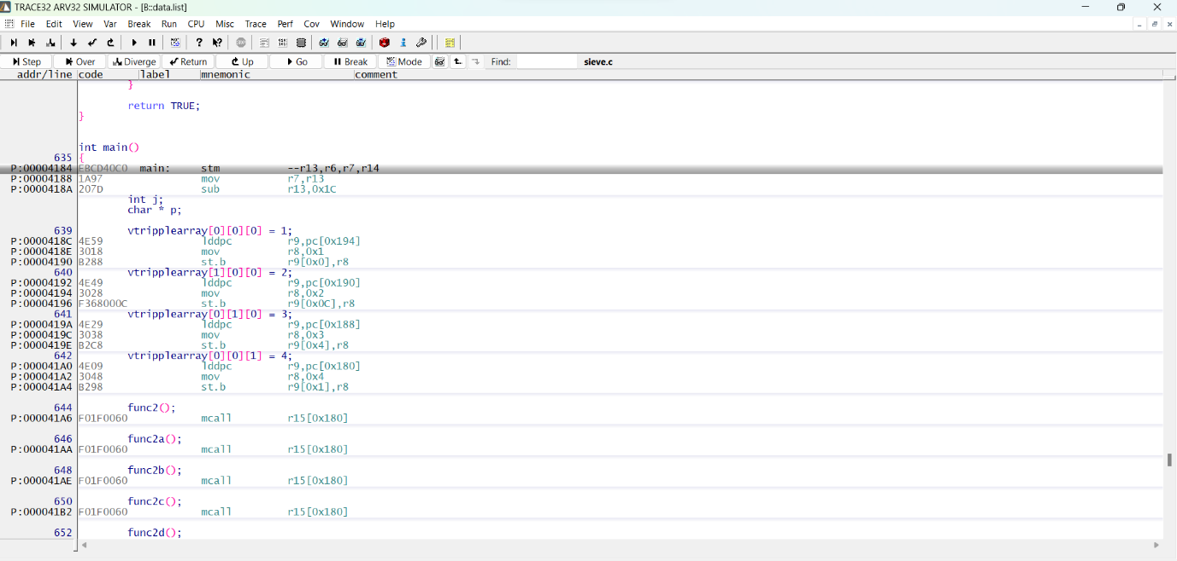

Theory:
Step 1: Set Up Lauterbach Debug Environment
Download TRACE32 Software:
1. Visit the Lauterbach Website:
- Open your web browser and go to the Lauterbach official website:
https://www.lauterbach.com
2. Navigate to the Downloads Section:
- On the website, find and click on the 'Downloads' section.
3. Select TRACE32 Software:
- Locate the TRACE32 software download link appropriate for your operating system
(Windows, Linux, macOS).
4. Register or Log In:
- You may need to register or log in to your Lauterbach account to access the download.
5. Download the Installer:
- Download the installer file for TRACE32.
6. Install TRACE32:
- Run the installer and follow the on-screen instructions to complete the installation
process.
Launch TRACE32 Simulator:
1. Open the TRACE32 software on your development PC.
2. Select the AVR32 simulator mode in the GUI.
Step 2: Configure TRACE32 Simulator
Select Target Processor:
1. In the TRACE32 GUI, navigate to the menu to select the target processor.
2. Choose the AVR target processor for your project, such as C3A0128.
- Command: SYStem.CPU C3A0128
Load Application Code:
1. In the TRACE32 GUI, go to the File menu and select the option to load an ELF file.
2. Locate and select the ELF file you want to load (e.g., main.elf).
- Command: Data.LOAD.Elf /path/to/your_application.elf
Load Configuration Scripts:
1. In the TRACE32 GUI, open the command window and execute the necessary configuration
scripts.
- Command: PERIPH.SYStem.CPU C3A0128
Step 3: Perform Simulation Tasks
Set Breakpoints:
1. In the TRACE32 GUI, navigate to the source code window.
2. Set breakpoints by clicking on the line numbers where you want the execution to pause or
use the command window:
- Command: Break.Set main
Run and Halt Execution:
1. In the TRACE32 GUI, use the control buttons to start and stop the execution of your
program.
- Command to start the execution: Go
- Command to halt the execution: Break
Step Through Code:
1. In the TRACE32 GUI, use the step and next buttons to step through your code line by line.
- Commands: Step, Next
Inspect Variables and Registers:
1. In the TRACE32 GUI, open the variable and register windows to inspect the current state
of your program.
- Commands: Var.Watch counter, Register.view
Monitor Performance:
1. In the TRACE32 GUI, use the performance monitoring tools available to analyze the
execution of your code.
- Commands: Perf.Meter, Trace.ON
Log and Analyze Simulation Data:
1. In the TRACE32 GUI, use the logging features to record simulation sessions for later
analysis.
- Commands: Trace.Save /path/to/trace.log, Perf.Save /path/to/perf.log
Example Session
Let's assume we have a simple application for an AVR CPU C3A0128. Below is a detailed
example configuration and simulation session:
Select Target Processor:
Command: SYStem.CPU C3A0128
Load Application Code:
Command: Data.LOAD.Elf /path/to/main.elf
Load Configuration Scripts:
Command: PERIPH.SYStem.CPU C3A0128
Set Breakpoints:
Command: Break.Set main
Run and Halt Execution:
Command to start execution: Go
Command to halt execution: Break
Step Through Code:
Commands: Step, Next
Inspect Variables and Registers:
Commands: Var.Watch counter, Register.view
Monitor Performance:
Commands: Perf.Meter, Trace.ON
Log and Analyze Simulation Data:
Command: Trace.Save /path/to/trace.log

