INTERSECT AND UNION

# Command to create tables

1) CREATE TABLE DETAILS(NAME VARCHAR2(16) , AGE NUMBER);

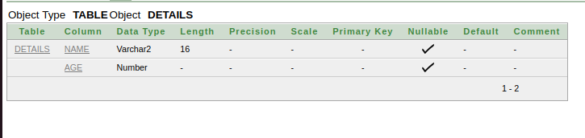

2) CREATE TABLE SALARY(NAME VARCHAR2(16) , SALARY NUMBER);

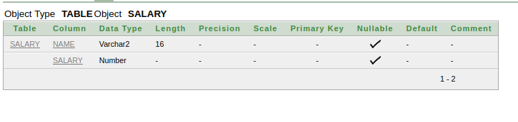

3) CREATE TABLE STUDENTS(
ID INT NOT NULL,
NAME VARCHAR(20) NOT NULL,
SUBJECT VARCHAR(20) NOT NULL,
AGE INT NOT NULL,
HOBBY VARCHAR(20) NOT NULL,
PRIMARY KEY(ID)
);

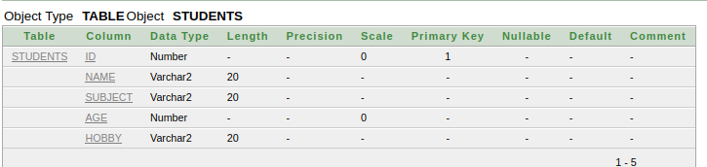

4) CREATE TABLE STUDENTS_HOBBY(
ID INT NOT NULL,
NAME VARCHAR(20) NOT NULL,
HOBBY VARCHAR(20) NOT NULL,
AGE INT NOT NULL,
PRIMARY KEY(ID)
);

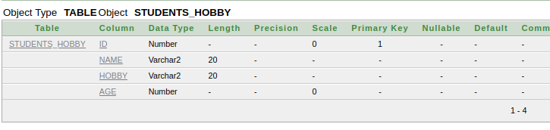

- Tables has been created and data has been inserted to perform intersect and union operations.

# Intersect

Defination :
- Intersect command helps us to find the command records in two table i.e the vale that is comman in both tables.
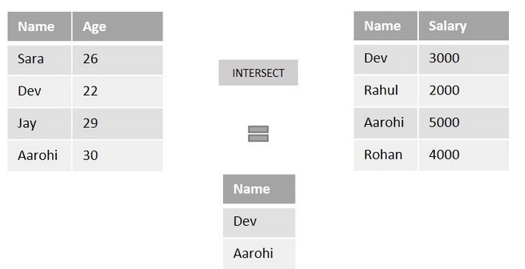
Example:

#Command

SELECT NAME FROM DETAILS
INTERSECT
SELECT NAME FROM SALARY;

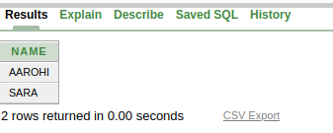
Output:

SELECT NAME, AGE, HOBBY FROM STUDENTS_HOBBY
INTERSECT
SELECT NAME, AGE, HOBBY FROM STUDENTS;

Output:

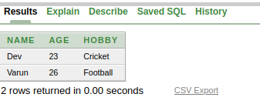

2) Intersect with between operator

Command:
SELECT NAME, AGE, HOBBY FROM STUDENTS_HOBBY
WHERE AGE BETWEEN 25 AND 30
INTERSECT
SELECT NAME, AGE, HOBBY FROM STUDENTS
WHERE AGE BETWEEN 20 AND 30;

Output:
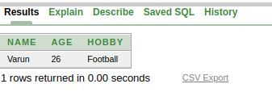

- This will only return rows which has age between 25 and 30 and common in both tables.

3) Intersect with In operator

Command:

SELECT NAME, AGE, HOBBY FROM STUDENTS_HOBBY
WHERE HOBBY IN('Cricket')
INTERSECT
SELECT NAME, AGE, HOBBY FROM STUDENTS
WHERE HOBBY IN('Cricket');

Output:

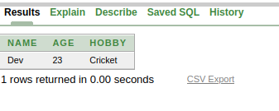

- It will only return the rows which has crickect as hobby and comman in both tables.

4) Intersect with like operator

command:
SELECT NAME, AGE, HOBBY FROM STUDENTS_HOBBY
WHERE NAME LIKE 'V%'
INTERSECT
SELECT NAME, AGE, HOBBY FROM STUDENTS
WHERE NAME LIKE 'V%';

output
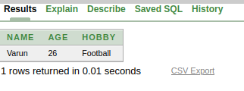

- It will return the rows which contain ‘V’ as starting character in name and common in both the tables.

#UNION

Defination:
- It helps to combind two sql statements and return result by vertically joining results of two tables as a single result.
- To perform union both the table shouls have same column datatype.
- Each table used within UNION must have the same number of columns.
- he columns in each table must be in the same order.
Command
SELECT NAME FROM DETAILS
UNION
SELECT NAME FROM STUDENTS;

Output
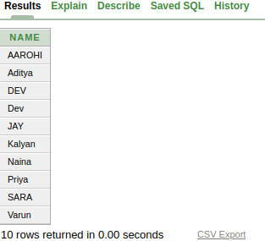

- This has returned names from both the tables i.e students and details as a single table or single daya set.

