JOINS IN ORACLE
Defination:
- Join are used to fetch data from two or more different table and return as a single result set.

Types of joins

- Inner join

Defination: It is use to join the data which is common in the table and retur as a single result set.

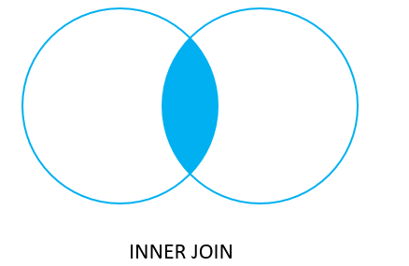

Command :

SELECT A.SUP_ID,A.SUP_NAME,B.CITY,B.ORDER_NO FROM SUPPLIER1 A INNER JOIN ORDERS B ON A.SUP_ID = B.SUP_ID;

Output:

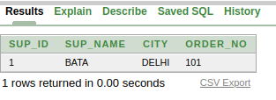

2.Left join

Defination : It will return all data form left table and matiching data from right table.

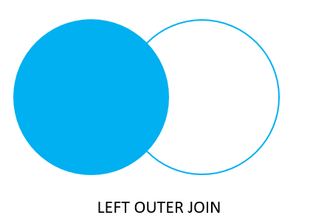

Command :
SELECT B.SUP_ID,B.SUP_NAME,A.CITY,A.ORDER_NO FROM ORDERS A LEFT JOIN SUPPLIER1 B ON A.SUP_ID = B.SUP_ID;

Output:

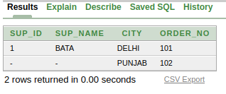

3.Right Join
Defination : It will return all data form rigjt table and matiching data from left table.

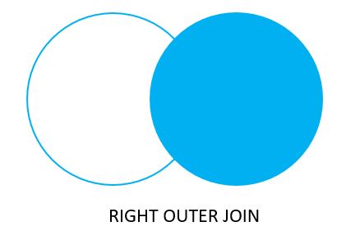

Command:
SELECT B.SUP_ID,B.SUP_NAME,A.CITY,A.ORDER_NO FROM ORDERS A RIGHT JOIN SUPPLIER1 B ON A.SUP_ID = B.SUP_ID;

Output:
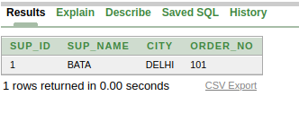

4.Full outer join

Defination : It will fetch all data from both the table irrespective of matching condition.

Command:

SELECT B.SUP_ID,B.SUP_NAME,A.CITY,A.ORDER_NO FROM ORDERS A FULL JOIN SUPPLIER1 B ON A.SUP_ID = B.SUP_ID;

Output:
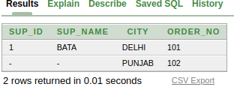

Refrence
- Data in both tables

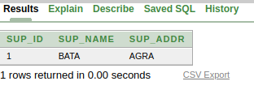
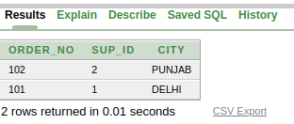

1) Supplier Table 2) Orders Table

