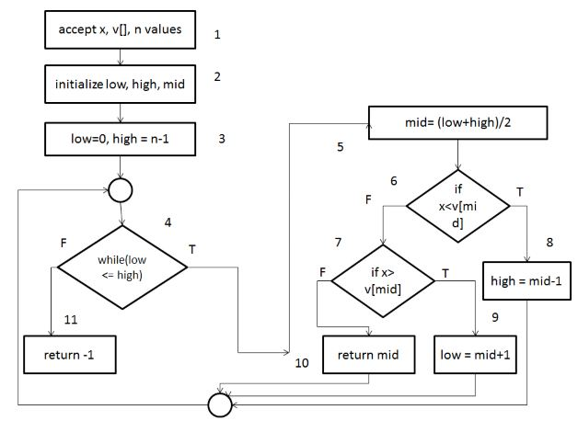

Binary search took 15 minutes to complete.

I have used Integer class array.

We can improve the by binarySearch by using generics feature of Java.

So that we will be able to Search any element which are stored in the sorted Array of elements.