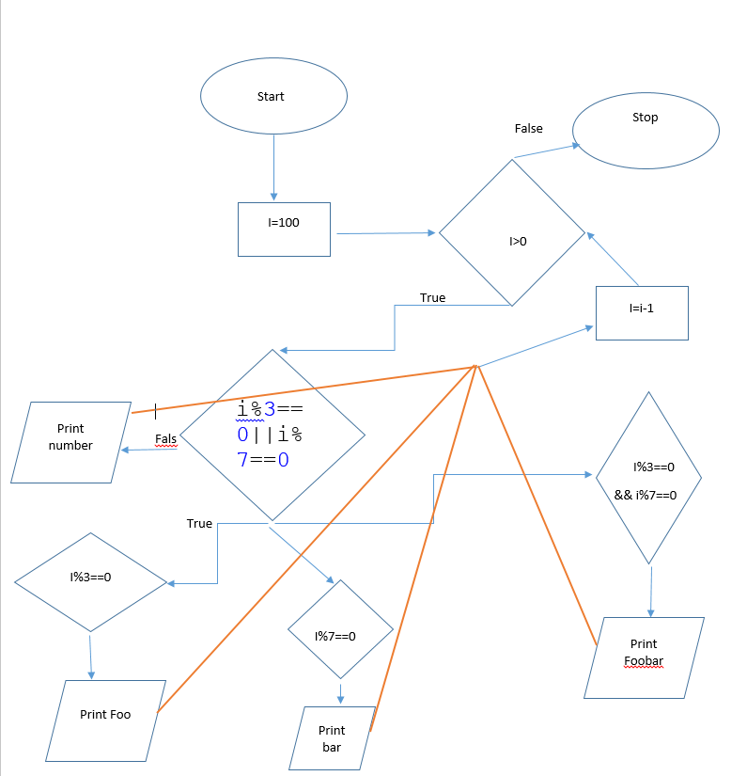

Above is the Flow Chart for FooBar it took Hardly 10 minutes to complete the whole System.

The Code is tested with one negative test case.