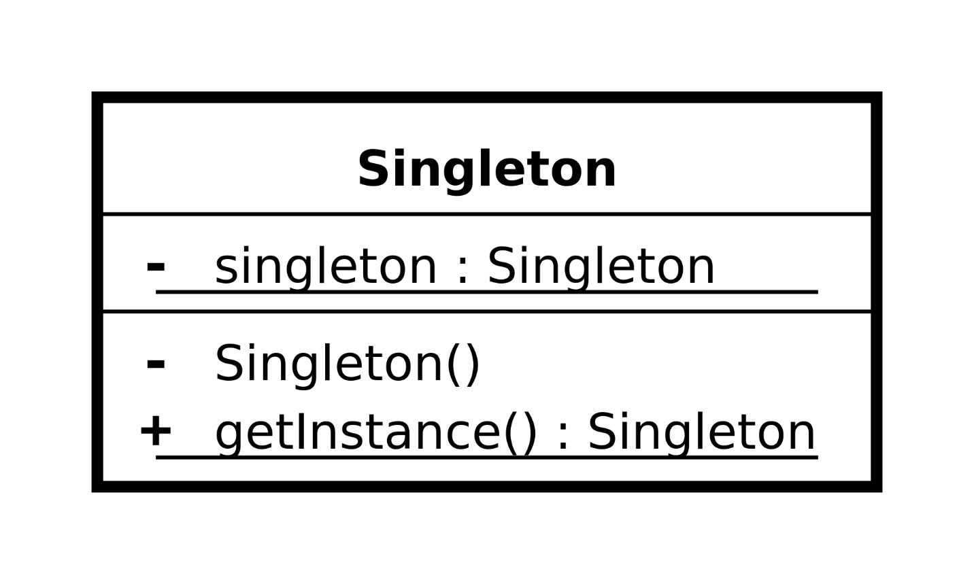

Above is the diagram of singleton design pattern this was completed in hardly 8 minutes.

The have tested the code with MySQL DB, creating the single instance.