Land Rover Robot Operated by Cellphone
A Course Based Project Report
B.E. Electronics and Communication Engineering
Submitted
By
Kolluru Akul Kumar 1602-24-735-130

Subject Name: Microprocessors and Microcontrollers
Department of Electronics and Communication Engineering
Vasavi College of Engineering (Autonomous)
ACCREDITED BY NAAC WITH 'A++' GRADE
IBRAHIMBAGH, HYDERABAD-500031
2026-2027
ABSTRACT
This project presents the design of a manually operated, four-wheel Land Rover robot that is driven from an Android cellphone over Bluetooth. The system is built around an Arduino UNO (ATmega328P) microcontroller board, an HC-05 Bluetooth serial module and an L298N dual H-bridge motor driver that drives four DC geared motors. The smartphone sends single-character commands (F, B, L, R, and S for forward, backward, left, right, and stop). The HC-05 passes them to the Arduino over a serial link, and the Arduino sets the direction and enables inputs of the L298N accordingly.
The two motors on each side of the chassis are wired in parallel and treated as one group, so that steering is obtained by differential (skid) steering: the left and right groups run in the same direction to move straight and in opposite directions to spin the robot. A 7.4 V rechargeable battery pack supplies the motors through the L298N, and a buck converter adjusted to 5 V supplies the Arduino and the Bluetooth module, with all grounds common. The report documents the architecture, circuit connections, directional control logic, wiring schematic, software flowchart, and Arduino sketch. The robot is remotely driven by a person and is not autonomous. Its intended use is a low-cost educational platform for embedded systems, wireless communication and motor control; the performance tests are listed as to be verified by physical testing.
Keywords: Arduino UNO, HC-05 Bluetooth, L298N motor driver, differential steering, Land Rover robot, embedded systems.
TABLE OF CONTENTS
CHAPTER 1: INTRODUCTION4
1.1 Aim of the Project 4
1.2 Motivation 4
1.3 Objectives 4
1.4 Scope of the Project 4
CHAPTER 2: SYSTEM DESIGN AND METHODOLOGY 5
2.1 System Overview 5
2.2 Block Diagram 5
2.3 Working Principle 5
2.4 Directional Control Logic 6
CHAPTER 3: HARDWARE AND SOFTWARE IMPLEMENTATION 6
3.1 Hardware Components 6
3.2 Arduino UNO 7
3.3 HC-05 Bluetooth Module 7
3.4 L298N Motor Driver 7
3.5 DC Geared Motors and Chassis 7
3.6 Power Supply 8
3.7 Circuit Connections 8
3.8 Software Implementation 9
4. RESULTS AND DISCUSSIONS 10
5. CONCLUSION 11
6. FUTURE SCOPE 11
7. REFERENCES 11
8. APPENDIX: ARDUINO CODE 13
CHAPTER 1: INTRODUCTION
Mobile robots are machines that move through their environment under electronic control. Remotely controlled ground vehicles are the simplest form: a person sends commands over a wireless link, and the vehicle turns them into wheel motion. Building such a vehicle brings together embedded systems, wireless communication, microcontroller programming, motor-driver circuits, and DC motor control, which makes it a practical introduction to mechatronics for undergraduate students.
1.1 Aim of the Project
The aim of this project is to design and build a four-wheel Land Rover robot that is driven wirelessly from an Android cellphone through a Bluetooth link. The robot uses an Arduino UNO to interpret the received commands and an L298N motor driver to move the wheels forward, backward, left, right or to stop.
1.2 Motivation
Almost every student owns an Android smartphone with built-in Bluetooth, so the phone can serve as a free and familiar remote control, with no dedicated transmitter hardware. The project combines serial communication, digital input and output, pulse-width modulation, H-bridge motor driving, battery power, and level compatibility in one working system. It uses low-cost, widely documented parts and a visible, easily tested outcome, and so it suits a course-based project.
1.3 Objectives
- To establish a Bluetooth serial link between an Android smartphone and an HC-05 module connected to an Arduino UNO.
- To program the Arduino to decode the commands F, B, L, R, and S and to set the L298N inputs accordingly.
- To drive four DC geared motors, as left and right groups, through an L298N dual H-bridge for differential steering.
- To power the motors and the control electronics safely from one 7.4 V battery using a regulated 5 V supply and a common ground.
- To document the hardware, wiring, and software so that the robot can be reproduced.
1.4 Scope of the Project
The robot is driven manually by a person within Bluetooth range, and it can move forward and backward, turn left and right, and stop. The scope does not include autonomous navigation, obstacle detection, cameras, GPS, internet-based control, or artificial intelligence. Measured performance figures (speed, range, battery life) are outside the scope of this report.
CHAPTER 2: SYSTEM DESIGN AND METHODOLOGY
2.1 System Overview
The system has a command path and a power path. In the command path, an Android smartphone running on a Bluetooth controller application sends command characters over a Bluetooth link to the HC-05 module. The HC-05 converts them to serial data for the Arduino UNO, which sets control signals for the L298N motor driver, and the L298N drives the four DC geared motors. In the power path, a 7.4 V (nominal) rechargeable battery feeds the L298N motor supply and a buck converter, which provides a regulated 5 V for the Arduino and the HC-05.
2.2 Block Diagram
Figure 1 shows the architecture, with the communication and control signals (solid blue) separated from the power connections (dashed red).
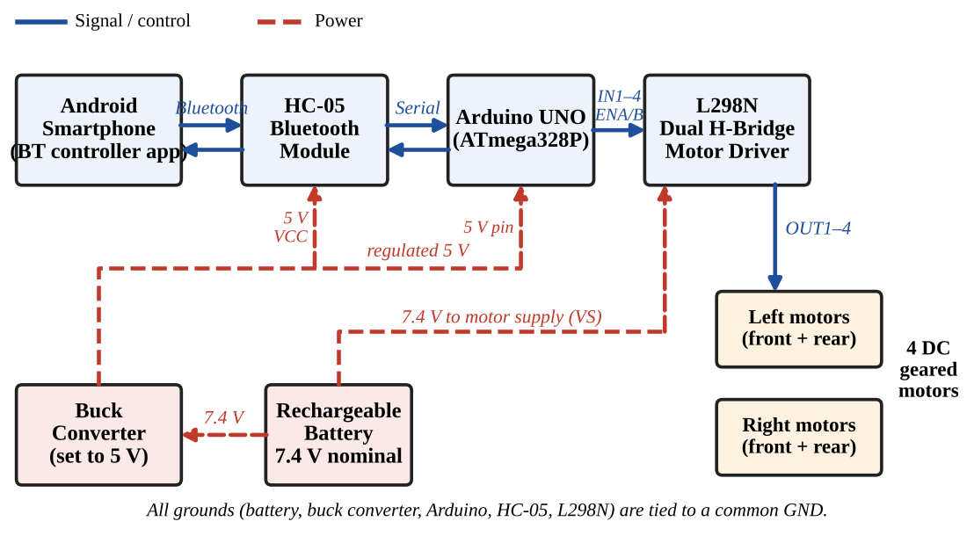
Figure 1: System block diagram of the cellphone-operated Land Rover robot.
2.3 Working Principle
The phone pairs with the HC-05 and sends one character per key press: F, B, L, R or S. The HC-05 receives the character over Bluetooth [5], [6] and outputs it on its TXD pin as 9600-baud serial data. The Arduino reads it through a SoftwareSerial port on D2 and D3 [2], decides which command it is, and sets the L298N direction inputs (IN1–IN4) and enable pins (ENA, ENB). The L298N applies the battery voltage to the motor terminals in the required polarity [4], and the wheels turn. The motors keep their state until the next command arrives, and S switches all outputs off.
The robot uses differential (skid) steering. The two left motors form one group and the two right motors form another. When both groups turn forward the robot moves straight ahead, and when both turn backward it reverses. To turn, the groups are driven in opposite directions, so the robot spins about its centre.
2.4 Directional Control Logic
Table 1 gives the action of each command, together with the logic levels set on the L298N inputs by the sketch in the Appendix. A left or right command is a spin turn, in which the left and right groups rotate in opposite directions.
Table 1: Directional control logic.
Command | Left Motor Group | Right Motor Group | IN1 IN2 IN3 IN4 | Expected Action
F | Forward | Forward | 1 0 1 0 | Moves straight ahead
B | Backward | Backward | 0 1 0 1 | Moves straight back
L | Backward | Forward | 0 1 1 0 | Spins left (anticlockwise) on the spot
R | Forward | Backward | 1 0 0 1 | Spins right (clockwise) on the spot
S | Stopped | Stopped | 0 0 0 0 (ENA = ENB = 0) | All motors stop

CHAPTER 3: HARDWARE AND SOFTWARE IMPLEMENTATION
3.1 Hardware Components
Table 2: Hardware components.
Component | Quantity | Function
Arduino UNO (ATmega328P) | 1 | Main controller; decodes commands and drives the L298N
HC-05 Bluetooth module | 1 | Wireless serial link to the smartphone
L298N dual H-bridge driver | 1 | Switches and reverses motor current
DC geared motors | 4 | Wheel drive
Robot wheels | 4 | Traction
Four-wheel robot chassis | 1 | Mechanical frame
Rechargeable battery pack, 7.4 V nominal | 1 | Main power source
Buck converter (set to 5 V) | 1 | Regulated 5 V for Arduino and HC-05
Resistors, 1 kΩ and 2 kΩ | 1 each | Voltage divider on the HC-05 RXD line
Three-pin slide switch (if fitted) | 1 | Battery on/off
Jumper wires, breadboard (if used) | As required | Interconnections
Android smartphone with Bluetooth app | 1 | Remote controller

3.2 Arduino UNO
The Arduino UNO is a microcontroller board based on the ATmega328P [1]. In this project it receives the commands from the HC-05, runs the control program and sets the six L298N control lines. Its hardware serial port is left free for programming over USB, so the HC-05 is connected through a SoftwareSerial port on D2 and D3. Pins D5 and D6 are PWM-capable and are used for the L298N enable inputs [3].
3.3 HC-05 Bluetooth Module
The HC-05 is a Bluetooth module with a serial port profile, which makes it behave like a wireless serial cable between the phone and the Arduino [5], [6]. In data mode its default baud rate is 9600. The module is a 3.3 V device, although the usual breakout board has an on-board regulator that accepts 5 V on VCC [5]. Its RXD input expects 3.3 V logic, so the Arduino's 5 V TX line (D3) is reduced with a 1 kΩ / 2 kΩ divider (about 3.3 V). The documentation of the particular module used must be checked before powering it.
3.4 L298N Motor Driver
The L298 contains two H-bridges, so one chip can drive two motors, or two motor groups, in both directions [4]. Each channel has two inputs (IN1/IN2 for channel A and IN3/IN4 for channel B) that set the polarity, and an enable input (ENA, ENB) that switches the channel on or off. If a PWM signal is applied to the enable pin, the average motor voltage, and hence the speed, can be varied. The module carries jumpers on ENA and ENB that tie the enables high; in this project they are removed so that D5 and D6 can control them. The L298 has voltage losses of about 1.8 V in total per channel at 1 A (typical saturation voltages, [4]), and it is rated for 2 A DC per channel, so the starting and stall currents of the motors must be kept within its limits.
Figures 2–4: Illustrations of the main modules (drawn by the authors; not photographs of the project hardware).
Figure 2: Arduino UNO. | Figure 3: HC-05 module. | Figure 4: L298N driver module.
3.5 DC Geared Motors and Chassis
The four-wheel chassis carries one geared DC motor on each wheel (Figure 5). The two left motors are wired in parallel to OUT1/OUT2 and the two right motors to OUT3/OUT4, so each side is driven as one group. The polarity of an individual motor may have to be swapped so that both motors on a side turn the wheels the same way. The combined starting and stall current of two parallel motors must stay within the driver's rating.
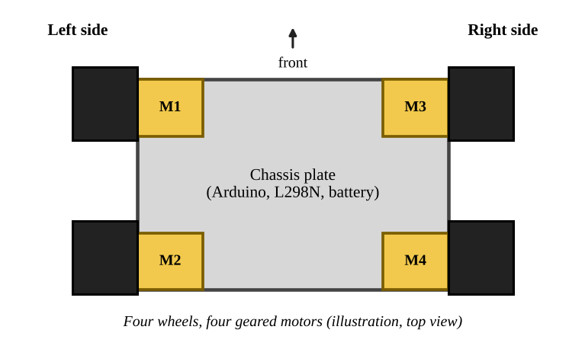
Figure 5: Four-wheel chassis with four geared motors (top-view illustration drawn by the authors; not a photograph of the completed project).
3.6 Power Supply
The 7.4 V (nominal) battery pack is connected to the L298N motor supply terminal (VS) and to the input of the buck converter. The buck converter output must be adjusted and measured to be 5 V before it is connected to the Arduino 5V pin and the HC-05 VCC, because the raw battery voltage must never be connected to the Arduino 5V pin. Because the L298N drops some voltage, the motors receive less than the battery voltage. The battery negative, the buck converter ground, the Arduino GND, the HC-05 GND and the L298N GND must all be joined at a common ground, otherwise the logic signals have no common reference. The Arduino should not be powered from USB while it is fed from the buck converter.
3.7 Circuit Connections
Tables 3 to 6 list the connections for the configuration used throughout this report (ENA/ENB jumpers removed, PWM on D5 and D6), and Figure 6 shows the complete wiring schematic. These are the intended connections, and they must be verified on the built hardware.
Table 3: HC-05 to Arduino UNO.
HC-05 pin | Connected to
VCC | Regulated 5 V (buck converter output)
GND | Common GND
TXD | Arduino D2 (SoftwareSerial RX)
RXD | Arduino D3 (SoftwareSerial TX) through 1 kΩ / 2 kΩ divider
Table 4: Arduino UNO to L298N.
Arduino pin | L298N terminal
D5 (PWM) | ENA (jumper removed)
D8 | IN1
D9 | IN2
D10 | IN3
D11 | IN4
D6 (PWM) | ENB (jumper removed)
GND | GND
Table 5: L298N to motors.
L298N terminal | Motors
OUT1, OUT2 | Left front and left rear motors, in parallel
OUT3, OUT4 | Right front and right rear motors, in parallel
Table 6: Battery and buck converter.
Source terminal | Connected to
Battery + (via slide switch, if fitted) | L298N VS and buck converter IN+
Battery − | Common GND
Buck OUT+ (set to 5 V) | Arduino 5V pin and HC-05 VCC
Buck OUT−, buck IN− | Common GND

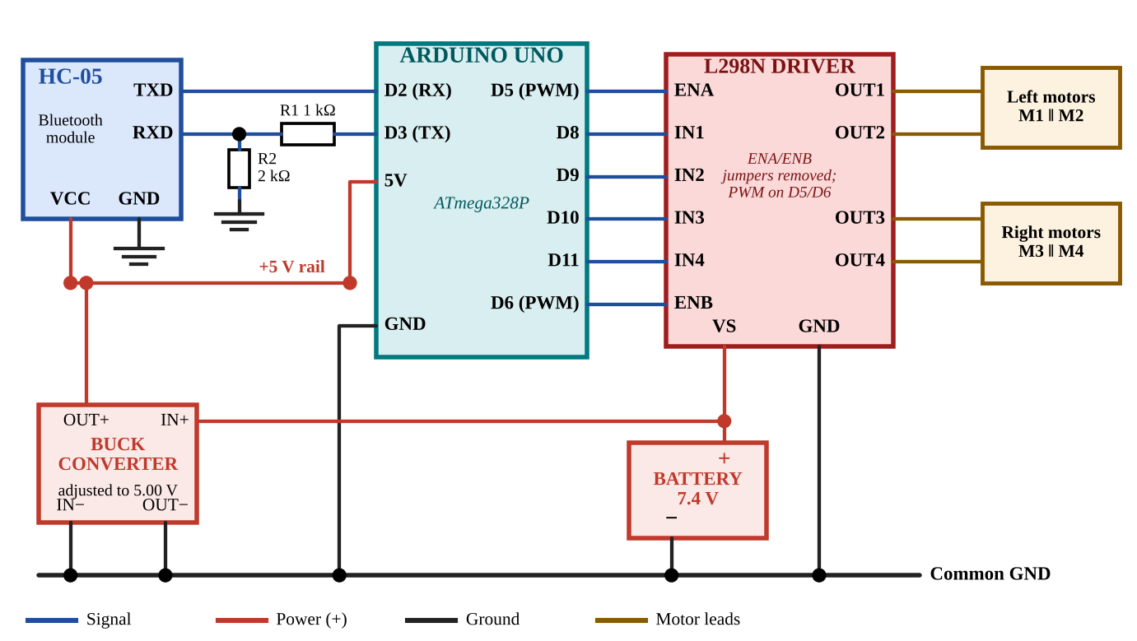
Figure 6: Complete wiring schematic (ENA/ENB jumpers removed; PWM on D5/D6).
3.8 Software Implementation
The program is written in the Arduino IDE. It uses the standard SoftwareSerial library [2] to create a serial port on D2 (receive) and D3 (transmit) at 9600 baud. In setup(), the six L298N pins are set as outputs, the motors are stopped and the Bluetooth port is opened. In loop(), the program checks whether a character has arrived, reads it and converts it to upper case. A switch statement then selects the action: the function drive() writes the direction inputs IN1–IN4 and uses analogWrite() [3] to set the PWM duty on ENA and ENB to 200 out of 255. A direction change simply writes the opposite input levels, and S sets all inputs and both enables to zero, which stops the robot. Any other character is ignored. Figure 7 is the flowchart and the complete code is given in the Appendix.
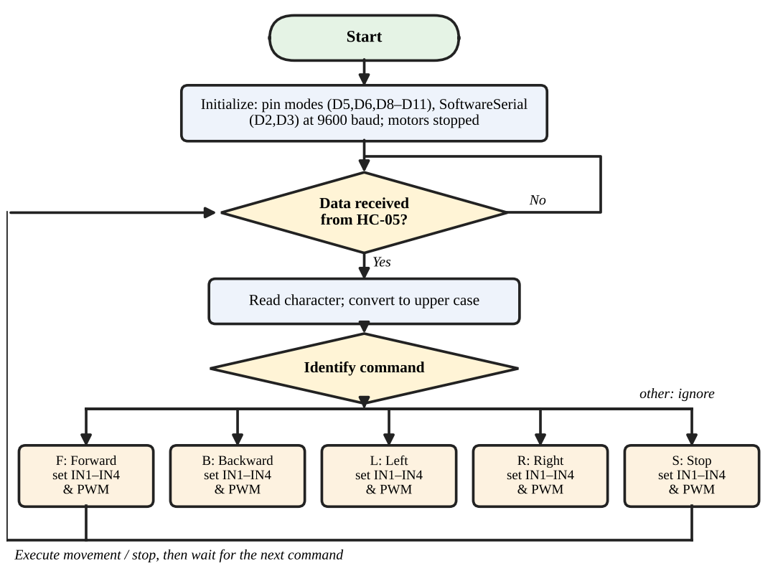
Figure 7: Software flowchart.
4. RESULTS AND DISCUSSIONS
The robot is designed so that each command from the phone produces the motion in Table 1, within the range of the Bluetooth link. No measured results have been supplied for this report, so the actual outcome of every test in Table 7 is marked "To be verified"; the final evaluation depends on physical testing of the assembled robot.
Table 7: Test plan and status.
Test | Expected Result | Actual Result/Status
Bluetooth pairing | Phone pairs with HC-05 and connects | To be verified
Command reception | Arduino receives each command character | To be verified
Forward movement | All four wheels turn forward | To be verified
Backward movement | All four wheels turn backward | To be verified
Left turning | Left wheels backward, right wheels forward | To be verified
Right turning | Left wheels forward, right wheels backward | To be verified
Stop response | Motors stop on S | To be verified
Motor direction consistency | Both motors on a side turn the same way | To be verified
Power supply stability | 5 V rail stays steady while motors run | To be verified

Points to check during testing are the polarity of each motor, a 5 V rail that does not droop or reset the Arduino at motor start-up, the heating of the L298N, and the PWM value (200 in the sketch) that gives a suitable speed.
5. CONCLUSION
This report presented a cellphone-operated, four-wheel Land Rover robot built from an Arduino UNO, an HC-05 Bluetooth module and an L298N motor driver. Bluetooth serial communication and embedded control are combined so that single-character commands from an Android phone drive the left and right motor groups, and four-wheel differential steering provides forward, backward, left, right and stop motions. The design is a manually operated educational prototype, and its performance remains to be confirmed by testing; the project nevertheless gives hands-on experience of wireless communication, motor drivers, power regulation and microcontroller programming.
6. FUTURE SCOPE
The following are possible future improvements and are not features of the present prototype:
- PWM-based speed control selectable from the phone.
- Ultrasonic obstacle detection.
- A more efficient motor driver in place of the L298N.
- Battery-voltage monitoring.
- A more user-friendly mobile interface.
- Alternative wireless control technologies.

7. REFERENCES
[1] Arduino, "UNO R3," Arduino Documentation. [Online]. Available: https://docs.arduino.cc/hardware/uno-rev3/ (accessed Oct. 11, 2026).
[2] Arduino, "SoftwareSerial library," Arduino Documentation. [Online]. Available: https://docs.arduino.cc/learn/built-in-libraries/software-serial/ (accessed Oct. 11, 2026).
[3] Arduino, "analogWrite()," Arduino Language Reference. [Online]. Available: https://docs.arduino.cc/language-reference/en/functions/analog-io/analogWrite/ (accessed Oct. 11, 2026).
[4] STMicroelectronics, "L298 Dual full-bridge driver," Datasheet DS0218, Rev. 5, Oct. 2023. [Online]. Available: https://www.st.com/resource/en/datasheet/l298.pdf
[5] Core Electronics, "Bluetooth Module (HC-05)," SKU CE00021, product page. [Online]. Available: https://core-electronics.com.au/bluetooth-module-hc-05.html (accessed Oct. 11, 2026).
[6] Bluetooth SIG, "Specifications," Bluetooth Technology Website. [Online]. Available: https://www.bluetooth.com/specifications/specs/ (accessed Oct. 11, 2026).
All figures in this report are original diagrams or illustrations prepared by the authors; no third-party images are used.
8. APPENDIX: ARDUINO CODE
/*
* Land Rover Robot Operated by Cellphone
* Arduino UNO + HC-05 (SoftwareSerial) + L298N, four DC geared motors
* Commands: F = Forward, B = Backward, L = Left, R = Right, S = Stop
* ENA/ENB jumpers removed; ENA -> D5, ENB -> D6 (PWM speed control)
*/
#include <SoftwareSerial.h>

const uint8_t BT_RX = 2; // Arduino D2 <- HC-05 TXD
const uint8_t BT_TX = 3; // Arduino D3 -> HC-05 RXD (via 1k/2k divider)

const uint8_t ENA = 5; // left motor group speed (PWM)
const uint8_t IN1 = 8; // left group direction
const uint8_t IN2 = 9;
const uint8_t IN3 = 10; // right group direction
const uint8_t IN4 = 11;
const uint8_t ENB = 6; // right motor group speed (PWM)

const uint8_t SPEED = 200; // PWM duty, 0-255

SoftwareSerial bluetooth(BT_RX, BT_TX);

// dirL/dirR: 1 = forward, -1 = backward, 0 = stop
void drive(int8_t dirL, int8_t dirR, uint8_t speed) {
digitalWrite(IN1, dirL > 0);
digitalWrite(IN2, dirL < 0);
digitalWrite(IN3, dirR > 0);
digitalWrite(IN4, dirR < 0);
analogWrite(ENA, dirL != 0 ? speed : 0);
analogWrite(ENB, dirR != 0 ? speed : 0);
}

void moveForward() { drive( 1, 1, SPEED); }
void moveBackward() { drive(-1, -1, SPEED); }
void turnLeft() { drive(-1, 1, SPEED); } // spin left in place
void turnRight() { drive( 1, -1, SPEED); } // spin right in place
void stopMotors() { drive( 0, 0, 0); }

void setup() {
pinMode(ENA, OUTPUT);
pinMode(IN1, OUTPUT);
pinMode(IN2, OUTPUT);
pinMode(IN3, OUTPUT);
pinMode(IN4, OUTPUT);
pinMode(ENB, OUTPUT);
stopMotors();
bluetooth.begin(9600); // HC-05 default data-mode baud rate
}

void loop() {
if (bluetooth.available() > 0) {
char cmd = toupper(bluetooth.read());
switch (cmd) {
case 'F': moveForward(); break;
case 'B': moveBackward(); break;
case 'L': turnLeft(); break;
case 'R': turnRight(); break;
case 'S': stopMotors(); break;
default: break; // ignore any other character
}
}
}

