**S3**

* S3 stores objects allows
* Maximum object size in S3 in 5 TB
* Objects are stored in other fundamental structure called bucket
* Objects are uniquely identified in s3 via the key

S3 access with permissions

* Only account owner
* Via permissions but only view not editable
* S3 or IAM policies

Creating S3

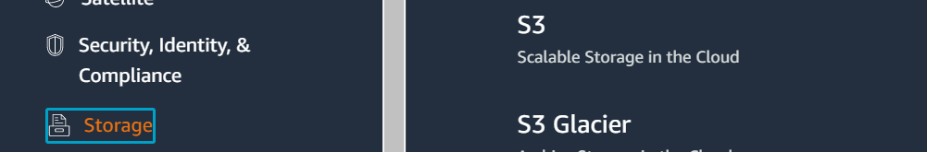

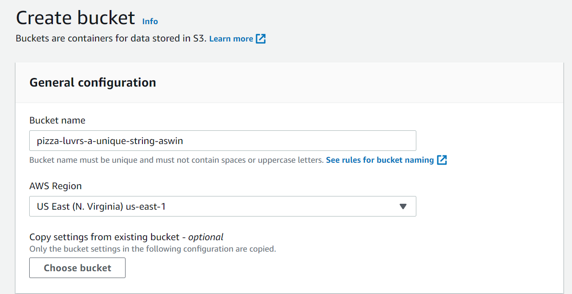

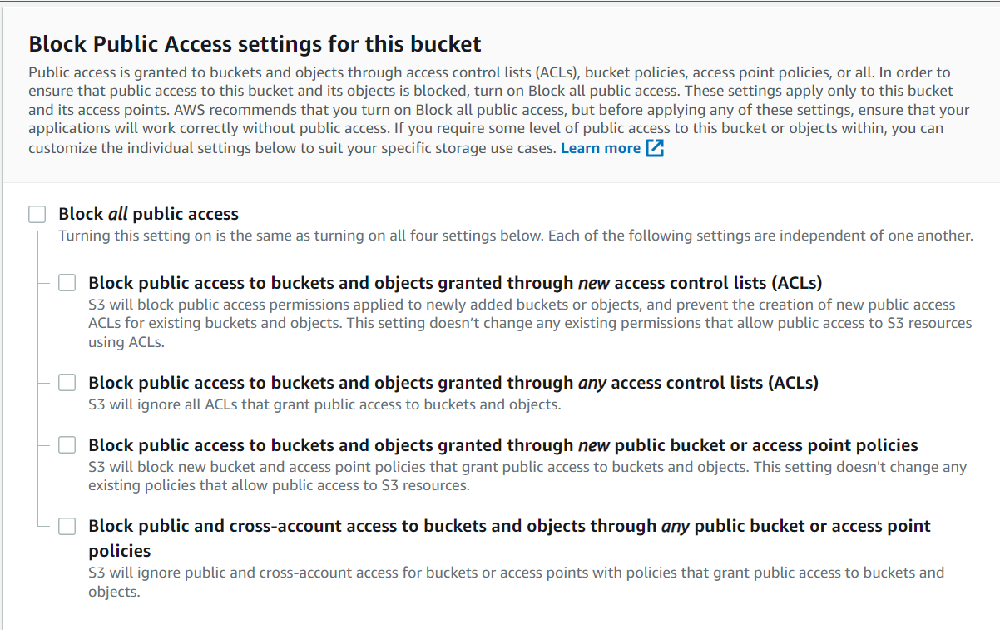

By Default the block is checked for now it has bee unchecked

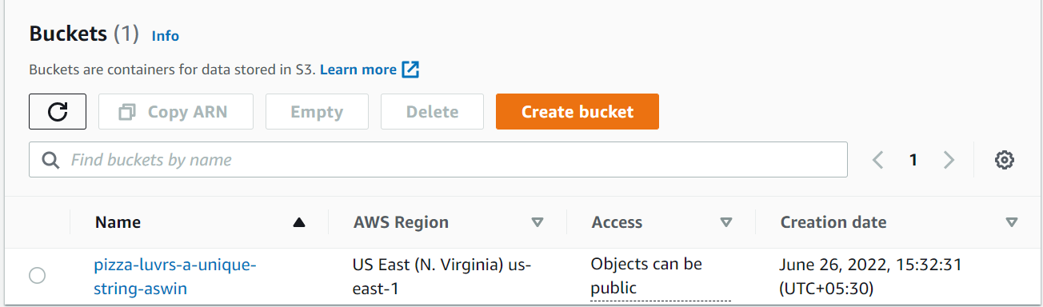

To set policy for the bucket – select the bucket and permissions 🡪 bucket policy edit

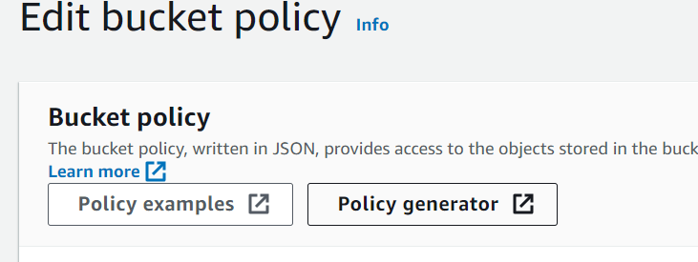

Select Policy generator

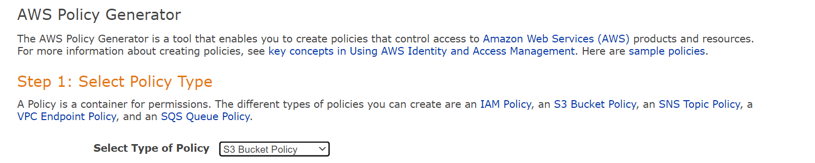

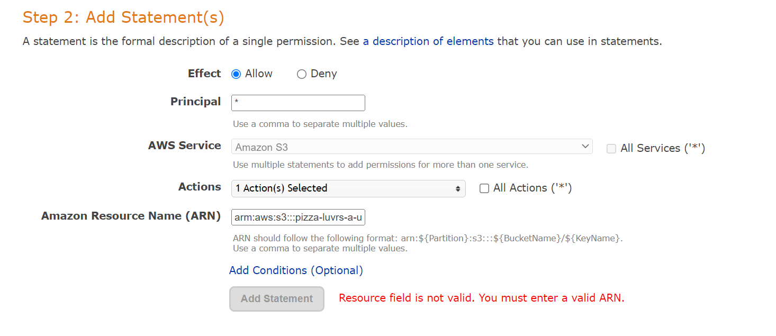

Principal : who should be able to access so use * to apply for all

ARN : arn:aws:s3::: [pizza-luvrs-a-unique-string-aswin](https://s3.console.aws.amazon.com/s3/buckets/pizza-luvrs-a-unique-string-aswin?region=us-east-1)/*

**Updating objeects in S3**

Using console, CLI, and SDk

Console : ADhoc or small number of file uploading

CLI: recursive ddirectory uploading

SDk : dynamic in code uploading

CLI :

**Syntax : aws s3 cp <local_folder> s3://<bucket>/<remote_folder> --recursive --exclude "<pattern>"**

Eg: **aws s3 cp ./assets/js s3 cp://pizza-luvrs-a-unique-string-ryan/js --recursive --exclude ".DS_Store or file type"**

**Console :**

Create Folder

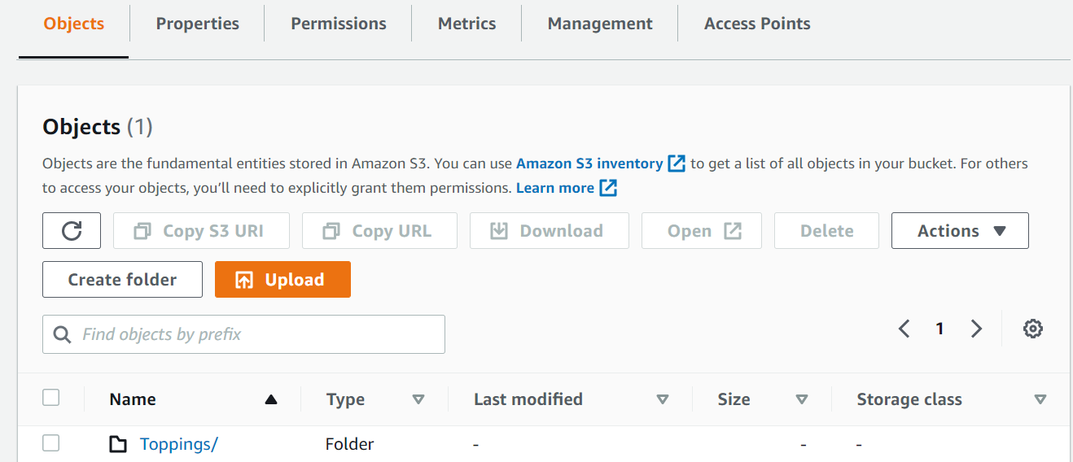

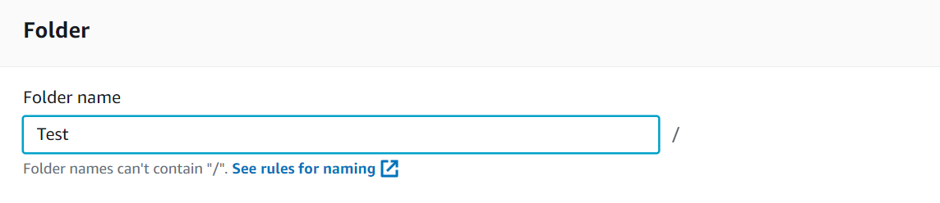

**Select folder and upload**

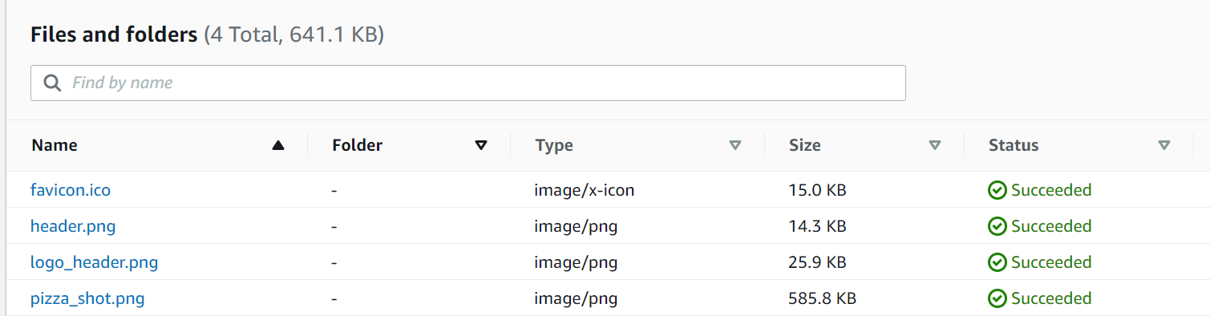

**Connecting S3 with Code**

The first step is to get the root path that these files should share since the path and file names wont change in S3

Select one PNG file and the look for the object URL field.

**CROS in S3**

Select the S3 bucket and Permissions