**SQS – Simple Queue Service**

A message can be upto 256KB

Enables us to create asynchronous process

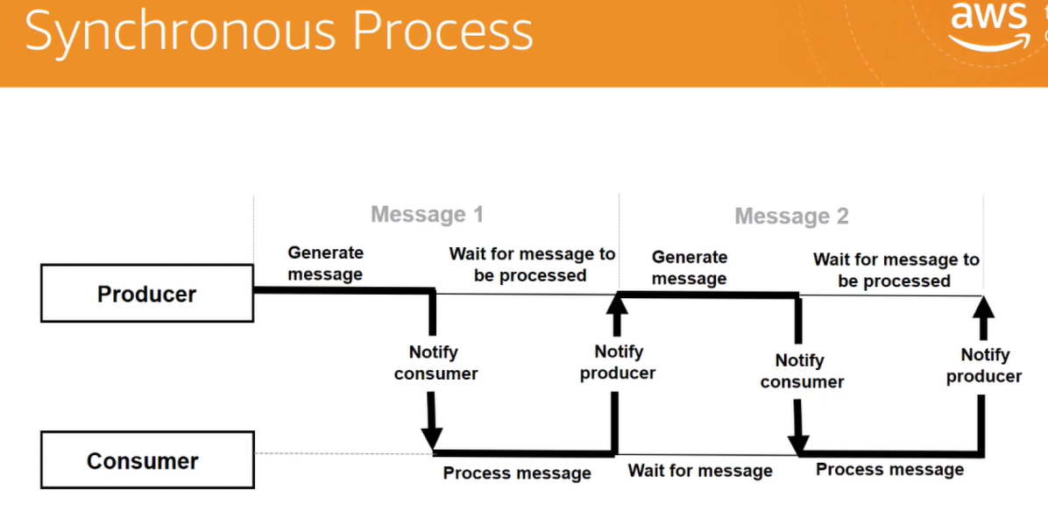

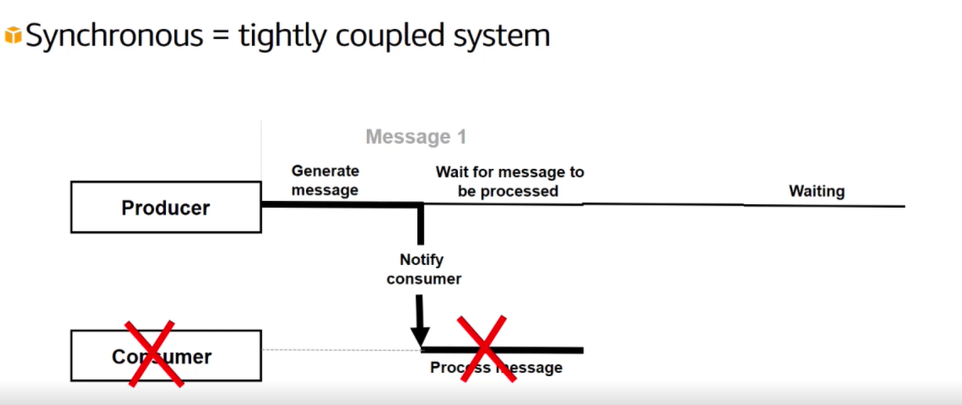

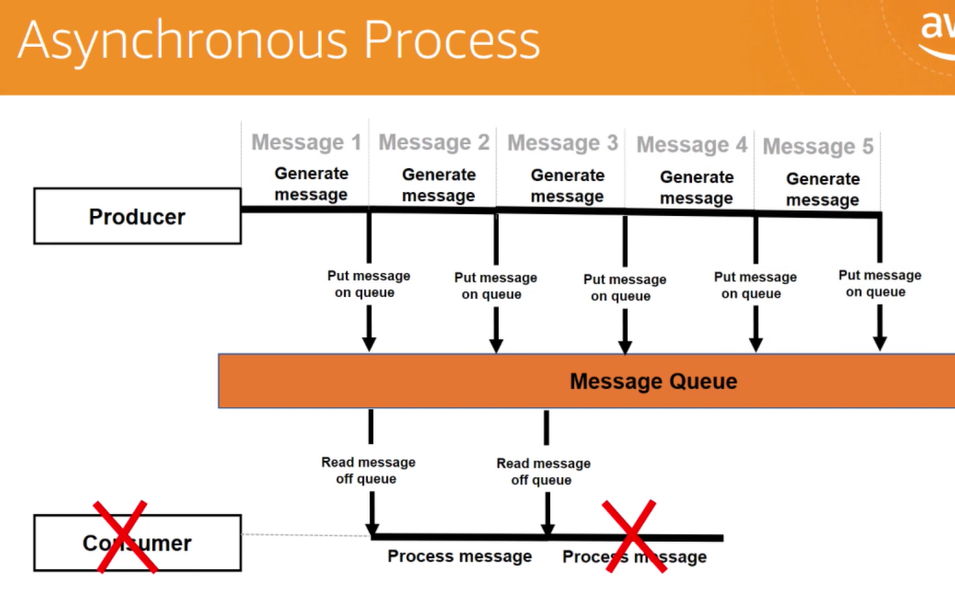

**Benefits of using Amazon SQS**

* Reduce administrative overhead
* reliably deliver messages
* message are stores redundantly across multiple availability zones
* keep sensitive data secure
* Elastic scaling and cost efficient
* your costs align with the demand you require

**Standard Queue**

* Support nearly an unlimited number of transactions per second
* Support at least once message delivery
* Best effort ordering

**FIFO Queue**

* Events are delivered in the right order ad they are received
* Exactly once processing of each message
* limited number of transactions we can send per sec
* SNS is not available in FIFO queues

**Amazon SQS short polling**

* Short polling returns messages immediately
* increased costs
* only a subnet of the SQS servers are polled

**Amazon SQS long polling**

* Long polling fixes a lot of the cost issue associated with using short polling
* almost all cases awe should use long polling
* maximum long polling time of 20 secs

**Create Long polling SQS Queue**

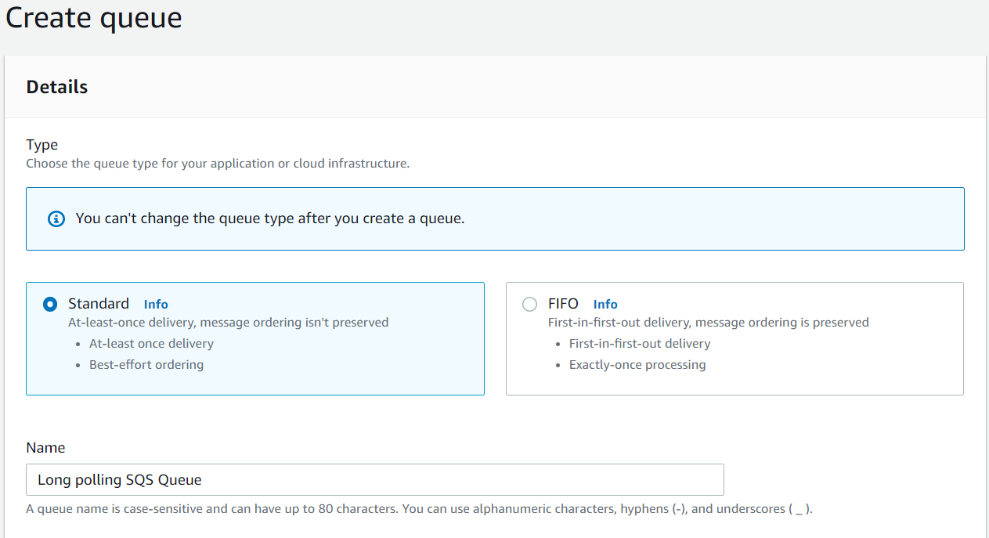

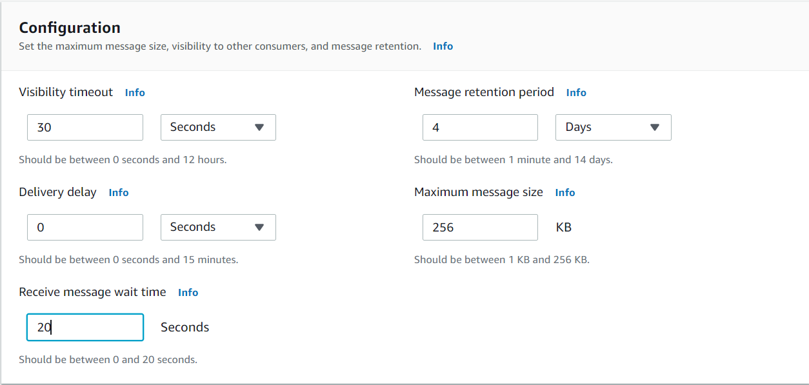

And create queue

**Dead-Letter Queue-** The dead letter queues main purpose is to handle message failure

* Unsuccessful messages
* Debugging messages

**Subscribing an SQS queue to and SNS topic**

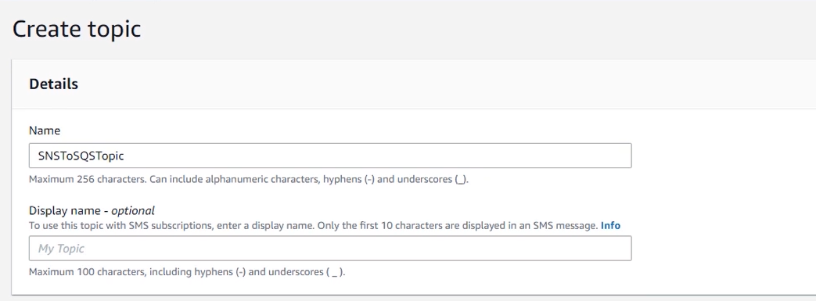

Create subscription

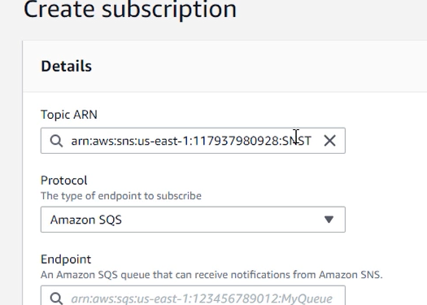

In endpoint copy the SQS ARN and paste it 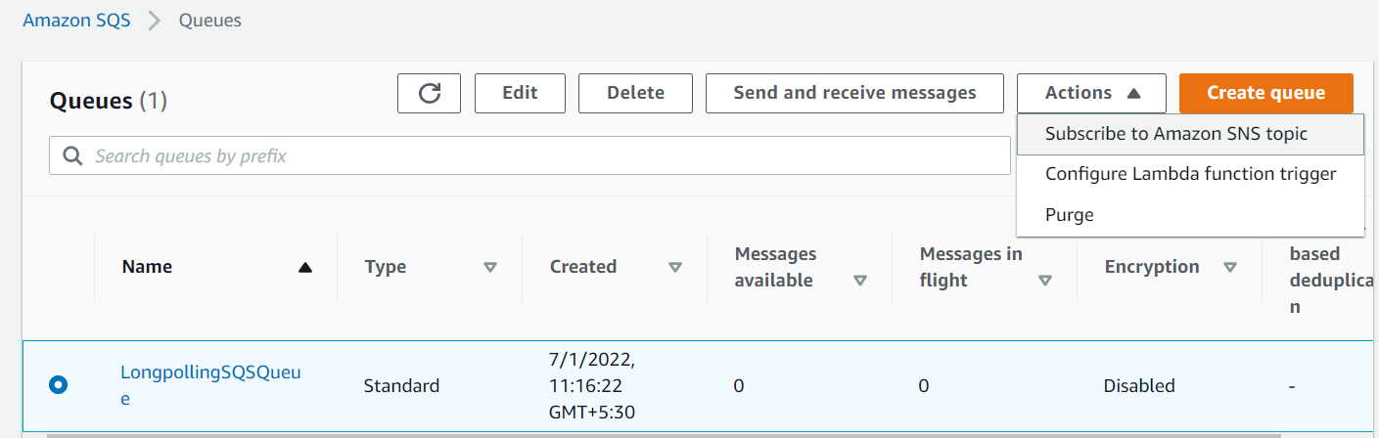

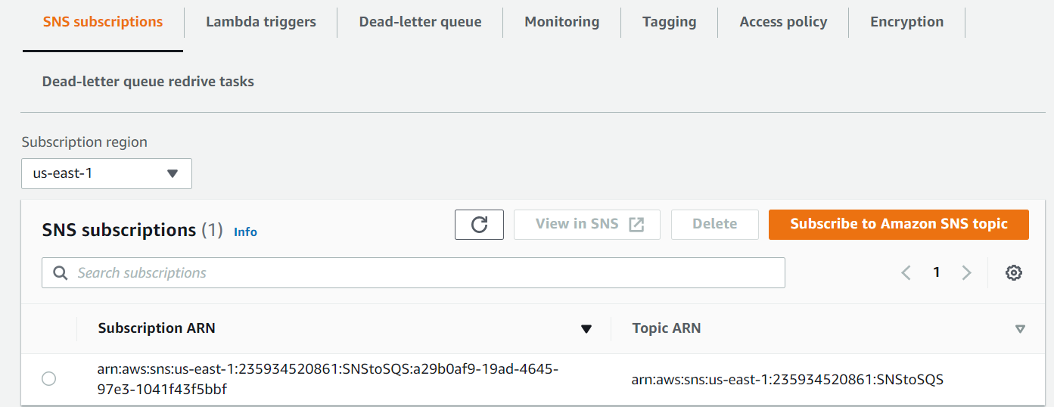

To send message  
in topic select publish message

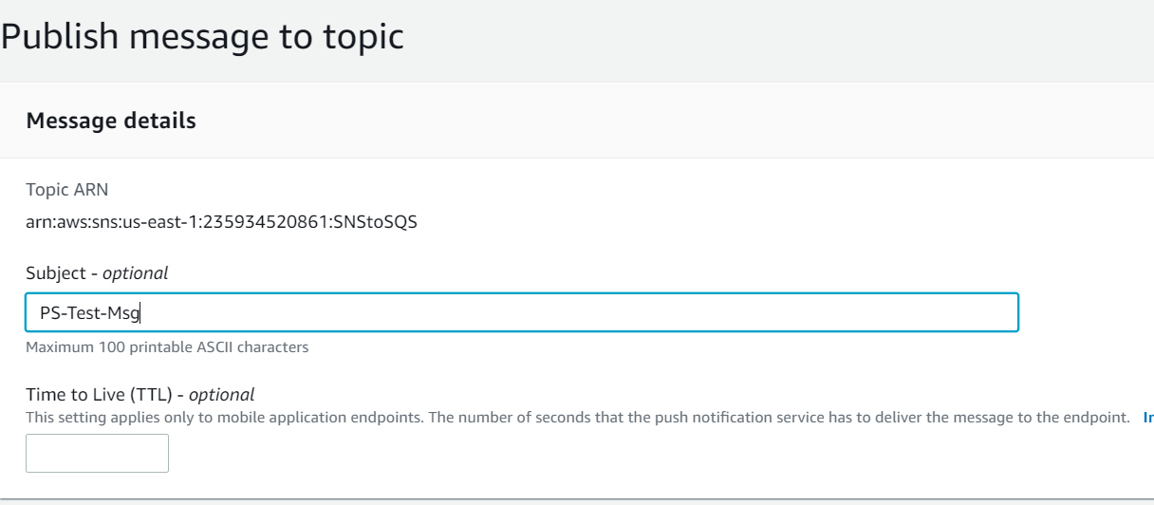

Once message has been published can be viewed in SQS  
  
