Introduction to Software Engineering
COSC 336
ReSource (Phases IV and V)
Design Document
Architecture Design and Detailed Design
Intelligent AI-Powered Circular Campus Resource Exchange and Asset Life Cycle Management System
Dr. Ala' Alsamarneh
Dr. Hamdan Alshkeili
Dr. Natnael Takele
Date: 03/11/2026
Prepared by: Group 3
Mohamed Almarzooqi 100066203

Prepared for:
Head of Facilities Management
Proposed Technical Owner:
University IT Department

Sections in This File
This file contains the parts of the ReSource Phase 4 and 5 Design Document prepared by Mohamed Almarzooqi (100066203). Section, figure and table numbers are the same as in the combined group document.
- Introduction
- 1. Context Diagram
- 2. Data-Flow Diagrams
- 3. Architecture
- 8. Use Case Diagram
- 10.8 Register and Activate an Account (UC-13, UC-8)
- 13. Component and Deployment Diagrams (section introduction)
- 13.1 Component Diagram
- Appendix A: Requirement-to-Design Traceability
- AI Contributions

Introduction
Prepared by: Mohamed Almarzooqi

Purpose and Scope
Prepared by: Mohamed Almarzooqi
This document is the design of ReSource, the university system for exchanging surplus campus resources and managing assets through their life cycle. Sections 1 to 7 give the architecture design requested for Phase 4 [1], [2]: the context and data-flow diagrams, the architecture and its design decisions, the AI services, the human approval points, security, and mockups of the eight screens named in the project description. Sections 8 to 19 give the detailed design requested for Phase 5 [1], [3]: the use case, class, sequence, activity, state, component and deployment diagrams, the AI recommendation workflow, the entity relationship diagram (ERD), the interfaces between modules and AI services, the recommendation score and explanation design, the sustainability calculations and the model-monitoring records.
The design covers the whole system specified in the Phase 3 Requirements Document [4]: the 13 use cases UC-1 to UC-13, the feature groups FR-1 to FR-13, the nonfunctional requirements and the business rules. Essential and Desirable requirements are designed. The three Future requirements (FR-1.14 bulk registration, FR-5.33 registration of usable components and FR-7.R8 scheduled reports) are left out of the design, and nothing in the design prevents adding them. The design keeps the Django and MySQL stack, the team, the student IDs and the scope approved in Phase 2 [5].

Document Conventions
Prepared by: Mohamed Almarzooqi
Requirement IDs (FR, AI, PER, SAF, SEC, QUA, BR, LEG and ORG) and use case IDs (UC) are those of the Phase 3 document [4]. Each design element cites the requirements it meets, and Appendix A traces every requirement group to its design. Design elements have their own IDs: DR-n for decision records, H-n for human approval points and D-n for data stores; the data-flow processes are numbered 1.0 to 7.0 on Level 1 and 3.1 to 3.6 on Level 2. Amounts are in UAE dirhams (AED) and dates are written DD/MM/YYYY.
All sample data in the figures and mockups is synthetic, as ORG-2 requires. It follows one example: the Physics department needs two oscilloscopes for a teaching lab on SAN Campus (request R-2026-0391), and Electrical Engineering has listed three surplus 100 MHz oscilloscopes on Main Campus (asset A-2026-0412). The other screens use other assets so that every role and module is shown.
Role names follow Phase 3. Table I-1 gives the abbreviations used in the diagrams, which save space in the figures.
Table I-1: Roles and abbreviations
Abbreviation | Role (Phase 3) | Main use cases
DR | Department Representative | UC-2, UC-3, UC-5, UC-6, UC-11
AC | Asset Coordinator | UC-1, UC-4, UC-5, UC-6, UC-7, UC-10
AD | Administrator | UC-4, UC-5, UC-6, UC-7, UC-12
PT | Procurement Team | UC-4, UC-9, UC-12
MS | Maintenance Staff | UC-6
FO | Finance Officer | UC-12
SO | Sustainability Officer | UC-6, UC-7, UC-12
SA | System Administrator | UC-8, UC-13
UM | University Management | UC-12
None | Applicant (no active account yet) | UC-13

Design Summary
Prepared by: Mohamed Almarzooqi
ReSource is one Django web application with one MySQL database, organized as a modular monolith: nine business modules with clear borders, an AI gateway (AIGateway) that is the only way to reach the AI services, and a background worker for jobs that nobody waits for (Section 3). Semantic matching uses a small open embedding model that runs on the server, so request and asset text used for matching never leaves the university server. A hosted language model is used only for classification text, the assistant and report drafting, through the gateway, with personal data removed (SEC-11). Every AI output is a suggestion with a confidence level and a reason; a named person decides at each of the approval points in Section 5, and every module keeps working with forms, standard search and standard reports when the AI is unavailable (AI-6, PER-6).

1. Context Diagram
Prepared by: Mohamed Almarzooqi
Figure 1-1 shows ReSource as a single process, numbered 0, with every external entity that gives data to the system or receives data from it. The entities are the nine roles of Phase 3, the Applicant (a person without an active account, UC-13), "Any Signed-in User" for the functions that every role shares (searching the catalogue and viewing personal data, FR-2.2, FR-6.11), and the AI Provider, the hosted language model reached through AIGateway (DR-4). Flows are grouped and named with nouns; there are no data stores and no internal steps on this level.

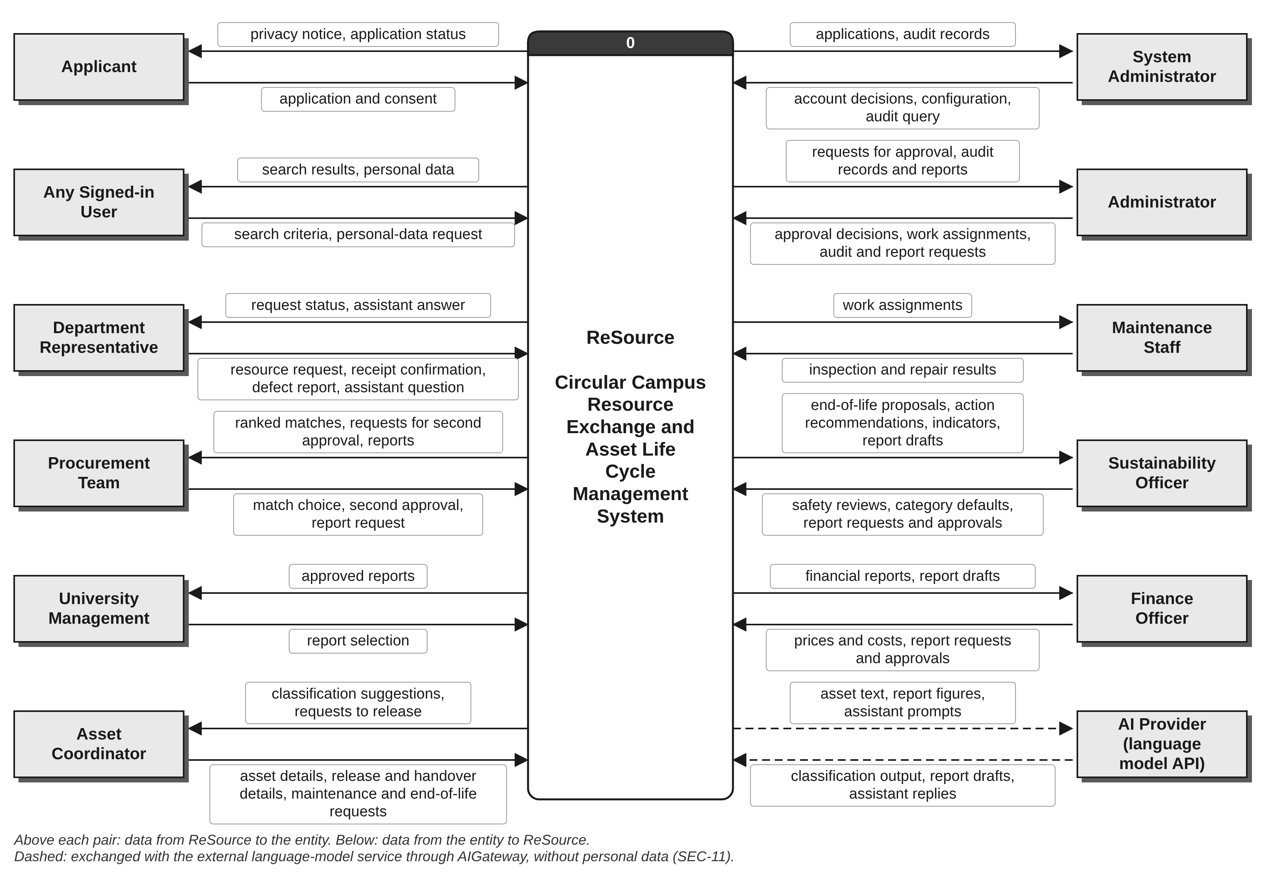
Figure 1-1: Context diagram

Some participants are deliberately not entities. Facilities Management, approved recycling vendors and donation recipients have no account; their evidence is entered by campus staff (Phase 3, Section 5.1), so their data reaches the system through the Sustainability Officer and the Asset Coordinator. The e-mail service and university single sign-on are not part of the prototype (TBD-6, ORG-3) and are shown as later integration points in Section 6.6. The embedding model runs inside ReSource and the backup copy holds ReSource's own data, so neither is an outside party in the logical data flow.
Table 1-1: External entities and their data flows
External entity | Data in (to ReSource) | Data out (from ReSource) | Source in Phase 3
Applicant | application and consent | privacy notice, application status | UC-13; FR-6.1, FR-6.2
Any Signed-in User | search criteria, personal-data request | search results, personal data | UC-2; FR-2.2, FR-6.11, SEC-9
Department Representative | resource request, receipt confirmation, defect report, assistant question | request status, assistant answer | UC-3, UC-5, UC-6, UC-11; FR-3, FR-4.10, FR-5.1, FR-11
Asset Coordinator | asset details, release and handover details, maintenance and end-of-life requests | classification suggestions, requests to release | UC-1, UC-4, UC-5, UC-7, UC-10; FR-1, FR-4.1, FR-4.7, FR-9
Procurement Team | match choice, second approval, report request | ranked matches, requests for second approval, reports | UC-4, UC-9, UC-12; FR-4.3, FR-8.7, FR-12.1
University Management | report selection | approved reports | UC-12; FR-7.R1, FR-12.9
System Administrator | account decisions, configuration, audit query | applications, audit records | UC-8, UC-13; FR-6.3, FR-6.8, FR-7.A3
Administrator | approval decisions, work assignments, audit and report requests | requests for approval, audit records and reports | UC-4 to UC-7, UC-12; FR-4.2, FR-4.12, FR-5.3, BR-8
Maintenance Staff | inspection and repair results | work assignments | UC-6; FR-5.3 to FR-5.8
Sustainability Officer | safety reviews, category defaults, report requests and approvals | end-of-life proposals, action recommendations, indicators, report drafts | UC-6, UC-7, UC-12; FR-5.23, FR-10, FR-13.4
Finance Officer | prices and costs, report requests and approvals | financial reports, report drafts | UC-12; FR-13.4, FR-12.9
AI Provider | classification output, report drafts, assistant replies | asset text, report figures, assistant prompts | UC-10 to UC-12; FR-9, FR-11, FR-12; SEC-11

Every entity sends and receives at least one flow, and the 24 grouped flows are the ones balanced against Level 1 in Table 2-3.

2. Data-Flow Diagrams
Prepared by: Mohamed Almarzooqi

2.1 Level 1
Prepared by: Mohamed Almarzooqi
Level 1 splits process 0 into seven processes, one for each main job of the system (Table 2-1). Each process is a verb and a noun, is numbered 1.0 to 7.0 and serves a group of Phase 3 use cases. The nine data stores D1 to D9 hold data that waits between processes (Table 2-2).
Table 2-1: Level 1 processes
ID | Process | Main job | AI used | Requirements and use cases
1.0 | Manage Accounts and Access | Registers applicants with consent, activates accounts, assigns roles and departments, and returns personal data on request. | None | FR-6; SEC-1 to SEC-9; UC-8, UC-13
2.0 | Register and Publish Assets | Records and publishes assets, gets classification suggestions and answers catalogue searches. | ClassificationService (AI Provider and local model) | FR-1, FR-2, FR-9; UC-1, UC-2, UC-10
3.0 | Match Requests to Assets | Records requests and open needs, finds and ranks suitable assets and records the match decision. | EmbeddingService, MatchingEngine, RankingModel | FR-3, FR-8; UC-3, UC-9
4.0 | Approve and Transfer Assets | Takes the release and approval decisions, reserves units, records the transfer and the receipt. | None | FR-4; BR-3 to BR-6; UC-4, UC-5
5.0 | Maintain and Retire Assets | Records defects, inspections and repairs, and takes end-of-life proposals through safety review, approval and completion. | ActionRecommender (Desirable) | FR-5, FR-10; SAF-1 to SAF-9; UC-6, UC-7
6.0 | Report and Measure Impact | Calculates indicators, produces standard and AI reports for review, keeps category values, answers audit queries and records weekly model-monitoring metrics. | ReportGenerator (AI Provider) | FR-7.R, FR-7.A, FR-12, FR-13; UC-12
7.0 | Assist Users in Conversation | Answers questions and prepares request drafts in conversation (Desirable). | AssistantService (AI Provider) | FR-11; UC-11

Figure 2-1 is the complete Level 1 diagram: the 12 entities, the seven processes, the nine stores and every flow between them, on one large page. Figures 2-2 to 2-8 repeat the same diagram one process at a time at a larger size, so each flow label can be read easily; the same entity or store therefore appears on several of those figures. Two flows are used by every process and are drawn once (Figure 2-9): each process reads permissions from D1 and writes an audit entry to D8 (FR-6.7, FR-7.A1). Table 2-2 shows which process writes and reads each store.

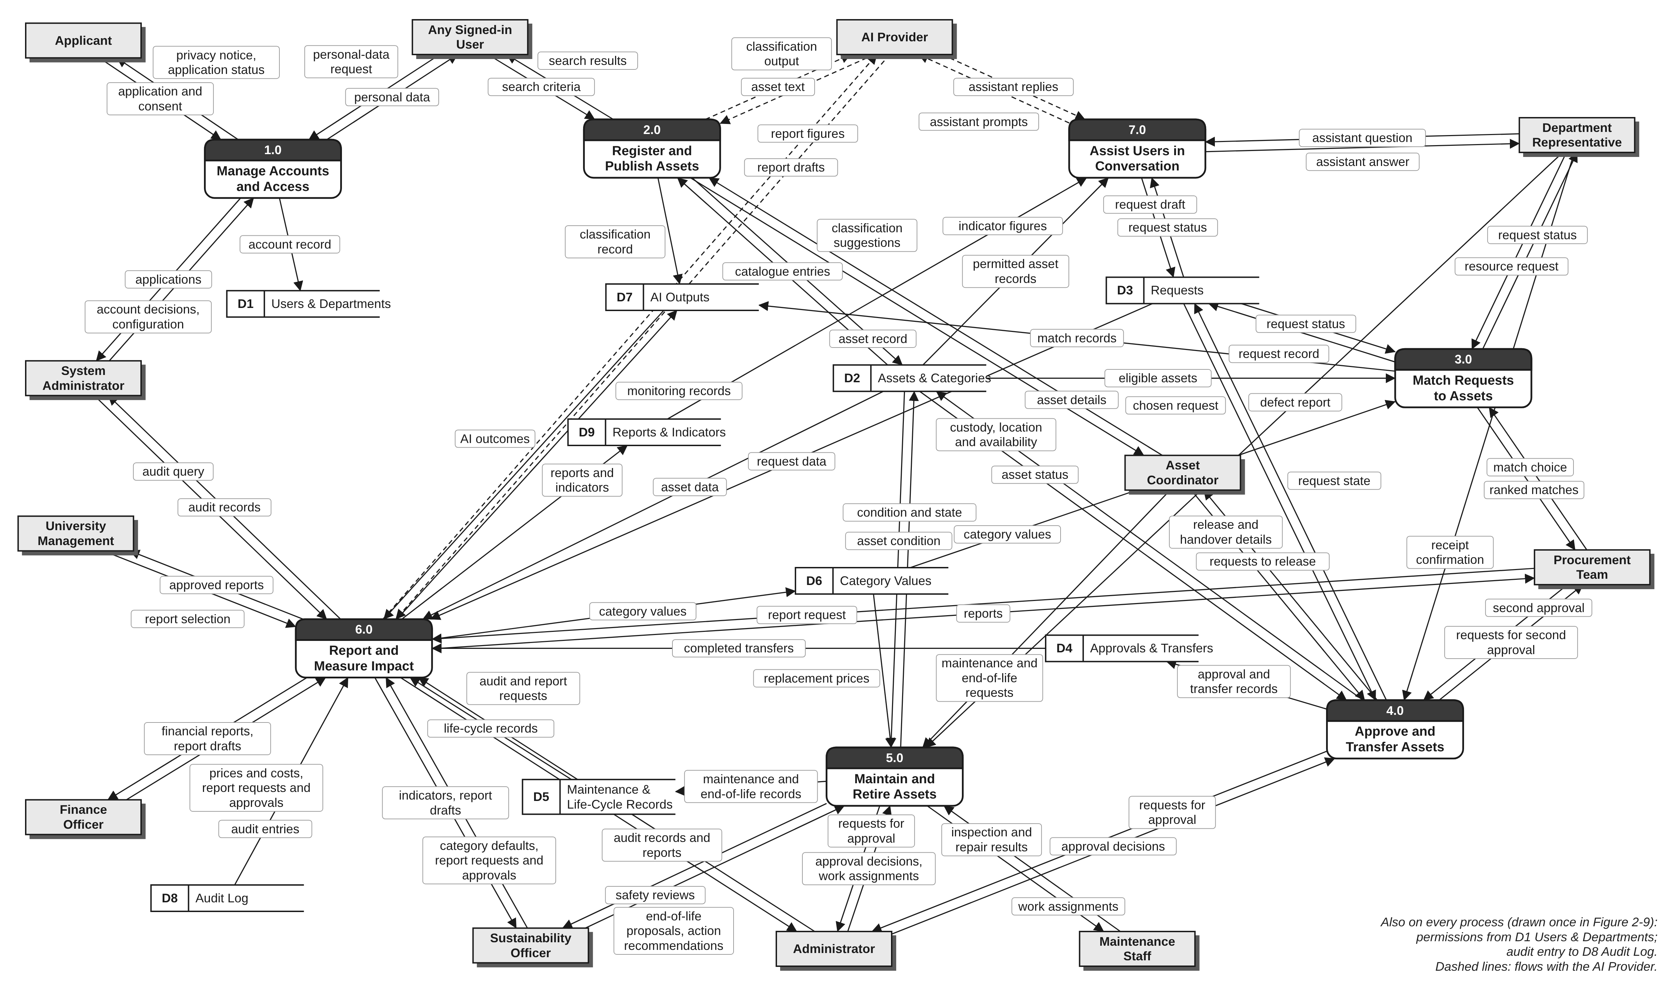
Figure 2-1: Level 1 data-flow diagram

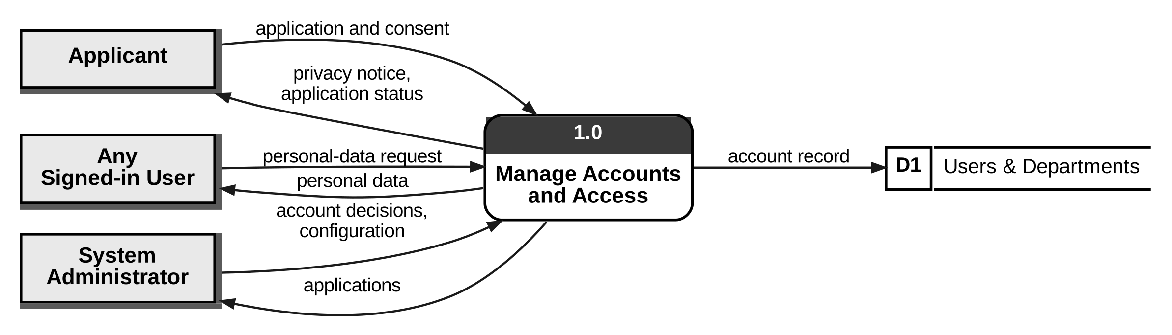
Figure 2-2: Level 1, process 1.0
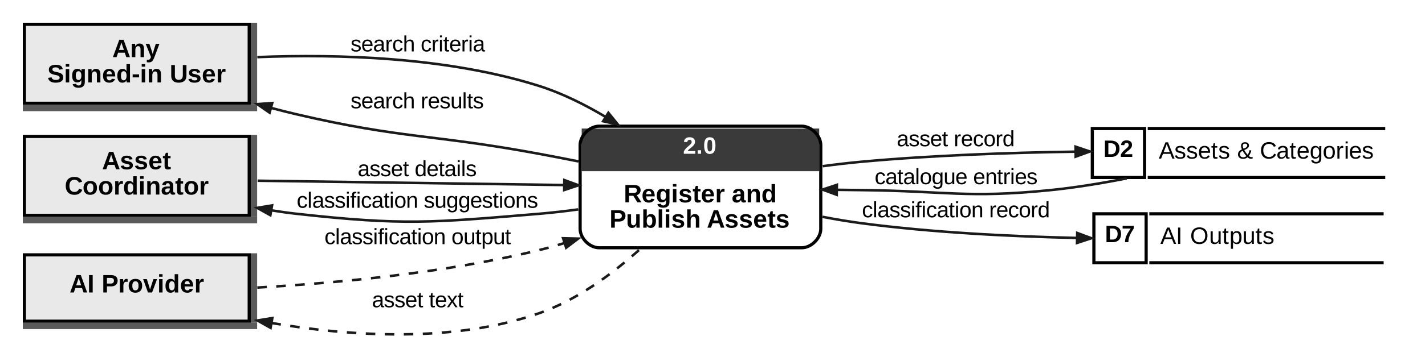
Figure 2-3: Level 1, process 2.0
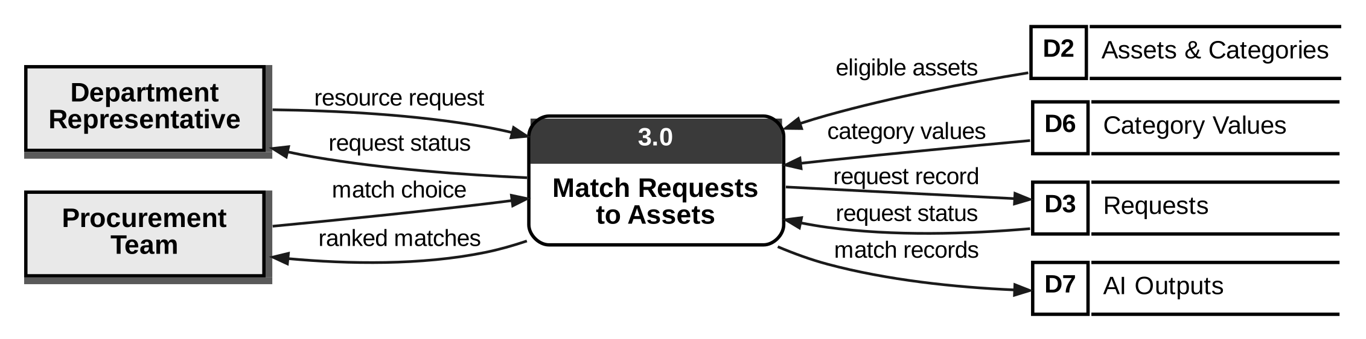
Figure 2-4: Level 1, process 3.0
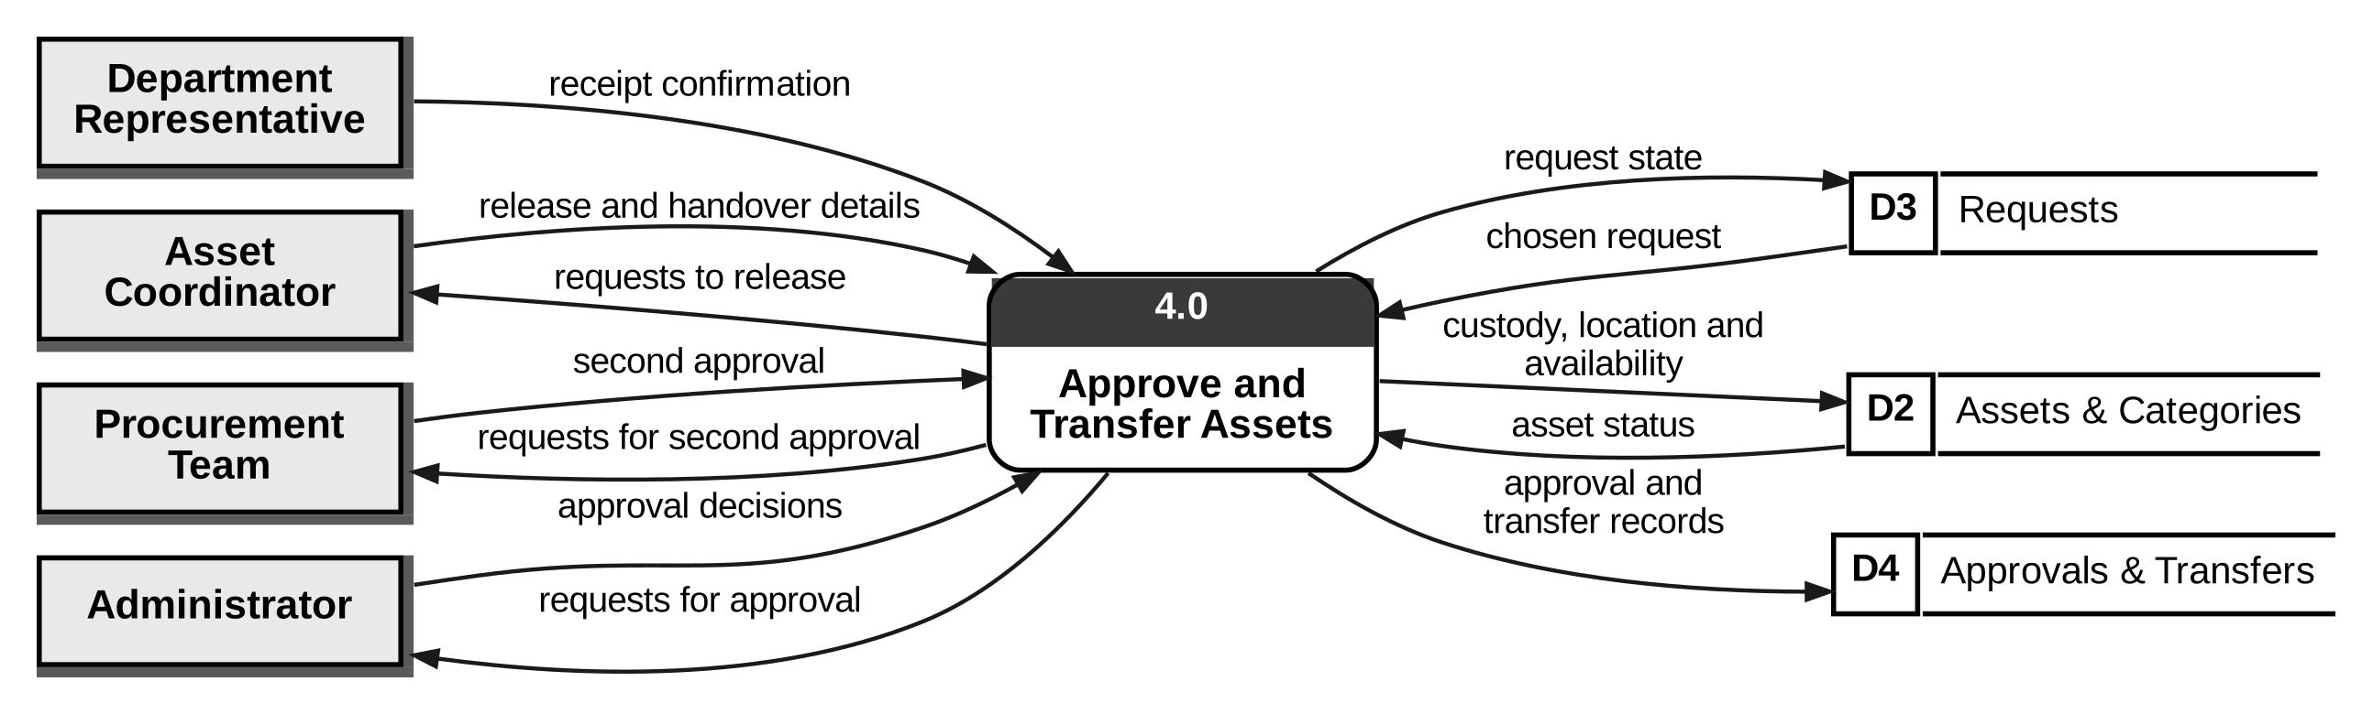
Figure 2-5: Level 1, process 4.0
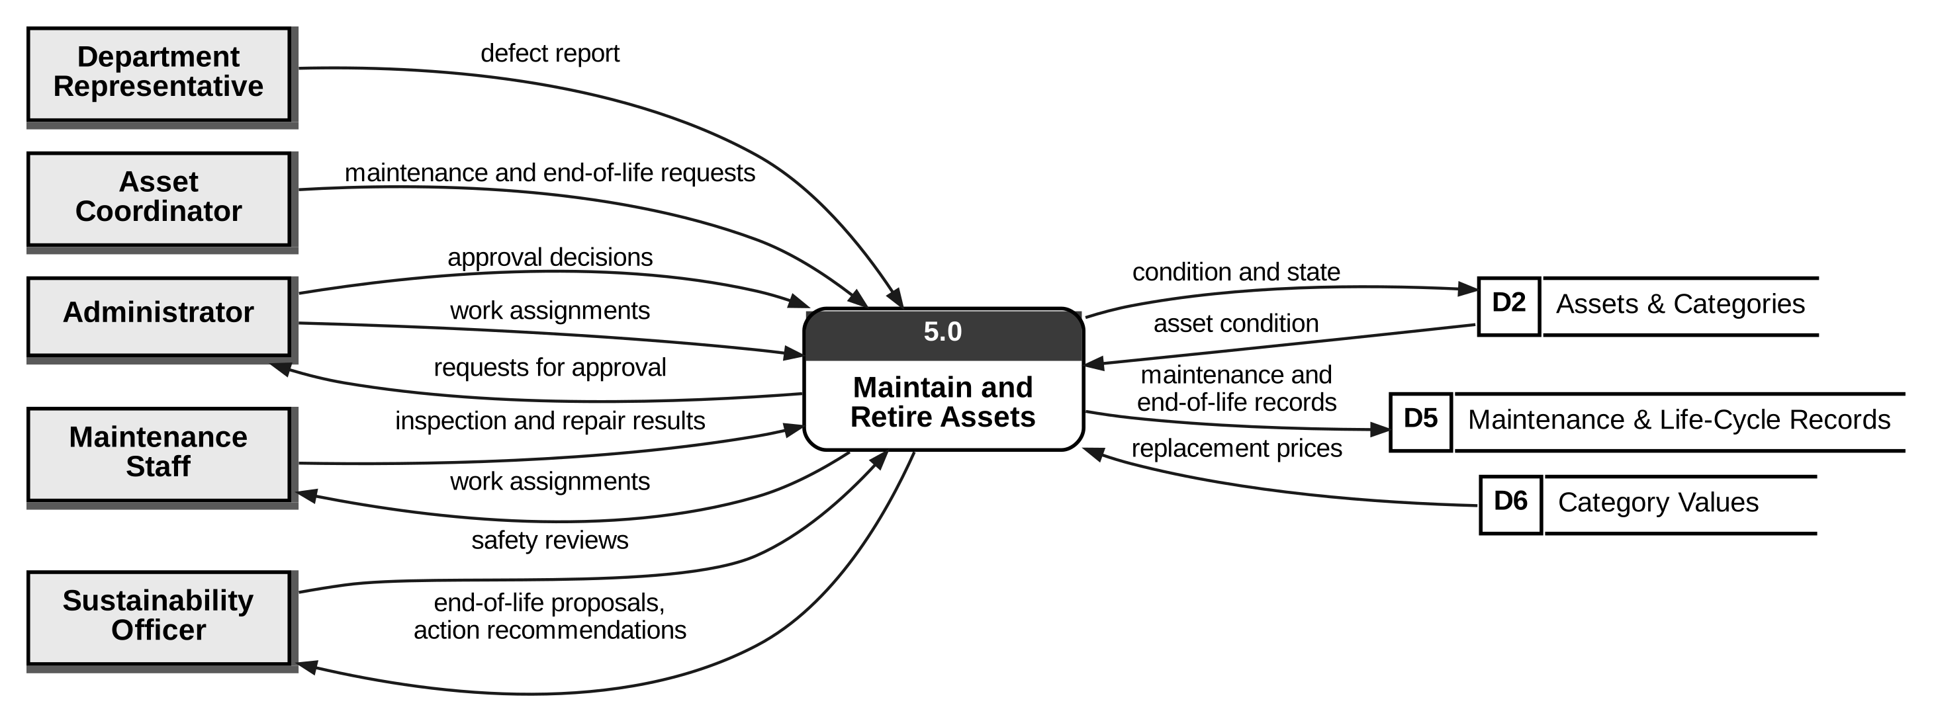
Figure 2-6: Level 1, process 5.0
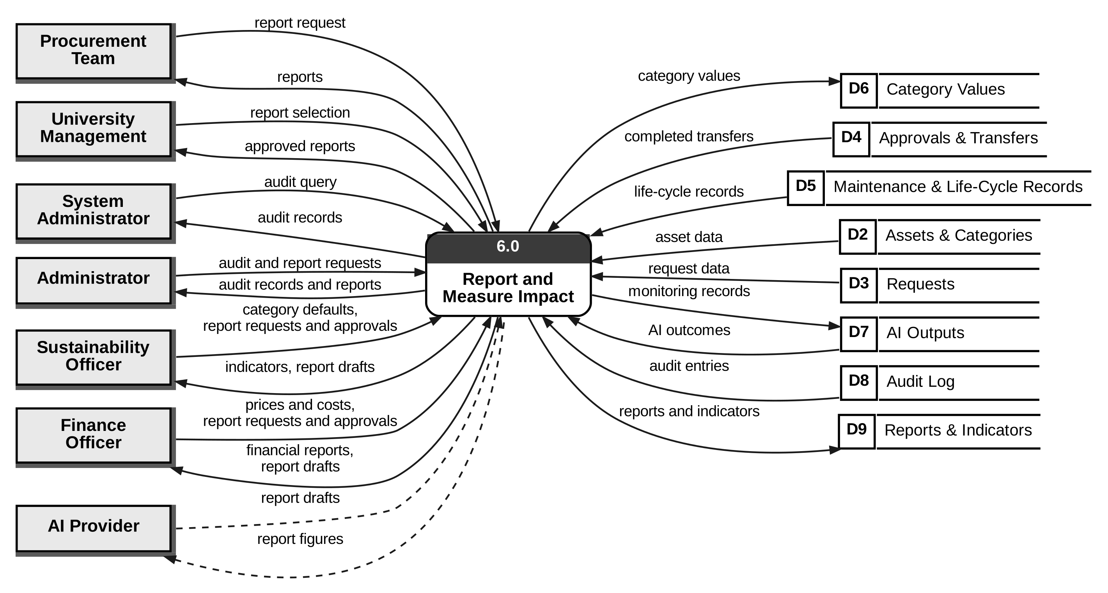
Figure 2-7: Level 1, process 6.0
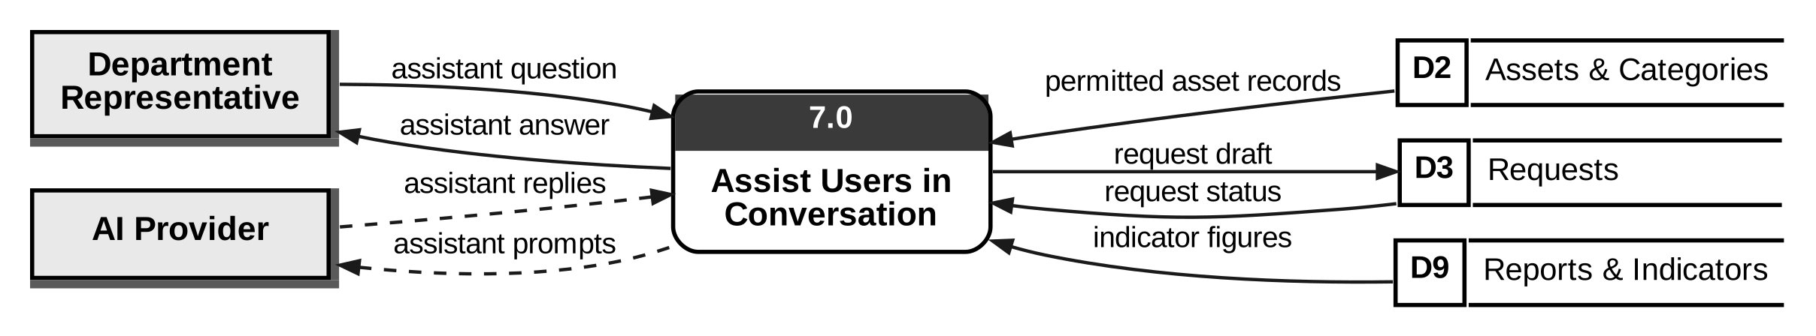
Figure 2-8: Level 1, process 7.0
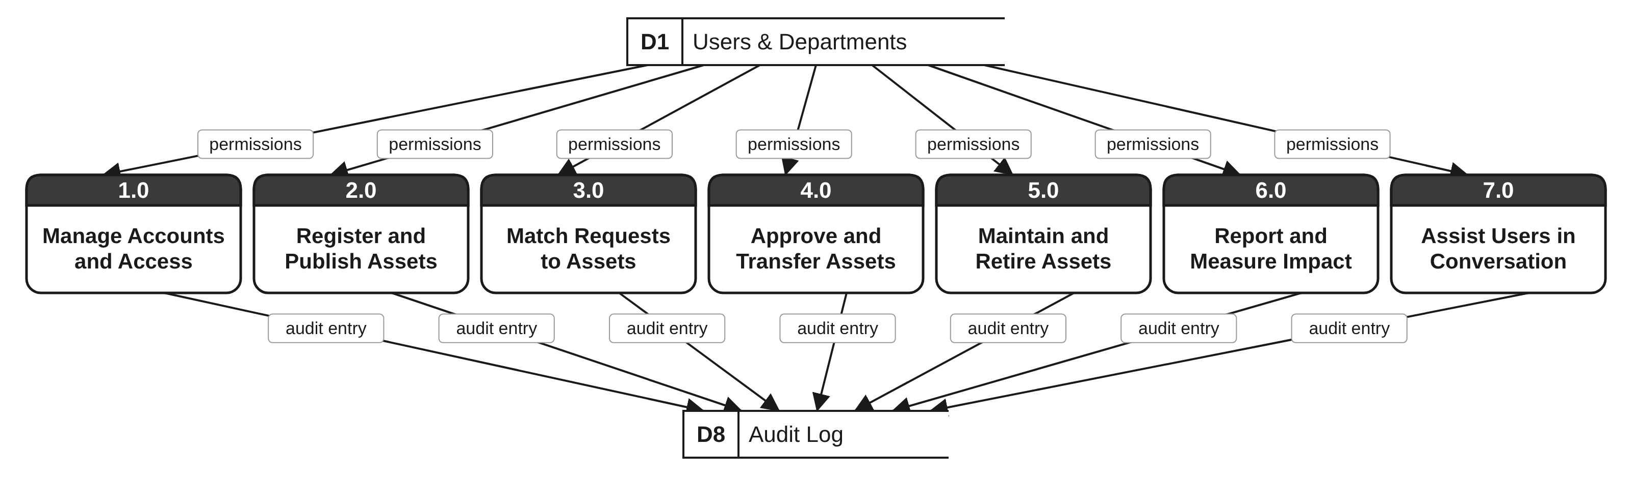
Figure 2-9: Level 1, common flows

2.2 Data Stores
Prepared by: Mohamed Almarzooqi
Table 2-2: Data stores
ID | Store | Contents | Written by | Read by | ERD tables (Section 15) | Requirements
D1 | Users & Departments | Users, roles, departments, consent records | 1.0 | All processes | DEPARTMENT, USER, ROLE, USER_ROLE, CONSENT_RECORD | FR-6; SEC-7, SEC-8
D2 | Assets & Categories | Assets, photos, categories, text embeddings, life-cycle state | 2.0, 4.0, 5.0 | 2.0, 3.0, 4.0, 5.0, 6.0, 7.0 | ASSET, ASSET_FILE, ASSET_EMBEDDING, CATEGORY | FR-1, FR-2, FR-9
D3 | Requests | Requests, request drafts, request history | 3.0, 4.0, 7.0 | 3.0, 4.0, 6.0, 7.0 | REQUEST | FR-3, FR-11.2
D4 | Approvals & Transfers | Approvals, reservations, transfers, receipt records | 4.0 | 6.0 | APPROVAL, RESERVATION, TRANSFER, TRANSFER_DOCUMENT | FR-4; BR-3 to BR-6
D5 | Maintenance & Life-Cycle Records | Maintenance requests, inspections, end-of-life proposals, vendors, life-cycle events | 5.0 | 6.0 | MAINTENANCE_REQUEST, INSPECTION, MAINTENANCE_RECORD, END_OF_LIFE_PROPOSAL, VENDOR, LIFECYCLE_EVENT | FR-5
D6 | Category Values | Versioned prices, costs, weights, years of use, emission factors | 6.0 | 3.0, 5.0 | CATEGORY_VALUE | FR-13.4, FR-13.5
D7 | AI Outputs | AI output records, match recommendations, model versions, reviewer decisions | 2.0, 3.0, 6.0 | 6.0 | MODEL_VERSION, AI_OUTPUT, RECOMMENDATION, HUMAN_REVIEW, EVALUATION_RUN, MONITORING_RECORD | AI-5, FR-7.A4, FR-8.7, FR-9.9
D8 | Audit Log | Append-only audit entries | All processes | 6.0 | AUDIT_ENTRY | FR-7.A1 to FR-7.A6
D9 | Reports & Indicators | Calculated indicators, AI report drafts and approved reports | 6.0 | 7.0 | SUSTAINABILITY_IMPACT, IMPACT_VALUE_USED, AI_REPORT | FR-12, FR-13

Each store is written by at least one process and read by at least one other process or by the same process at a later time, so no store is a dead end. The data stores are the Phase 4 data model; Section 15 refines them into 32 tables. The NOTIFICATION table keeps a copy of outgoing flows already shown in Figure 2-1, such as requests to release and request status, so it is not a separate store.

2.3 Balancing Level 1 Against the Context Diagram
Prepared by: Mohamed Almarzooqi
Table 2-3 checks every grouped flow of the context diagram. A grouped flow is split on Level 1 into parts, each handled by one process; the parts keep the same entity and direction, and together they make up the grouped flow. Level 1 has no external flow that is not in the context diagram.
Table 2-3: Balancing Level 1 against the context diagram
# | Context flow | External entity | In/out | Level 1 process (part) | Same name and direction
1 | application and consent | Applicant | in | 1.0 | Yes
2 | privacy notice, application status | Applicant | out | 1.0 | Yes
3 | search criteria, personal-data request | Any Signed-in User | in | 2.0 (search criteria), 1.0 (personal-data request) | Yes
4 | search results, personal data | Any Signed-in User | out | 2.0 (search results), 1.0 (personal data) | Yes
5 | resource request, receipt confirmation, defect report, assistant question | Department Representative | in | 3.0 (resource request), 4.0 (receipt confirmation), 5.0 (defect report), 7.0 (assistant question) | Yes
6 | request status, assistant answer | Department Representative | out | 3.0 (request status), 7.0 (assistant answer) | Yes
7 | asset details, release and handover details, maintenance and end-of-life requests | Asset Coordinator | in | 2.0 (asset details), 4.0 (release and handover details), 5.0 (maintenance and end-of-life requests) | Yes
8 | classification suggestions, requests to release | Asset Coordinator | out | 2.0 (classification suggestions), 4.0 (requests to release) | Yes
9 | match choice, second approval, report request | Procurement Team | in | 3.0 (match choice), 4.0 (second approval), 6.0 (report request) | Yes
10 | ranked matches, requests for second approval, reports | Procurement Team | out | 3.0 (ranked matches), 4.0 (requests for second approval), 6.0 (reports) | Yes
11 | report selection | University Management | in | 6.0 | Yes
12 | approved reports | University Management | out | 6.0 | Yes
13 | account decisions, configuration, audit query | System Administrator | in | 1.0 (account decisions, configuration), 6.0 (audit query) | Yes
14 | applications, audit records | System Administrator | out | 1.0 (applications), 6.0 (audit records) | Yes
15 | approval decisions, work assignments, audit and report requests | Administrator | in | 4.0 (approval decisions), 5.0 (approval decisions), 5.0 (work assignments), 6.0 (audit and report requests) | Yes
16 | requests for approval, audit records and reports | Administrator | out | 4.0 (requests for approval), 5.0 (requests for approval), 6.0 (audit records and reports) | Yes
17 | inspection and repair results | Maintenance Staff | in | 5.0 | Yes
18 | work assignments | Maintenance Staff | out | 5.0 | Yes
19 | safety reviews, category defaults, report requests and approvals | Sustainability Officer | in | 5.0 (safety reviews), 6.0 (category defaults, report requests and approvals) | Yes
20 | end-of-life proposals, action recommendations, indicators, report drafts | Sustainability Officer | out | 5.0 (end-of-life proposals, action recommendations), 6.0 (indicators, report drafts) | Yes
21 | prices and costs, report requests and approvals | Finance Officer | in | 6.0 | Yes
22 | financial reports, report drafts | Finance Officer | out | 6.0 | Yes
23 | asset text, report figures, assistant prompts | AI Provider | out | 2.0 (asset text), 6.0 (report figures), 7.0 (assistant prompts) | Yes
24 | classification output, report drafts, assistant replies | AI Provider | in | 2.0 (classification output), 6.0 (report drafts), 7.0 (assistant replies) | Yes

In/out is seen from ReSource: "in" means the entity sends the flow to ReSource. For the AI Provider, ReSource sends asset text, report figures and assistant prompts (out) and receives the outputs (in).

2.4 Level 2 of 3.0 Match Requests to Assets
Prepared by: Mohamed Almarzooqi
We open process 3.0 because it holds the two AI calls that matter most and it carries the highest risk in the system. A wrong or unfair ranking can send a department the wrong asset or favor one department over another (LEG-9, QUA-13), and a match chosen on stale data could promise units that are no longer free (FR-8.8). Level 2 shows where each check happens and where the AI output is stored before a person decides.
Table 2-4: Level 2 processes of 3.0
ID | Process | What it does | Requirements
3.1 | Validate and Record Request | Checks the required fields, the role and own department; saves a request for a listing as Submitted or a need as Open; returns the request status; writes the audit entry. | FR-3.1 to FR-3.7, FR-3.13
3.2 | Embed Request Text | Builds the text from category, purpose and specifications and turns it into a 384-number vector with the local embedding model (run by the worker, pattern B). | FR-8.1
3.3 | Filter Eligible Assets | Keeps only published, available assets that the requester may see and that pass the quantity, safety and essential-specification checks. | FR-8.2, FR-5.9, FR-5.27, SAF-1, SAF-5
3.4 | Find Similar Assets | Compares the request vector with the vectors of the eligible assets (cosine similarity) and keeps the 20 most similar. | FR-8.1
3.5 | Score, Rank and Explain | Scores each candidate on eight documented factors, sets the confidence level, writes the explanation, stores the match records and shows the ranked list. | FR-8.3 to FR-8.6, LEG-9, AI-10, AI-5
3.6 | Record Match Decision | Records the Procurement Team choice and reason, rechecks the chosen asset and permissions, attaches the asset to the request and sends it to release. | FR-8.7, FR-8.8, FR-7.A4, QUA-12

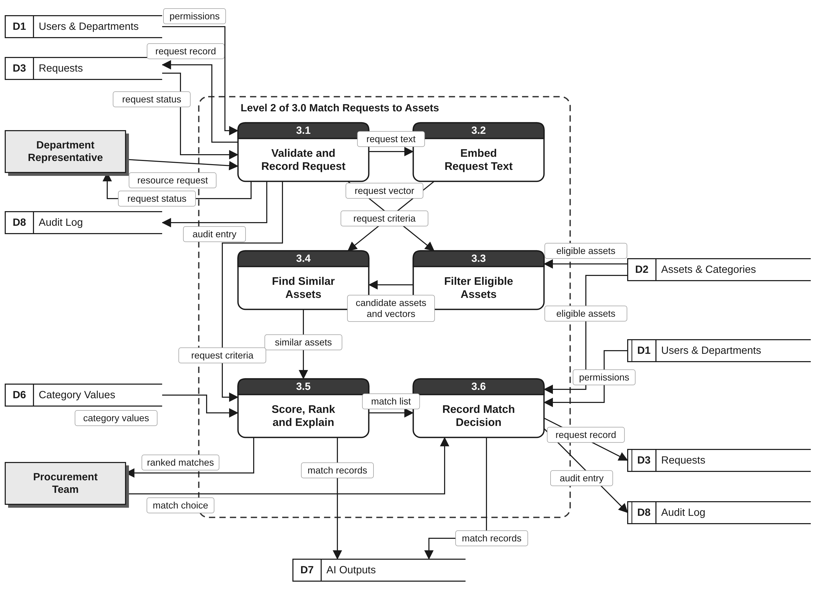
Figure 2-10: Level 2 of process 3.0

Table 2-5 balances Level 2 against the flows of 3.0 on Level 1: all 11 flows appear with the same names and directions, and no new external flow is added. The flows between 3.1 and 3.6 (request text, request criteria, request vector, candidate assets and vectors, similar assets and match list) are internal to 3.0.
Table 2-5: Balancing Level 2 against process 3.0
Level 1 flow of 3.0 | From or to | Direction | Level 2 process | OK
resource request | Department Representative | in | 3.1 | Yes
request status | Department Representative | out | 3.1 | Yes
match choice | Procurement Team | in | 3.6 | Yes
ranked matches | Procurement Team | out | 3.5 | Yes
eligible assets | D2 Assets & Categories | in | 3.3, 3.6 | Yes
category values | D6 Category Values | in | 3.5 | Yes
request status | D3 Requests | in | 3.1 | Yes
request record | D3 Requests | out | 3.1, 3.6 | Yes
match records | D7 AI Outputs | out | 3.5, 3.6 | Yes
permissions | D1 Users & Departments | in | 3.1, 3.6 | Yes
audit entry | D8 Audit Log | out | 3.1, 3.6 | Yes

2.5 Rule Checks
Prepared by: Mohamed Almarzooqi
Table 2-6 counts the inputs and outputs of each Level 1 process, including the common flows. Every process has at least one input and one output, so there is no black hole (input with no output) and no miracle (output with no input). We also checked each output against the inputs it needs to avoid grey holes: for example, ranked matches from 3.0 need the request (resource request, request status), the assets (eligible assets) and the cost and carbon values (category values), and all three reach 3.0. Every flow has a process at one end or both, so no data moves directly from store to store.
Table 2-6: Inputs and outputs of each Level 1 process
ID | Process | Inputs | Outputs | Has input and output | Outputs derivable
1.0 | Manage Accounts and Access | 4 | 5 | Yes | Yes
2.0 | Register and Publish Assets | 5 | 6 | Yes | Yes
3.0 | Match Requests to Assets | 6 | 5 | Yes | Yes
4.0 | Approve and Transfer Assets | 7 | 7 | Yes | Yes
5.0 | Maintain and Retire Assets | 9 | 6 | Yes | Yes
6.0 | Report and Measure Impact | 14 | 11 | Yes | Yes
7.0 | Assist Users in Conversation | 6 | 4 | Yes | Yes

Counts include the common flows: one input (permissions from D1) and one output (audit entry to D8).

3. Architecture
Prepared by: Mohamed Almarzooqi

3.1 How We Chose
Prepared by: Mohamed Almarzooqi
Each major choice below is recorded as a decision record. A record gives the driver (the requirements that force a choice), at least two real options, the choice and why ("because"), what we give up, how we checked the choice and the links to the rest of the design. The checks are design walkthroughs and calculations done on this design; they are not test results of running software. Table 3-1 lists the six records.
Table 3-1: Decision records
ID | Decision | Choice
DR-1 | How to split the system | Modular monolith with an AI gateway (AIGateway) and a background worker
DR-2 | Application stack | Django and MySQL (Phase 2 stack)
DR-3 | Where to keep and search text vectors | MySQL table plus in-memory search with NumPy
DR-4 | Language model and where data goes | Hosted Claude Haiku 5.5 through the gateway, no personal data
DR-5 | Background jobs | Django-Q2 with the database as the queue
DR-6 | Hosting | One Linux virtual machine in the UAE with Docker Compose

3.2 Decision Records
Prepared by: Mohamed Almarzooqi
Table 3-2: DR-1 How to split the system
Driver | Many business areas (FR-1 to FR-13) built by four students in three-week phases on one server; records must stay correct when several users act at once (QUA-4); standard functions must keep working when AI is down (PER-6).
Options | A. Modular monolith: one Django project, one app per business module, one database; the AI services sit behind AIGateway inside the same code base, and slow AI jobs run in a separate worker process.  B. Service-oriented: the same modules, but the AI part is a separate Python web service called over HTTP. Microservices were also considered and ruled out at once: a team of four cannot run and monitor many services.
We choose | A, modular monolith.
Because | Django and the AI libraries are both Python, so the AI part needs no separate service to use its own language. One database lets an approval, its reservation and its audit entry commit in one transaction (FR-4.5, FR-7.A6). The worker gives the AI work its own process, so a slow embedding job never blocks a web page.
We give up | Scaling the AI part on its own machine; module borders are kept by our rules (Section 3.4) rather than by the network; a fault in the web process stops all modules until it restarts.
Verify | Change walk: moving the AI services to a separate service later changes only AIGateway, because no module calls an AI service directly (Rule 3). Result: 1 component changes.  Failure walk: with the worker and the AI Provider both stopped, each of UC-1 to UC-13 still has a working path (form, standard search or standard report) through the fallbacks in Table 4-1. Result: 13 of 13.
Links | Figure 3-1, Figure 13-1, Section 4; QUA-4, QUA-5, PER-6

Table 3-3: DR-2 Application stack
Driver | Sign-in, password, session and permission rules (SEC-1 to SEC-6); safe input handling (SEC-13); reservations that never double-book (FR-4.5); the Phase 2 plan and skills [5].
Options | A. Django (Python) with MySQL and server-rendered pages, the Phase 2 stack.  B. Node.js with a React single-page front end and Firebase as the database.
We choose | A, Django and MySQL.
Because | Django provides hashed passwords, sessions, permission checks, forms with validation, protection against cross-site request forgery and safe database queries [6], which cover most of SEC-2 to SEC-6 and SEC-13 without custom security code. MySQL transactions and row locks let the final approval recheck and reserve units safely (FR-4.5). Python lets us use the embedding library directly. Phase 2 costed and planned this stack.
We give up | The smoother page updates of a single-page React app; Firebase live updates for notifications (a page refresh or a short poll shows new notifications within the five minutes FR-7.N3 allows).
Verify | Mapping check: each of SEC-1 to SEC-6 and SEC-13 maps to a named Django feature or a stated design rule in Table 6-6. Result: 7 of 7 mapped.
Links | Section 6; Figure 13-2; SEC-1 to SEC-6, SEC-13, FR-4.5

Table 3-4: DR-3 Where to keep and search text vectors
Driver | Matching must find assets by meaning (FR-8.1) and return within the AI time limit (PER-4) for a prototype of at least 100 assets (PER-1); we plan for up to 5,000.
Options | A. Store each 384-number vector in a MySQL table and compare vectors in memory with NumPy.  B. Move to PostgreSQL with the pgvector extension, or add a separate vector database.
We choose | A, MySQL table and NumPy.
Because | At 5,000 assets all vectors fit in 7.68 MB of memory and one comparison is about 1.9 million multiplications, a few milliseconds on a normal CPU. We keep one database (DR-2) and nothing new to run, back up or secure.
We give up | Indexed search for very large catalogues. Above about 100,000 assets we would move to option B.
Verify | Arithmetic: 5,000 assets x 384 numbers x 4 bytes = 7,680,000 bytes; 5,000 x 384 = 1,920,000 multiplications per search. Both are far inside the 2-second budget we set for ranking (Table 4-1).
Links | Section 2.4 (3.4 Find Similar Assets), Section 14, ASSET_EMBEDDING in Section 15; FR-8.1, PER-4

Table 3-5: DR-4 Language model and where data goes
Driver | Classification must read titles, descriptions and photos (FR-9.1); the assistant and AI reports need fluent text (FR-11, FR-12); no names, university IDs or e-mail addresses may be sent (SEC-11), and no personal data may leave the UAE until university IT confirms (LEG-3, TBD-9).
Options | A. A hosted model, Claude Haiku 5.5 [7], called only through AIGateway with a field allow-list.  B. An open model run on our own server.  C. No language model: rule-based templates only.
We choose | A, with C kept as the fallback for every feature.
Because | Haiku 5.5 accepts text and images, costs about AED 0.37 per million input tokens and AED 1.84 per million output tokens for prompts up to 100,000 tokens [7] (converted at the fixed rate of AED 3.6725 per US dollar), and needs no graphics card, which our budget does not include. At an estimated 2,000 AI calls a month (3,000 tokens in and 500 out each) the cost is about AED 4 a month. The gateway sends only the asset and request fields listed in Section 16.2 and removes e-mail addresses, university ID patterns and the names of registered users from free text, so no personal data is sent. Matching uses the local model (DR-3), so most AI work never leaves the server.
We give up | Independence from an outside service (covered by the fallbacks); a small running cost; model retirements by the provider. Phase 2 costed Claude Haiku 4.5, which the provider now lists as a legacy model, so the design uses Haiku 5.5 and records the model version with every output (AI-5).
Verify | Allow-list check: none of the six request schemas in Section 16.2 has a name, university ID or e-mail field. Result: 0 of 6 schemas carry personal fields.  Change walk: switching to another provider changes only the provider adapter inside the gateway. Result: 1 component changes.
Links | Section 4, Section 16.2, DPIA in Section 6.7; SEC-11, LEG-3, AI-5, TBD-9

Table 3-6: DR-5 Background jobs
Driver | Embedding on save, retries, notification retries (FR-7.N5), expiry checks and reminders (FR-3.9, FR-7.N6), nightly backup (SAF-8) and weekly monitoring (Section 19) must run without a user waiting.
Options | A. Celery with a Redis server as the queue.  B. Django-Q2 using the existing MySQL database as the queue [8].
We choose | B, Django-Q2.
Because | It needs no extra server to run, secure and back up; queued jobs survive a restart because they are stored in the database; it has retries and scheduled jobs built in.
We give up | The higher job throughput of Redis. Our load is a few hundred small jobs a day for five users at a time (PER-1), which the database handles easily.
Verify | Job list check: all seven job types (embed asset, embed request, AI retry, notification retry, expiry and reminder checks, nightly backup, weekly monitoring) are low volume and none needs an answer within one second.
Links | Figure 13-2; SAF-8, FR-3.9, FR-7.N5

Table 3-7: DR-6 Hosting
Driver | Personal data stays in the UAE (LEG-3); daily backups and a 60-minute restore (SAF-8, QUA-6); a university IT review before real data (ORG-1); 99% availability during testing (QUA-5).
Options | A. One Linux virtual machine in a UAE data center or on university servers, running the containers with Docker Compose.  B. A hosted platform service in a data center outside the UAE.
We choose | A, one UAE virtual machine.
Because | We control where the data and the backups are kept, the whole system starts with one command, and the same files can be given to university IT for review.
We give up | Automatic scaling and managed updates; we apply operating-system updates and renew the TLS certificate ourselves.
Verify | Restore walk: the restore steps in Section 6.5 rebuild the system from the last backup in an estimated 35 minutes, inside the 60-minute target; the weekly restore test measures the real time.
Links | Section 6.5, Figure 13-2; LEG-3, SAF-8, QUA-5, QUA-6, ORG-1

3.3 Architecture View
Prepared by: Mohamed Almarzooqi
Figure 3-1 shows the architecture. It has four layers (presentation, application, AI and analytics, and data), a security column that applies to every layer and the outside systems ReSource integrates with. The eight components named in the project description are numbered (1) to (8) on the figure.
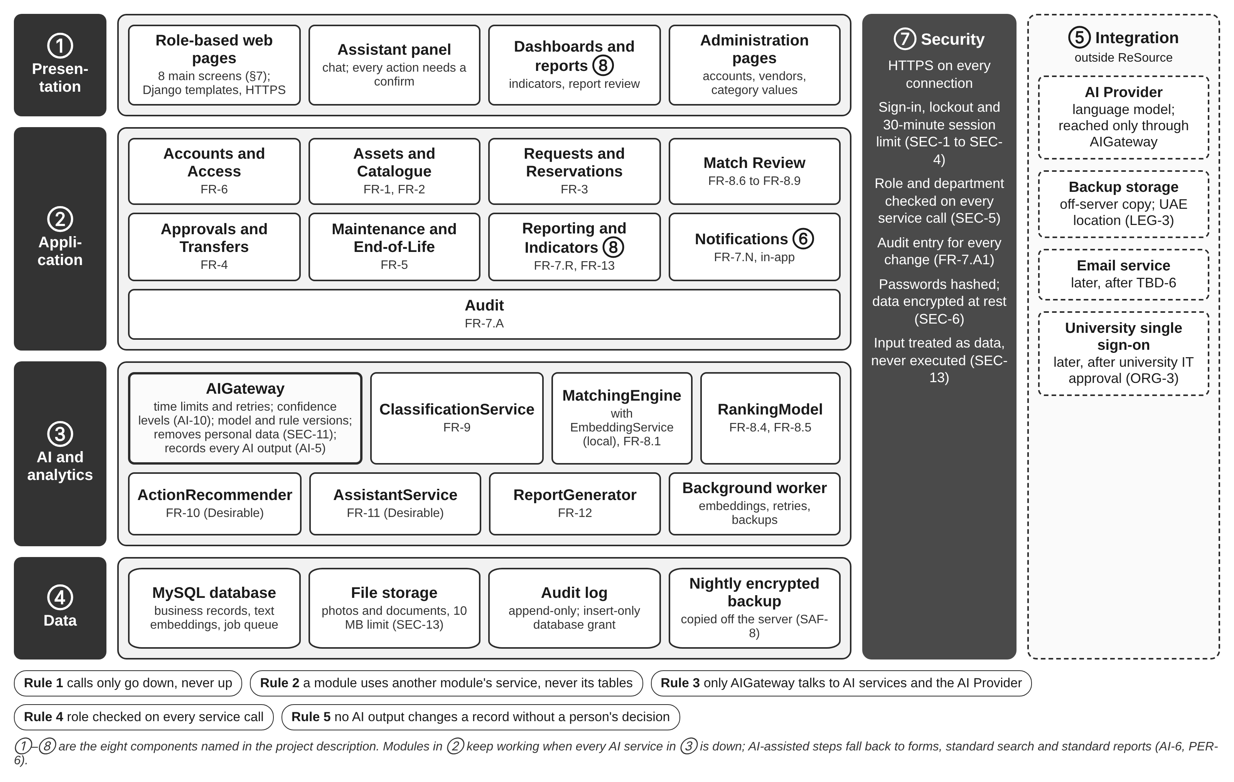
Figure 3-1: Architecture view

Table 3-8: Components
Component | Contents | Requirements | When AI is down
(1) Presentation | Role-based web pages (Django templates), the assistant panel, dashboards and administration pages; keyboard use and 200% zoom [9] | QUA-1 to QUA-3 | Pages show the standard form or list and an "AI unavailable" note
(2) Application | Nine business modules: Accounts and Access, Assets and Catalogue, Requests and Reservations, Match Review, Approvals and Transfers, Maintenance and End-of-Life, Reporting and Indicators, Notifications, Audit | FR-1 to FR-8, FR-13, BR-1 to BR-12 | Unchanged; every module works without AI (PER-6)
(3) AI and analytics | AIGateway; classification, semantic matching, ranking, sustainable-action recommender, assistant and report generator; background worker | FR-8 to FR-12, AI-1 to AI-10 | Gateway returns "unavailable" within 20 s or at once when the service is marked down
(4) Data | MySQL database (business records, text vectors, job queue), file storage, append-only audit log, nightly encrypted backup | FR-7.A, SAF-8, SEC-6 | Unchanged
(5) Integration | AI Provider; off-server backup storage; later the e-mail service (TBD-6) and university single sign-on (ORG-3) | LEG-3, SAF-8 | Provider down: fallbacks in Table 4-1
(6) Notification | In-application notifications created after each committed event, with retry | FR-7.N1 to FR-7.N6 | Unchanged
(7) Security | HTTPS, sign-in and lockout, role and department checks on every call, audit entries, encryption, input handling | SEC-1 to SEC-13 | Unchanged
(8) Reporting | Standard reports and the nine indicators calculated by fixed formulas; AI report review | FR-7.R, FR-12, FR-13 | Standard reports and indicators replace the AI report (FR-12.11)

3.4 How the Parts Communicate
Prepared by: Mohamed Almarzooqi
Five rules keep the module borders and make the AI part replaceable. Rule 1: calls only go down: a layer may call any layer below it, never one above it. Rule 2: a module uses another module through its service interface and never reads or writes the other module's tables directly. Rule 3: only AIGateway talks to the AI services and the AI Provider. Rule 4: the role and department are checked on every service call, not only on the page. Rule 5: no AI output changes a business record without a decision by an authorized person (BR-9, SAF-2).
Table 3-9: Communication paths
From | To | How | Example
Web pages | Module services | Direct Python call in the same request; HTTPS from the browser | Request form calls submit (Requests and Reservations)
Assistant panel | AIGateway | Synchronous call, 20 s limit (pattern A); the only page that calls AIGateway | A question in the Conversational Interaction screen
Module service | Another module | Service interface call (Section 16.1) | approve (Approvals and Transfers) calls reserve (Assets and Catalogue)
Module service | AIGateway | Synchronous call, 20 s limit (pattern A) | Match Review asks AIGateway to rank a request
Module service | Worker | Job placed in the queue (patterns B and C) | Assets and Catalogue queues "embed asset" after a save
AIGateway | AI Provider | HTTPS API call with the field allow-list | Classification text, report draft
Any module | Notifications, Audit | Audit entry in the same transaction; notification after commit | Approval writes its audit entry, then notifies

8. Use Case Diagram
Prepared by: Mohamed Almarzooqi
Figure 8-1 is the use case diagram from the Phase 3 document [4]; the 13 use cases and the actors have not changed. Table 8-1 shows where each use case is designed in this document, so a reader can follow one use case from the data flow to the screen.
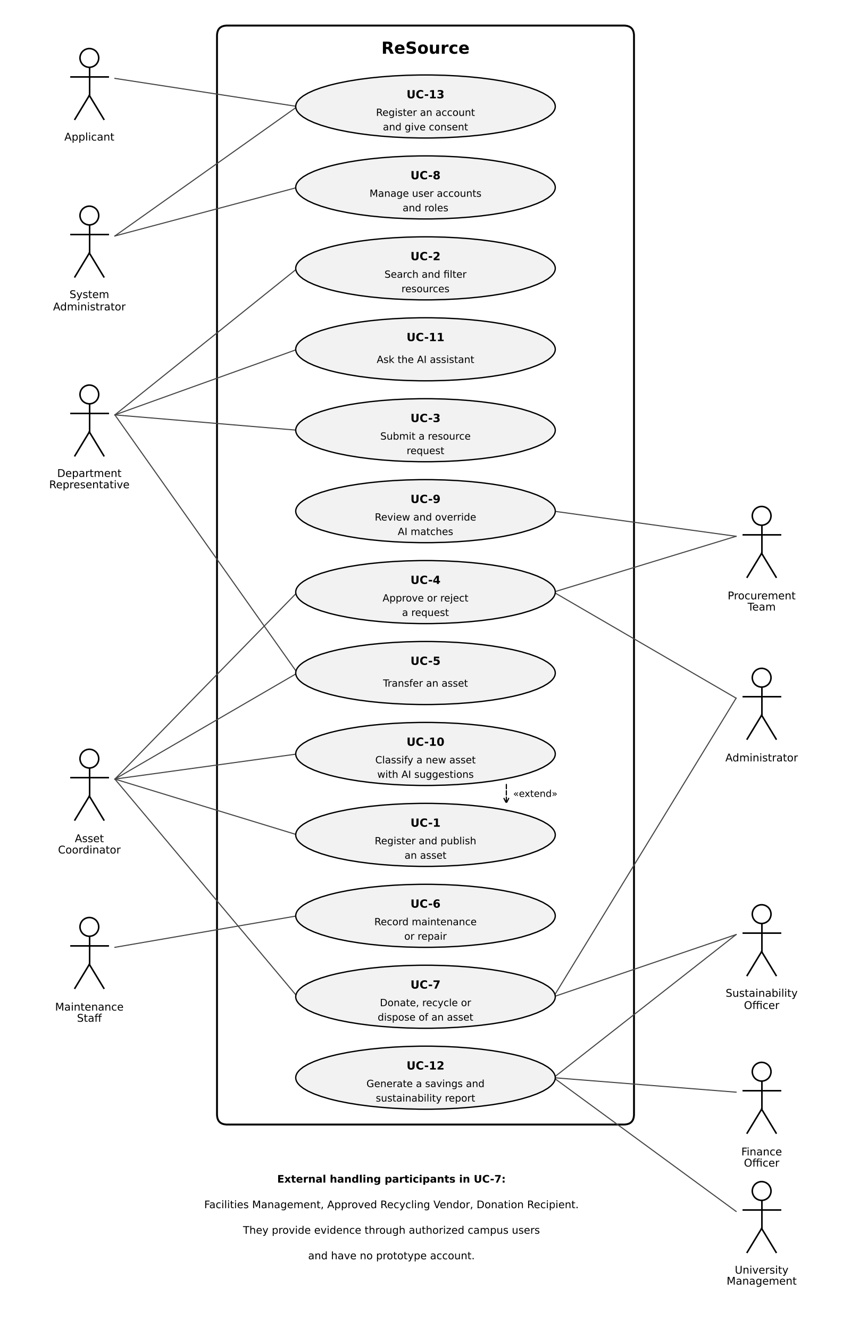
Figure 8-1: Use case diagram
Table 8-1: Where each use case is designed
Use case | DFD process | Class | Sequence | Activity | State | Mockup
UC-1 Register and Publish an Asset | 2.0 | 9.1, 9.3 | 10.3 | 11.1 | 12.1 | 7.1
UC-2 Search and Filter Resources | 2.0 | 9.1 | 10.7 | 11.1 | 12.1 | 7.2
UC-3 Submit a Resource Request | 3.0 (Level 2) | 9.1 | 10.6, 10.7 | 11.1 | 12.3 | 7.2
UC-4 Approve or Reject a Request | 4.0 | 9.2 | 10.1 | 11.1 | 12.3, 12.4 | 7.4
UC-5 Transfer an Asset | 4.0 | 9.2 | 10.2 | 11.2 | 12.1, 12.4 | -
UC-6 Record Maintenance or Repair | 5.0 | 9.2 | 10.9 | 11.3 | 12.2, 12.5 | 7.5
UC-7 Donate, Recycle or Dispose of an Asset | 5.0 | 9.2, 9.4 | 10.10 | 11.3 | 12.2, 12.6 | 7.5
UC-8 Manage User Accounts and Roles | 1.0 | 9.1, 9.4 | 10.8 | - | - | -
UC-9 Review and Override AI Matches | 3.0 (Level 2) | 9.3 | 10.4 | 11.1, 14 | 12.3 | 7.3
UC-10 Classify a New Asset with AI Suggestions | 2.0 | 9.3 | 10.3 | 11.1 | - | 7.1
UC-11 Use the AI Assistant | 7.0 | 9.3 | 10.6 | - | - | 7.8
UC-12 Generate a Savings and Sustainability Report | 6.0 | 9.3, 9.4 | 10.5 | - | - | 7.6, 7.7
UC-13 Register an Account and Give Consent | 1.0 | 9.1 | 10.8 | - | - | -

Every use case has classes in Section 9 and at least one sequence diagram in Section 10. UC-8 and UC-13 have no activity or state diagram because their steps are short; Figure 10-9 shows them in full.

10. Sequence Diagrams

10.8 Register and Activate an Account (UC-13, UC-8)
Prepared by: Mohamed Almarzooqi
An application is saved only with consent and with a university ID and email that are not already used (FR-6.1, FR-6.2) and waits in Pending (FR-6.3). The System Administrator either refuses it with a reason, which closes the account, or activates it and assigns the role and department (FR-6.8); each outcome is notified to the applicant.
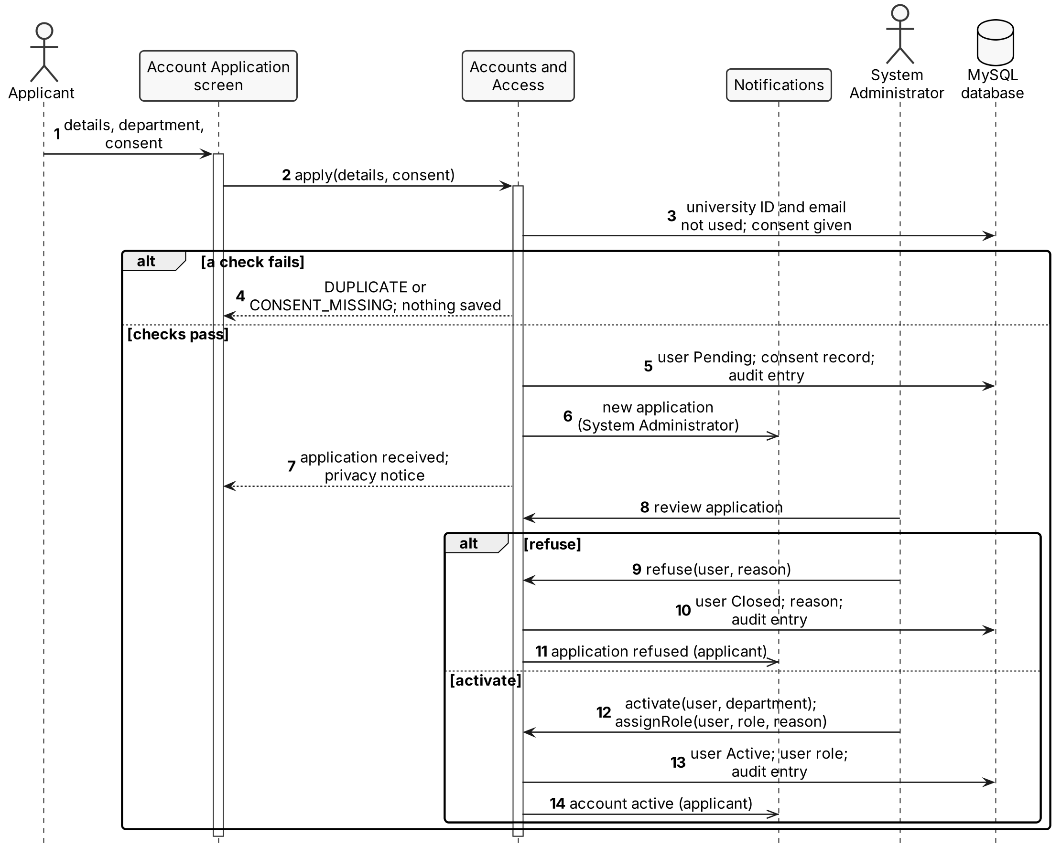
Figure 10-9: Register and activate an account

13. Component and Deployment Diagrams
Prepared by: Mohamed Almarzooqi

13.1 Component Diagram
Prepared by: Mohamed Almarzooqi
Business modules offer their operations through module service interfaces (Section 16.1) and require four shared interfaces: AccessCheck, AuditLog, Notify and AIService. Only AIGateway requires ProviderAPI. Replacing an AI service or the AI Provider therefore touches only the AI and analytics package (DR-1, DR-4).
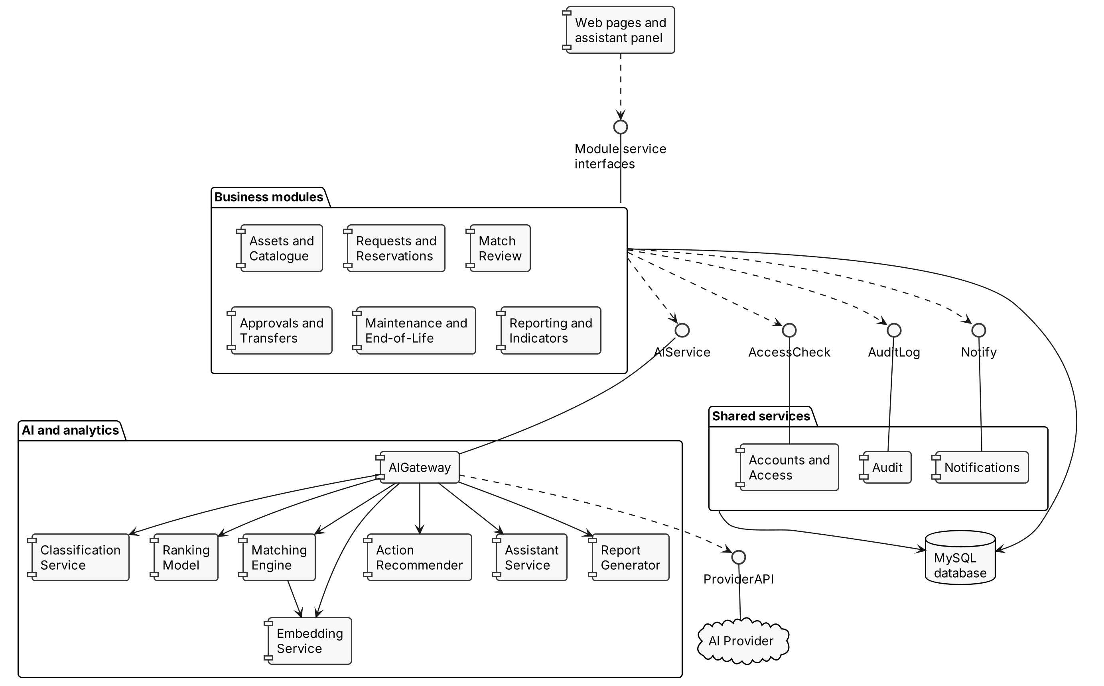
Figure 13-1: Component diagram

Appendix A: Requirement-to-Design Traceability
Prepared by: Mohamed Almarzooqi
Table A-1 traces each requirement group of the Phase 3 document [4] to the parts of this design that meet it.
Table A-1: Traceability from requirements to design
Requirements | DFD | Architecture and AI | Detailed design | Screens
FR-1 Asset registration | 2.0, D2 | Table 3-8 | 9.1, 10.3, 11.1, 12.1, 15, 16.1 | 7.1
FR-2 Publication and search | 2.0, D2 | Table 3-8 | 9.1, 10.3, 10.7, 12.1, 16.1 | 7.2
FR-3 Requests and reservations | 3.0, D3, Level 2 | Table 3-8 | 9.1, 10.6, 10.7, 11.1, 12.3, 16.1 | 7.2, 7.8
FR-4 Approvals and transfers | 4.0, D4 | Section 5 (H-4 to H-7) | 9.2, 10.1, 10.2, 11.1, 11.2, 12.4, 15, 16.1 | 7.4
FR-5 Maintenance and life cycle | 5.0, D5 | Section 5 (H-8, H-9) | 9.2, 10.9, 10.10, 11.3, 12.2, 12.5, 12.6, 15, 16.1 | 7.5
FR-6 Accounts and access | 1.0, D1 | Section 6 | 9.1, 10.8, 15, 16.1 | -
FR-7 Notifications, reports, audit | 6.0, D8, D9 | Sections 3.3, 6.3 | 9.4, 10, 15, 16.1 | 7.6, 7.7
FR-8 Matching and ranking | 3.0, Level 2, D7 | Table 4-1 | 9.3, 10.4, 14, 15, 16.2, 17 | 7.2, 7.3
FR-9 Classification | 2.0, D7 | Table 4-1, Section 4.2 | 9.3, 10.3, 16.2 | 7.1
FR-10 Sustainable actions | 5.0 | Table 4-1 | 9.3, 10.10, 11.3, 16.2 | 7.5
FR-11 Assistant | 7.0 | Table 4-1 | 9.3, 10.6, 16.2 | 7.8
FR-12 AI reports | 6.0, D9 | Table 4-1, H-10 | 9.3, 10.5, 16.2 | 7.6, 7.7
FR-13 Indicators | 6.0, D6, D9 | Table 3-8 | 9.4, 15, 18 | 7.6
AI-1 to AI-10 | D7 | Sections 4, 5 | 9.3, 14, 16.2, 17, 19 | All
PER-1 to PER-6 | - | DR-3, DR-5, Table 4-1 | 13.2 | AI-down states
SAF-1 to SAF-9 | 5.0 | Section 5, Table 6-5 | 10.2, 10.10, 11.3, 12.2 | 7.5
SEC-1 to SEC-13 | D1, D8 | Section 6, DR-2, DR-4 | 13, 15 | -
QUA-1 to QUA-15 | - | DR-1, Section 6.5 | 17, 19 | All
BR-1 to BR-12 | 4.0, 5.0 | Section 5, Table 6-2 | 10, 11, 12 | 7.4
LEG-1 to LEG-9 | - | DR-4, DR-6, Section 6.7 | 17.1 | 7.3
ORG-1 to ORG-4 | - | DR-6, Section 6.7 | - | Sample data only

ORG-4 is met outside the document: each member commits their own work to the course GitHub repository.

AI Contributions

Mohamed Almarzooqi
Prepared by: Mohamed Almarzooqi
I used an AI assistant (Claude, Anthropic) to help draw the context and data-flow diagrams, the architecture view (Section 3), the account sequence diagram (Section 10.8) and the component diagram (Section 13.1) from my design, and to check the flows, data stores and use case mapping against the Phase 2 and Phase 3 reports. I wrote the section content, chose the architecture options and reviewed every figure.

References
[1] University, "Intelligent, AI-Powered Circular Campus Resource Exchange and Asset Life Cycle Management System," COSC 336 Introduction to Software Engineering project description, University, Abu Dhabi, UAE, Fall 2026.
[2] University, "Phase 4: Architecture Design," COSC 336 lab slides, University, Abu Dhabi, UAE, Fall 2026.
[3] University, "Phase 4 & 5: Design Document, Sequence, ER and Class Diagrams," COSC 336 lab slides, University, Abu Dhabi, UAE, Fall 2026.
[4] R. Alzaabi, M. Alsuwaidi, A. AlAbdouli and M. Almarzooqi, "ReSource Phase III: Requirements Document," COSC 336, University, Abu Dhabi, UAE, Oct. 2026.
[5] R. Alzaabi, M. Alsuwaidi, A. AlAbdouli and M. Almarzooqi, "ReSource Phase II Feasibility Study," COSC 336, University, Abu Dhabi, UAE, Sep. 2026.
[6] Django Software Foundation, "User authentication in Django," Django documentation. [Online]. Available: https://docs.djangoproject.com/en/stable/topics/auth/
[7] Anthropic, "Models overview," Claude Platform Docs, 2026. [Online]. Available: https://platform.claude.com/docs/en/about-claude/models/overview
[8] Django Q2 project, "Brokers," Django Q2 documentation. [Online]. Available: https://django-q2.readthedocs.io/en/stable/brokers.html
[9] World Wide Web Consortium, "Web Content Accessibility Guidelines (WCAG) 2.2," W3C Recommendation, Dec. 2024. [Online]. Available: https://www.w3.org/TR/WCAG22/
[10] Sentence Transformers, "all-MiniLM-L6-v2," model card, Hugging Face. [Online]. Available: https://huggingface.co/sentence-transformers/all-MiniLM-L6-v2
[11] N. Reimers and I. Gurevych, "Sentence-BERT: Sentence embeddings using Siamese BERT-networks," in Proc. 2019 Conf. Empirical Methods in Natural Language Processing (EMNLP-IJCNLP), Hong Kong, 2019, pp. 3982-3992.
[12] OWASP Foundation, "OWASP Top 10:2025," 2025. [Online]. Available: https://owasp.org/Top10/2025/
[13] United Arab Emirates, Federal Decree-Law No. 45 of 2021 Concerning the Protection of Personal Data, 2021. [Online]. Available: https://uaelegislation.gov.ae/en/legislations/1972
[14] J. Platt, "Probabilistic outputs for support vector machines and comparisons to regularized likelihood methods," in Advances in Large Margin Classifiers, A. Smola et al., Eds. Cambridge, MA, USA: MIT Press, 1999, pp. 61-74.
[15] U.S. Environmental Protection Agency, "Documentation chapters for greenhouse gas emission, energy and economic factors used in the Waste Reduction Model (WARM)," WARM version 16, Dec. 2023. [Online]. Available: https://www.epa.gov/warm/documentation-chapters-greenhouse-gas-emission-energy-and-economic-factors-used-waste

