Introduction to Software Engineering
COSC 336
ReSource (Phases IV and V)
Design Document
Architecture Design and Detailed Design
Intelligent AI-Powered Circular Campus Resource Exchange and Asset Life Cycle Management System
Dr. Ala' Alsamarneh
Dr. Hamdan Alshkeili
Dr. Natnael Takele
Date: 03/11/2026
Prepared by: Group 3
Mohammad Alsuwaidi 100064887

Prepared for:
Head of Facilities Management
Proposed Technical Owner:
University IT Department

Sections in This File
This file contains the parts of the ReSource Phase 4 and 5 Design Document prepared by Mohammad Alsuwaidi (100064887). Section, figure and table numbers are the same as in the combined group document.
- 7. Mockups (section introduction)
- 7.1 Asset Registration
- 7.2 Request Submission
- 7.4 Transfer Approval
- 9. Class Diagrams (section introduction)
- 9.1 Core Domain
- 9.2 Approvals, Transfers and Maintenance
- 10.1 Release and Approve a Request (UC-4)
- 10.2 Transfer an Asset (UC-5)
- 10.7 Search and Request a Listing (UC-2, UC-3)
- 11. Activity Diagrams (section introduction)
- 11.1 From Listing to Approved Request (UC-1 to UC-4, UC-9)
- 11.2 Transfer and Receipt (UC-5)
- 12. State Diagrams (section introduction)
- 12.1 Asset
- 12.3 Request
- 12.4 Approval and Transfer
- 15. Entity Relationship Diagram
- 16. Interface Contracts (section introduction)
- 16.1 Module Operations
- AI Contributions

7. Mockups
Prepared by: Mohammad Alsuwaidi
The eight screens below are the ones listed in the project description. Each screen shows the role, real fields with sample data, the AI result with its confidence and reason, the decision the person takes and the state shown when the AI is unavailable. Numbered markers on each screen point to these five parts: (1) AI result, (2) confidence, (3) reason, (4) human decision and (5) AI-down state. Table 7-1 summarizes the screens.
Table 7-1: Mockup screens
Screen | Role | Use case | AI result shown | Human decision | AI-down state | Requirements
7.1 Asset Registration | Asset Coordinator, Electrical Engineering | UC-1, UC-10 | Category, tags and description suggestions with confidence and reason | Accept, edit or reject each field | Fields stay empty; choose from the list | FR-1.2, FR-9.1 to FR-9.9
7.2 Request Submission | Department Representative, Physics | UC-3, UC-2 | Existing listings that may meet the need, with fit score and reason | Request a listing or submit an open need | Standard search, results not ranked | FR-3.2, FR-3.3, FR-3.13, FR-8.1
7.3 Recommendation Review | Procurement Team | UC-9 | Ranked matches, factor values, confidence, explanation | Select, choose another or reject with a reason | Keyword and rule matches, not ranked | FR-8.3 to FR-8.9, LEG-9
7.4 Transfer Approval | Administrator | UC-4 | Match score and reasons that led to the request | Approve or reject with a reason | Approval works; AI details hidden | FR-4.2 to FR-4.6
7.5 Maintenance Tracking | Maintenance Staff | UC-6, UC-7 | Sustainable-action suggestion with confidence and estimates | Record results; propose or reject the action | No suggestion; manual review | FR-5.4 to FR-5.12, FR-10
7.6 Sustainability Dashboard | Sustainability Officer | UC-12 | AI highlights of large changes | Review indicators and request a report | Indicators shown, no highlights | FR-13.1 to FR-13.12, FR-12.8
7.7 AI Report Review | Finance Officer | UC-12 | AI report draft with a figure check and assumptions | Approve, edit or discard | Standard report opens | FR-12.1 to FR-12.11, BR-11
7.8 Conversational Interaction | Department Representative | UC-11 | Answer with linked listing and a request draft | Confirm, edit or cancel | Assistant unavailable; draft kept | FR-11.1 to FR-11.10

7.1 Asset Registration
Prepared by: Mohammad Alsuwaidi
The Asset Coordinator of Electrical Engineering registers the surplus oscilloscopes. The AI suggestions appear in a separate panel, none is pre-accepted, and each field is accepted, edited or rejected on its own (FR-9.6). The hazard flag is entered by the person, never suggested (FR-1.15).
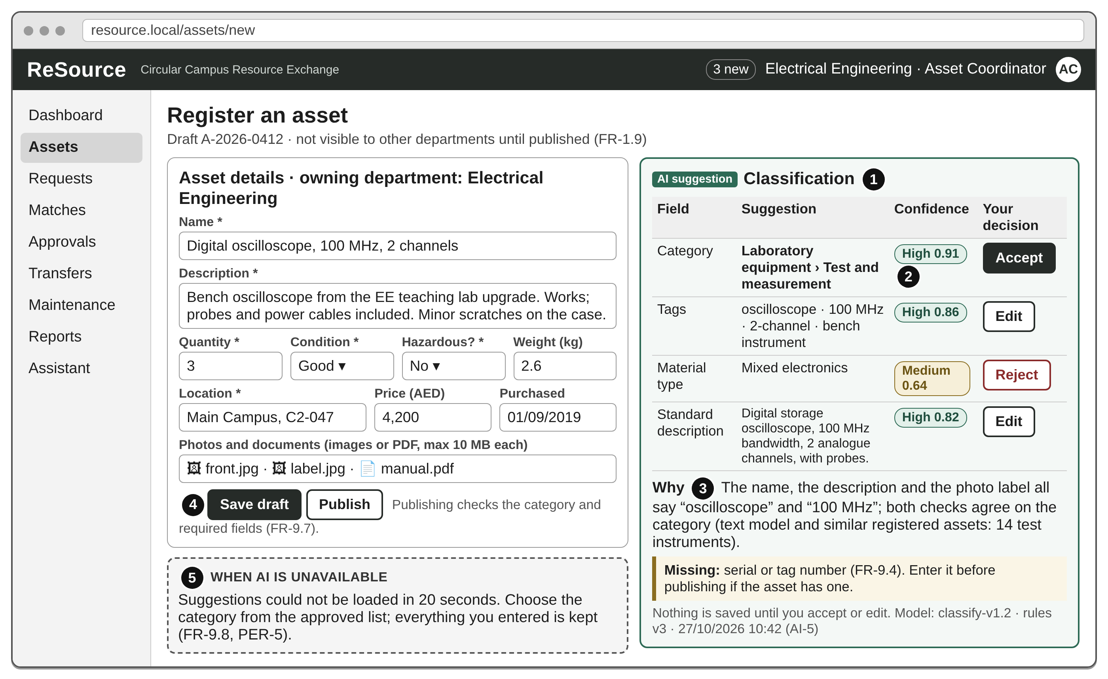
Figure 7-1: Asset Registration screen

7.2 Request Submission
Prepared by: Mohammad Alsuwaidi
A Physics Department Representative describes the need. While typing, the page shows listings that may already meet it, with a fit score, a confidence level and the reason (FR-8.1). The representative can request a listing directly (UC-3) or submit an open need for the Procurement Team (UC-9).
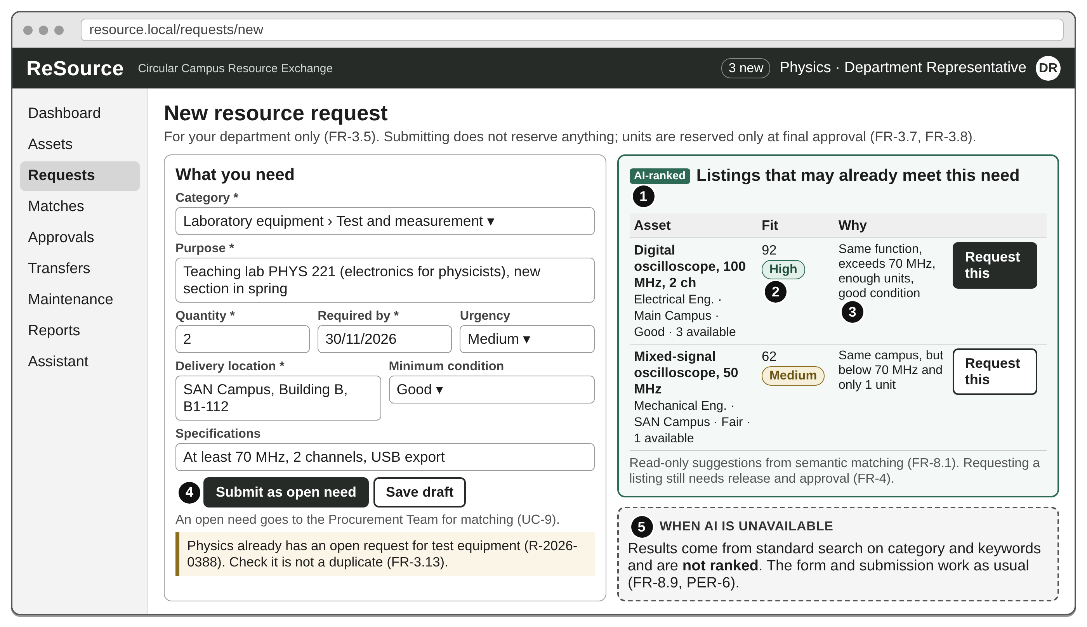
Figure 7-2: Request Submission screen

7.4 Transfer Approval
Prepared by: Mohammad Alsuwaidi
The Administrator approves the request released by the owning Asset Coordinator. The system shows that the quantity has just been rechecked and that the approver did not submit or release the request (FR-4.4, FR-4.5). The AI score is shown as background only; the decision is the approver's.
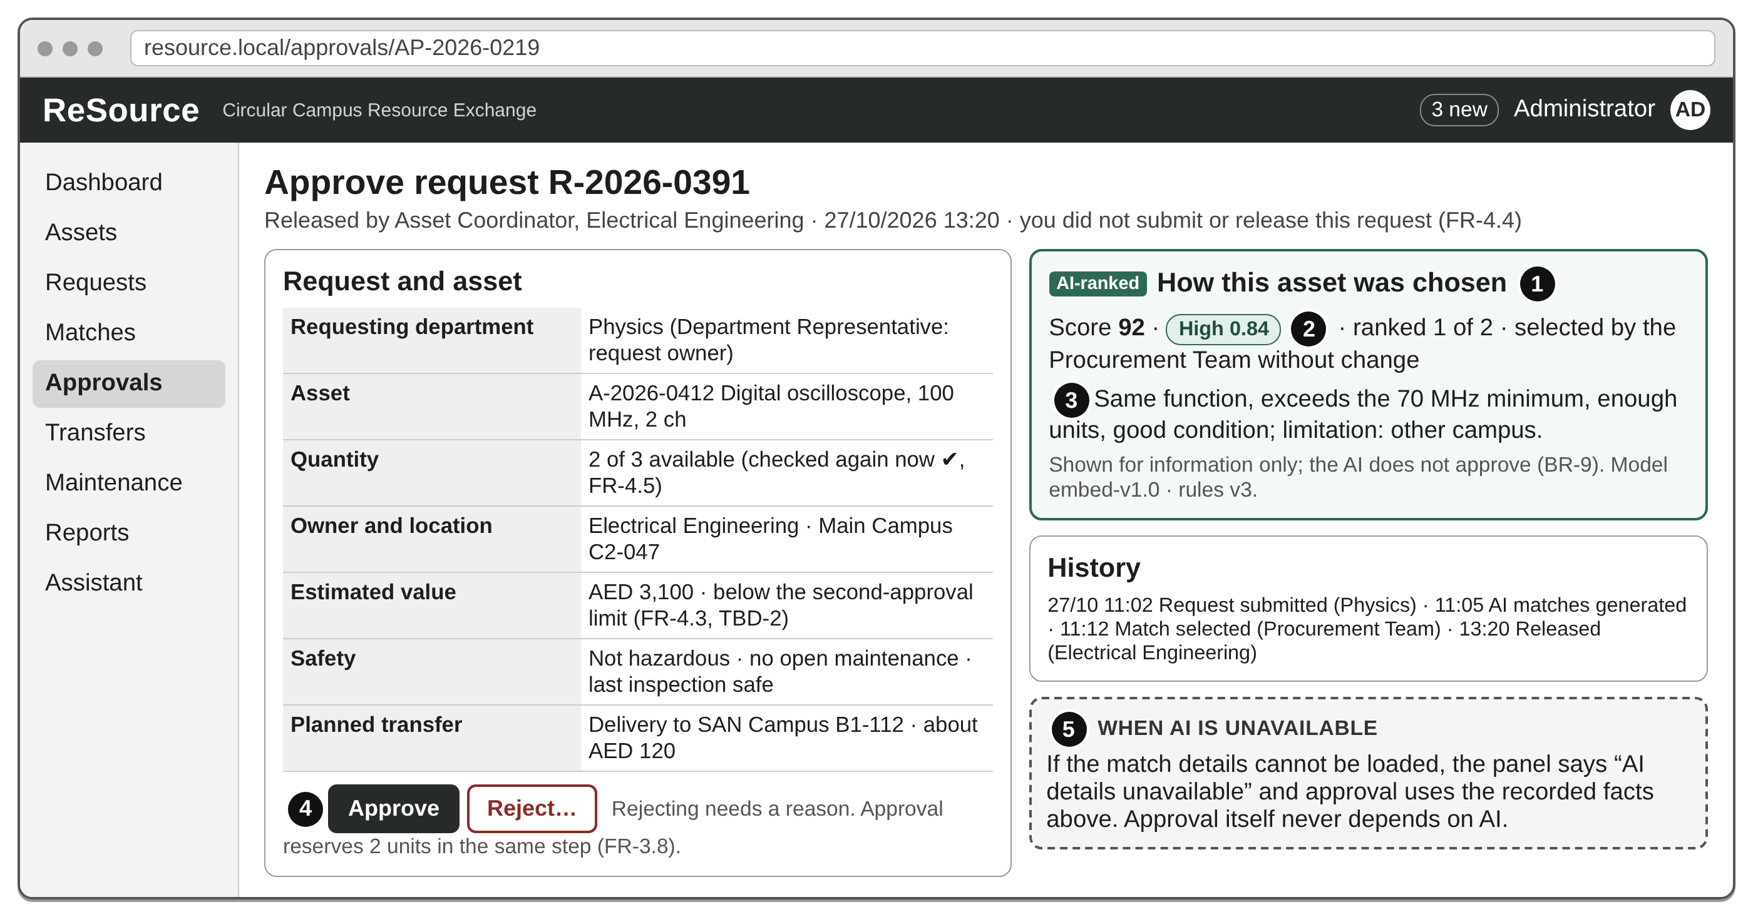
Figure 7-4: Transfer Approval screen

9. Class Diagrams
Prepared by: Mohammad Alsuwaidi
The class model is drawn in six diagrams: the core domain (Figure 9-1); approvals and transfers (Figure 9-2); maintenance and end of life (Figure 9-3); the AI services (Figure 9-4) and the AI records they keep (Figure 9-5); and notifications, audit and sustainability (Figure 9-6). Every association has a name and a multiplicity at both ends; the name is the relationship name used in the ERD (Section 15) and is read in the direction of the small arrow. Every class that a person creates, decides on or receives is linked to User by a named association. Attributes are private (-) and operations public (+); the operations change state and match the transitions in Section 12. A class drawn in more than one diagram is the same class, shown with only the members needed there, and each class has the name of its table in Section 15 (for example Request and REQUEST).

9.1 Core Domain
Prepared by: Mohammad Alsuwaidi
Figure 9-1 shows accounts, the catalogue and requests.
- Aggregation. A Department employs its Users, but a user record survives a department change and a department cannot be deactivated while it has active users (FR-6.9).
- Association class. UserRole records who assigned a role and why (FR-6.8, BR-4). A User gives one or more ConsentRecords, and a withdrawal is a new state of the record, not a deletion (FR-6.2, SEC-8).
- Composition. An Asset owns its Location value and its files (up to 5 photos and 3 documents, so 0..8, FR-1.6); a Request owns its RequestSpecification. The parts are deleted only with their owner.
- Generalization. ITAsset and FurnitureAsset specialize Asset with their own fields. They are stored in the one ASSET table with an asset_kind column (single-table inheritance), so search and matching treat all assets alike.
- Navigability. A Request points to 0..1 Asset: an open need (FR-3.2) has no asset until the Procurement Team selects a match (UC-9).

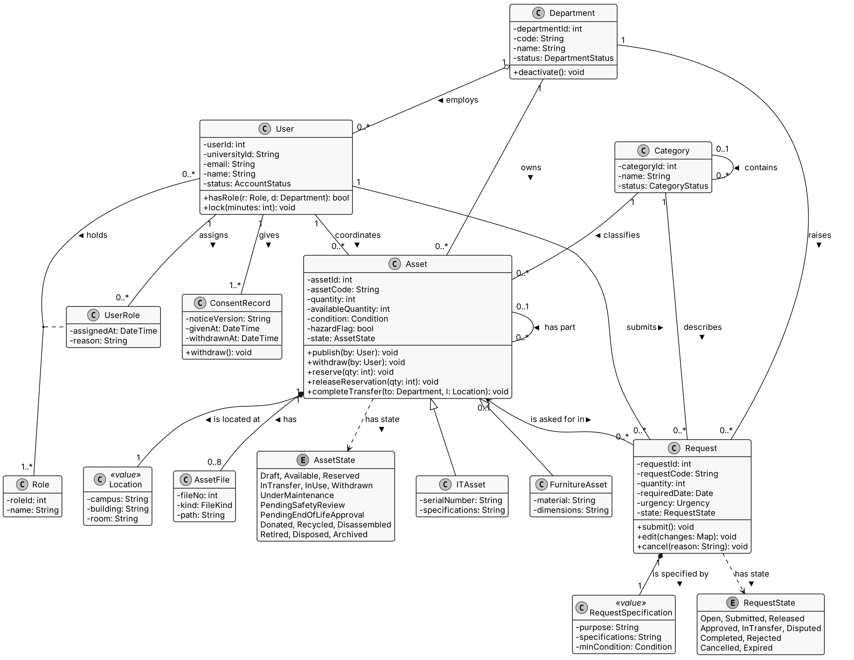
Figure 9-1: Class diagram, core domain

9.2 Approvals, Transfers and Maintenance
Prepared by: Mohammad Alsuwaidi
A Request has 0 to 3 Approvals: release, approval and, when FR-4.3 applies, the second approval. Each Approval is linked to the User who decides it, and Approval.isBy(user) lets the service refuse a person who already filled another stage (FR-4.4). A Reservation exists only after the final approval (BR-5); a Transfer holds up to 5 documents (FR-4.8) and is linked to the User who receives it.
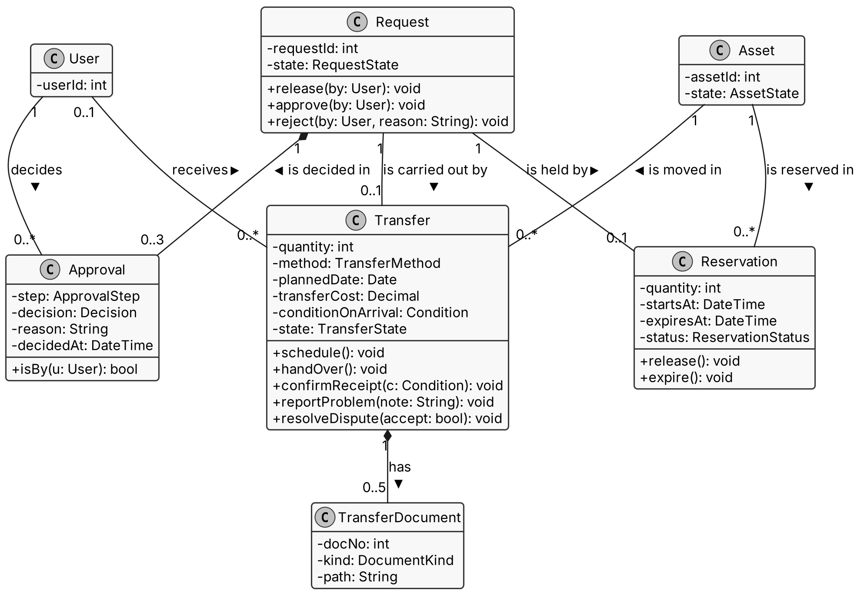
Figure 9-2: Class diagram, approvals and transfers

Inspections, MaintenanceRecords and LifecycleEvents are composed into their owners and have no update operation, because recorded results and life-cycle events cannot be edited (FR-5.18, SEC-12); a mistake is fixed by a new event that corrects the old one. An EndOfLifeProposal is linked to three different Users (proposes, reviews safety of, approves), which is how BR-8 is checked, and to a Vendor only when a vendor handles it; Vendor.isApproved(date) blocks expired vendors (FR-5.25).
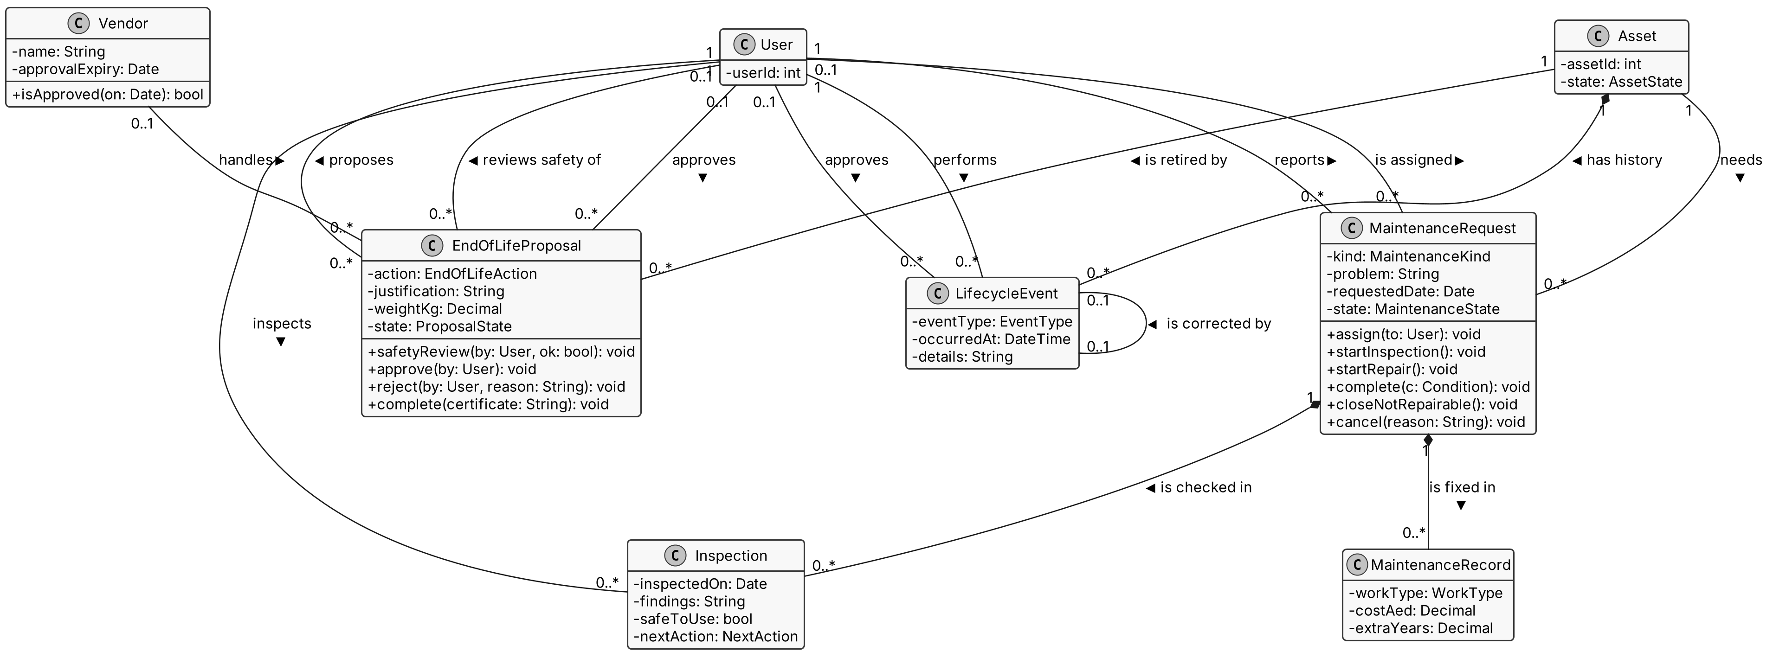
Figure 9-3: Class diagram, maintenance and end of life

10. Sequence Diagrams

10.1 Release and Approve a Request (UC-4)
Prepared by: Mohammad Alsuwaidi
The release and the approval are separate decisions by different people (FR-4.4, BR-4), and each may end the request. A decline or rejection records the reason, closes the request and notifies the requester; nothing else happens after it. When the value is above the limit or unknown, the Procurement Team gives a second approval (Figure 10-2) before any units are reserved (FR-4.3). The final approval locks the asset row, rechecks the units and reserves them in one transaction, so the last unit can never go to two requests (FR-4.5, QUA-4).
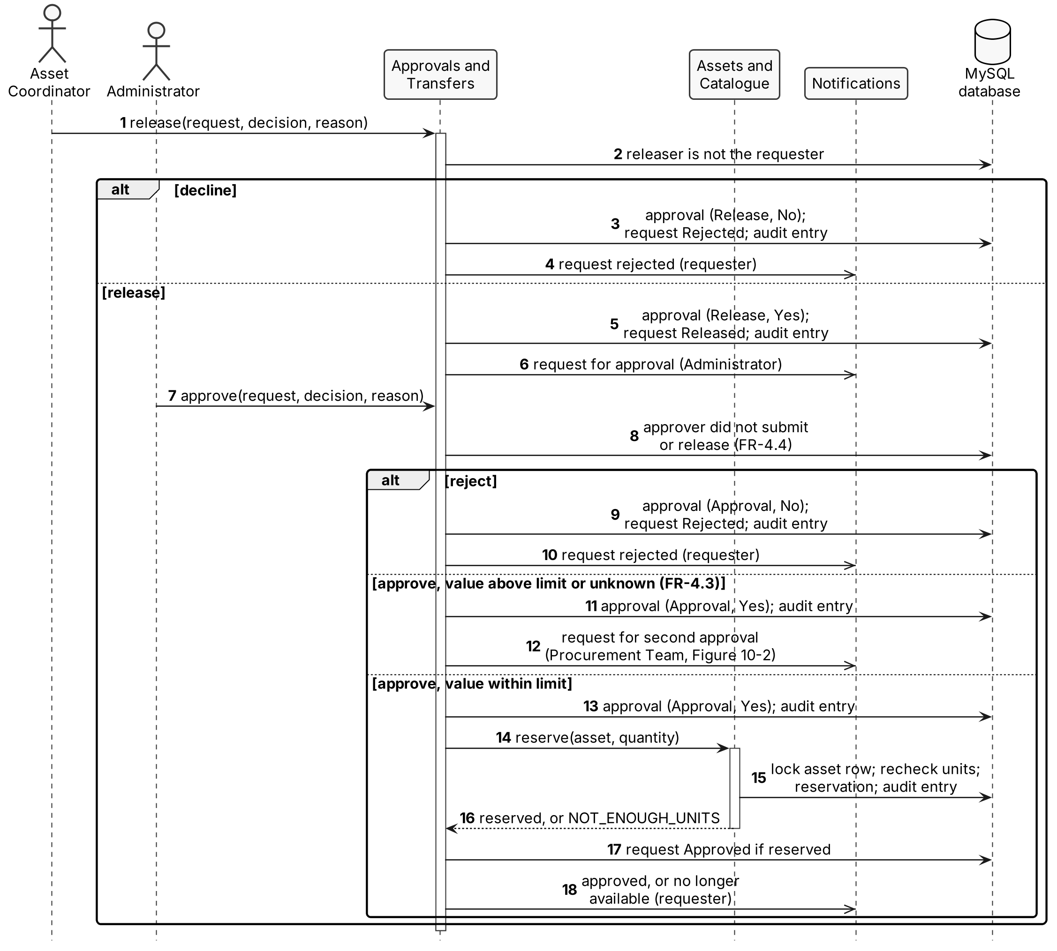
Figure 10-1: Release and approve a request

The second approval is given by a third person, who did not submit, release or approve the request (BR-4). A rejection closes the request; an approval reserves the units exactly as in Figure 10-1.
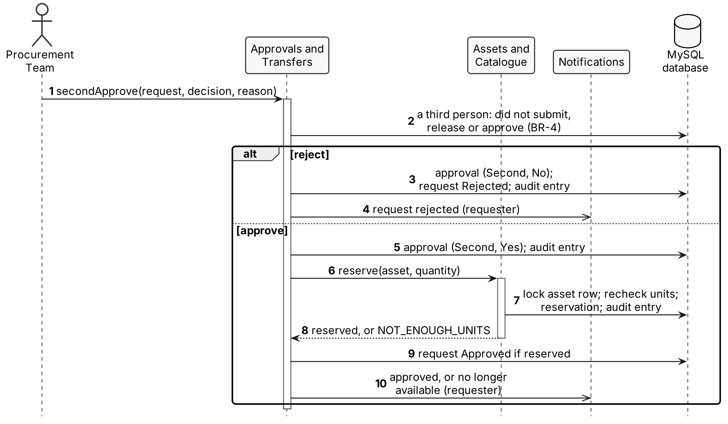
Figure 10-2: Second approval

10.2 Transfer an Asset (UC-5)
Prepared by: Mohammad Alsuwaidi
Handover is blocked for unsafe or uninspected risky assets (FR-4.16, SAF-9), and handling notes are shown to the people involved (SAF-7). Custody, owning department and location change only when receipt is confirmed or the Administrator accepts a disputed transfer (FR-4.11, FR-4.12); a returned asset becomes available again and the request is cancelled.
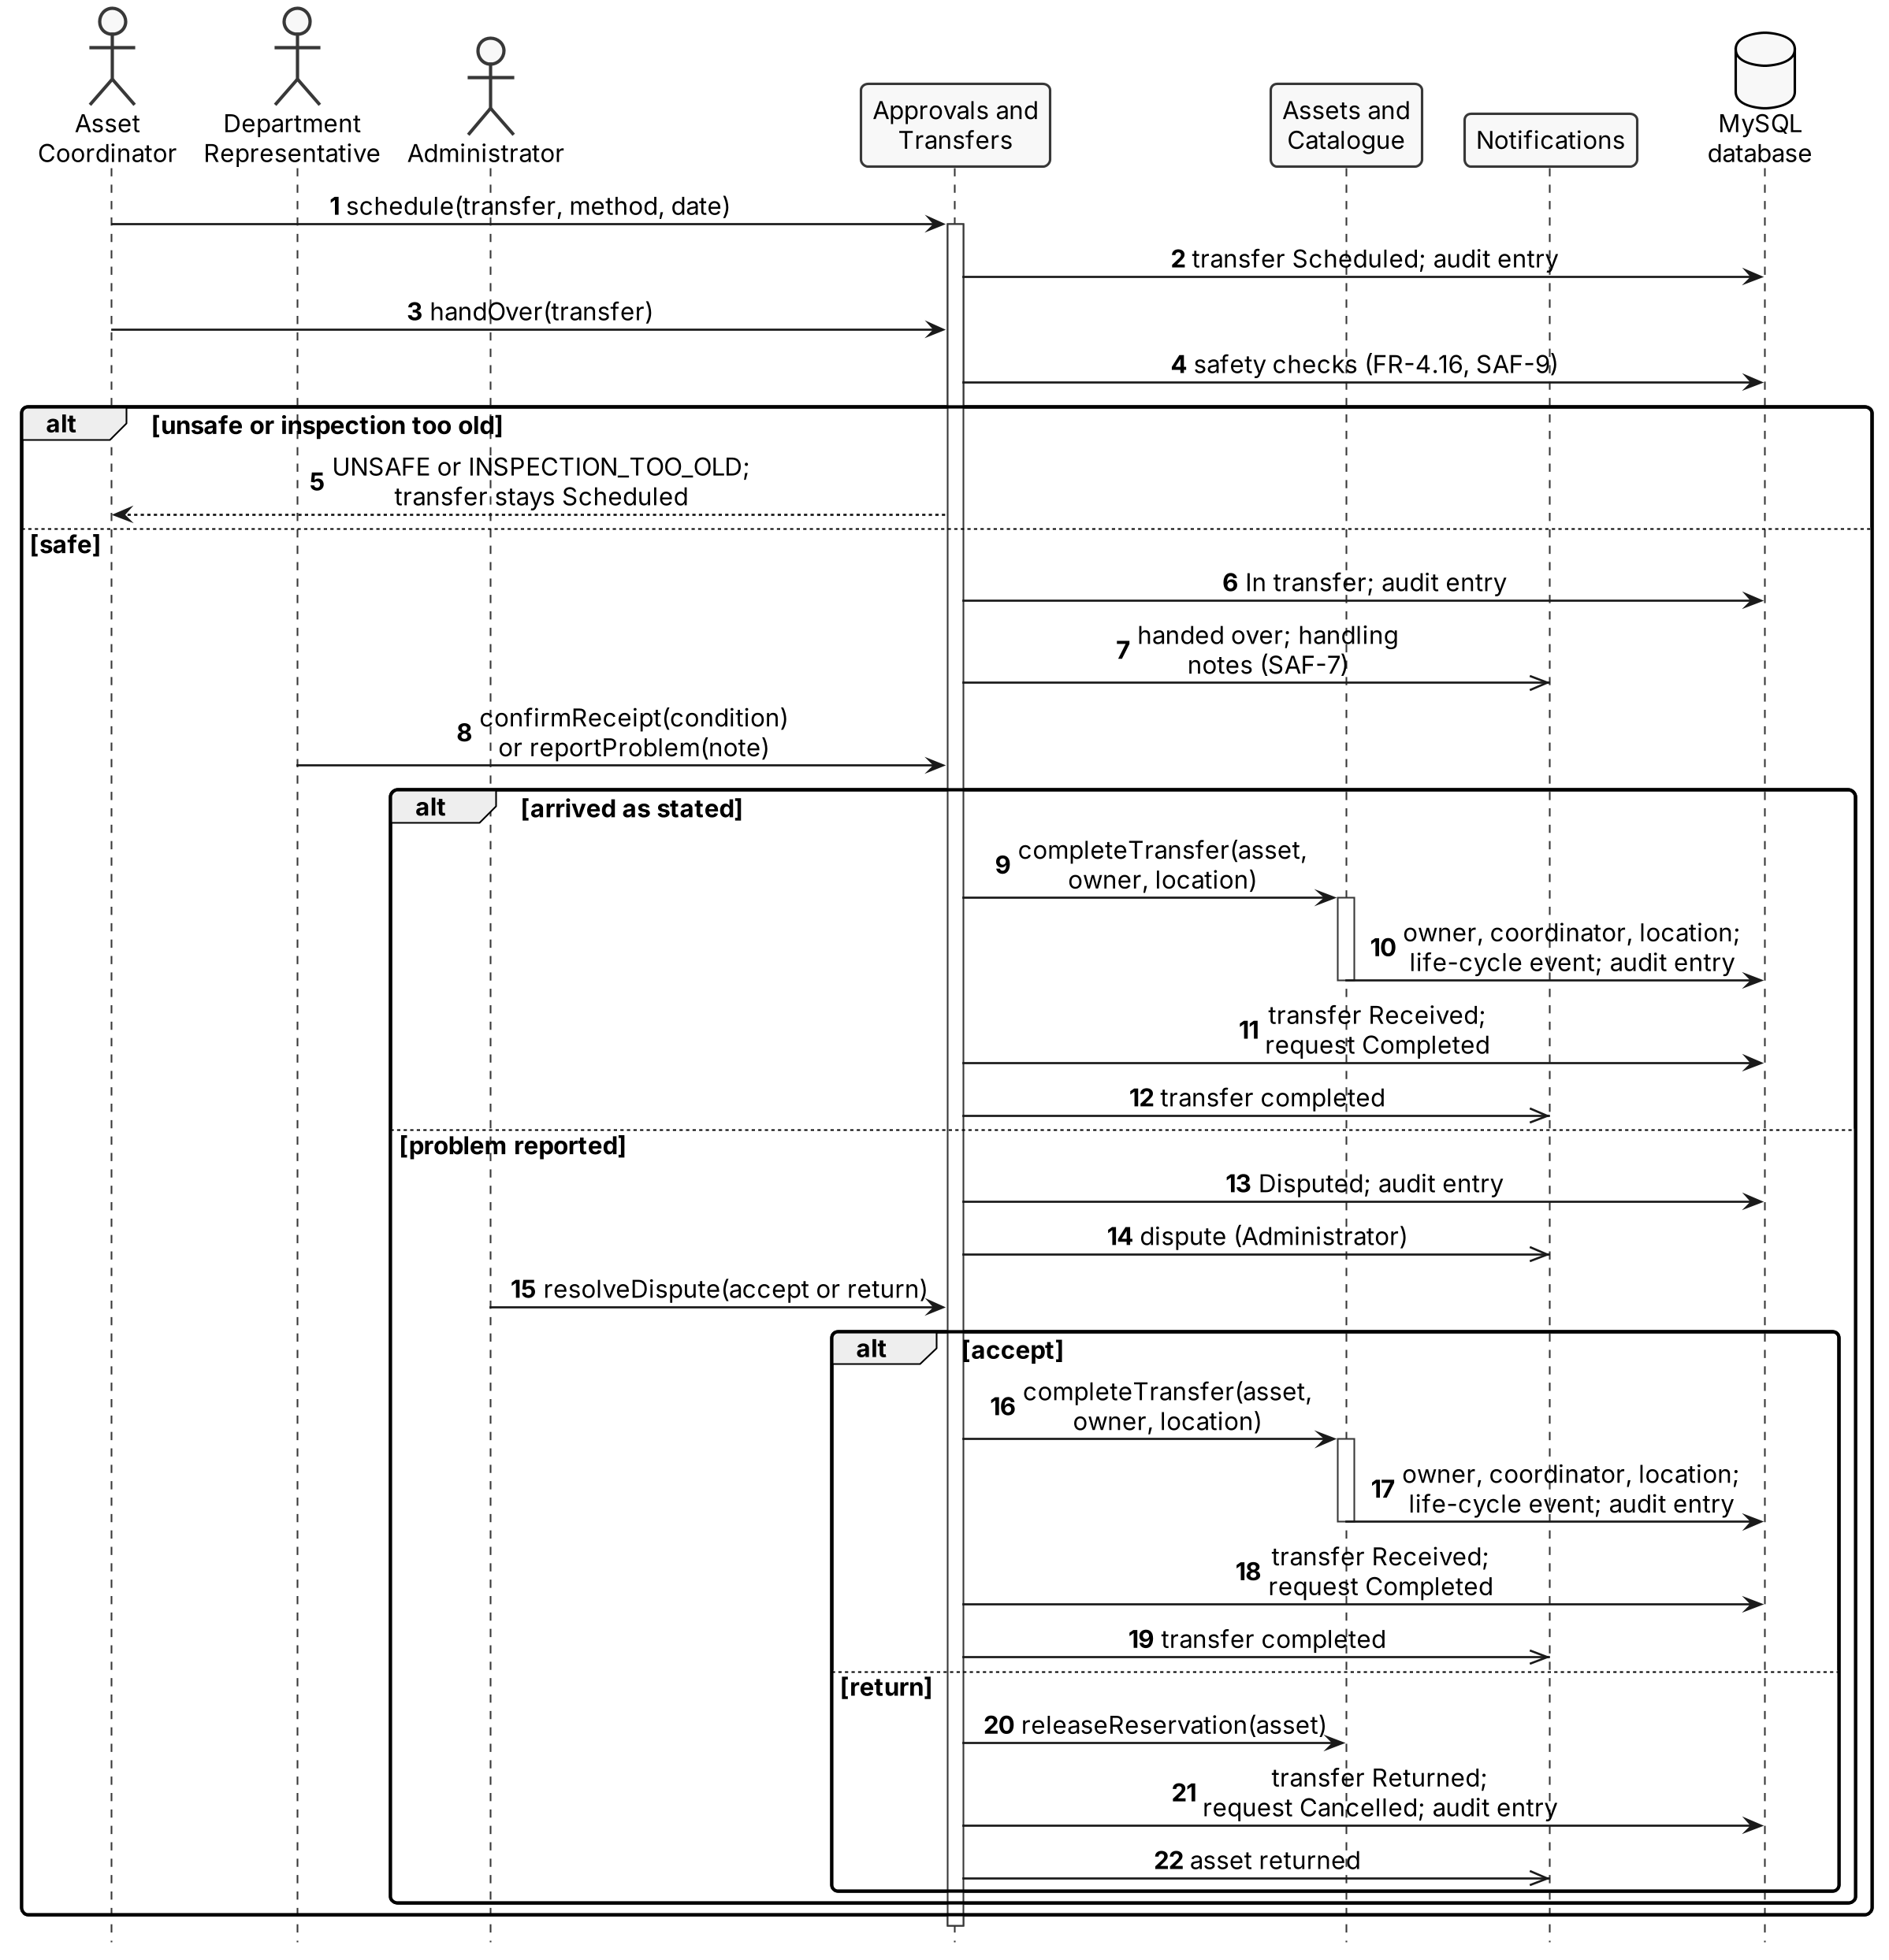
Figure 10-3: Transfer an asset

10.7 Search and Request a Listing (UC-2, UC-3)
Prepared by: Mohammad Alsuwaidi
Search returns only published assets that the user may see (FR-2.2, FR-2.5). A listing that fits is requested directly; every check runs before anything is saved, and a failed check returns its error code. When nothing fits, the user describes the need and it is saved as an open need for matching (FR-3.2).
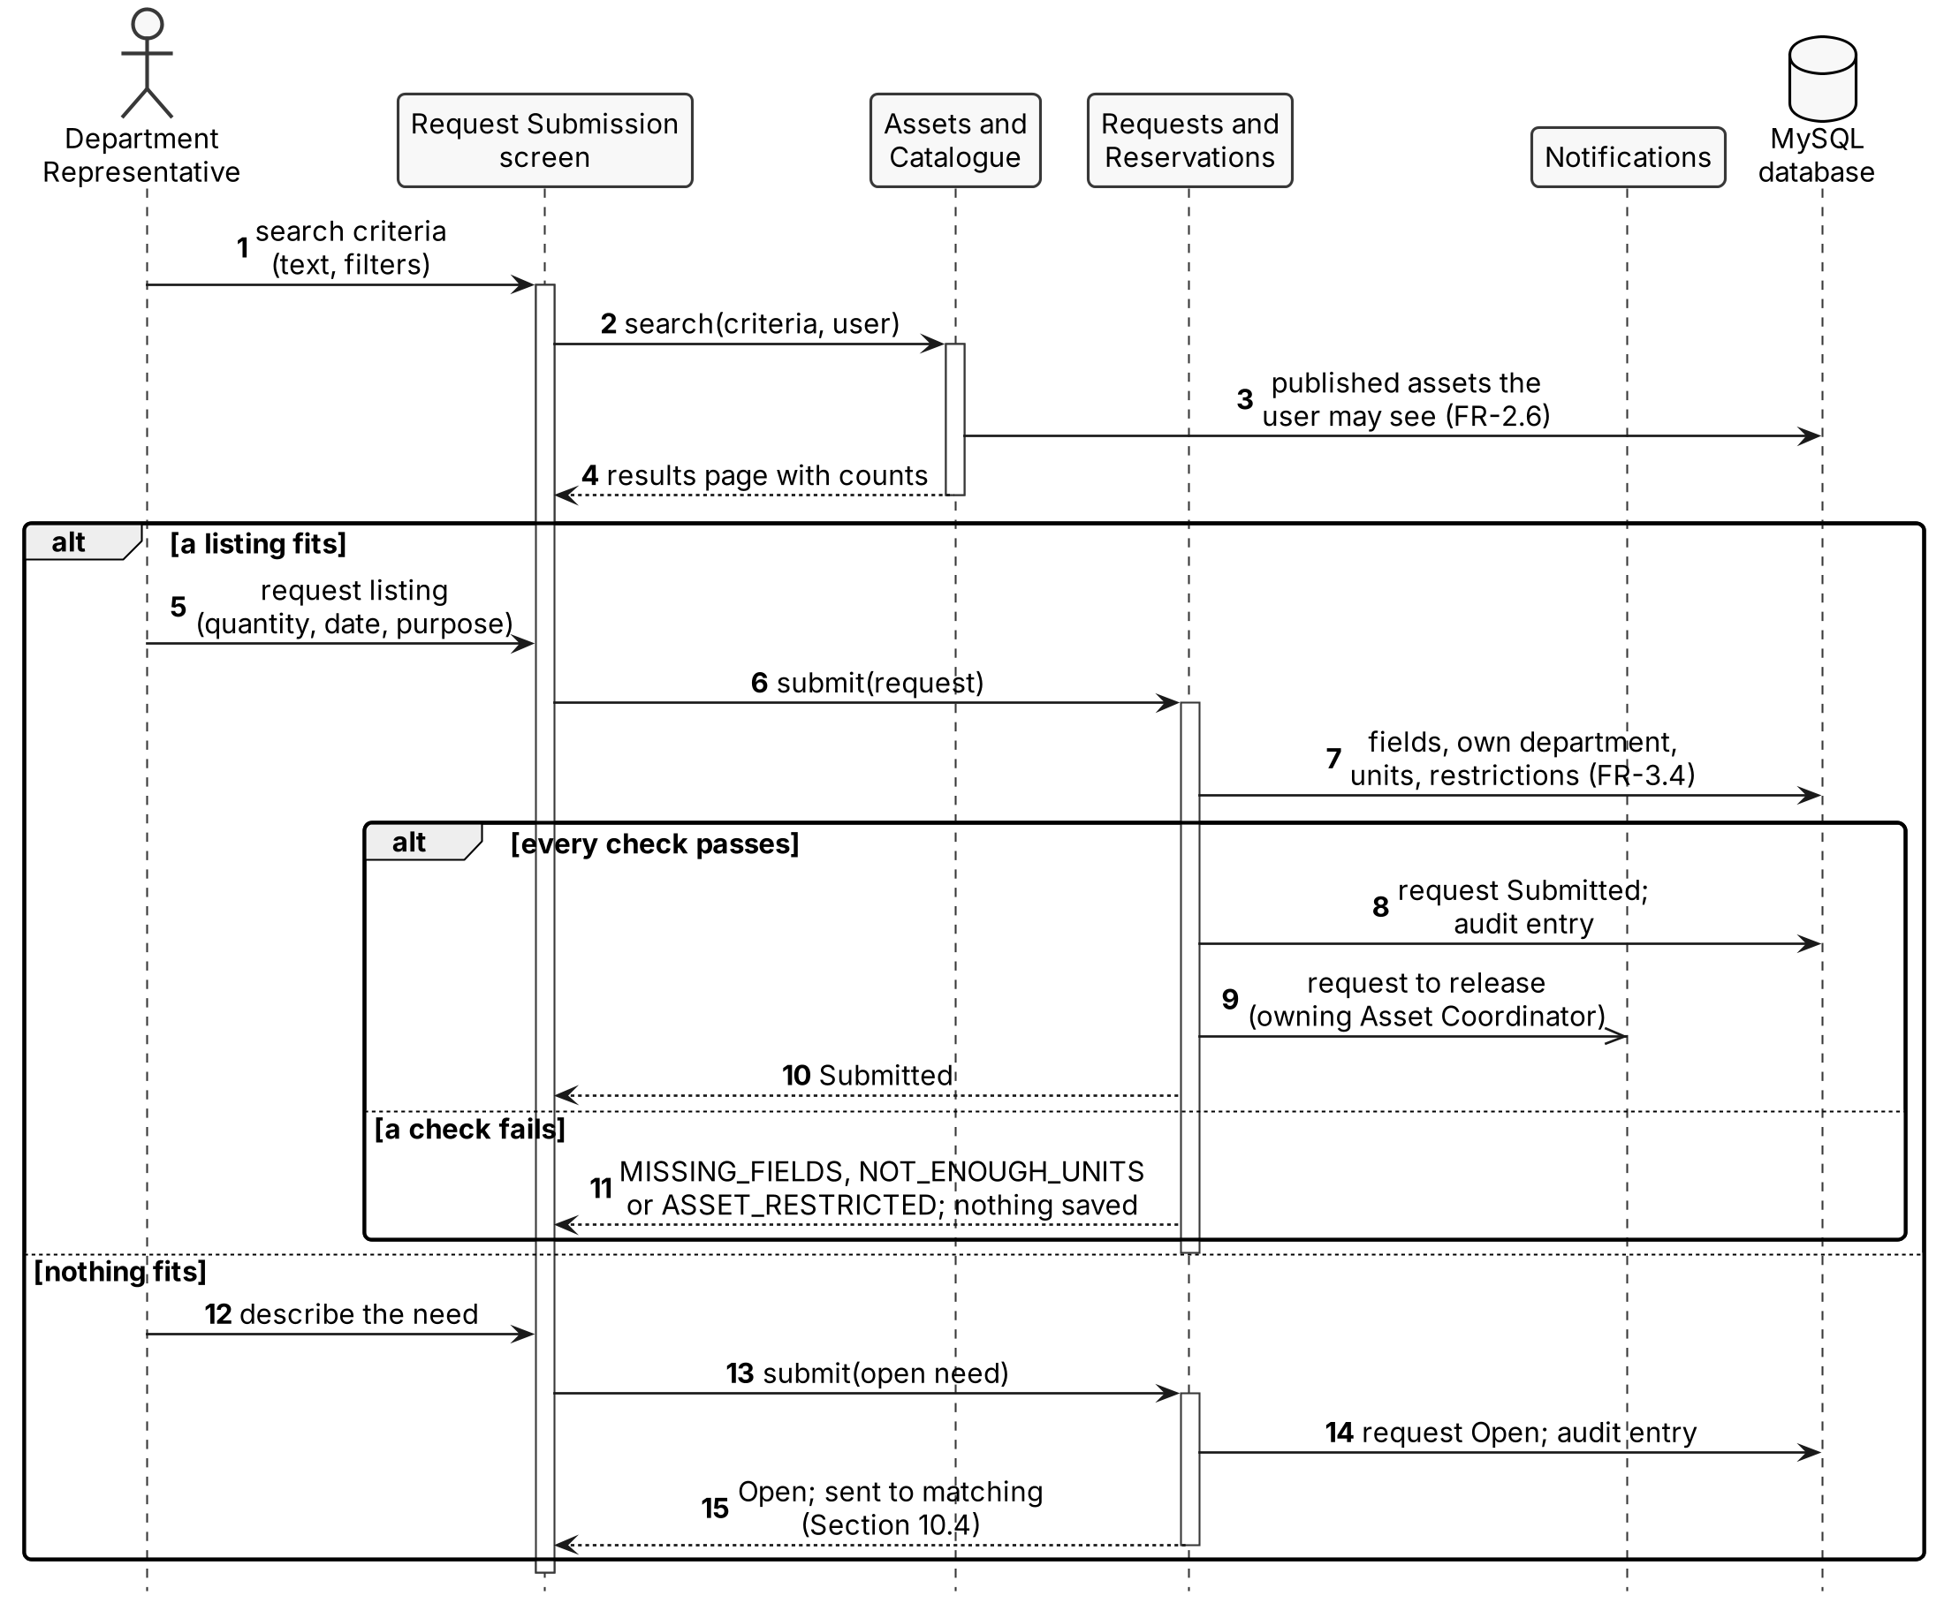
Figure 10-8: Search and request a listing

11. Activity Diagrams
Prepared by: Mohammad Alsuwaidi
Each swimlane is a role or ReSource itself; a diamond is a decision by the person in that lane, and every "no" branch that ends the flow records a reason.

11.1 From Listing to Approved Request (UC-1 to UC-4, UC-9)
Prepared by: Mohammad Alsuwaidi
A listing can be requested directly; an open need goes to the Procurement Team, who choose an AI-ranked match or reject all. Both paths then need release and approval, and units are reserved only after the final recheck (FR-4.5).
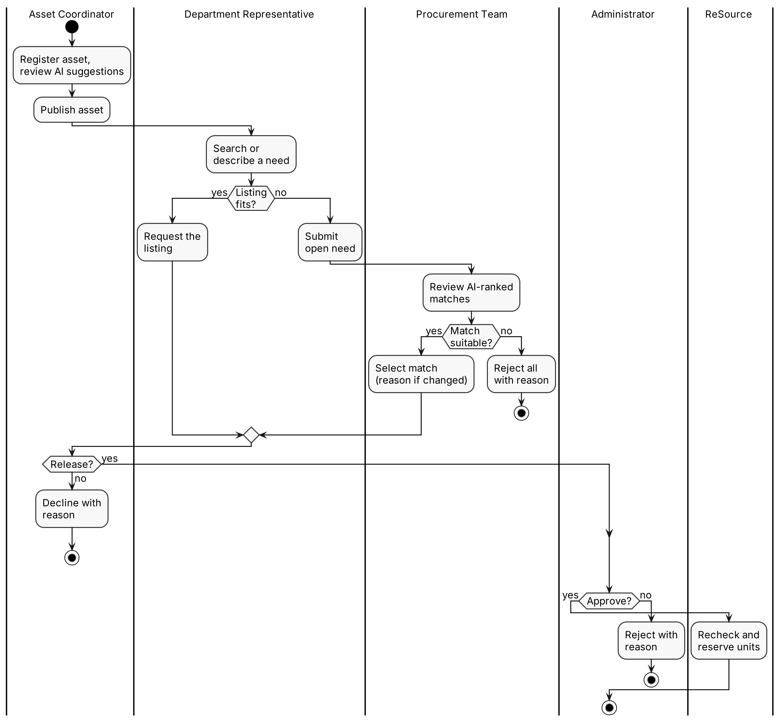
Figure 11-1: Listing to approved request

11.2 Transfer and Receipt (UC-5)
Prepared by: Mohammad Alsuwaidi
After approval, the owning Asset Coordinator schedules and hands over the asset. A problem on arrival goes to the Administrator, who accepts the transfer or returns the asset (FR-4.12). Custody, owner and location change only on a confirmed receipt or an accepted dispute, and only then do the indicators count the reuse (FR-4.11, FR-13.3).
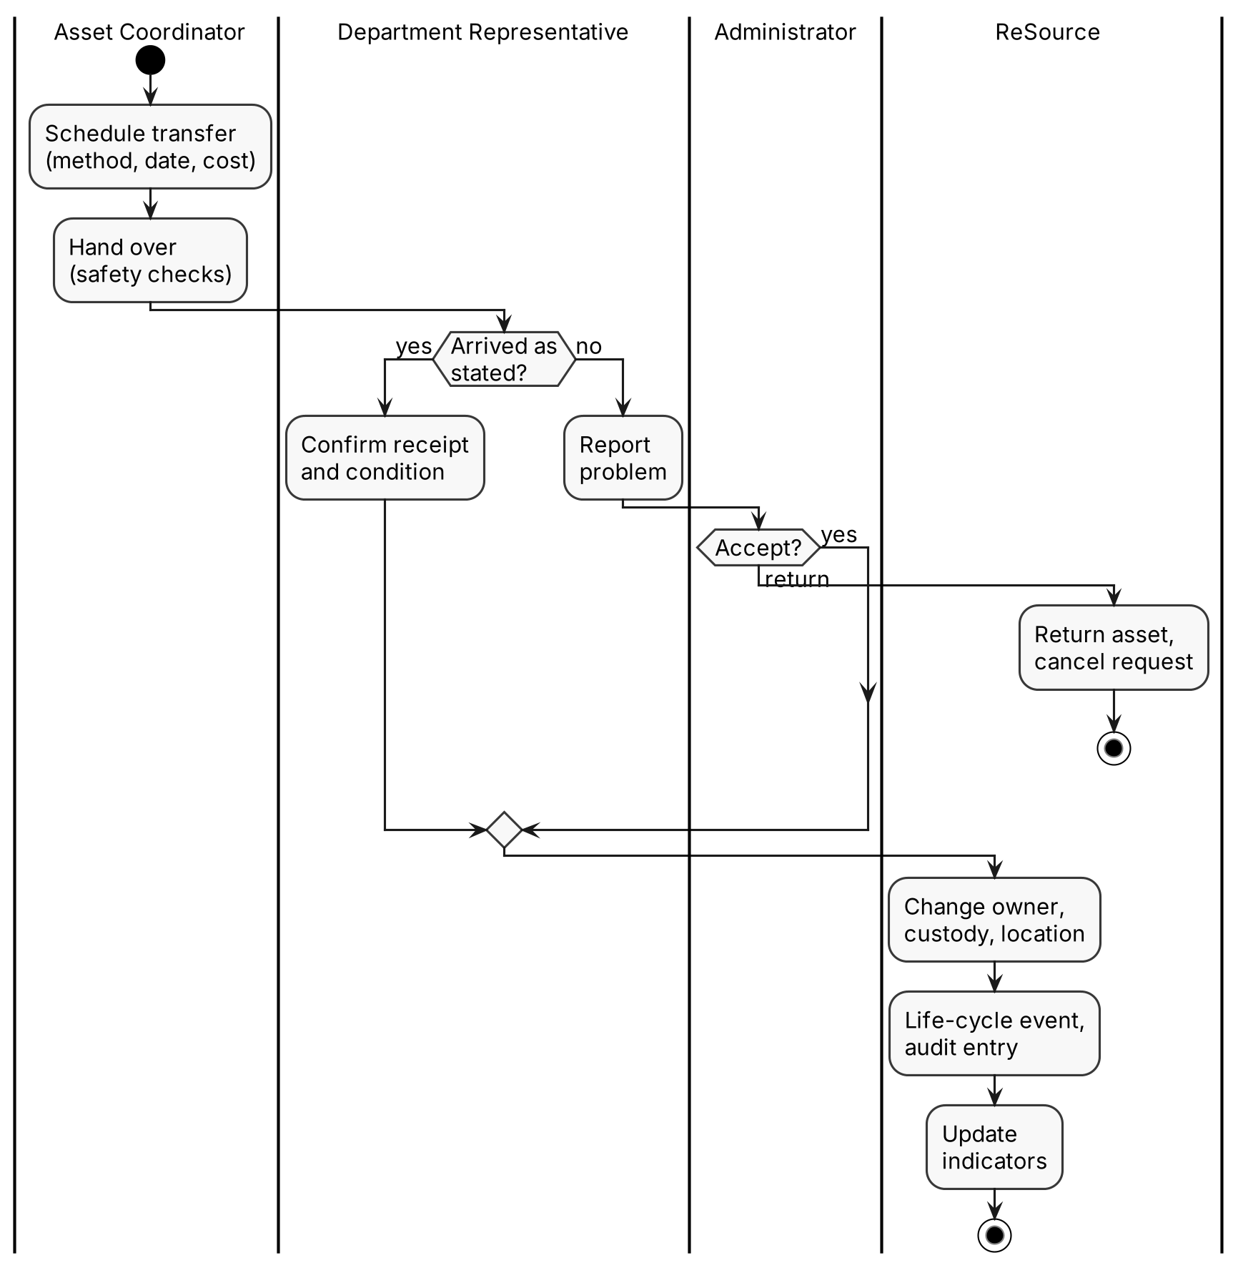
Figure 11-2: Transfer and receipt

12. State Diagrams
Prepared by: Mohammad Alsuwaidi
The state diagrams use the state lists of Phase 3, Appendix B. Each transition is labeled "event [guard] / action (who)": the guard in brackets must be true, the action after the slash is done by the system, and the role in brackets causes the event, using the abbreviations of Table I-1 ("receiver" is the receiving Department Representative or Asset Coordinator). Approval states are drawn as the first part of the transfer diagram (Figure 12-4), because an approval exists only within one request.

12.1 Asset
Prepared by: Mohammad Alsuwaidi
Availability is never set by hand; it follows from these states (FR-1.4). Category, quantity and condition cannot change while the asset is Reserved or In transfer (FR-1.10).
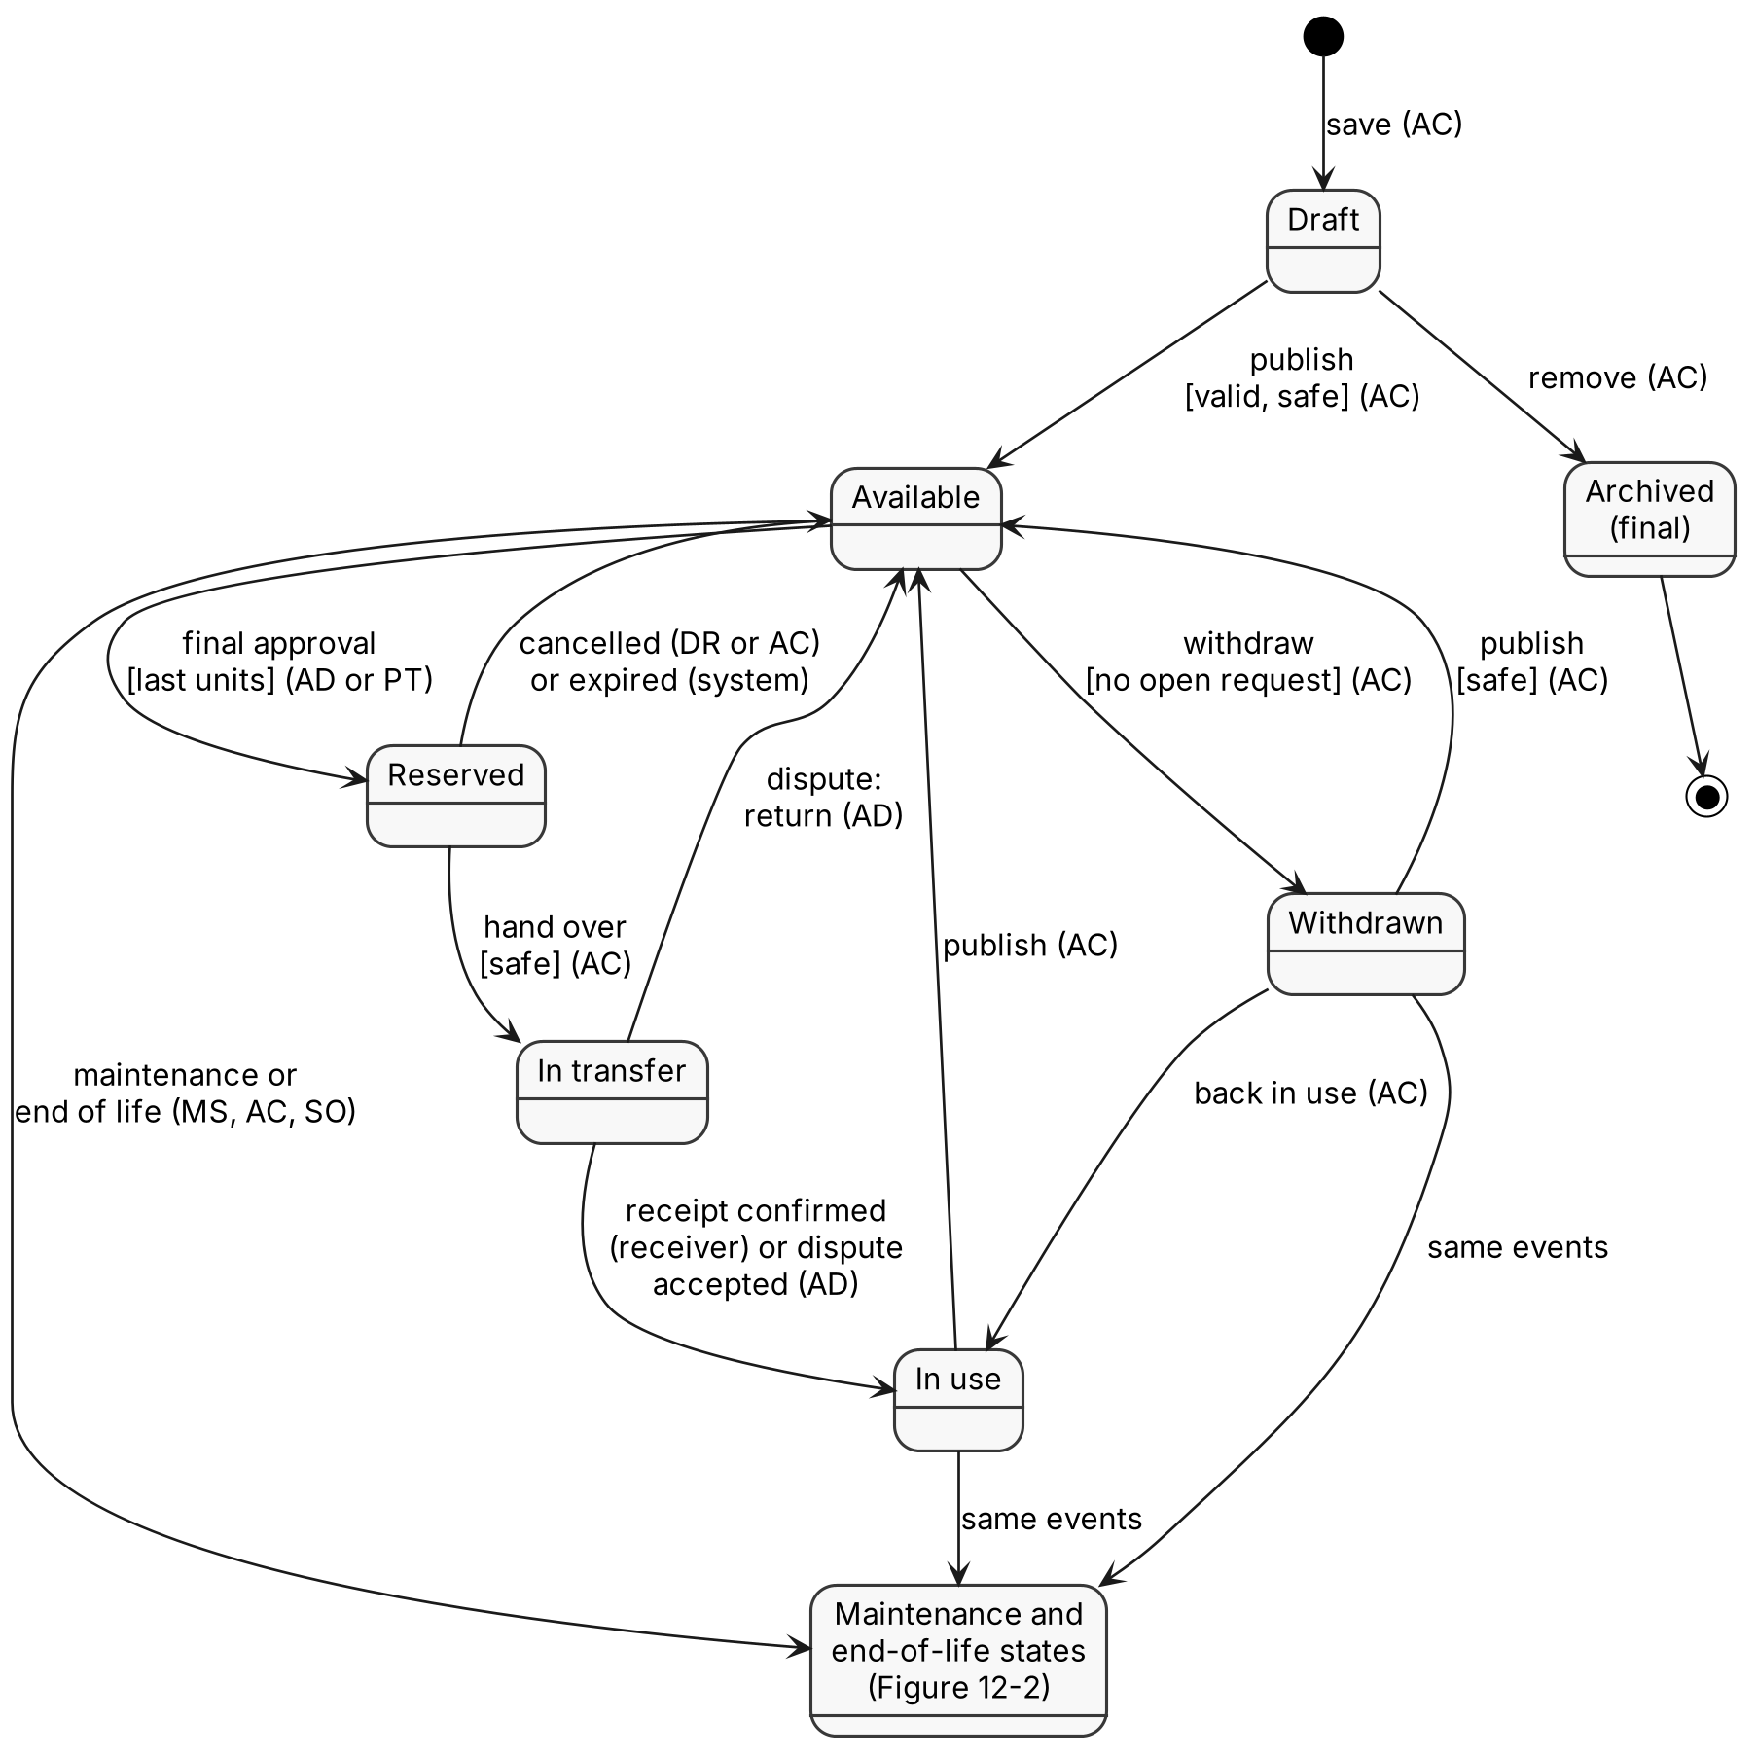
Figure 12-1: Asset states

12.3 Request
Prepared by: Mohammad Alsuwaidi
A request for a listing starts as Submitted; an open need starts as Open and becomes Submitted when the Procurement Team selects a match. Units are reserved on approval and released on cancellation or expiry (BR-5, FR-3.9).
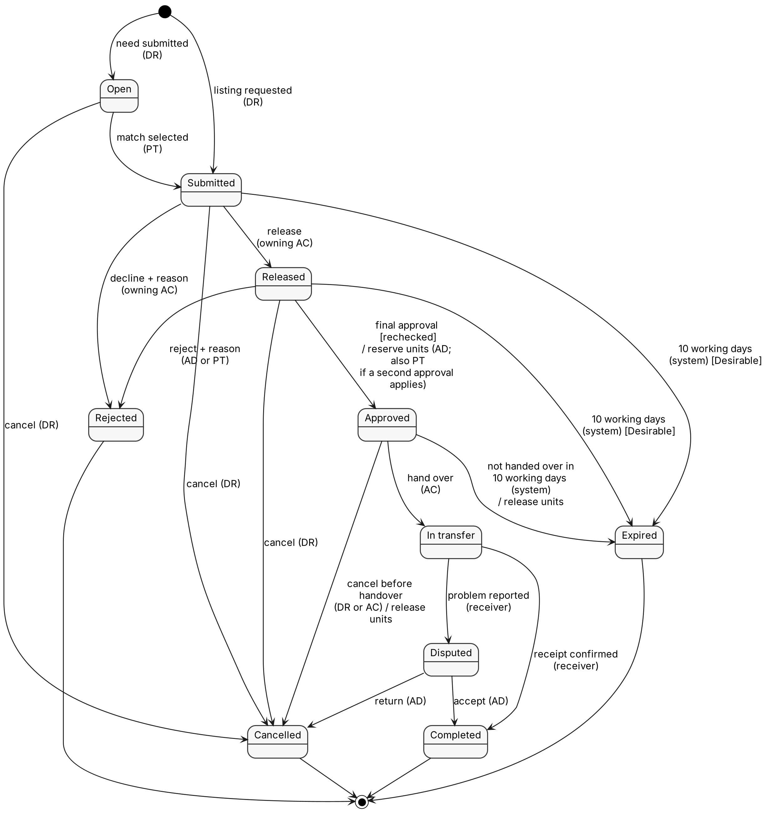
Figure 12-3: Request states

12.4 Approval and Transfer
Prepared by: Mohammad Alsuwaidi
The approval stages are Awaiting release, Awaiting approval and, for a value above the limit or unknown, Awaiting second approval (FR-4.1 to FR-4.3). Units are reserved when the last required stage approves (BR-5).
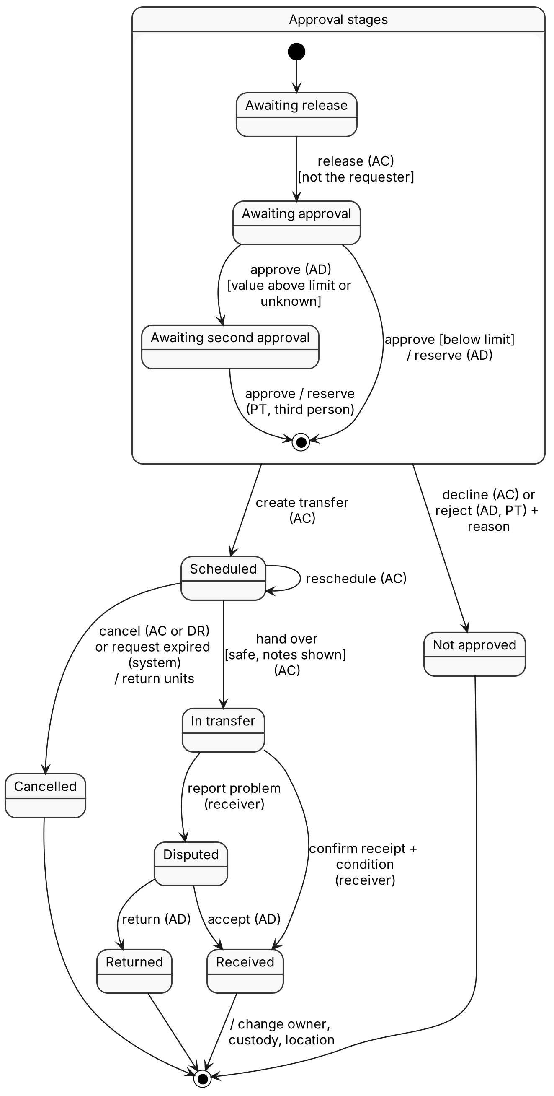
Figure 12-4: Approval and transfer states

15. Entity Relationship Diagram
Prepared by: Mohammad Alsuwaidi
The ERD has 32 tables and 61 foreign keys, drawn in five parts: accounts and catalogue (Figure 15-1); requests, approvals and transfers (Figure 15-2); maintenance, end of life and life-cycle events (Figure 15-3); AI records (Figure 15-4); and sustainability, notifications and audit (Figure 15-5). Every column is shown with its MySQL type and its keys (PK, FK, UQ). Every foreign key is drawn as its own line, labeled with the relationship name and the foreign key column, with the cardinality at both ends. A grey entity is a table drawn in full in the figure named under it; it is repeated so that each foreign key line can be drawn. Table 15-1 lists the same columns.
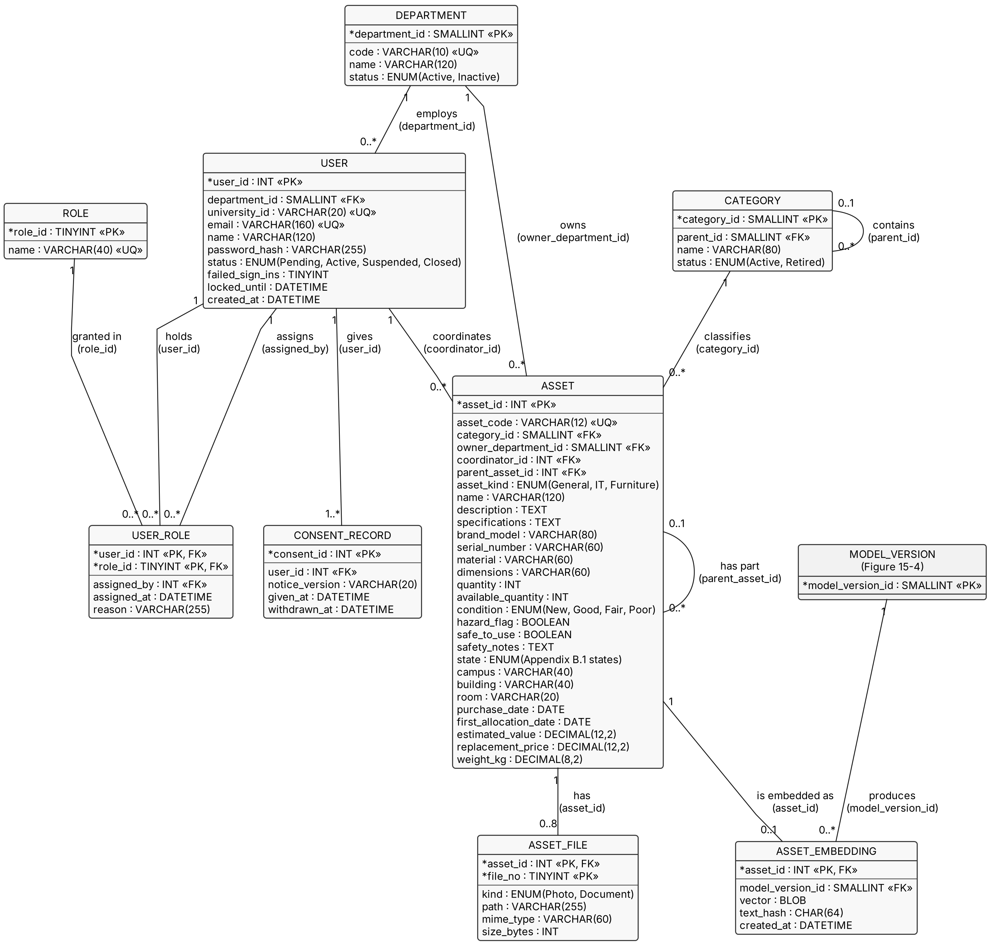
Figure 15-1: ERD part 1, accounts and catalogue

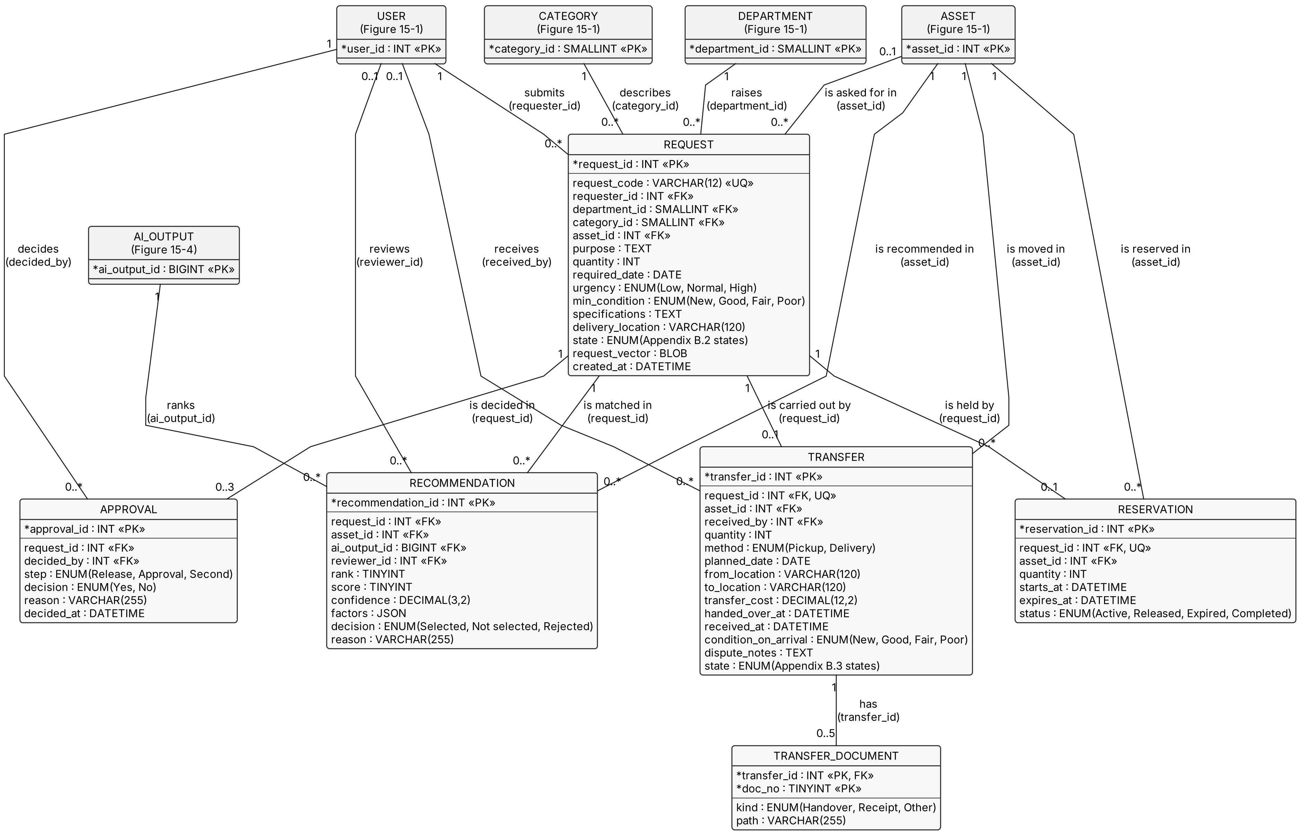
Figure 15-2: ERD part 2, requests, approvals and transfers
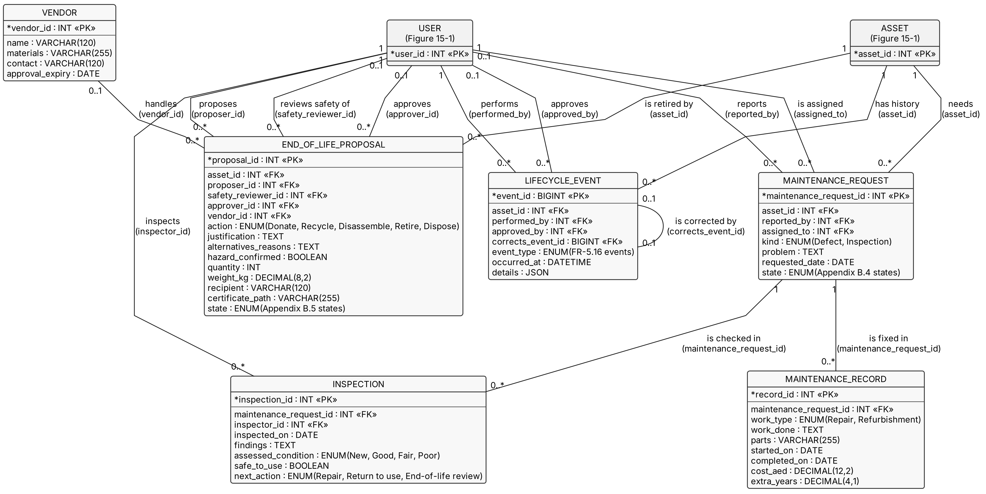
Figure 15-3: ERD part 3, maintenance, end of life and life-cycle events
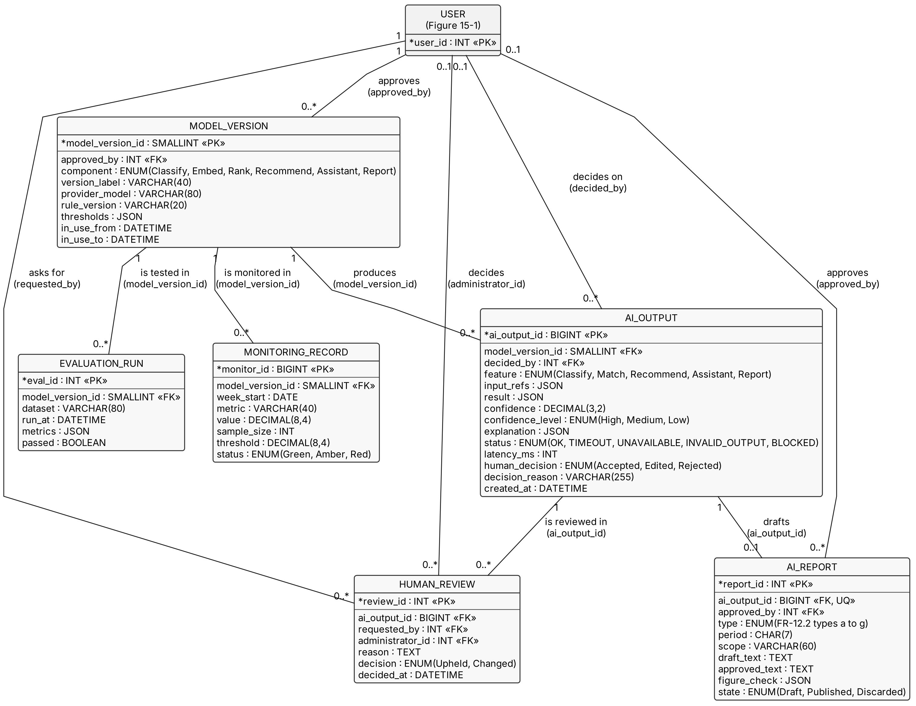
Figure 15-4: ERD part 4, AI records

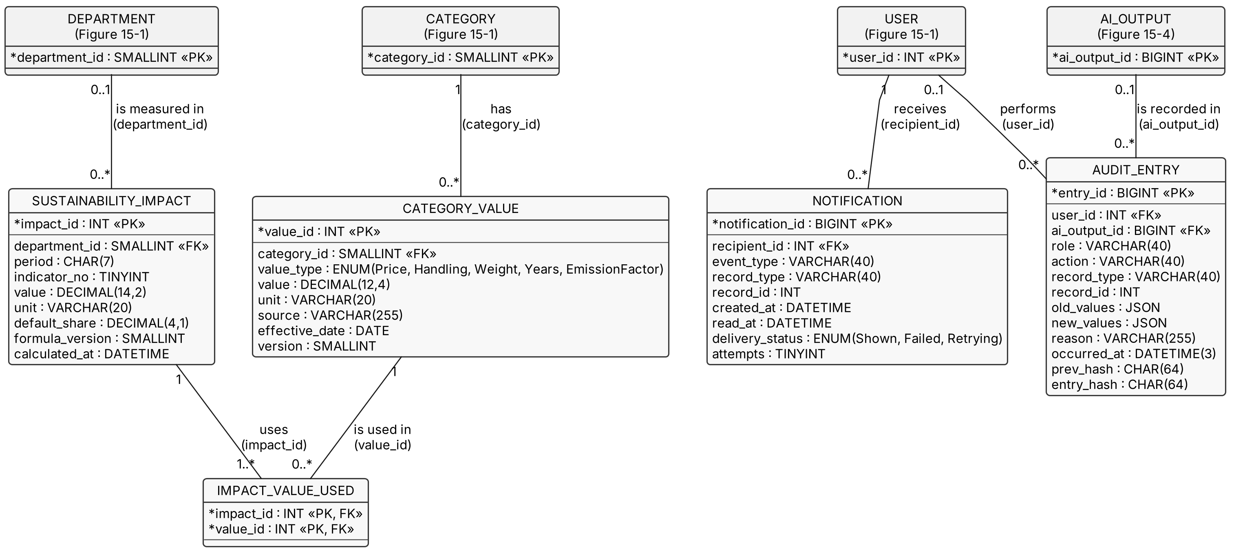
Figure 15-5: ERD part 5, sustainability, notifications and audit

15.1 Notation and Data Dictionary
Prepared by: Mohammad Alsuwaidi
- Weak entities. ASSET_FILE and TRANSFER_DOCUMENT use their owner key plus a partial key (file_no, doc_no).
- Composite and derived attributes. Location is stored as campus, building and room. Age is derived from purchase_date and today, so it is calculated, not stored (FR-5.19).
- Many-to-many links. USER_ROLE links users and roles; RECOMMENDATION links requests and assets and stores the score, explanation and model version, following [3]; IMPACT_VALUE_USED links each indicator result to the category value versions it used (FR-13.5).
- Types. ENUM columns list their values, or name the Phase 3 list they use (Appendix B states, FR-5.16 events, FR-12.2 report types). Money columns are DECIMAL(12,2) in AED and all dates are stored in UAE time.
Table 15-1: Tables and columns
Table | Holds | Keys (PK; FK) | Other columns | Requirements
DEPARTMENT | Campus departments | department_id | code, name, status | FR-6.9
USER | Accounts | user_id; department_id | university_id, email, name, password_hash, status, failed_sign_ins, locked_until, created_at | FR-6.1, SEC-6, SEC-7
ROLE | The nine roles | role_id | name | FR-6.8
USER_ROLE | Role assignments | user_id + role_id; assigned_by | assigned_at, reason | FR-6.8, BR-4
CONSENT_RECORD | Consent given and withdrawn | consent_id; user_id | notice_version, given_at, withdrawn_at | FR-6.2, SEC-8
CATEGORY | Approved category list | category_id; parent_id | name, status | FR-9.2, QUA-7
ASSET | Registered assets | asset_id; category_id, owner_department_id, coordinator_id, parent_asset_id | asset_code, asset_kind, name, description, specifications, brand_model, serial_number, material, dimensions, quantity, available_quantity, condition, hazard_flag, safe_to_use, safety_notes, state, campus, building, room, purchase_date, first_allocation_date, estimated_value, replacement_price, weight_kg | FR-1.2 to FR-1.10, FR-4.15
ASSET_FILE | Photos and documents (weak entity) | asset_id + file_no | kind, path, mime_type, size_bytes | FR-1.6, SEC-13
ASSET_EMBEDDING | Text vector of an asset | asset_id; model_version_id | vector, text_hash, created_at | FR-8.1
REQUEST | Requests and open needs | request_id; requester_id, department_id, category_id, asset_id | request_code, purpose, quantity, required_date, urgency, min_condition, specifications, delivery_location, state, request_vector, created_at | FR-3.1 to FR-3.15
RECOMMENDATION | One ranked match (links requests and assets) | recommendation_id; request_id, asset_id, ai_output_id, reviewer_id | rank, score, confidence, factors, decision, reason | FR-8.4, FR-8.7, QUA-12
APPROVAL | Release, approval and second approval | approval_id; request_id, decided_by | step, decision, reason, decided_at | FR-4.1 to FR-4.4
RESERVATION | Reserved units | reservation_id; request_id, asset_id | quantity, starts_at, expires_at, status | FR-3.8, FR-4.5
TRANSFER | Movement of an asset | transfer_id; request_id, asset_id, received_by | quantity, method, planned_date, from_location, to_location, transfer_cost, handed_over_at, received_at, condition_on_arrival, dispute_notes, state | FR-4.7 to FR-4.12
TRANSFER_DOCUMENT | Handover files (weak entity) | transfer_id + doc_no | kind, path | FR-4.8
MAINTENANCE_REQUEST | Defects and inspection requests | maintenance_request_id; asset_id, reported_by, assigned_to | kind, problem, requested_date, state | FR-5.1 to FR-5.7
INSPECTION | Inspection results | inspection_id; maintenance_request_id, inspector_id | inspected_on, findings, assessed_condition, safe_to_use, next_action | FR-5.5, SAF-5
MAINTENANCE_RECORD | Repair and refurbishment work | record_id; maintenance_request_id | work_type, work_done, parts, started_on, completed_on, cost_aed, extra_years | FR-5.6, FR-5.10
END_OF_LIFE_PROPOSAL | End-of-life proposal and completion | proposal_id; asset_id, proposer_id, safety_reviewer_id, approver_id, vendor_id | action, justification, alternatives_reasons, hazard_confirmed, quantity, weight_kg, recipient, certificate_path, state | FR-5.20 to FR-5.32, SAF-4
VENDOR | Approved recycling and disposal vendors | vendor_id | name, materials, contact, approval_expiry | FR-5.25
LIFECYCLE_EVENT | Life-cycle history (no updates) | event_id; asset_id, performed_by, approved_by, corrects_event_id | event_type, occurred_at, details | FR-5.16 to FR-5.18
CATEGORY_VALUE | Versioned prices, costs, weights, years and emission factors | value_id; category_id | value_type, value, unit, source, effective_date, version | FR-13.4, FR-13.5
SUSTAINABILITY_IMPACT | Calculated indicator values | impact_id; department_id | period, indicator_no, value, unit, default_share, formula_version, calculated_at | FR-13.1, FR-13.7
IMPACT_VALUE_USED | Category value versions used in each result | impact_id + value_id | - | FR-13.5
MODEL_VERSION | AI model, rule and threshold versions | model_version_id; approved_by | component, version_label, provider_model, rule_version, thresholds, in_use_from, in_use_to | AI-5, AI-10
AI_OUTPUT | Every AI result and its human decision | ai_output_id; model_version_id, decided_by | feature, input_refs, result, confidence, confidence_level, explanation, status, latency_ms, human_decision, decision_reason, created_at | FR-7.A4, AI-5
HUMAN_REVIEW | Requests for human review of an AI result | review_id; ai_output_id, requested_by, administrator_id | reason, decision, decided_at | SEC-10
AI_REPORT | AI report drafts and approved versions | report_id; ai_output_id, approved_by | type, period, scope, draft_text, approved_text, figure_check, state | FR-12.6 to FR-12.10
EVALUATION_RUN | Test-set evaluations of a model version | eval_id; model_version_id | dataset, run_at, metrics, passed | QUA-9, QUA-10
MONITORING_RECORD | Weekly monitoring metrics | monitor_id; model_version_id | week_start, metric, value, sample_size, threshold, status | QUA-12
NOTIFICATION | In-application notifications | notification_id; recipient_id | event_type, record_type, record_id, created_at, read_at, delivery_status, attempts | FR-7.N1 to FR-7.N5
AUDIT_ENTRY | Append-only audit trail | entry_id; user_id, ai_output_id | role, action, record_type, record_id, old_values, new_values, reason, occurred_at, prev_hash, entry_hash | FR-7.A1 to FR-7.A6

Django-Q2 adds its own job tables, and Django adds its session table. The data stores of Section 2.2 map to these tables as shown in Table 2-2.

16. Interface Contracts
Prepared by: Mohammad Alsuwaidi
Section 16.1 defines the operations that modules offer each other and the web pages; Section 16.2 defines the contracts between the modules and the AI services. All operations follow four common rules:
1. Every operation receives the acting user and checks access first (AccessCheck); a refusal raises PERMISSION_DENIED and is audited (FR-6.7, FR-7.A1).
2. Every operation that changes data runs in one database transaction with its audit entry; if the audit entry fails, nothing is saved (FR-7.A6).
3. Notifications are sent after the transaction commits; a notification failure never reverses the change (FR-7.N3).
4. Errors are returned as a code and a message that names the problem (for example MISSING_FIELDS: location, condition).

16.1 Module Operations
Prepared by: Mohammad Alsuwaidi
Table 16-1: Module service operations
Module | Operation | Input | Output | Errors | Requirements
Accounts and Access | apply, activate, refuse, assignRole, suspend, withdrawConsent | Applicant details and consent; user, role, department, reason | Account state | DUPLICATE, NOT_AUTHORIZED, CONSENT_MISSING | FR-6.1 to FR-6.12
Accounts and Access | allowed(user, action, record) | User, action, record | Yes or no | - | FR-6.7, SEC-5
Assets and Catalogue | saveDraft, publish, withdraw | Asset fields, files | asset_id, state | MISSING_FIELDS, INVALID_VALUE, SAFETY_REVIEW_NEEDED, FILE_REJECTED | FR-1, FR-2.1
Assets and Catalogue | search(criteria) | Text, filters, page | Results page with counts | INVALID_CRITERIA | FR-2.2 to FR-2.6
Assets and Catalogue | reserve, releaseReservation, completeTransfer | asset_id, quantity, request_id or transfer_id | Reservation or updated asset | NOT_ENOUGH_UNITS, RESTRICTED | FR-4.5, FR-4.11, FR-4.15
Requests and Reservations | submit, edit, cancel | Request fields | request_id, state | MISSING_FIELDS, NOT_OWN_DEPARTMENT, NOT_ENOUGH_UNITS, ASSET_RESTRICTED, WRONG_STATE | FR-3.1 to FR-3.15
Match Review | matches(request_id) | request_id | Ranked list or "not ranked" list | NO_ELIGIBLE_ASSETS | FR-8.1 to FR-8.9
Match Review | decide(request_id, asset_id, decision, reason) | Choice and reason | Request sent to release | REASON_REQUIRED, NO_LONGER_AVAILABLE | FR-8.7, FR-8.8
Approvals and Transfers | release, approve, secondApprove | request_id, decision, reason | Approval record; reservation on final approval | SAME_PERSON, REASON_REQUIRED, NOT_ENOUGH_UNITS | FR-4.1 to FR-4.6
Approvals and Transfers | schedule, handOver, confirmReceipt, reportProblem, resolveDispute | transfer details, condition, decision | Transfer state | NOT_APPROVED, UNSAFE, INSPECTION_TOO_OLD, NOT_RECEIVER | FR-4.7 to FR-4.16
Maintenance and End-of-Life | report, assign, startInspection, recordInspection, recordWork, complete, closeNotRepairable, cancel | Maintenance fields | Maintenance state | NOT_MAINTENANCE_ROLE, INVALID_DATES, MISSING_FIELDS | FR-5.1 to FR-5.15
Maintenance and End-of-Life | propose, safetyReview, decide, complete | Action, reasons, review, completion record | Proposal state | BLOCKED_BY_OPEN_WORK, SAME_PERSON, VENDOR_EXPIRED, CERTIFICATE_REQUIRED | FR-5.20 to FR-5.34
Reporting and Indicators | standardReport, indicators, requestAIReport, approveReport, discardReport | Report type, period, scope | Report, indicator set or AI report draft | NO_RECORDS, NOT_AUTHORIZED | FR-7.R, FR-12, FR-13
Notifications | notify(event, record, recipients) | Event and record | Notification IDs | Retried on failure | FR-7.N1 to FR-7.N5
Audit | write(user, action, record, before, after, reason, ai_output_id) | Entry fields | entry_id | AUDIT_FAILED (change rolled back) | FR-7.A1 to FR-7.A6

AI Contributions

Mohammad Alsuwaidi
Prepared by: Mohammad Alsuwaidi
I used an AI assistant (ChatGPT astra6, OpenAI) to help draw the class diagrams in Sections 9.1 and 9.2, the sequence, activity and state diagrams in Sections 10.1, 10.2, 10.7, 11.1, 11.2, 12.1, 12.3 and 12.4, the ERD (Section 15) and the screen mockups in Sections 7.1, 7.2 and 7.4 from my design, and to check the states, entities and keys against the Phase 3 report. I wrote the section content and reviewed every figure.

References
[1] University, "Intelligent, AI-Powered Circular Campus Resource Exchange and Asset Life Cycle Management System," COSC 336 Introduction to Software Engineering project description, University, Abu Dhabi, UAE, Fall 2026.
[2] University, "Phase 4: Architecture Design," COSC 336 lab slides, University, Abu Dhabi, UAE, Fall 2026.
[3] University, "Phase 4 & 5: Design Document, Sequence, ER and Class Diagrams," COSC 336 lab slides, University, Abu Dhabi, UAE, Fall 2026.
[4] R. Alzaabi, M. Alsuwaidi, A. AlAbdouli and M. Almarzooqi, "ReSource Phase III: Requirements Document," COSC 336, University, Abu Dhabi, UAE, Oct. 2026.
[5] R. Alzaabi, M. Alsuwaidi, A. AlAbdouli and M. Almarzooqi, "ReSource Phase II Feasibility Study," COSC 336, University, Abu Dhabi, UAE, Sep. 2026.
[6] Django Software Foundation, "User authentication in Django," Django documentation. [Online]. Available: https://docs.djangoproject.com/en/stable/topics/auth/
[7] Anthropic, "Models overview," Claude Platform Docs, 2026. [Online]. Available: https://platform.claude.com/docs/en/about-claude/models/overview
[8] Django Q2 project, "Brokers," Django Q2 documentation. [Online]. Available: https://django-q2.readthedocs.io/en/stable/brokers.html
[9] World Wide Web Consortium, "Web Content Accessibility Guidelines (WCAG) 2.2," W3C Recommendation, Dec. 2024. [Online]. Available: https://www.w3.org/TR/WCAG22/
[10] Sentence Transformers, "all-MiniLM-L6-v2," model card, Hugging Face. [Online]. Available: https://huggingface.co/sentence-transformers/all-MiniLM-L6-v2
[11] N. Reimers and I. Gurevych, "Sentence-BERT: Sentence embeddings using Siamese BERT-networks," in Proc. 2019 Conf. Empirical Methods in Natural Language Processing (EMNLP-IJCNLP), Hong Kong, 2019, pp. 3982-3992.
[12] OWASP Foundation, "OWASP Top 10:2025," 2025. [Online]. Available: https://owasp.org/Top10/2025/
[13] United Arab Emirates, Federal Decree-Law No. 45 of 2021 Concerning the Protection of Personal Data, 2021. [Online]. Available: https://uaelegislation.gov.ae/en/legislations/1972
[14] J. Platt, "Probabilistic outputs for support vector machines and comparisons to regularized likelihood methods," in Advances in Large Margin Classifiers, A. Smola et al., Eds. Cambridge, MA, USA: MIT Press, 1999, pp. 61-74.
[15] U.S. Environmental Protection Agency, "Documentation chapters for greenhouse gas emission, energy and economic factors used in the Waste Reduction Model (WARM)," WARM version 16, Dec. 2023. [Online]. Available: https://www.epa.gov/warm/documentation-chapters-greenhouse-gas-emission-energy-and-economic-factors-used-waste

