**SmatSocial Task**

Step1:

Created Database and table

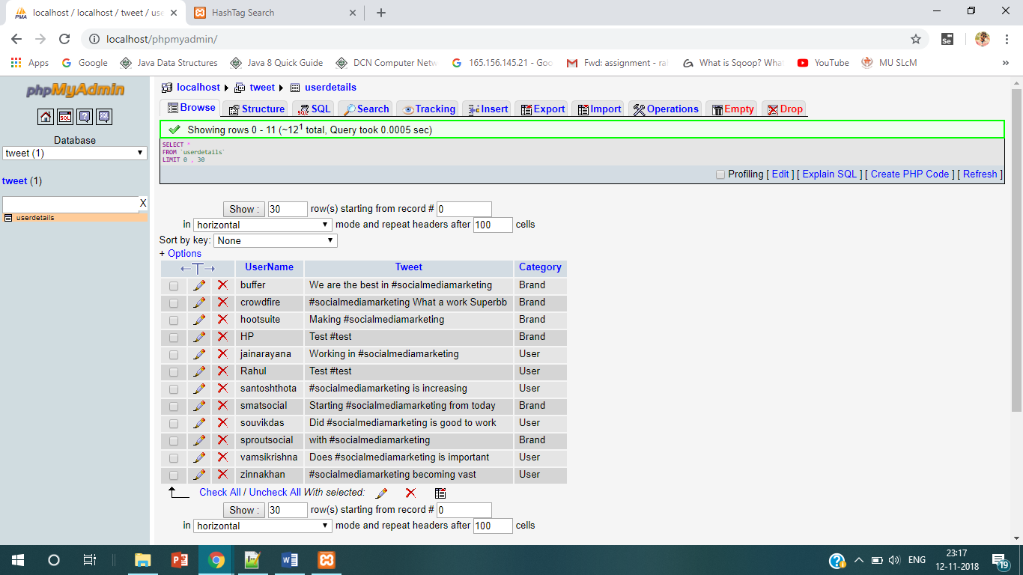

We can see in Tweet Column they are two tweets without #socialmediamarketing.

Step2:

Written a Script including both HTML and PHP

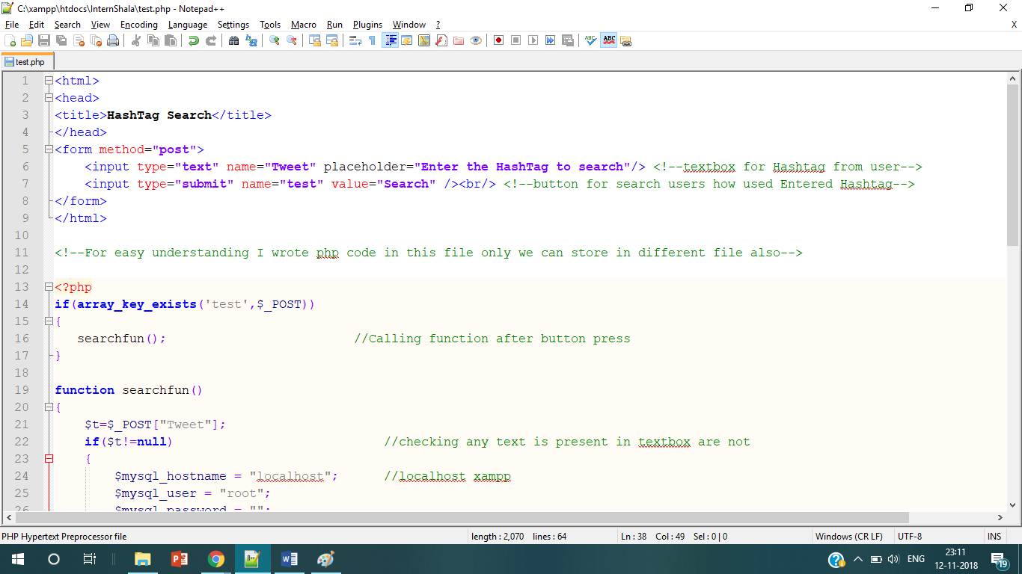

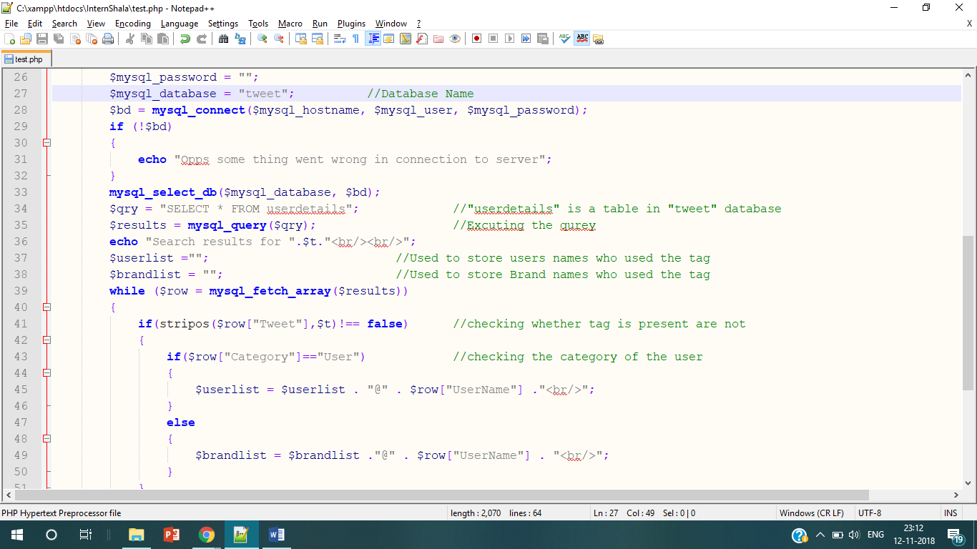

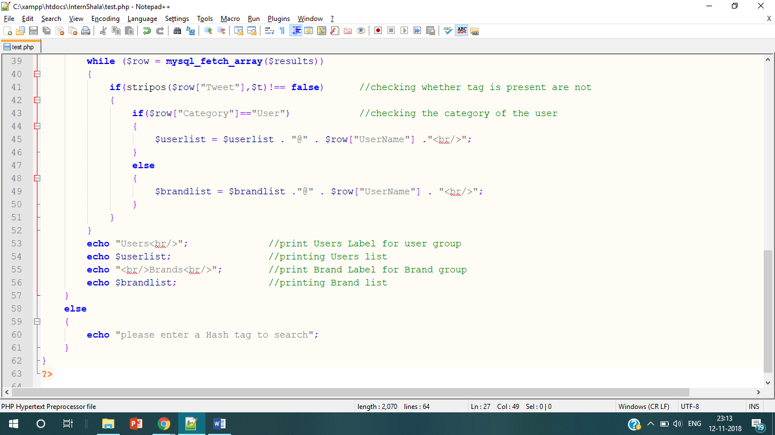

Stored in c:\xampp\htdoc\ because hosting localhost

Step3:

Open a web browser and accessed localhost file “test.php”

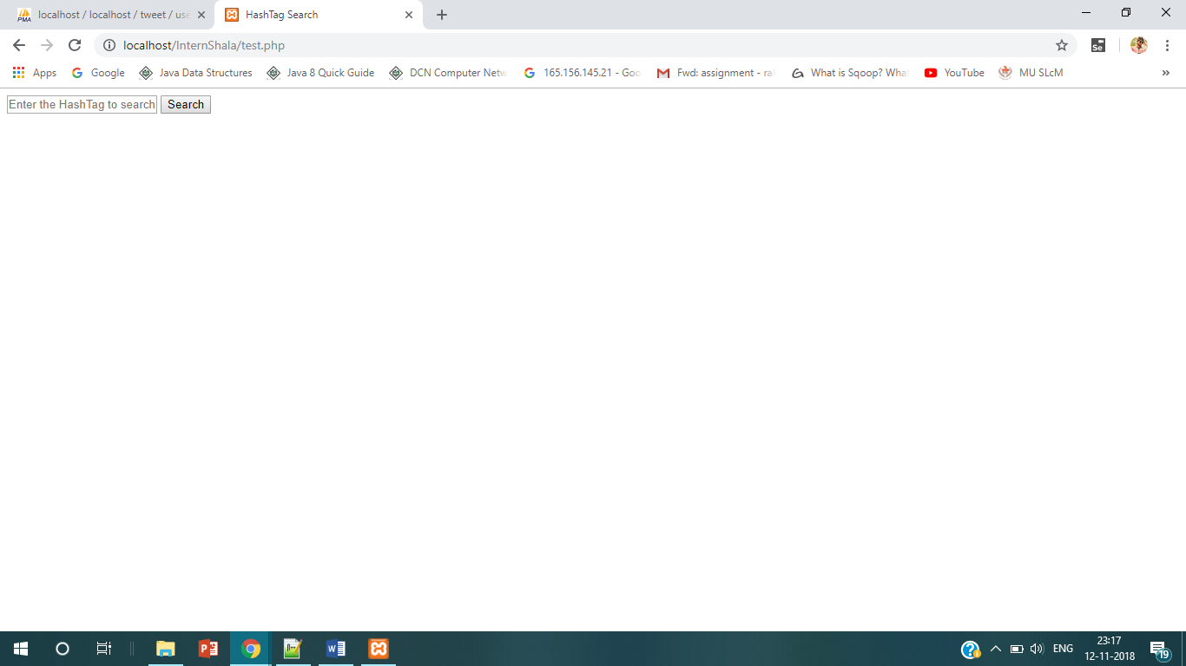

Step4:

Enter the #socialmediamarketing in textbox and press Search button

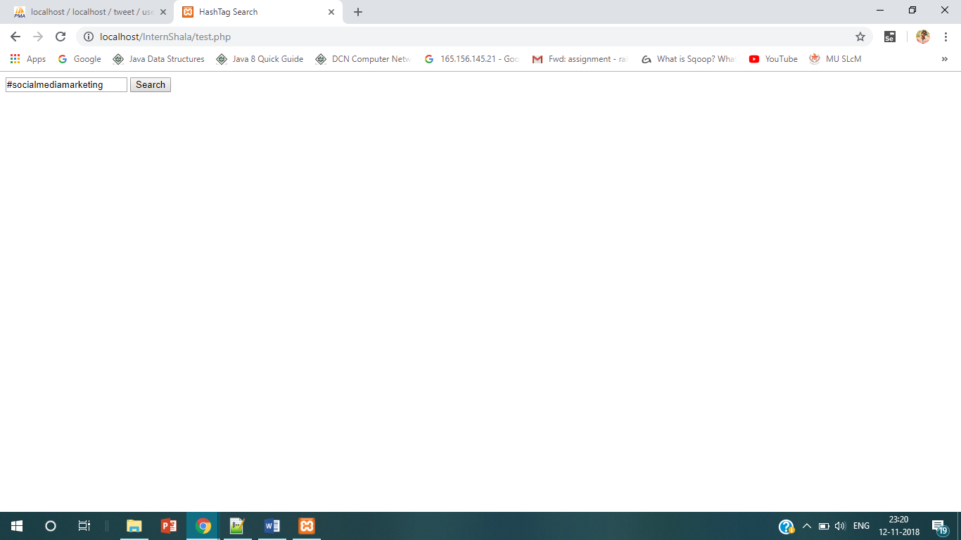

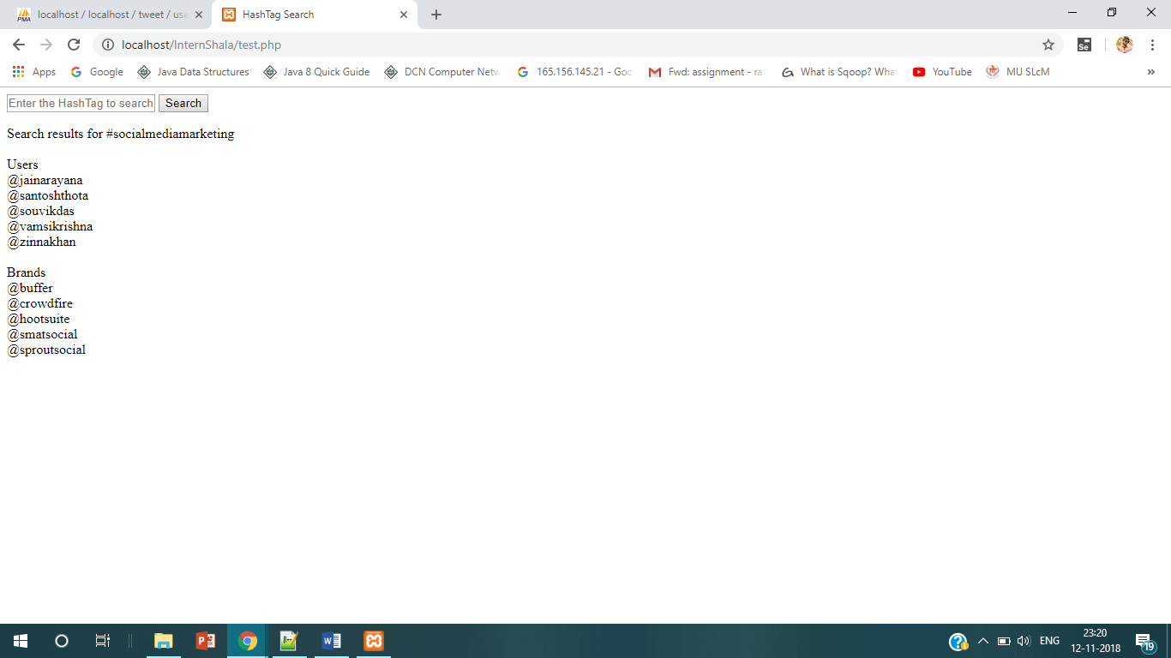

As we have 10 records(5 Users and 5Brands) with #socialmediamarketing tweetin database we got them

Step4:

Try with different hashtag like “#test”

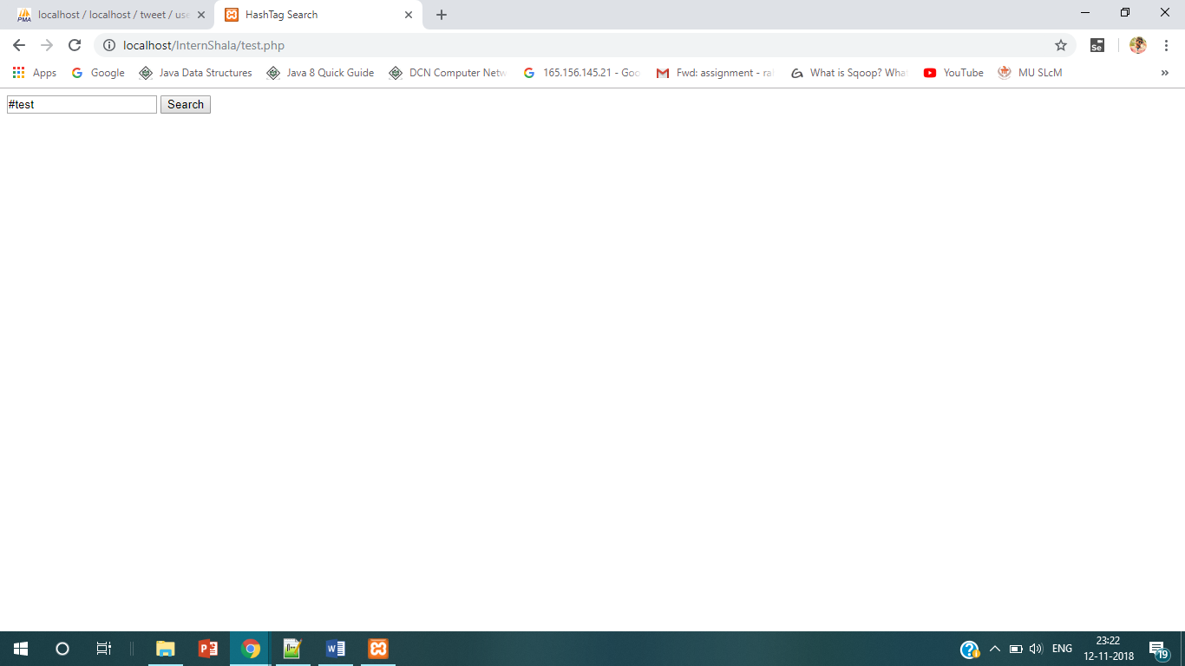

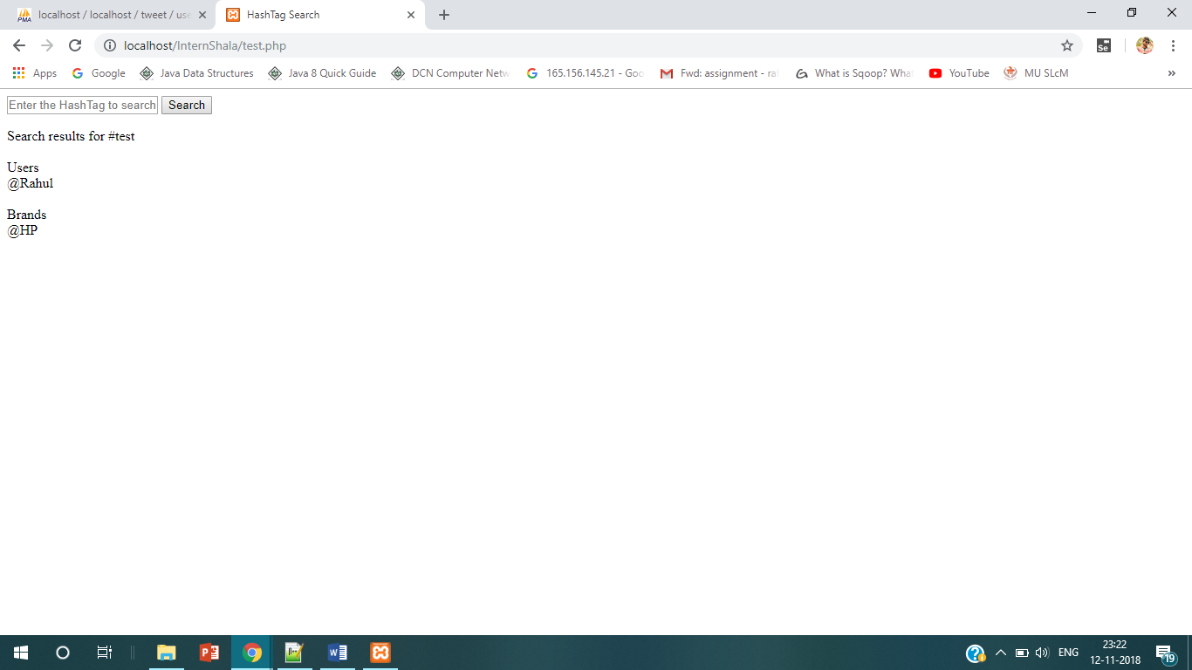

As we have only two records(one User and one Brand) with #test tweet in database we got them

Try3:

With #test2

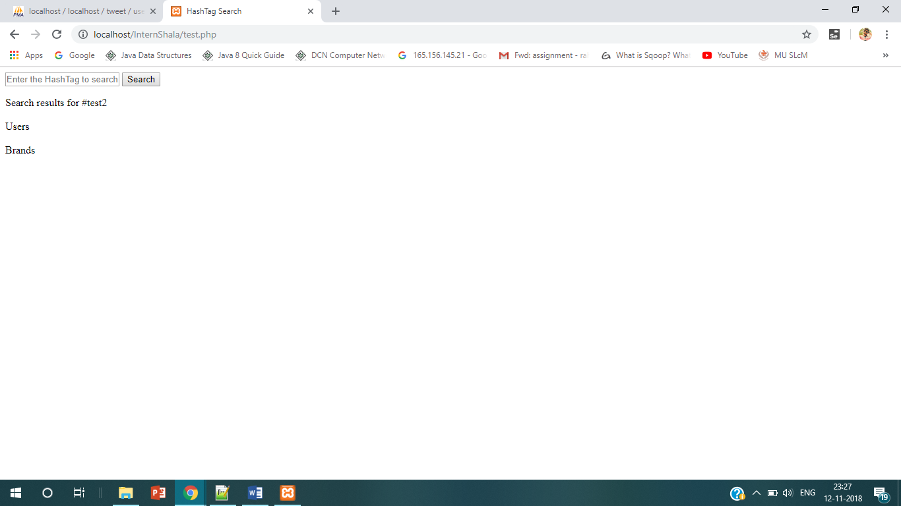

As we have no tweets having #test2 we get 0 results.